***A1-Uniform***

*User Guide*

|  |  |  |
| --- | --- | --- |
| **Supervisor** | Sir Wajahat | |
| **Batch** | 2407D | |
| **Group** | **A1-uniform** | |
| **Serial No.** | **Enrollment Number** | **Student Name** |
| 1. | 1586902 | Ume Hoorain |
| 2. | 1586895 | Areeba |
| 3. | 1586945 | Rimsha |
| 4. | 1597510 | Aqsa |

# USER GUIDE

**“**A1 uniform” This Website is basically based on uniform ,if you want to buy uniforms, so just this website made for you.

## 1. Top Layout

This is the Top of the page.

* User can know about the website by clicking on About Us button



## 2. Home Page

➢ This page contain our special uniforms & their details.

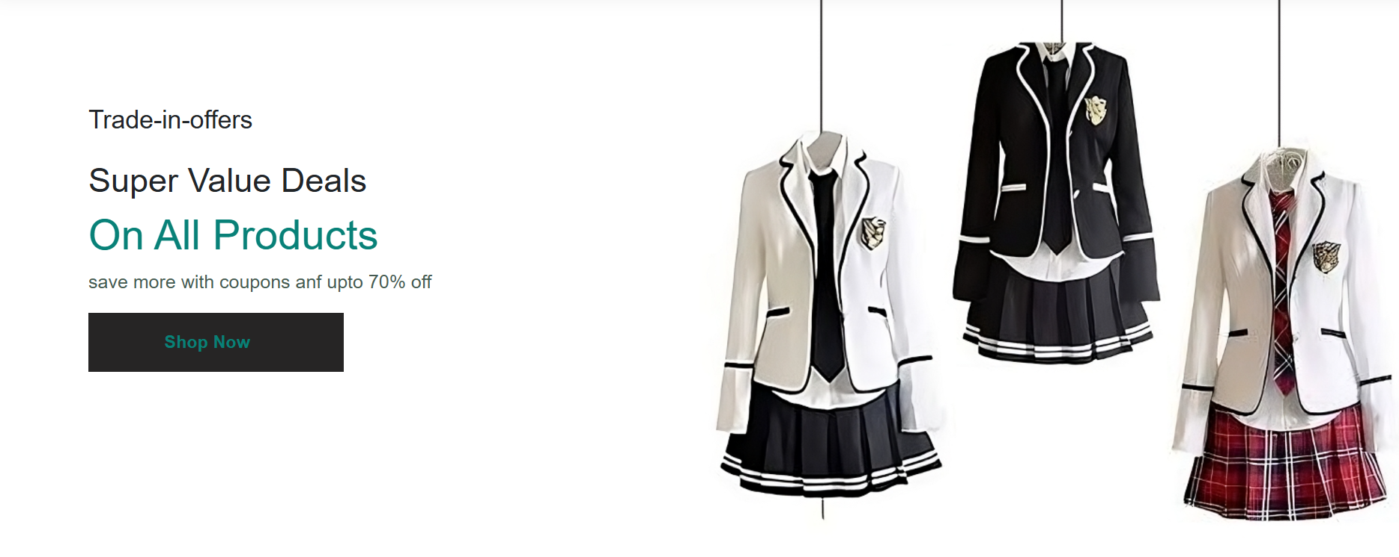

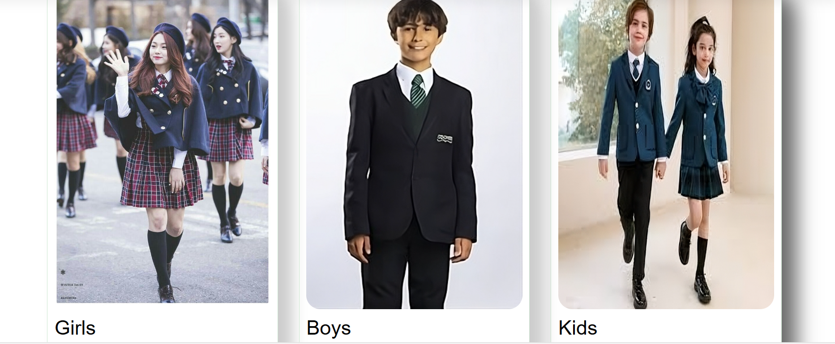

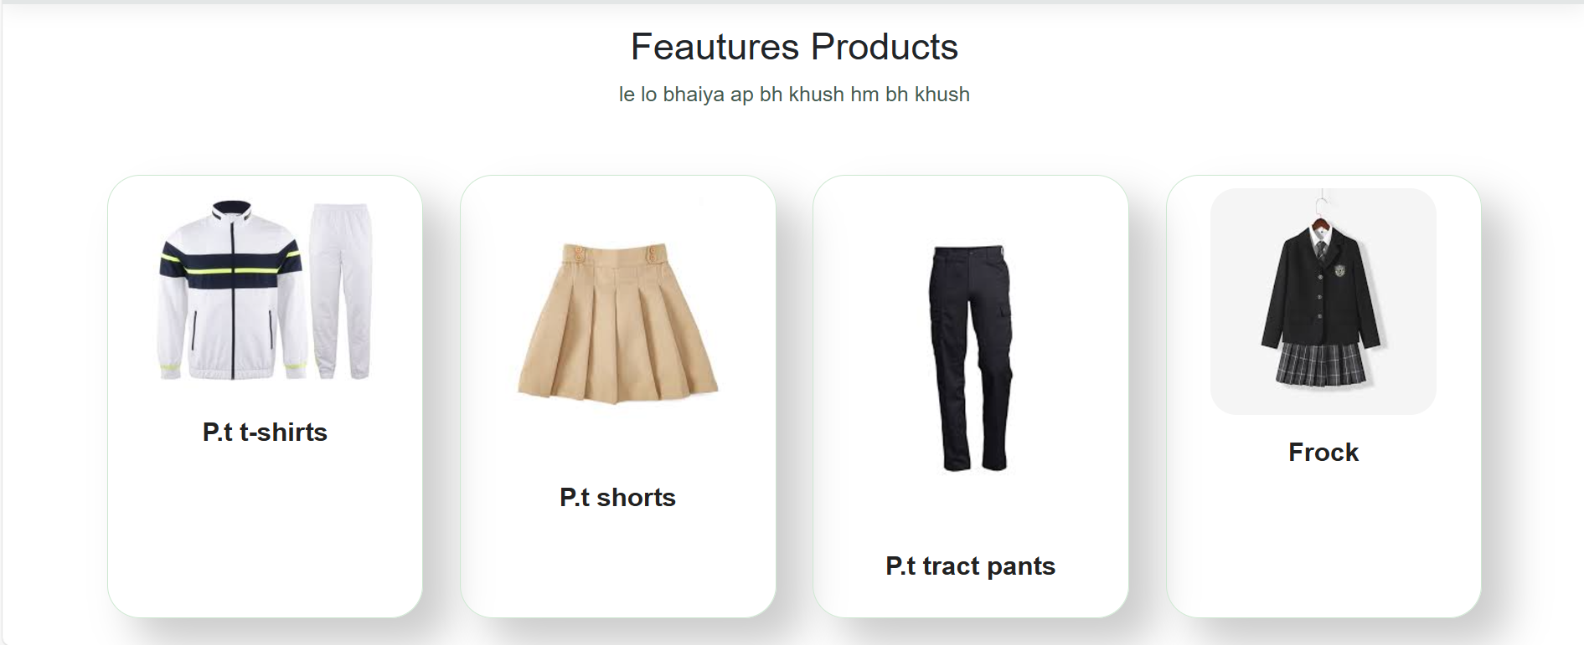

## 3. Shop Page

This is the Shop Page.

➢ In this page users can see their uniforms accoding to their school.



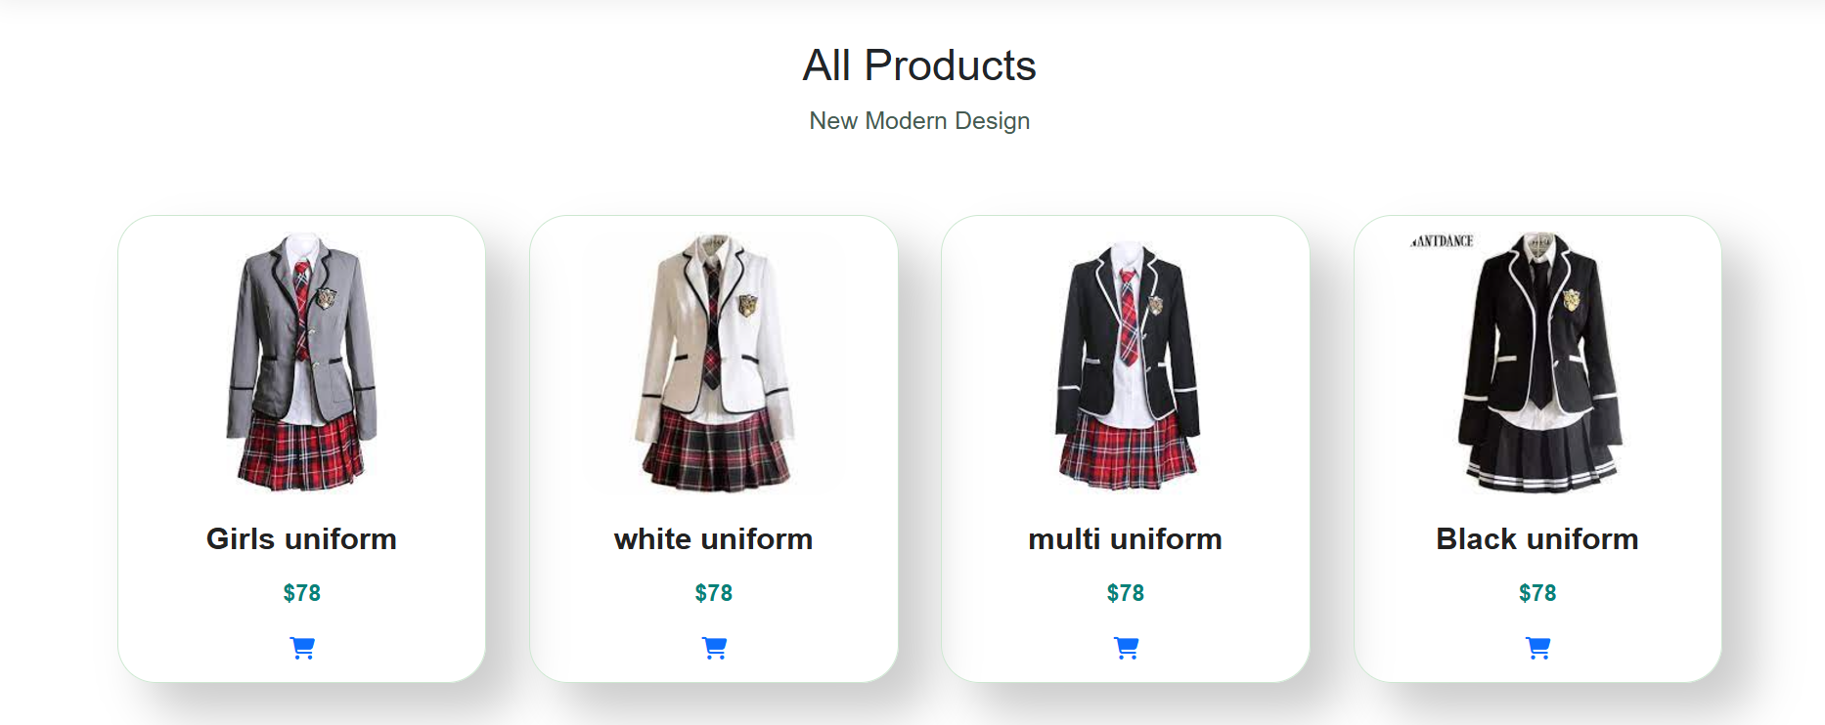

## 4. Contact Page

This is the Contact Page.

* In this page users can get in touch with us.
* They can leave their comment.

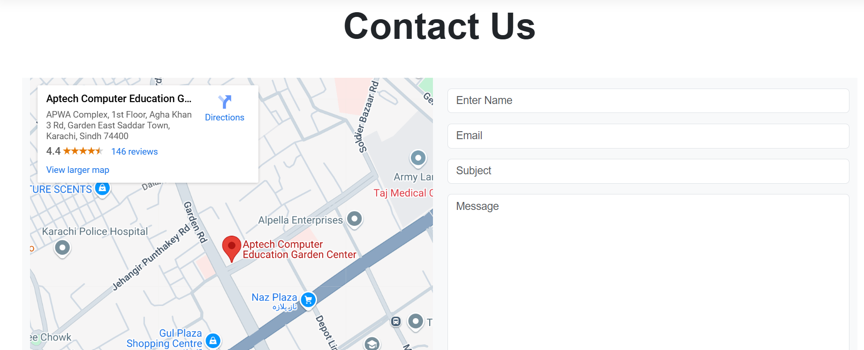

## 5. About Page

This is the About Us Page.

➢ This page has some Information about our shop.

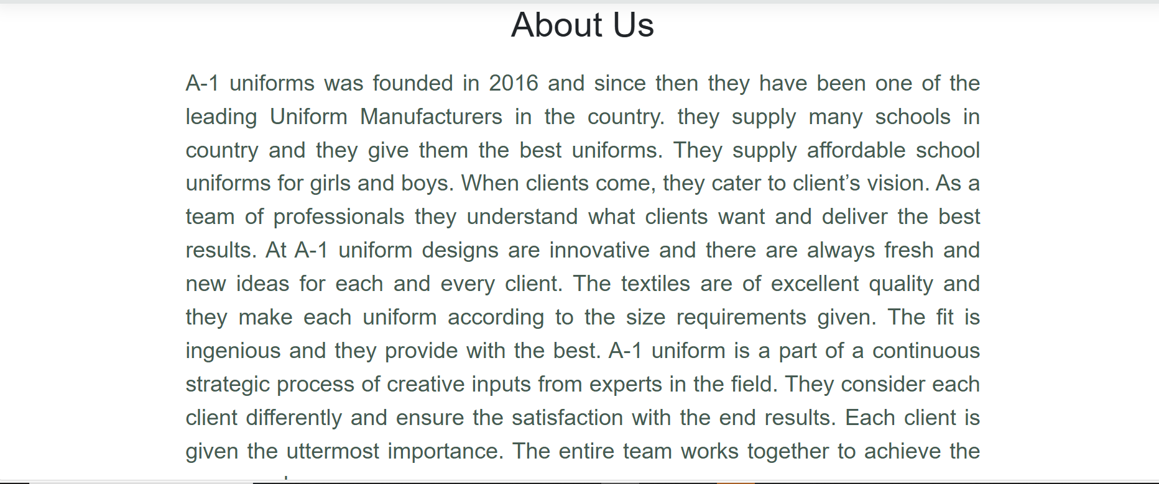

## 6. Why Us

* In this page first user can know about us more.

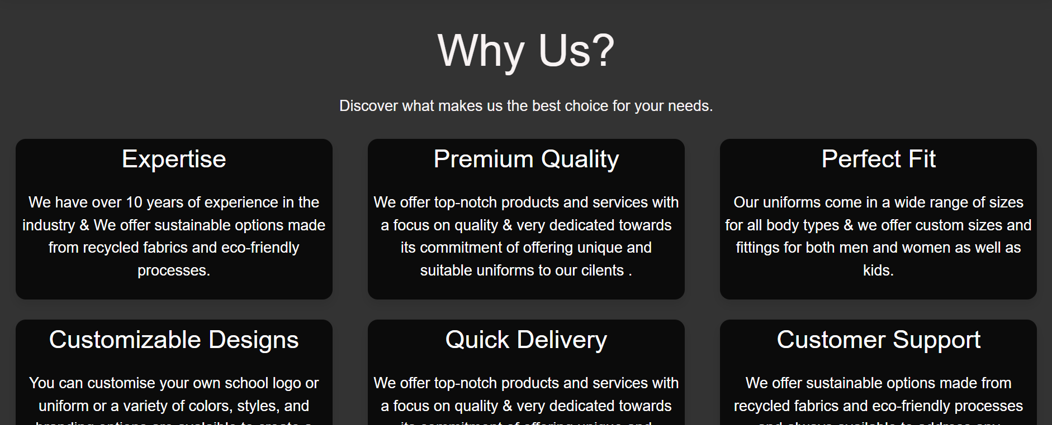

## 7. Bottom Layout

This is the Bottom of the page.

* It has some Links like Shop Page , Contact Page and Our Special uniform

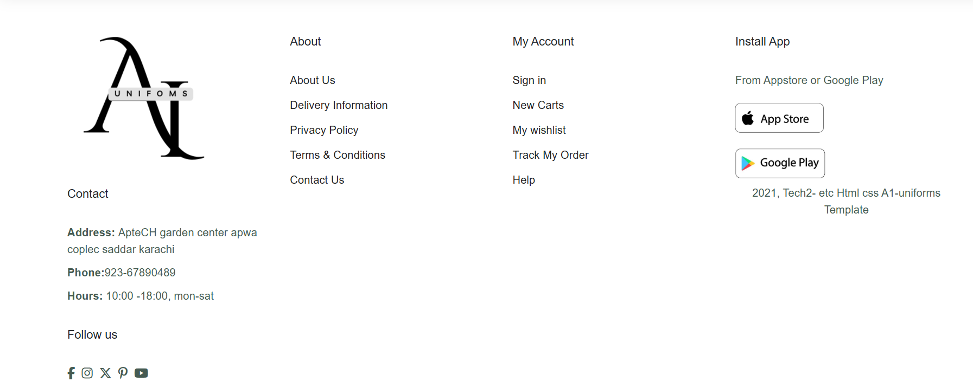

**Thank You For Reading The Documentation.**