|  |  |  |
| --- | --- | --- |
| **Batch** | **2406e** | |
| **Supervisor** | **Sir Wajahat** | |
| **Group** | **Topic karachi zoo** | |
| **Serial No.** | **Enrollment**  **Number** | **Student Name** |
| **1.** | **1585213** | **Syed Bilawal Hussain** |
| **2.** | **1584253** | **Sadiq Hussain** |
| **3.** | **1584475** | **M. Noman** |

**KARACHI ZOO USER GUIDE:-**

|  |
| --- |
| **USER GUIDE** |

**Discover a world of wonder at our zoo, where every visit brings you face-to-face with majestic animals from around the globe! Enjoy interactive exhibits, educational talks, and thrilling encounters that spark curiosity and inspire conservation. Plan your adventure today and create unforgettable memories with family and friends**

**Documentation**

**Navbar**

* This is a navbar of our website.
* Here is a logo of zoo at left side of the navbar.
* Navbar color is green.
* Navbar have many pages which is linked each other at the right side of navbar.

**Carousel**



* In Bootstrap, a carousel is a slideshow component that can cycle through various content elements such as images.
* Inside the carousel-inner div, add each slide using div.carousel-item. Add active to the first item to make it the initial slid
* Include a.carousel-control-prev and a.carousel-control-next with data-slide attributes set to "prev" and "next", respectively, for manual navigation.

**Cards**

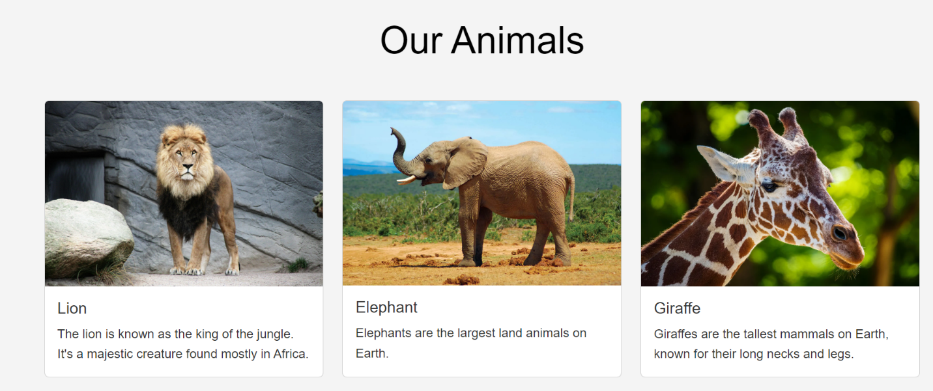

* A card is created with div class="card". Inside it, you can include other components such as images, text, headers, and footers.
* The main content area is defined with card-body. Add text, buttons, and links within the card body.
* Add images at the top or bottom using card-img-top or card-img-bottom, or inside the body with card-img for inline images.
* Use card-text to add descriptive text within the card body. This ensures consistent spacing and styling.

**Footer**

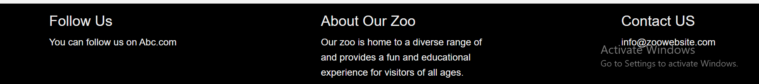

* The footer with the <footer> tag. Place it at the end of your HTML document for semantic structure and accessibility.
* Use CSS properties like position: relative, absolute, or fixed for the footer's placement. For a sticky footer, use position: fixed; bottom: 0; width: 100% to keep it at the bottom of the viewport
* Use CSS media queries to adjust the footer layout on different screen sizes. Stack elements vertically on smaller screens or use a flexbox/ grid for multi-column layouts.
* Add padding to create space inside the footer, giving it a balanced look. Use margin-top or margin-bottom to separate it from other page content.

**About Us**

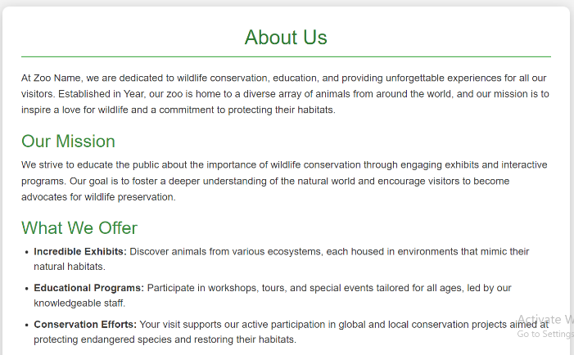

**Our Mission**

**1. Animal Welfare and Care**

* **Ensuring Ethical Treatment:** The primary responsibility of zoo management is to provide a high standard of care for all animals. This includes ensuring animals have appropriate habitats, proper nutrition, veterinary care, and enrichment activities to maintain their physical and mental health.

**2. Habitat Management**

* **Cleanliness and Safety:** Ensuring the cleanliness of enclosures and public areas, as well as maintaining safety for both animals and visitors, is essential. Regular inspections and maintenance are critical to preventing hazards.

**3. Educational Programs**

* **Public Awareness and Engagement:** Zoo management is responsible for developing educational programs and initiatives that inform the public about wildlife conservation, biodiversity, and the importance of protecting ecosystems.
* **School and Community Outreach:** Zoos often partner with schools and community organizations to offer guided tours, workshops, and conservation talks, aimed at educating future generations on wildlife and environmental issues.

**Tickets**

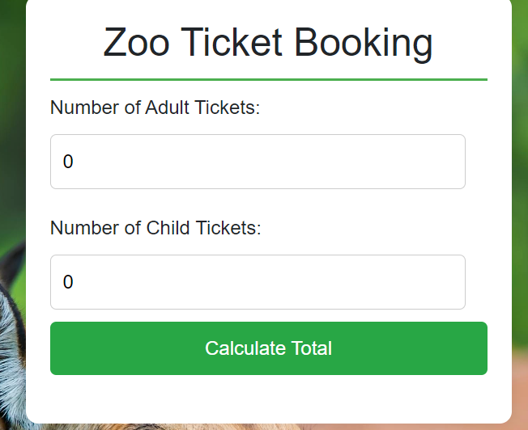

* In this page visitor can book their online tickets which is develop by Javascript.
* There are two variables.
* A and B assign with their prices.
* Each variable have their own id and with help of id# var can be easily called for the appearance on the website.
* Price of tickets can be calculated by the quantity of both variables.
* Total Price can be shown in the below of Calculate Total Button.

**Contact Us**

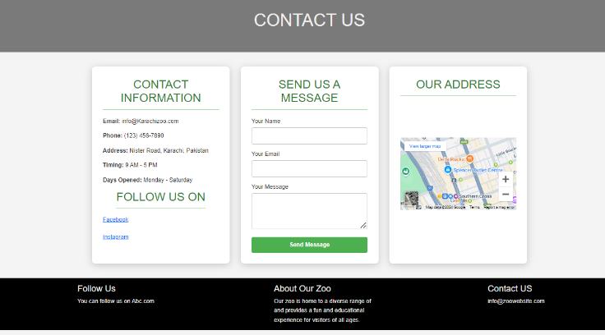

* **Form Structure**: Bootstrap's form controls like form-group, form-control, input, and textarea provide a consistent and accessible form structure.
* **Form Layout**: Use container and row classes to structure the form within a responsive grid. You can split the form into sections or create multi-column layouts using col-md-6 or other column classes for larger screens.
* **Input Fields**: Use input elements with form-control class for fields like name, email, phone, and textarea for the message. Set type attributes (e.g., type="email") for specific input validation.
* **Labels and Placeholders**: Add label elements to enhance accessibility, and placeholders inside input fields to guide users on what information to enter.
* **Submit Button**: Use a button with btn classes like btn-primary for a styled submit button. Align it with flex utilities if needed.
* **Validation**: Use Bootstrap’s is-invalid and is-valid classes for real-time validation feedback, and optionally JavaScript for additional validation.
* **Icons and Visuals**: Use Font Awesome or Bootstrap Icons for adding icons next to input fields or in the footer for social media links.
* **Map Integration**: Include an embedded Google Map or other maps API in an iframe to show the office location. Use responsive classes like embed-responsive for scaling.
* **Contact Information**: Display contact details such as phone, email, and address outside the form, often in a separate column or section.