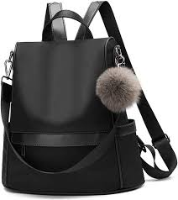

Description: This stylish bag combines fashion and function with its sleek design and durable material. Featuring multiple compartments, it ensures easy organization for all your essentials. The adjustable strap offers comfort, while the sturdy handle adds versatility. Perfect for both casual and professional settings.

Women Backpack