Software Requirements and Design Document
for
<Plant Management Sytem>
Prepared by <Nimra Aslam 22i-1164>
<Wajahat Ullah 22i-0776>
<Alishba Naveed 22i-0808>

<FAST NUCES Islamabad>
<27th November, 2024>
Table of Contents
Table of Contents ii
1. Introduction 1
1.1 Purpose 1
1.2 Product Scope 1
1.3 Title 1
1.4 Objectives 1
1.5 Problem Statement 1
2. Overall Description 1
2.1 Product Perspective 1
2.2 Product Functions 2
2.3 List of Use Cases 2
2.4 Extended Use Cases 2
2.5 Use Case Diagram 2
3. Other Nonfunctional Requirements 2
3.1 Performance Requirements 2
3.2 Safety Requirements 2
3.3 Security Requirements 2
3.4 Software Quality Attributes 2
3.5 Business Rules 3
3.6 Operating Environment 3
3.7 User Interfaces 3
4. Domain Model 3
5. System Sequence Diagram 3
6. Sequence Diagram 3
7. Class Diagram 4
8. Package Diagram 4
9. Deployment Diagram 4

Introduction

Purpose
This Software Requirements Specification (SRS) document outlines the software requirements for the Plant Management System (PMS). The PMS is designed to assist plant owners and enthusiasts in effectively managing their plant collections by providing tools for inventory management, health monitoring, care scheduling, and collaboration. This SRS covers the entire system, detailing both user-level functionalities and manager-level controls, ensuring a comprehensive guide for the development and deployment of the PMS.

Product Scope
The Plant Management System (PMS) is a comprehensive platform aimed at simplifying plant care and management for users ranging from casual plant owners to professional horticulturists. The software enables users to:
- Manage Plant Inventory: Add, edit, or remove plants from their personal collection.
- Monitor Plant Health: Track and display health metrics to ensure optimal plant well-being.
- Receive Care Reminders: Get timely notifications for essential plant care tasks.
- Generate Reports: Access detailed reports on plant performance and growth trends.
- Collaborate with Others: Share insights and tips with a community of plant enthusiasts.
- Managerial Controls: Administrators can manage user groups, add new plant species, access historical data, generate system performance reports, and integrate external weather data.
By aligning with corporate goals of promoting sustainable living and enhancing user engagement through technology, the PMS offers significant benefits such as improved plant health management, reduced manual tracking efforts, and enhanced community interaction.

Title
Plant Management System (PMS)

Objectives
The primary objectives of the Plant Management System are to:
- Enhance Plant Care Efficiency: Automate and streamline the process of managing plant care schedules and monitoring plant health.
- Provide Comprehensive Monitoring Tools: Offer detailed insights and visualizations of plant growth trends and health metrics.
- Facilitate Community Engagement: Enable users to collaborate, share knowledge, and provide feedback to foster a supportive plant care community.
- Ensure Data Security and Integrity: Protect user data through robust security measures and ensure reliable system performance.
- Support Managerial Oversight: Allow system managers to efficiently organize user groups, manage plant species data, and monitor system performance.
- Integrate Environmental Data: Utilize weather data to provide context-aware plant care recommendations, enhancing the decision-making process for users.

Problem Statement
Plant owners and enthusiasts often encounter challenges in maintaining the health and growth of their plants due to inconsistent care schedules, lack of monitoring tools, and limited access to reliable plant care information. Manual tracking of watering, pruning, and other care tasks can lead to missed activities, resulting in plant stress or decline. Additionally, the absence of a centralized platform for sharing experiences and receiving personalized care suggestions hinders effective plant management.
The Plant Management System (PMS) addresses these issues by providing an integrated solution that automates care reminders, offers real-time health monitoring, and facilitates community collaboration. By leveraging technology to organize and optimize plant care routines, the PMS reduces manual workload, enhances plant well-being, and fosters a knowledgeable community of plant enthusiasts. The feasibility of the project is supported by the growing trend of smart gardening solutions and the increasing demand for user-friendly plant management tools

Overall Description

Product Perspective
The Plant Management System (PMS) is a standalone, self-contained software application designed to cater to both individual plant owners and system administrators. It is not part of an existing product family but serves as a comprehensive solution addressing the specific needs of plant management. The PMS interfaces with external weather data APIs to provide contextual care recommendations and integrates with secure payment gateways for subscription management.
System Components:
- User Interface (UI): Accessible via web and mobile platforms, allowing users to interact with the system seamlessly.
- Database: Stores user data, plant inventories, health metrics, care schedules, and system logs.
- Weather Integration Module: Fetches and processes weather data to inform plant care suggestions.
- Authentication Module: Manages user registration, login, and security protocols.
- Reporting Module: Generates performance and growth trend reports for users and system administrators.
Subsystem Interconnections:
- The UI interacts with the Database through the Application Logic Layer, ensuring data consistency and integrity.
- The Weather Integration Module communicates with external APIs and feeds data into the Reporting Module for enhanced analytics.
- The Authentication Module ensures secure access across all system components.

Product Functions
The Plant Management System offers a range of functionalities tailored to enhance plant care and management:
User Account Management:
  - Register: Create new user accounts.
  - Login/Logout: Secure access to the system.
  - Profile Management: Update personal information and preferences.
Plant Inventory Management:
  - Add Plant: Include new plants to the inventory.
  - Edit Plant Details: Modify existing plant information.
  - Remove Plant: Delete plants from the inventory.
Health Monitoring:
  - View Health Metrics: Access real-time and historical health data.
  - Receive Alerts: Get notifications for abnormal health indicators.
Care Scheduling:
  - Schedule Tasks: Plan watering, pruning, and other care activities.
  - Receive Reminders: Timely notifications for upcoming tasks.
Subscription Management:
  - Pay Subscription Fee: Renew premium features.
  - Manage Subscription: Update payment methods and view billing history.
Reporting:
  - Generate Performance Reports: Detailed analyses of plant health and growth.
  - View Growth Trends: Graphical representations of plant development over time.
Collaboration Tools:
  - Collaborate with Users: Share tips, data, and messages with the community.
  - Give Feedback: Submit feedback for system improvements.
Managerial Controls:
  - Manage User Groups: Organize and edit user groups.
  - Add Plant Species: Introduce new plant species to the system.
  - Access Historical Data: Retrieve and review past plant data.
  - Generate System Performance Reports: Analyze system usage and performance.
  - Integrate Weather Data: Utilize weather information for enhanced plant care suggestions.

List of Use Cases
User-Level Use Cases:
- Register
- Manage Plant Inventory
- Pay Subscription Fee
- Monitor Plant Health
- Receive Plant Care Reminders
- View Plant Growth Trends
- Schedule Plant Care Tasks
- Generate Plant Performance Reports
- Give Feedback
- Collaborate with Users
Manager-Level Use Cases:
- Manage User Groups
- 12. Add Plant Species 13.
- Access Historical Data
- 14. Generate System Performance Reports
- 15. Integrate Weather Data

Extended Use Cases

Register:
- Use case name: Register

- Scope: Plant Management System

- Level: User goal

- Primary actor: User/Plant Owner

- Stakeholders and interests:

User/Plant Owner: Wants to create an account to access the plant management features.
System: Registers new users securely and ensures data validity.

- Preconditions:

The system must be operational.
The user is not already registered.
- Post conditions:

Success: The user is successfully registered and can now log in.
Failure: Registration fails, and an error message is displayed.

- Main success scenario:

User | System
- The user navigates to the registration page. | 2. The system prompts for registration details (name, email, password, etc.).
3. The user enters valid information. | 4. The system verifies the details and creates an account.
5. The user receives a confirmation of successful registration.

- Extensions:

5a. The system displays an error message and prompts the user to retry.

Manage Plant Inventory

- Use case name: Manage Plant Inventory

- Scope: Plant Management System

- Level: User goal

- Primary actor: User/Plant Owner

- Stakeholders and interests:

User/Plant Owner: Wants to add, edit, or remove plants from their inventory.
System: Manages user’s plant data securely and efficiently.

- Preconditions:

The user must be logged in.
Plants are available to be added to the inventory.

- Post conditions:

Success: The plant inventory is updated.
Failure: Changes to the inventory are not saved, and an error is displayed.

- Main success scenario:

User | System
- The user navigates to the plant inventory page. | 2. The system displays the user’s current inventory.
3. The user adds, edits, or removes plants as desired. | 4. The system saves the changes to the inventory.

- Extensions:

4a. The system fails to update the inventory and shows an error message.

Pay Subscription Fee

- Use case name: Pay Subscription Fee

- Scope: Plant Management System

- Level: User goal

- Primary actor: User/Plant Owner

- Stakeholders and interests:

User/Plant Owner: Wants to ensure continuous access to premium features.
System: Processes payments and updates user’s subscription status.

- Preconditions:

The user must be logged in.
The user’s subscription is due for renewal.
‘
- Post conditions:

Success: The user’s subscription is renewed.
Failure: Payment fails, and the system shows an error.

- Main success scenario:

User | System
2. The user navigates to the payment page. | 1. The system notifies the user of an upcoming subscription renewal.
4. The user enters payment information. | 3. The system prompts for payment details.
 | 5. The system processes the payment and updates the user’s subscription status.

- Extensions:

4a. The system shows an error message that information is not valid
5a. The system shows an error message, and the payment fails.

Monitor Plant Health

- Use case name: Monitor Plant Health

- Scope: Plant Management System

- Level: User goal

- Primary actor: User/Plant Owner

- Stakeholders and interests:

User/Plant Owner: Wants to monitor the health of their plants to provide timely care.
System: Collects and displays plant health data.

- Preconditions:

The user must have plants in their inventory.
The system is receiving plant data.

g. Post conditions:

Success: The plant health status is displayed.
Failure: The system shows an error message.

- Main success scenario:

User | System
1. The user navigates to the plant health page. | 2. The system displays the health data of each plant.
 | 3. The user reviews the data and takes necessary actions if required.

- Extensions:

2a. The system shows an error message or alerts the user.

Receive Plant Care Reminders:

- Use case name: Receive Plant Care Reminders

- Scope: Plant Management System

- Level: User goal

- Primary actor: User/Plant Owner

- Stakeholders and interests:

User/Plant Owner: Wants reminders to take timely care of plants.
System: Sends plant care reminders to the user.

- Preconditions:

The user must be logged in.
The system has reminders scheduled for plants.

- Post conditions:

Success: The user receives a notification for plant care.
Failure: No reminder is sent, or an error is shown.

- Main success scenario:

User | System
 | 1. The system checks the user’s plant care schedule.
3. The user receives the reminder and takes action. | 2. The system sends reminders to the user based on the care schedule.

- Extensions:

3a. The user does not receive the notification and misses the plant care task.

View Plant Growth Trends

- Use case name: View Plant Growth Trends

- Scope: Plant Management System

- Level: User goal

- Primary actor: User/Plant Owner

- Stakeholders and interests:

User/Plant Owner: Wants to observe trends in plant growth over time.
System: Displays visual growth trends based on plant data.

- Preconditions:

The user must have plants with recorded growth data.

- Post conditions:

Success: Growth trends are displayed for the selected plants.
Failure: An error message is shown.

- Main success scenario:

User | System
1. The user navigates to the growth trends page. | 2. The system gathers plant growth data over time.
 | 3. The system displays the trends in a graphical format.

- Extensions:

2a. The system shows an error or incomplete data.

Schedule Plant Care Tasks

- Use case name: Schedule Plant Care Tasks

- Scope: Plant Management System

- Level: User goal

- Primary actor: User/Plant Owner

- Stakeholders and interests:

User/Plant Owner: Wants to schedule tasks for plant care (e.g., watering, pruning).
System: Records and reminds the user of scheduled plant care tasks.

- Preconditions:

The user must have plants in their inventory.
The system allows task scheduling.

- Post conditions:

Success: Plant care tasks are scheduled and reminders are set.
Failure: Tasks are not scheduled, and the system displays an error.

- Main success scenario:

User | System
1. The user navigates to the task scheduling page. | 2. The system prompts the user to choose a plant and task.
3. The user selects the task and sets a schedule. | 4. The system records the schedule and sets reminders.

- Extensions:

4a. The system shows an error, and the user must correct the task or date.

Generate Plant Performance Reports

- Use case name: Generate Plant Performance Reports

- Scope: Plant Management System

- Level: User goal

- Primary actor: User/Plant Owner

- Stakeholders and interests:

User/Plant Owner: Wants to analyse the performance of their plants over time.
System: Generates detailed reports on plant health, growth, and other metrics.

- Preconditions:

The user must have historical data on their plants.
The system is able to generate reports.

- Post conditions:

Success: A performance report is generated and displayed.
Failure: The report generation fails, and an error message is shown.

- Main success scenario:

User | System
1. The user selects the option to generate a plant performance report. | 2. The system prompts the user to select plants and the time range.
 | 3. The system compiles data for the selected plants and generates a report.
 | 4. The report is displayed for the user.

- Extensions:

3a. The system shows a message indicating insufficient data to generate a report.

Give Feedback

- Use case name: Give Feedback

- Scope: Plant Management System

- Level: User goal

- Primary actor: User/Plant Owner

- Stakeholders and interests:

User/Plant Owner: Wants to provide feedback to improve the system or report issues.
System: Collects user feedback for future improvements.

- Preconditions:

The user must be logged in.

- Post conditions:

Success: The feedback is submitted and acknowledged by the system.
Failure: The feedback submission fails, and the user sees an error.

- Main success scenario:

User | System
1. The user selects the option to give feedback. | 2. The system prompts the user to enter feedback.
3. The user submits the feedback. | 4. The system confirms receipt of the feedback.

- Extensions:

4a. The system shows an error message, and the feedback is not submitted.

Collaborate with Users

- Use case name: Collaborate with Users

- Scope: Plant Management System

- Level: User goal

- Primary actor: User/Plant Owner

- Stakeholders and interests:

User/Plant Owner: Wants to collaborate with other plant owners for plant care tips, information sharing, and more.
System: Facilitates communication and collaboration between users.

- Preconditions:

The user must be logged in.

- Post conditions:

Success: The user can interact and collaborate with other users.
Failure: Collaboration features are inaccessible, and an error message is shown.

- Main success scenario:

User | System
1. The user selects the collaboration feature. | 2. The system connects the user to other plant owners.
3. The user collaborates by sharing or receiving tips, data, or messages.

- Extensions:

2a. The system shows a failure to connect, and collaboration is unavailable.

Manage User Groups

- Use case name: Manage User Groups

- Scope: Plant Management System

- Level: Manager goal

- Primary actor: Manager

- Stakeholders and interests:

Manager: Wants to manage user groups for organizing plant owners, granting permissions, etc.
System: Manages and organizes users into groups.

- Preconditions:

The user must be a manager.
There are groups available to manage.

- Post conditions:

Success: User groups are managed and updated.
Failure: Group management fails, and an error message is displayed.

- Main success scenario:

Manager | System
1. The manager selects the option to manage user groups. | 2. The system displays the current user groups.
3. The manager edits, adds, or removes groups as needed. | 4. The system saves the changes.

- Extensions:

4a. The system fails to save changes, and the manager must retry.

Add Plant Species

- Use case name: Add Plant Species

- Scope: Plant Management System

- Level: Manager goal

- Primary actor: Manager

- Stakeholders and interests:

Manager: Wants to add new plant species to the system for users to select.
System: Updates the list of available plant species.

- Preconditions:

The user must be a manager.

- Post conditions:

Success: New plant species are added to the system.
Failure: Species addition fails, and an error is displayed.

- Main success scenario:

Manager | System
1. The manager selects the option to add plant species. | 2. The system prompts the manager to enter details for the new species.
3. The manager submits the new species data. | 4. The system saves the new species in the database.

- Extensions:

4a. The system shows an error, and the species is not added.

Access Historical Data

- Use case name: Access Historical Data

- Scope: Plant Management System

- Level: Manager goal

- Primary actor: Manager

- Stakeholders and interests:

Manager: Wants to review historical data on plant health, growth trends, etc.
System: Displays and retrieves historical plant data.

- Preconditions:

The system contains historical plant data.

- Post conditions:

Success: Historical data is retrieved and displayed.
Failure: Data retrieval fails, and the system shows an error.

- Main success scenario:

Manager | System
1. The manager navigates to the historical data page. | 2. The system retrieves plant data from previous periods.
 | 3. The data is displayed for review.

- Extensions:

2a. The system alerts the manager to missing data.

Generate System Performance Reports

- Use case name: Generate System Performance Reports

- Scope: Plant Management System

- Level: Manager goal

- Primary actor: Manager

- Stakeholders and interests:

Manager: Wants reports on system performance for analysis and improvements.
System: Compiles performance data on the system's functionality.

- Preconditions:

The system has performance data available.

- Post conditions:

Success: A performance report is generated.
Failure: The report fails to generate, and an error message is shown.

- Main success scenario:

User | System
1. The manager selects the option to generate a system performance report. | 2. The system compiles data on system usage, response time, and other metrics.
 | 3. The report is generated and displayed for the manager.

- Extensions:

2a. The system shows an error, and the report is not generated.

Integrate Weather Data

- Use case name: Integrate Weather Data

- Scope: Plant Management System

- Level: System goal

- Primary actor: System

- Stakeholders and interests:

System: Wants to pull weather data to help users monitor plants based on environmental factors.
User/Plant Owner: Wants weather-based suggestions for plant care.

- Preconditions:

Weather data is available from external sources.

- Post conditions:

Success: Weather data is integrated into plant monitoring.
Failure: Weather data is not integrated, and an error is shown.

- Main success scenario:
User | System
 | 1.The system connects to a weather data API
 | - The weather data is pulled and analysed for relevant locations.
 | - The system suggests plant care adjustments based on the weather.

- Extensions:

1a. The system fails to retrieve weather data, and suggestions are not provided.

Use Case Diagram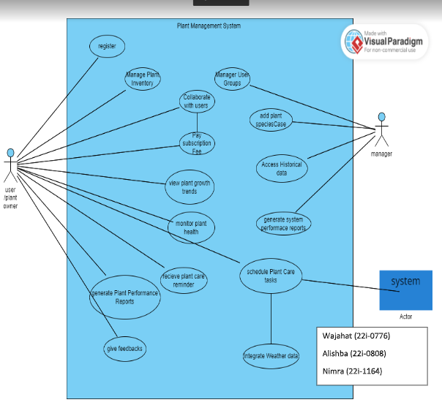

Other Nonfunctional Requirements

Performance Requirements
• Response Time: The system shall respond to user inputs within 2 seconds for standard operations such as navigating between pages or loading plant data.
• Scalability: The PMS must support up to 10,000 concurrent users without degradation in performance.
• Data Processing: Health monitoring data should be processed and displayed within 5 seconds of being received.
• Report Generation: Performance and growth trend reports shall be generated within 10 seconds for a dataset containing up to 1,000 plant records.

Safety Requirements
• Data Integrity: The system must ensure that all user and plant data is stored securely to prevent data loss or corruption.
• Error Handling: In the event of system failures, the PMS should gracefully handle errors without causing data inconsistencies or crashes.

Security Requirements
• Authentication: Users must authenticate using a secure login mechanism with support for strong passwords and optional two-factor authentication.
• Authorization: Role-based access control must be implemented to restrict managerial functions to authorized personnel only.
• Data Encryption: All sensitive data, including user credentials and payment information, must be encrypted both in transit (using SSL/TLS) and at rest.
• Privacy: The system must comply with privacy laws and regulations, ensuring that user data is handled responsibly and with consent.
• Audit Logging: All critical actions, such as user registrations, payments, and data modifications, must be logged for auditing purposes.

Software Quality Attributes
• Usability: The PMS should feature an intuitive user interface, ensuring that users can navigate and utilize functionalities with minimal training.
• Reliability: The system should maintain 99.9% uptime, ensuring continuous availability for users.
• Maintainability: The software architecture should allow for easy updates and maintenance, with well-documented code and modular components.
• Performance: The system should handle high volumes of data and user interactions efficiently without significant delay

Business Rules
• Subscription Management: Only users with active subscriptions can access premium features such as advanced reporting and collaboration tools.
• User Roles:
- Regular Users: Can manage their own plant inventories, monitor plant health, schedule care tasks, and collaborate with other users.
- Managers: Have additional privileges to manage user groups, add new plant species, access historical data, generate system reports, and integrate weather data.
• Data Access: Users can only view and modify their own plant data unless granted specific permissions by a manager.
• Payment Processing: All subscription payments must be processed through secure, PCI-compliant gateways to ensure financial data security.
• Feedback Handling: User feedback must be collected, stored securely, and accessible to managers for review and system improvement purposes.

Operating Environment
Hardware:
- Servers: Cloud-based servers with scalable resources to handle varying loads.
- Client Devices: Desktops, laptops, tablets, and smartphones running modern web browsers or the PMS mobile application.

User Interfaces
• Registration and Login Screens:
- Layout: Clean and straightforward forms requiring essential information (e.g., name, email, password).
- Standards: Adherence to accessibility standards (WCAG 2.1) to ensure usability for all users.
- Features: Input validation, error messaging for invalid entries, and secure password handling.
• Dashboard:
- Layout: Overview of plant inventory, upcoming care tasks, recent health metrics, and quick access to main functionalities.
- Navigation: Intuitive menu structure with clearly labeled sections for inventory management, health monitoring, scheduling, reports, and collaboration.
• Plant Inventory Page:
- Features: List view of all plants with options to add, edit, or remove entries. Search and filter capabilities to easily locate specific plants.
- Design: Consistent use of icons and buttons for actions, ensuring ease of use.
• Health Monitoring Page:
- Visualization: Graphs and charts displaying health metrics such as soil moisture, sunlight exposure, and growth rates.
- Alerts: Highlighting plants that require immediate attention based on health data.
• Care Scheduling Interface:
- Functionality: Calendar view for scheduling tasks with options to set recurring reminders.
- User Experience: Drag-and-drop features for easy task management and rescheduling.
• Reporting Section:
- Types of Reports: Performance reports, growth trend analyses, and system performance overviews.
- Presentation: Interactive charts and downloadable formats (PDF, CSV) for offline analysis.
• Collaboration Tools:
- Features: Messaging interface, forums for discussions, and options to share plant care tips and experiences.
- Design: Social media-like interface to encourage user engagement and interaction.
• Managerial Interfaces:
- User Group Management: Tools for creating, editing, and deleting user groups with role-based permissions.
- Plant Species Management: Forms for adding new plant species with detailed attributes.
- System Reports: Access to comprehensive system performance data with filtering and export options.
• Error Messages and Notifications:
- Consistency: Standardized formats and language for all error messages and notifications.
- Clarity: Clear instructions for resolving issues, avoiding technical jargon.
• Accessibility Features:
- Design: High-contrast themes, adjustable font sizes, and keyboard navigability to support users with disabilities.

Domain Model
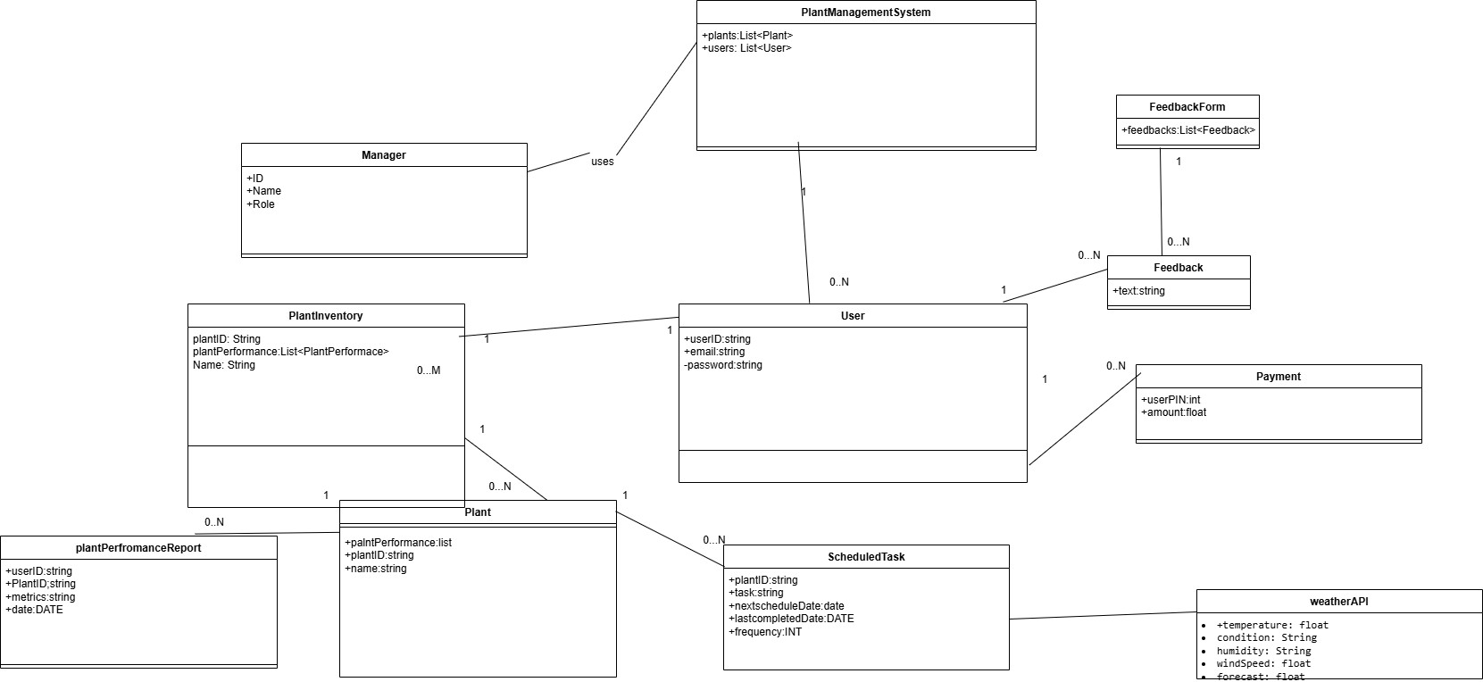

System Sequence Diagram
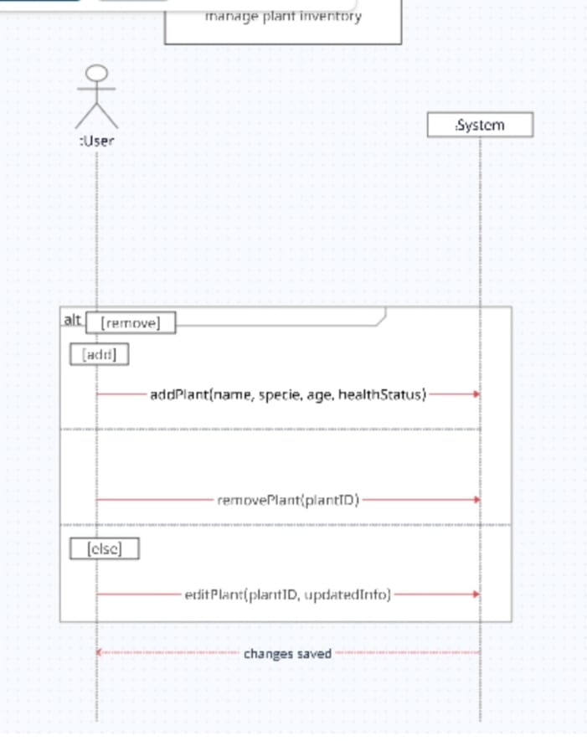

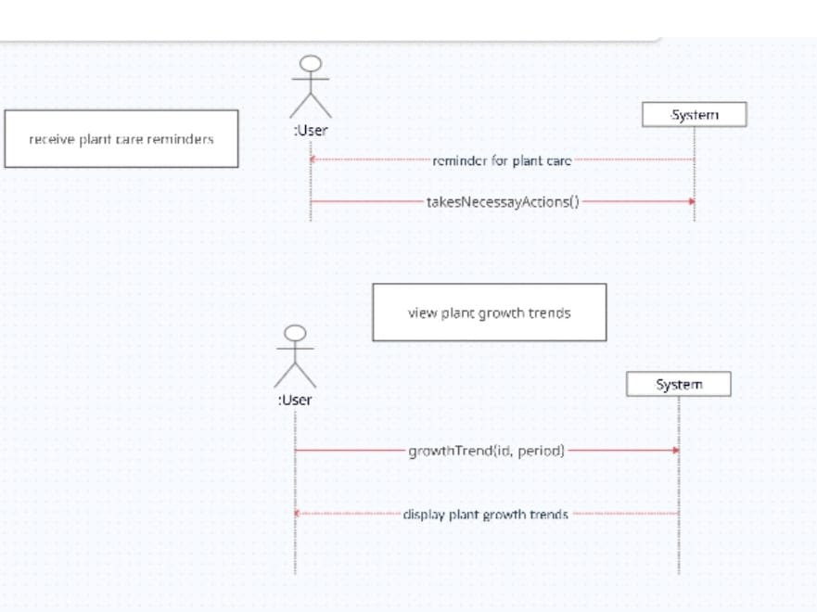

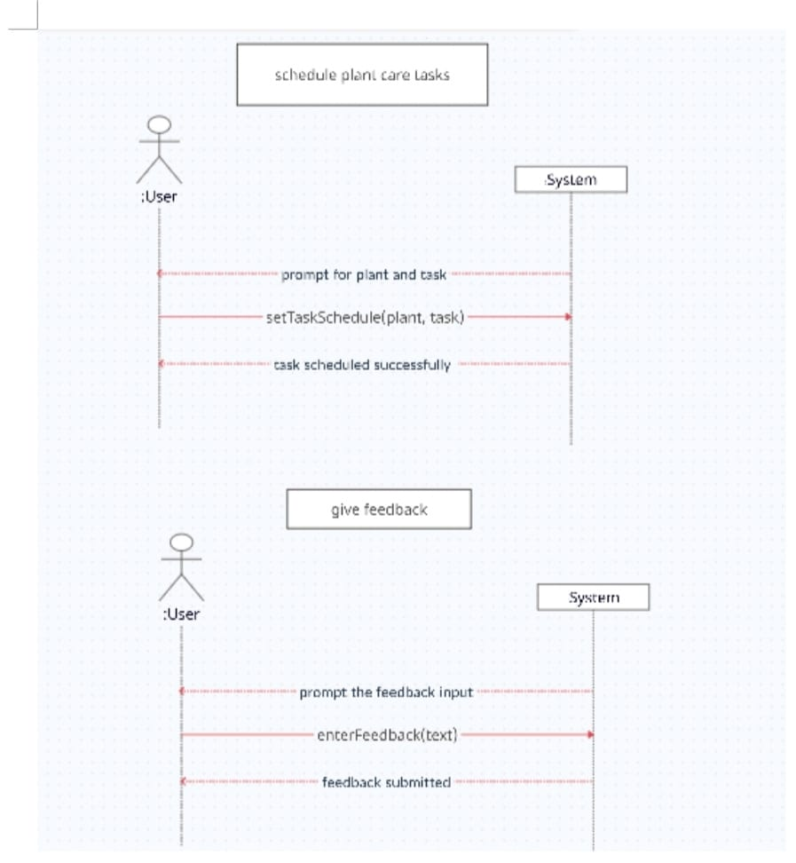
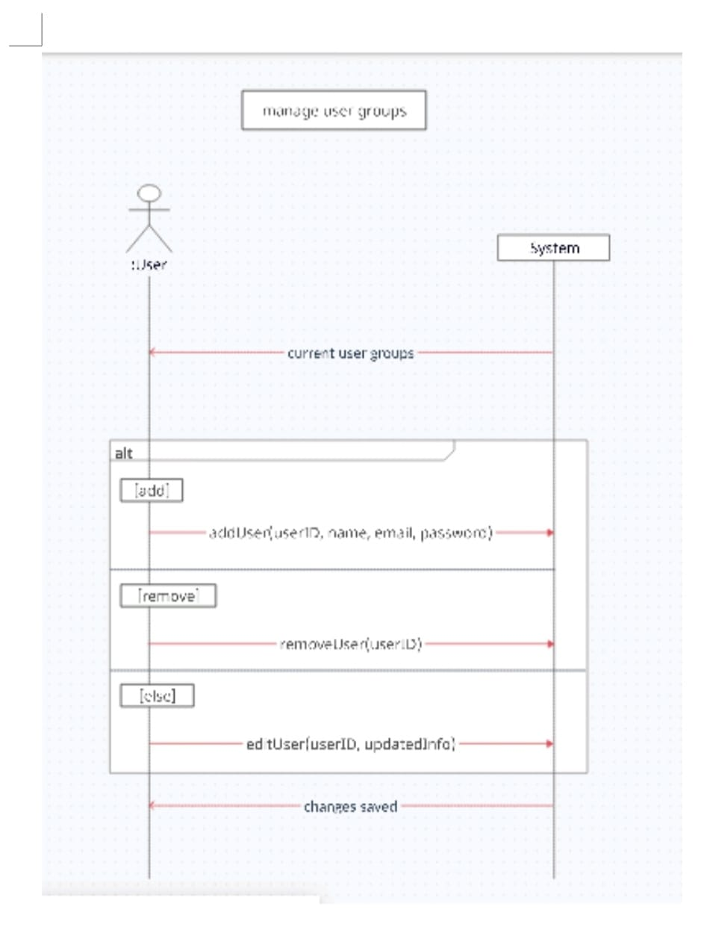

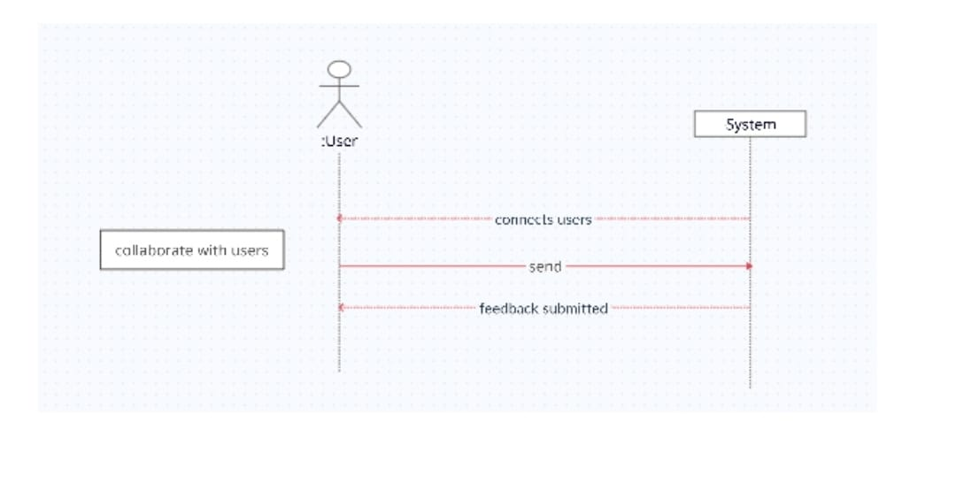
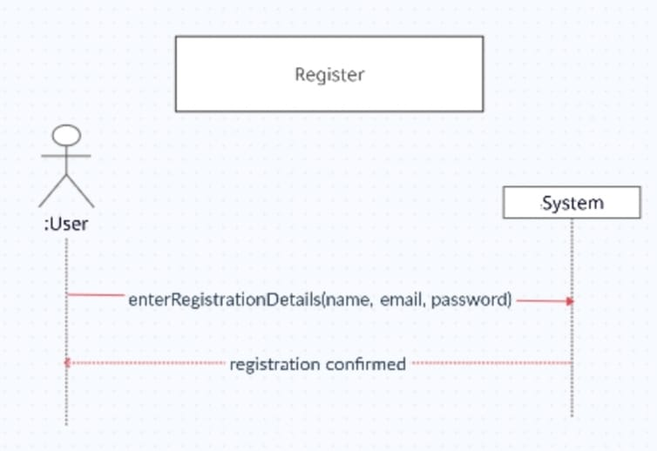

Sequence Diagram
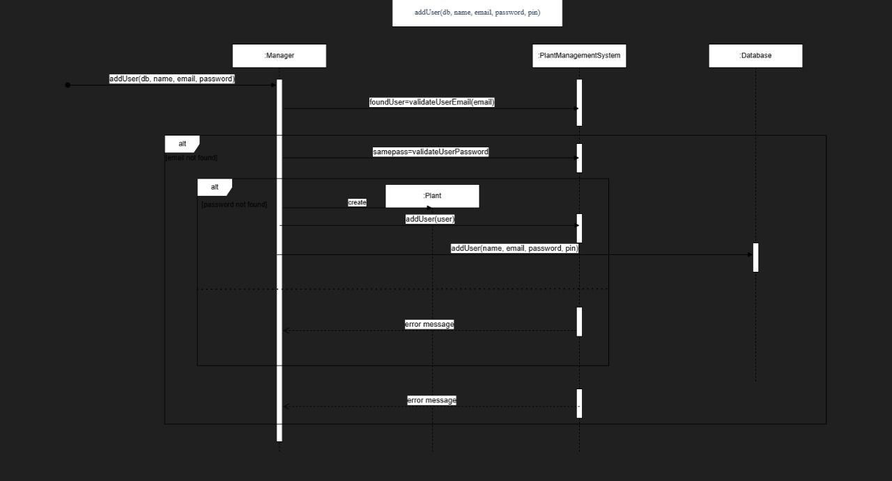

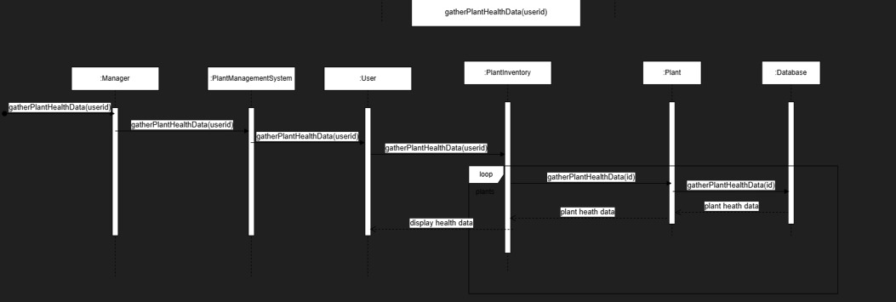

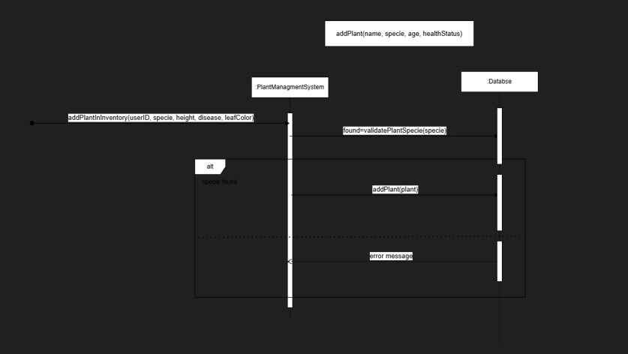

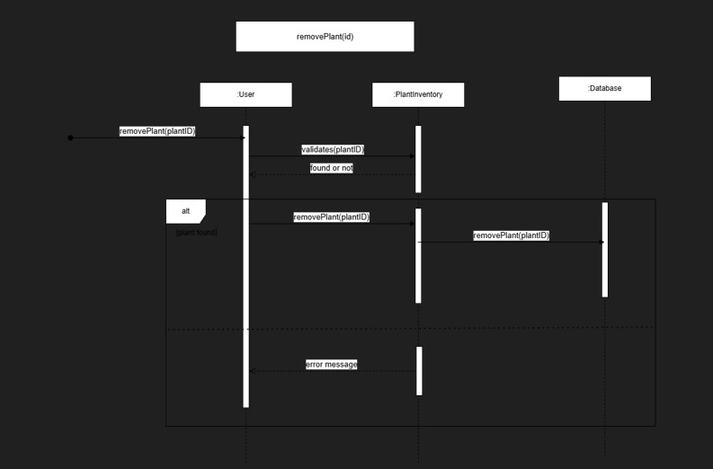

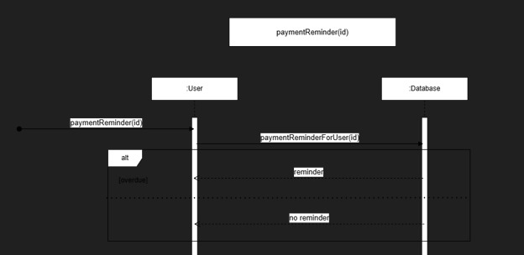
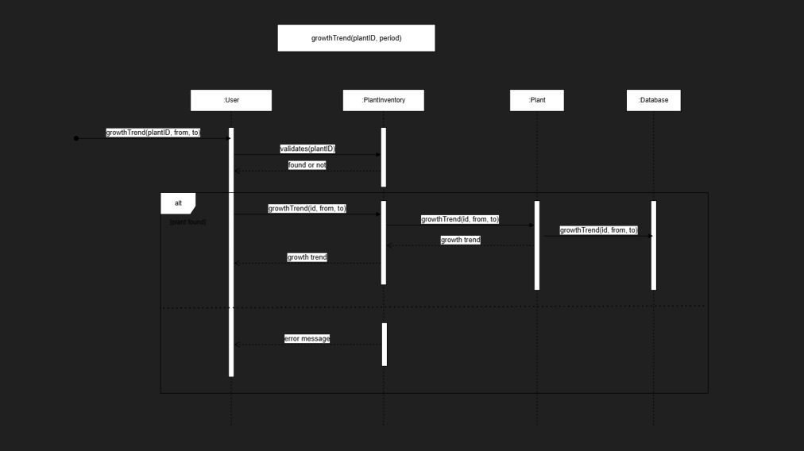

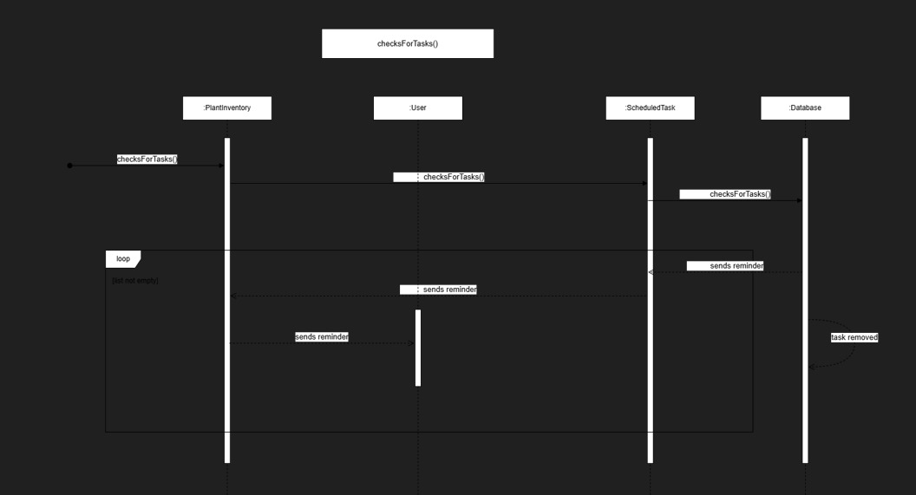

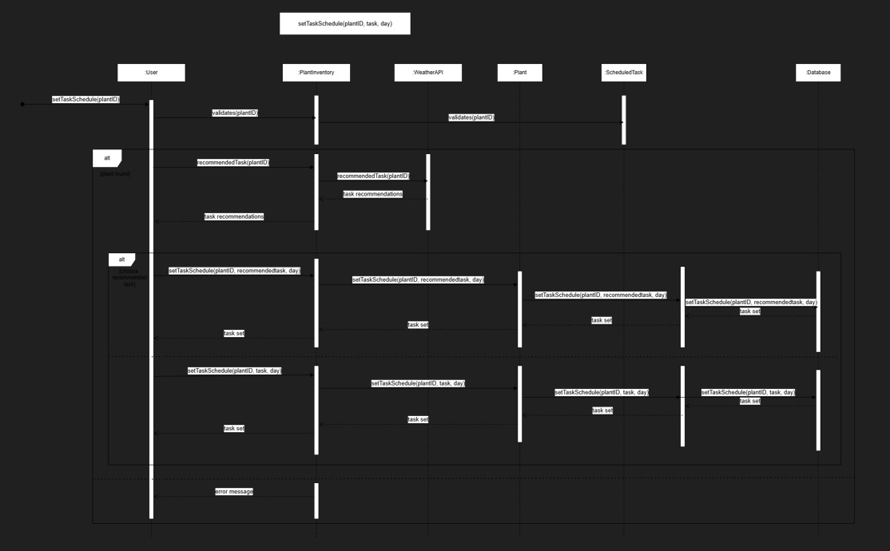

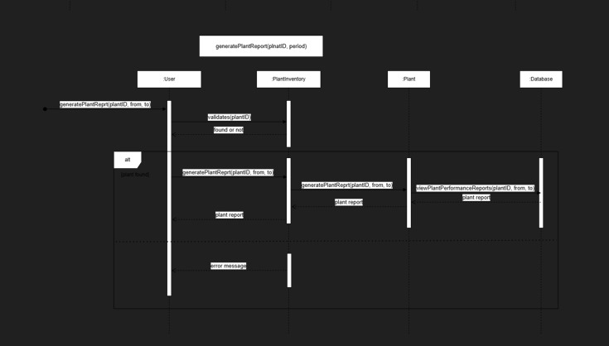

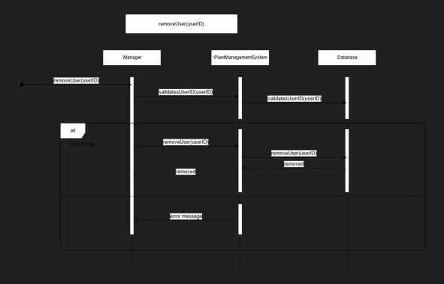

Class Diagram
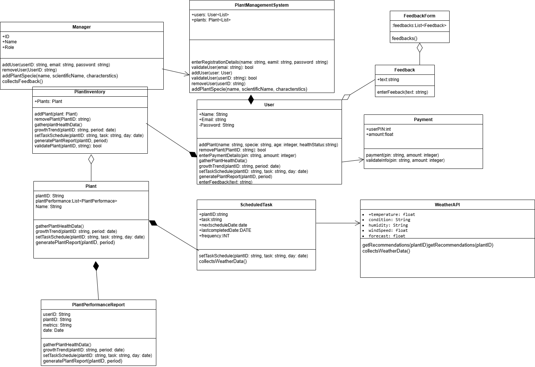

Component Diagram

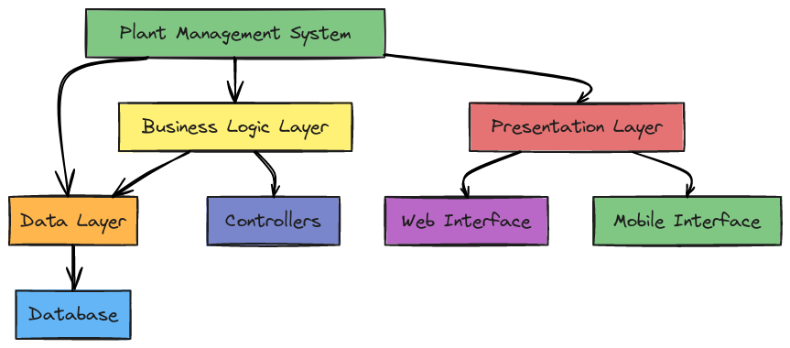

Package Diagram

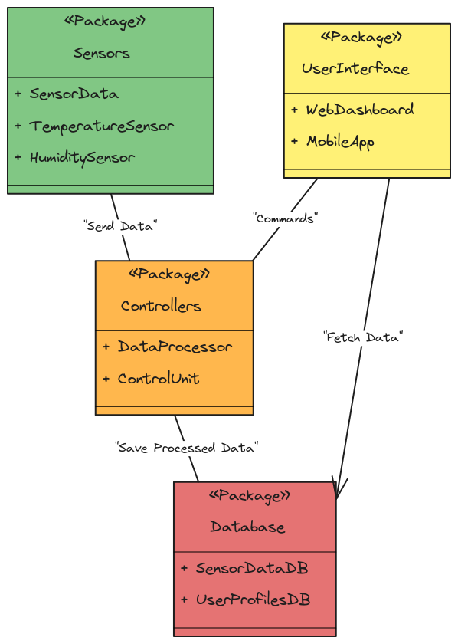

Deployment Diagram

