SecureChat System - Test Report

Course: CS-3002 Information Security
Assignment: Secure Chat System - Testing Evidence Student: Wajahat Ullah Khan
Roll No: 22i-0776

Introduction
This test report documents the comprehensive testing performed on the SecureChat system to verify that all security properties (Confidentiality, Integrity, Authenticity, and Non-Repudiation) are correctly implemented. Each test includes the commands used, expected results, and screenshots as evidence.

Test Environment Setup
Before running tests, ensure the following are set up:

- 1. MySQL Database Container Running:
  - Command: docker ps
  - Expected: securechat-db container should be running

- 2. Certificates Generated:
  - Commands:
python scripts/gen_ca.py --name "FAST-NU Root CA"
python scripts/gen_cert.py --cn server.local --out certs/server python scripts/gen_cert.py --cn client.local --out certs/client

- 3. Database Initialized:

  - Command: python -m app.storage.db --init

Test 1: Wireshark Capture - Confidentiality Verification

Objective
Verify that all network traffic is encrypted and no plaintext is visible in captured packets.

Procedure
Step 1: Start Wireshark and select loopback interface Step 2: Apply filter: tcp.port == 8888
Step 3: Start server in Terminal 1
Step 4: Start client in Terminal 2 and send messages Step 5: Stop capture and analyze packets

Commands Used
    - Terminal 1 (Server):
python -m app.server

    - Terminal 2 (Client):
python -m app.client
      - Then: Register/Login and send messages

    - Wireshark Filter:
tcp.port == 8888

Expected Results
All TCP packets should contain encrypted payloads (base64 encoded data). No readable plaintext should be visible.

Evidence
Figure 1: Wireshark Filter Applied (tcp.port == 8888)

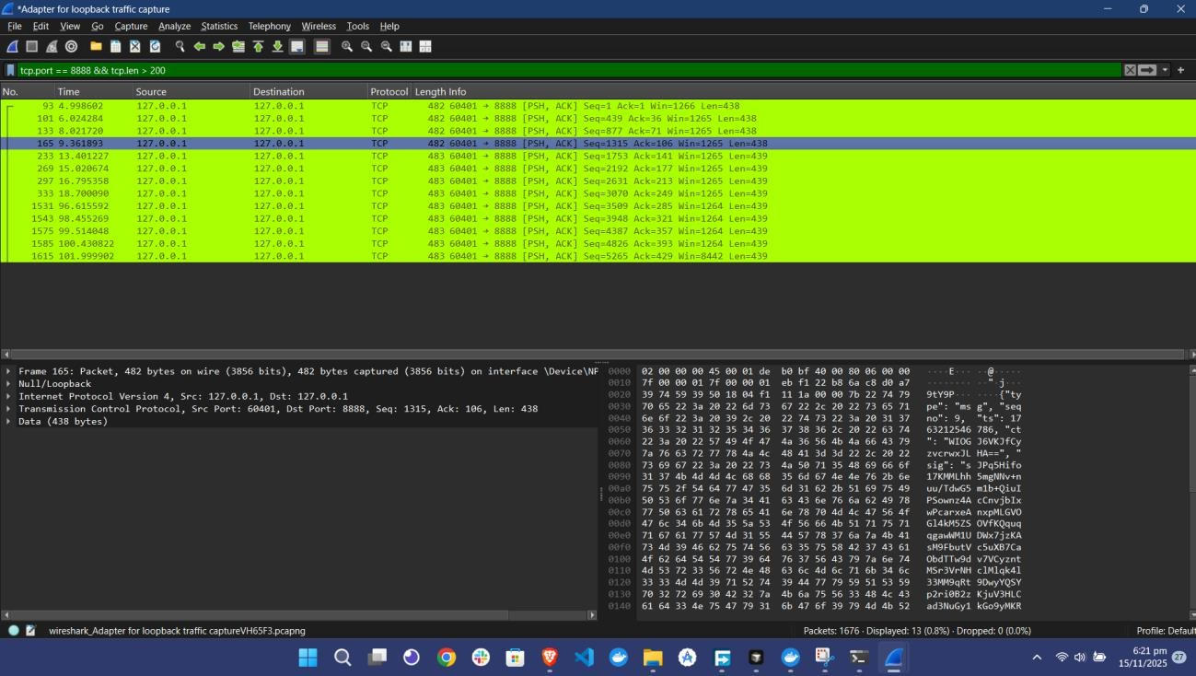

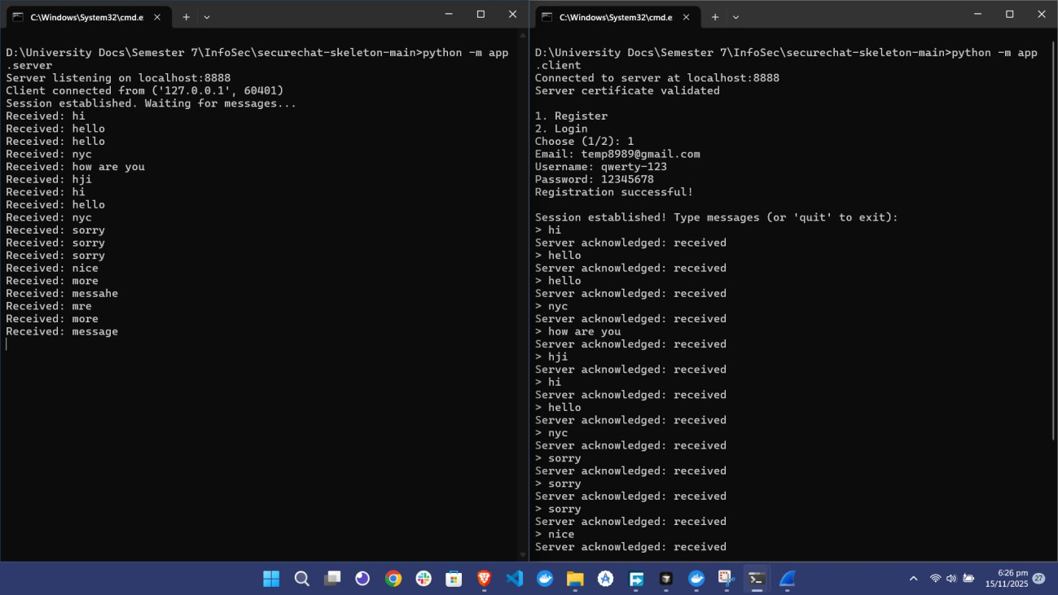
Figure 2: Wireshark Capture - Client to Server Communication

Figure 3: Encrypted Payload - No Plaintext Visible

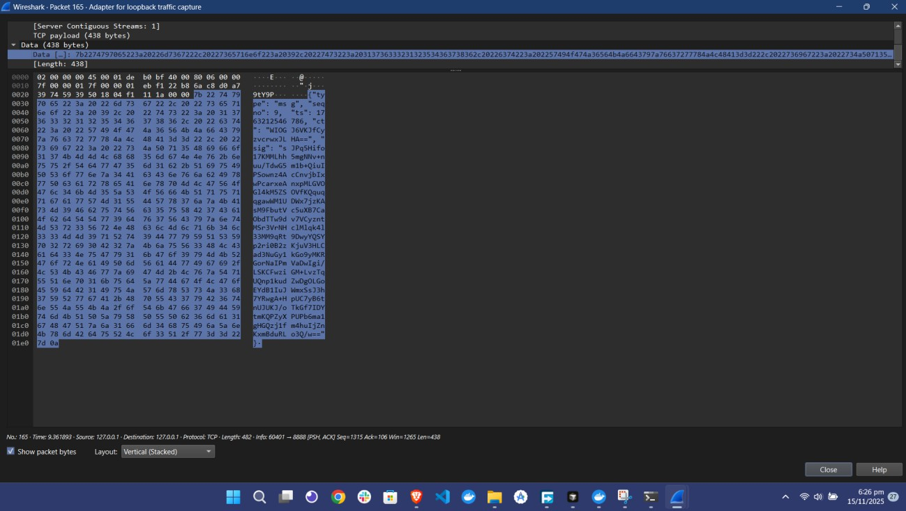

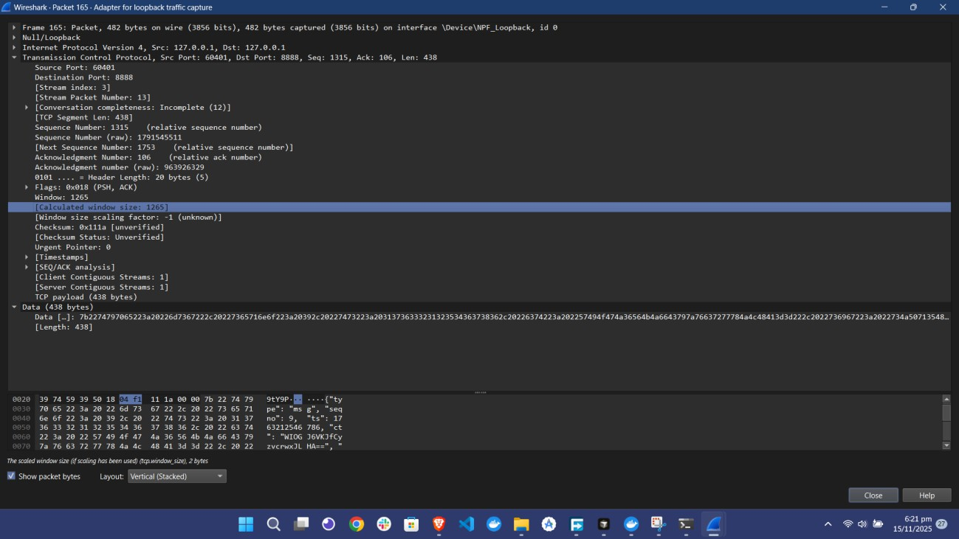
Figure 4: Wireshark Packet Detail - Encrypted Data Section

Result
- PASS: All network traffic is encrypted. No plaintext is visible in captured packets. Confidentiality is verified.

Test 2: Invalid Certificate Rejection - Authenticity Verification

Objective
Verify that the server rejects invalid, self-signed, or untrusted certificates with BAD_CERT error.

Procedure
Step 1: Generate invalid self-signed certificate Step 2: Backup valid client certificates
Step 3: Replace valid certificates with invalid ones Step 4: Attempt to connect to server
Step 5: Restore valid certificates

Commands Used
    - Generate Invalid Certificate:
python scripts/gen_invalid_cert.py

    - Backup Valid Certificates:
copy certs\client.crt certs\client.crt.backup copy certs\client.key certs\client.key.backup

    - Replace with Invalid Certificate:
copy certs\invalid.crt certs\client.crt copy certs\invalid.key certs\client.key

    - Start Server:

python -m app.server

    - Attempt Connection:
python -m app.client

    - Restore Valid Certificates:
copy certs\client.crt.backup certs\client.crt copy certs\client.key.backup certs\client.key

Expected Results
Connection should be rejected with error: BAD_CERT: Self-signed certificate rejected

Evidence
Figure 5: Invalid Certificate Rejection (BAD_CERT)

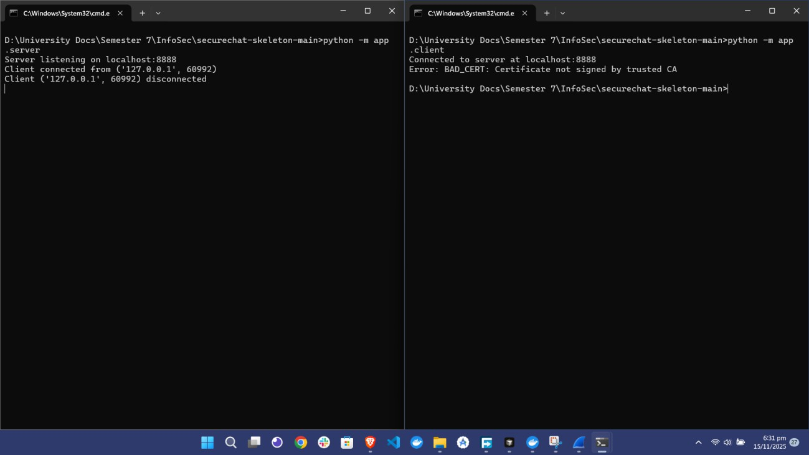

Result
- PASS: Invalid certificates are rejected. Only certificates signed by the trusted CA are accepted. Authenticity is verified.

Test 3: Tamper Detection - Integrity Verification

Objective
Verify that message tampering is detected through signature verification failure (SIG_FAIL).

Procedure
Step 1: Start server
Step 2: Run tamper test script
Step 3: Script sends normal message (should succeed)
Step 4: Script sends tampered message (should fail with SIG_FAIL)

Commands Used
    - Terminal 1 (Server):
python -m app.server

    - Terminal 2 (Test Script):
python -m tests.tamper_test

    - When prompted, enter:
      - Email: [your registered email]
      - Password: [your password]

Expected Results
First message should be accepted. Second (tampered) message should be rejected with: SIG_FAIL: Signature verification failed

Evidence
Figure 6: Tamper Test - Signature Verification Failure (SIG_FAIL)

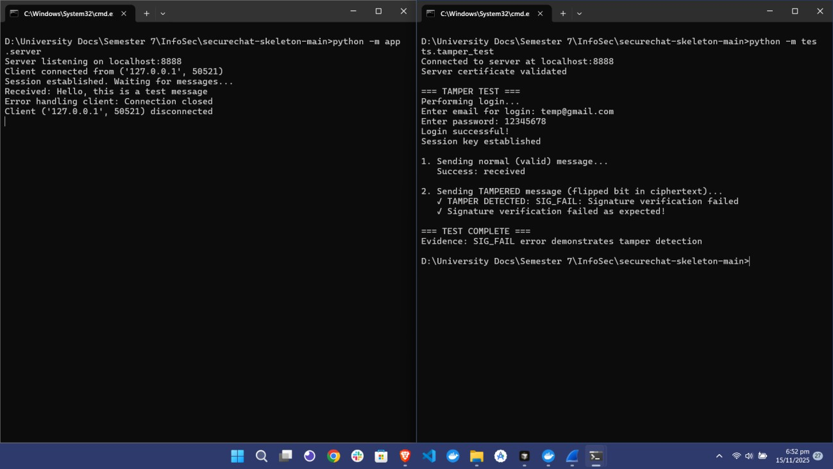

Result
- PASS: Message tampering is detected. Any modification to ciphertext invalidates the signature. Integrity is verified.

Test 4: Replay Protection Verification

Objective
Verify that replay attacks are prevented through sequence number checking (REPLAY error).

Procedure
Step 1: Start server
Step 2: Run replay test script
Step 3: Script sends message with seqno=1 (should succeed) Step 4: Script sends message with seqno=2 (should succeed)
Step 5: Script resends message with seqno=1 (should fail with REPLAY)

Commands Used
    - Terminal 1 (Server):
python -m app.server

    - Terminal 2 (Test Script):
python -m tests.replay_test

    - When prompted, enter:
      - Email: [your registered email]
      - Password: [your password]

Expected Results
First two messages should be accepted. Third message (replay) should be rejected with: REPLAY: Sequence number must be strictly increasing

Evidence
Figure 7: Replay Test - Sequence Number Rejection (REPLAY)

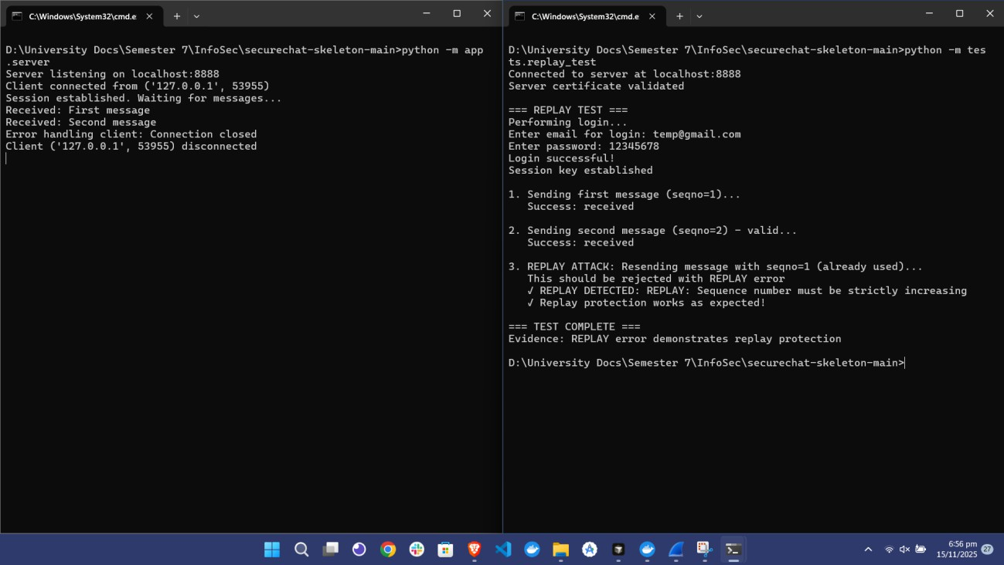

Result
- PASS: Replay attacks are prevented. Duplicate sequence numbers are rejected. Replay protection is verified.

Test 5: Non-Repudiation Verification

Objective
Verify that transcripts and SessionReceipts can be verified offline, providing cryptographic proof of communication.

Procedure
Step 1: Run a chat session (register/login, send messages)
Step 2: End session (type quit) - transcript and receipt are automatically saved Step 3: Run verification script on exported transcript and receipt
Step 4: Verify all message signatures are valid Step 5: Verify transcript hash matches receipt

Step 6: Verify receipt signature is valid

Commands Used
    - Step 1: Run Chat Session
Terminal 1: python -m app.server Terminal 2: python -m app.client
      - Then: Register/Login, send 2-3 messages, type quit

    - Step 2: Verify Transcript and Receipt
python -m tests.verify_transcript --transcript transcripts/client_localhost_8888.export.txt -- cert certs/client.crt --expected-cn client.local

      - Note: Receipt file is auto-detected from transcripts/ directory

Expected Results
Verification should show:
    - ✓All message signatures are valid
    - ✓Receipt hash matches computed transcript hash
    - ✓Receipt signature is valid
    - ✓ALL CHECKS PASSED

Evidence
Figure 8: Non-Repudiation Verification - Transcript and Receipt Validation

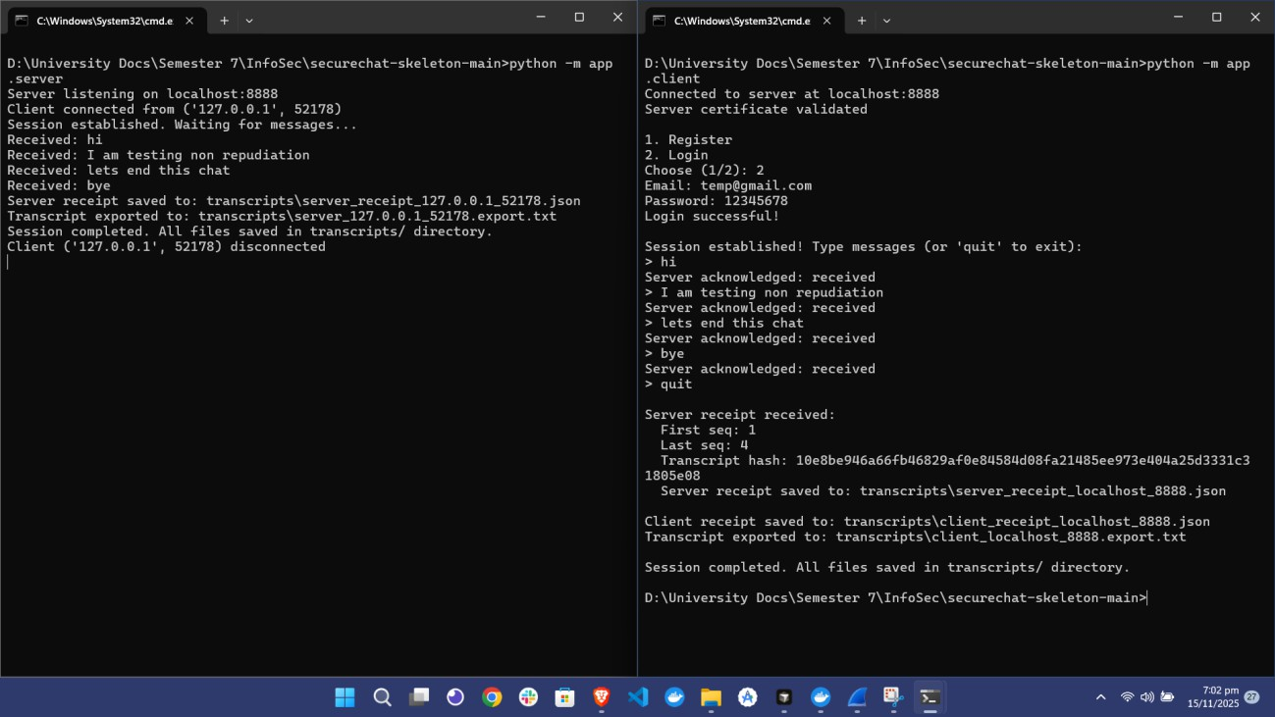

Result
- PASS: Transcripts and SessionReceipts can be verified offline. All signatures are valid. Non- repudiation is verified.

Test 6: Database Schema and User Storage Verification

Objective
Verify that user credentials are stored securely with salted SHA-256 password hashes.

Procedure
Step 1: Access Adminer web interface Step 2: Login to MySQL database
Step 3: View users table structure and data

Commands/Steps Used
- 1. Open browser: http://localhost:8081
- 2. Login credentials:
  - System: MySQL
  - Server: db
  - Username: user
  - Password: 12345678
  - Database: securechat
- 3. Select users table
- 4. View table structure and data

Expected Results
Users table should show:
    - • email (VARCHAR, PRIMARY KEY)
    - • username (VARCHAR, UNIQUE)
    - • salt (VARBINARY(16))
    - • pwd_hash (CHAR(64)) - SHA-256 hex string
    - • No plaintext passwords stored

Evidence
Figure 9: Database Schema in Adminer

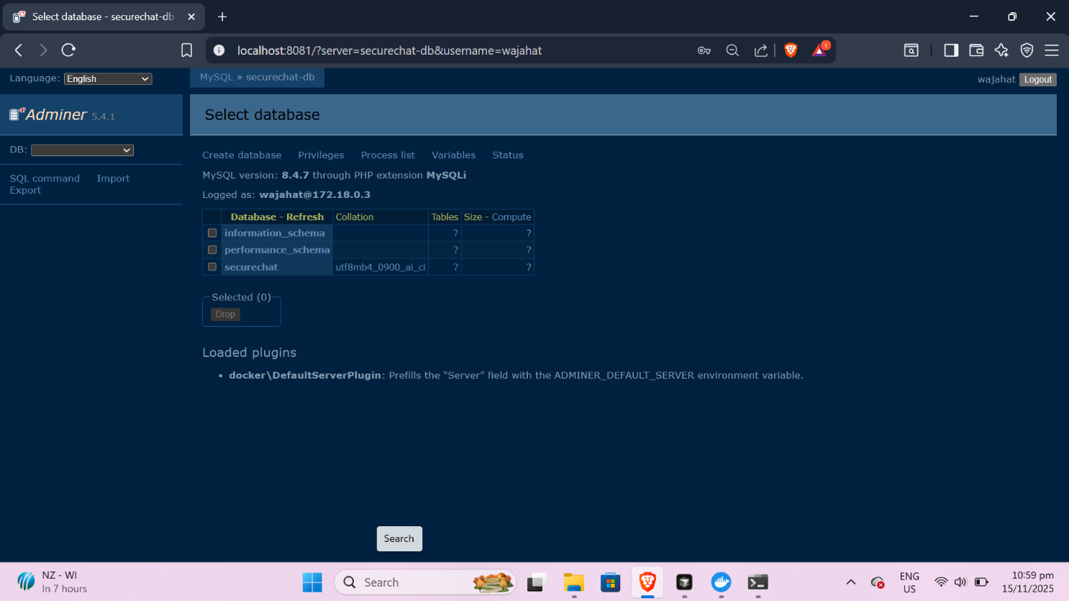

Figure 10: Users Table with Sample Records
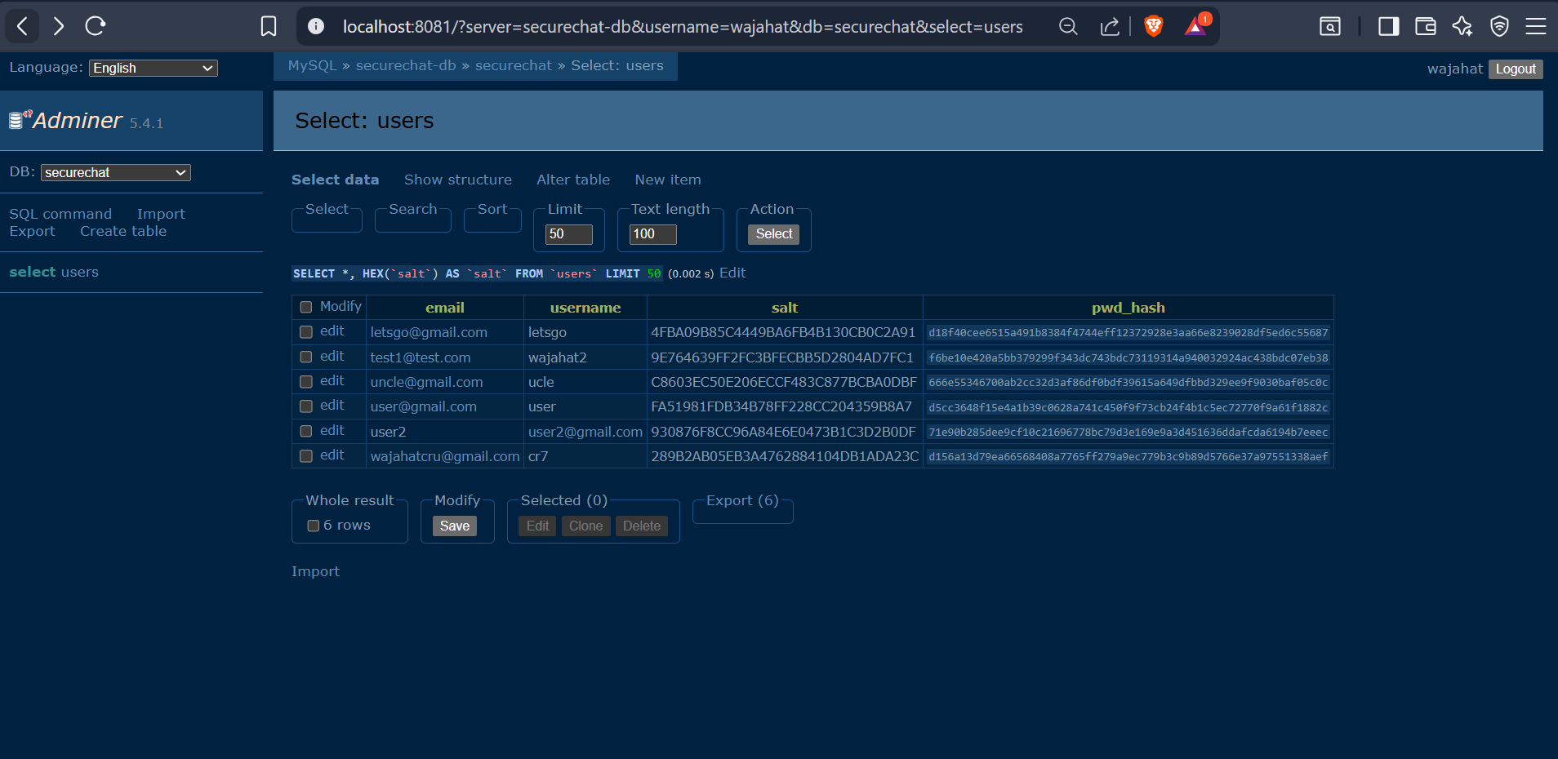

Result
- PASS: User credentials are stored securely with salted SHA-256 hashes. No plaintext passwords are stored.

- Conclusion
All tests have been successfully completed and verified. The SecureChat system correctly implements all required security properties:

- • Confidentiality: Verified through Wireshark capture showing encrypted payloads only
- • Integrity: Verified through tamper detection test showing signature verification failure
- • Authenticity: Verified through invalid certificate rejection test
- • Non-Repudiation: Verified through offline transcript and receipt verification
- • Replay Protection: Verified through sequence number checking
- • Secure Storage: Verified through database inspection showing salted password hashes

All test evidence has been captured through screenshots and command outputs. The system meets all assignment requirements and demonstrates proper implementation of cryptographic protocols at the application layer.

