Wajahat Ali, Brenna Weaver, Rey Romo

ISTM 615

Documentation Log

**1. How many customers have been referred to Wildcat Pizza by other customers?**

1. SQL

SELECT count(CUSTOMER_ID) as ‘# of Customers Referred’

FROM CUSTOMER

WHERE CUSTOMER_REFERRED_BY is not null;

b. 

**2. How many employees does Wildcat Pizza employ in each role?**

1. SQL

SELECT count(EMP_ID) as ‘Number of Employees’, EMP_ROLE

FROM EMPLOYEE

GROUP BY EMP_ROLE;

b. 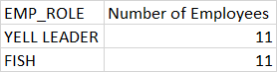

**3. How many orders have been placed that total less than $10?**

1. SQL

SELECT count(ORDER_ID) as ‘Num of Orders Under $10’

FROM ORDERS

WHERE ORDER_TOTAL <10;

b. 

**4. List the names of customers whose average payment amount is at least 1.5 times the overall average payment.**

1. SQL

SELECT CUSTOMER_FIRST_NAME, CUSTOMER_LAST_NAME, AVG(AMOUNT_RECEIVED) AS 'AVERAGE PAYMENT'

FROM CUSTOMER C JOIN PAYMENT P

ON C.CUSTOMER_ID=P.CUSTOMER_ID

GROUP BY CUSTOMER_FIRST_NAME, CUSTOMER_LAST_NAME

HAVING AVG(AMOUNT_RECEIVED)>=

(SELECT (AVG(AMOUNT_RECEIVED)*1.5)

FROM PAYMENT)

b. 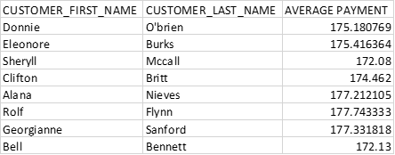

**5. What is the most money ever paid for a single order at Wildcat Pizza?**

1. SQL

SELECT max(AMOUNT_RECEIVED) as ‘MostMoneyPaid’, ORDER_ID

FROM PAYMENT

GROUP BY ORDER_ID

Order BY 1 Desc

Limit 3;

b. 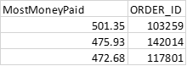

**6. How many customers have been referred to Wildcat Pizza by customers whose last names end in ‘z’?**

1. SQL

SELECT count(c.Customer_ID) as ‘Num of Customers Referred’

From Customer R JOIN Customer C

On C.customer_referred_by = R.Customer_ID

AND R.Customer_Last_Name LIKE "%Z";

b. 

**7. Which order (or orders) has had the greatest number of different items on it?**

1. SQL

SELECT COUNT(distinct Product_ID) as 'Num of Items', Order_ID

FROM ORDERLINE

GROUP BY Order_ID

Order By 1 desc

LIMIT 3;

b. 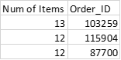

**8. What is the name of the customer who has referred the greatest number of customers?**

1. SQL

SELECT COUNT(c.customer_referred_by) as '# of Referrals', R.customer_last_Name as ‘LastName’, r.Customer_first_name as ‘FirstName’

From Customer R JOIN Customer C

On C.customer_referred_by = R.Customer_ID

GROUP BY R. Customer_Last_Name, R.Customer_First_Name

ORDER BY COUNT(C.Customer_referred_by) DESC

LIMIT 1;

b. 

**9. What are the toppings on the pizza that has generated the most revenue?**

1. SQL

SELECT P.Product_ID as 'Product ID', PRODUCT_TOPPINGS as 'Product Topping', SUM(LINE_COST) as 'Total Revenue'

FROM PRODUCT P RIGHT JOIN ORDERLINE OL

ON P.Product_ID = OL.PRODUCT_ID

GROUP BY P.PRODUCT_ID, Product_TOPPINGS

ORDER BY SUM(LINE_COST) DESC

LIMIT 5;

b. 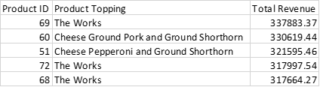

**10. How many pizzas have we sold to customers living on streets that begin with ‘W’?**

1. SQL

SELECT SUM(quantity) AS "# of Pizzas Sold"

FROM orderline ol JOIN orders o

ON ol.order_id = o.order_id

WHERE customer_id IN

(SELECT customer_id

FROM customer

WHERE customer_street_name like "W%");

b. 

**11. What is the name of our most valued customer (i.e., the one who has spent the most money)?**

1. SQL

SELECT CUSTOMER_FIRST_NAME, CUSTOMER_LAST_NAME, SUM(ORDER_TOTAL) AS ‘Total Money Spent’

FROM CUSTOMER C JOIN ORDERS O

ON C.CUSTOMER_ID=O.CUSTOMER_ID

GROUP BY CUSTOMER_FIRST_NAME, CUSTOMER_LAST_NAME

LIMIT 3;

b. 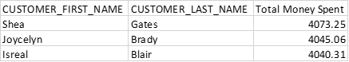

**12. What is the name of the Fish that has taken payments for the fewest orders?**

1. SQL

SELECT E.EMP_ID AS 'EMPLOYEE ID', EMP_FIRST_NAME AS 'EMPLOYEE FIRST NAME', EMP_LAST_NAME AS 'EMPLOYEE LAST NAME', COUNT(DISTINCT ORDER_ID) AS "# OF PAYMENTS", EMP_ROLE AS 'EMPLOYEE ROLE'

FROM PAYMENT P JOIN EMPLOYEE E

ON P.EMP_ID=E.EMP_ID

WHERE EMP_ROLE='FISH'

GROUP BY E.EMP_ID, EMP_FIRST_NAME, EMP_LAST_NAME, EMP_ROLE

ORDER BY COUNT(DISTINCT ORDER_ID) ASC

LIMIT 5;

b. 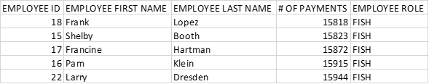

**13. What are the toppings on the most frequently ordered pizza?**

1. SQL

SELECT P.PRODUCT_ID, PRODUCT_TOPPINGS, count(orderline_ID) as 'Number of Pizzas'

FROM PRODUCT P JOIN ORDERLINE OL

ON P.PRODUCT_ID = OL.PRODUCT_ID

GROUP BY P.PRODUCT_ID, PRODUCT_TOPPINGS

ORDER BY count(orderline_ID) DESC

LIMIT 3;

b. 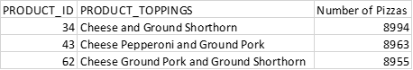

**14. What is the name of the Yell Leader who has fulfilled the most orders?**

1. SQL

SELECT E.EMP_ID AS 'EMPLOYEE ID', EMP_FIRST_NAME AS 'EMPLOYEE FIRST NAME', EMP_LAST_NAME AS 'EMPLOYEE LAST NAME', COUNT(ORDER_ID) AS 'ORDER FULFILLED', EMP_ROLE AS 'EMPLOYEE ROLE'

FROM ORDERS O JOIN EMPLOYEE E

ON O.EMP_ID=E.EMP_ID

WHERE EMP_ROLE = "YELL LEADER"

GROUP BY E.EMP_ID, EMP_FIRST_NAME, EMP_LAST_NAME, EMP_ROLE

ORDER BY COUNT(ORDER_ID) DESC

LIMIT 5;

b. 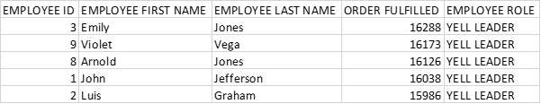

**15. What is the name of the Yell Leader who has cooked the greatest number of pizzas?**

1. SQL

SELECT EMP_FIRST_NAME, EMP_LAST_NAME, EMP_ROLE, Sum(QUANTITY) as 'Number of Pizzas'

FROM EMPLOYEE E JOIN ORDERS O

ON E.EMP_ID=O.EMP_ID

JOIN ORDERLINE OL

ON O.ORDER_ID=OL.ORDER_ID

AND EMP_ROLE = "Yell Leader"

GROUP BY EMP_FIRST_NAME, EMP_LAST_NAME, EMP_ROLE

ORDER BY Sum(QUANTITY) DESC

LIMIT 3;

b. 