Deep Learning Project Proposal

Cover Information
Project Title | Cost-Bounded Natural-Language Forensic Search over Surveillance Video via Distilled Vision-Language Re-Ranking
Student Name(s) & ID(s) | Wajahat Ahmed
Course & Section | CS-5138 Deep Learning
Date | 20 September 2026

1. Problem Definition
A modern surveillance installation produces thousands of automated alerts per day. When an incident is reported after the fact, an investigator must locate the relevant footage among them. Current practice is manual scrubbing: an operator watches hours of video, or filters by camera and timestamp, because no index exists over what actually happens in the frames. This is the dominant cost of video forensics and it scales linearly with archive size.
This project frames that task as cross-modal text-to-video moment retrieval. The input is a free-form natural-language query — for example, "a person taking a bag from a parked car" — together with a corpus of surveillance clips. The output is a ranked list of clips, each localised to a start and end time, ordered by relevance to the query. Performance is measured by Recall@K and Mean Reciprocal Rank.
The distinguishing constraint is cost. A vision-language model (VLM) applied to every candidate clip gives strong relevance judgements but is computationally infeasible at archive scale, because cost grows linearly in the number of query–clip pairs. The research question is therefore not only "how accurate can retrieval be?" but:
How much of the retrieval accuracy of an exhaustive VLM system can be retained while reducing VLM invocations by one to two orders of magnitude?
This matters because a forensic search tool that is accurate but costs dollars per query will not be deployed, while one that is cheap but misses the incident is worse than useless. The accuracy–cost frontier, not accuracy alone, determines whether such a system is practical.
Scope: an operating system, not only an offline benchmark. The project delivers two paths. The offline path trains the models on the annotated corpus. The online path ingests alerts as they are produced; sampling frames, embedding them with the trained encoder, and storing them with their metadata; and then serves natural-language queries against that store, returning ranked alerts with their frames, camera and timestamp.

2. Dataset Description

2.1 Data Source
The dataset is MEVA (Multiview Extended Video with Activities), collected and annotated by Kitware, Inc. at the Muscatatuck Urban Training Center for the IARPA DIVA programme [9]. Video is distributed through the AWS Registry of Open Data and annotations through the project's public repository. The dataset is released under a CC BY 4.0 licence.
Kaggle compliance. MEVA is not hosted on Kaggle. It originates from an institutional research archive and is distributed via the AWS Public Dataset Program, a primary source category the assignment brief names as acceptable.
Curated extension. MEVA provides activity annotations but no natural-language query set. A retrieval query set will therefore be curated as part of this project by composing queries from the existing human-made activity annotations and hand-verifying a held-out evaluation subset. This constitutes data curated by the author, which the brief also permits explicitly.

2.2 Data Characteristics
Property | Value
Total video | ~328 hours, 4,259 clips, 516 GB
Annotated portion | ~184 hours with human annotations
Activity classes | 37 activity types
Annotation type | Bounding boxes of actors and props, with activity labels and temporal extents
Cameras | Multiple synchronised fixed viewpoints, indoor and outdoor
Collection method | Filmed on real cameras at a physical urban training facility, under IRB oversight and approval
Modality | RGB video

2.3 Size & Balance Justification
Sufficiency 184 annotated hours across 37 activity types yields tens of thousands of temporally localised activity instances — far above the "thousands of labelled samples" threshold. For the retrieval task the training unit is the query–clip pair, and a single annotated activity instance can generate several paraphrased queries, so the effective training set is larger still. The corpus is also large enough that retrieval is genuinely difficult: a 4,259-clip search space makes Recall@1 a meaningful measurement rather than a near-trivial one, which a small corpus would not.
Balance. MEVA's 37 activity classes are naturally long-tailed, with common activities such as "person walks" vastly outnumber rare ones such as "person opens facility door". Three strategies will be applied and reported:
- Class-balanced sampling of query–clip training pairs, capping the contribution of head classes.
- Macro-averaged Recall@K reported alongside micro-averaged, so head classes cannot mask tail-class failure.
- A stratified evaluation query set constructed with approximately equal query counts per activity class, decoupling evaluation balance from corpus balance.
For the contrastive training objective, in-batch negatives are used, so class imbalance affects sampling rather than the loss formulation directly.

3. Literature Review
The foundation of modern cross-modal retrieval is contrastive vision-language pretraining. Radford et al. [1] introduced CLIP, a dual-encoder model trained on approximately 400 million image–text pairs that projects both modalities into a shared embedding space, enabling zero-shot retrieval without task-specific training. Because the image and text encoders are independent, clip embeddings can be precomputed and searched with approximate nearest-neighbour methods, which is what makes retrieval over large archives tractable at all. The limitation relevant here is domain: CLIP is trained overwhelmingly on web photographs, which are centred, well-lit and captured at eye level, whereas surveillance footage is recorded from fixed elevated cameras with small, distant subjects and substantial compression artefacts. This distribution shift is well documented and is the reason an unmodified CLIP encoder performs poorly on surveillance imagery.
Higher retrieval precision is typically obtained with cross-encoder architectures, which encode the query and the candidate jointly rather than separately. Li et al. [2] proposed BLIP-2, bridging a frozen image encoder and a frozen large language model through a lightweight querying transformer, and its image–text matching head is widely used as a re-ranker. The accuracy gain is real, but the cost structure is prohibitive: because the query and candidate must be encoded together, the number of forward passes grows linearly with the number of pairs scored, so exhaustive application across an archive is not feasible. This tension between the scalability of dual encoders and the precision of cross-encoders motivates the cascaded designs described below.
Several recent systems address retrieval over long or surveillance video specifically. Tran et al. [3] present a unified framework combining coarse-grained and fine-grained models with keyframe deduplication and temporal re-ranking over neighbouring frames, improving robustness for hour-long video. SurveiLens [4] targets CCTV directly, sampling frames, captioning them, computing semantic similarity and localising the matching interval, allowing an investigator to describe an event and recover the relevant footage. ForeSea [5] extends this to forensic search with multi-modal queries combining text and image exemplars. These systems establish that natural-language retrieval over surveillance video is achievable. However, all of them report retrieval quality alone — Recall@K and related accuracy metrics — without characterising the computational cost of obtaining it. Captioning or scoring every sampled frame with a large model is itself the dominant expense in these pipelines, and that expense is not quantified.
A parallel line of work adapts vision-language models to surveillance for detection rather than retrieval. Wu et al. [6] propose VadCLIP, which adapts CLIP for weakly supervised video anomaly detection through dual-branch prompt learning, demonstrating that vision-language transfer to the surveillance domain is viable. The task differs from the one addressed here: anomaly detection asks whether a segment is abnormal with respect to a fixed notion of normality, whereas retrieval must respond to arbitrary free-text queries supplied at inference time.
The mechanism this project adopts to resolve the cost problem originates in the model compression literature. Hinton et al. [7] established knowledge distillation, in which a compact student model is trained to reproduce the outputs of a larger teacher rather than the ground-truth labels alone, transferring much of the teacher's behaviour at a fraction of its inference cost. Hofstätter et al. [8] applied this specifically to ranking in text retrieval, distilling an expensive cross-encoder into a cheaper architecture with a margin-based objective and recovering much of the teacher's effectiveness. To the author's knowledge this technique has not been applied to vision-language re-ranking for surveillance video retrieval, and it is the combination of that established mechanism with the unmeasured cost dimension identified in [3], [4] and [5] that defines the opportunity addressed here.
References
[1] A. Radford et al., "Learning Transferable Visual Models From Natural Language Supervision," in Proc. ICML, 2021, pp. 8748–8763.
[2] J. Li, D. Li, S. Savarese, and S. Hoi, "BLIP-2: Bootstrapping Language-Image Pre-training with Frozen Image Encoders and Large Language Models," in Proc. ICML, 2023.
[3] T. Tran et al., "Towards Efficient and Robust Moment Retrieval System: A Unified Framework for Multi-Granularity Models and Temporal Reranking," in Proc. IEEE/CVF CVPR Workshops, 2025.
[4] "SurveiLens: Natural Language-Based Moment Retrieval for Surveillance Video Analysis," in Proc. IEEE Conf., 2026. [Online]. Available: https://ieeexplore.ieee.org/document/11400480/
[5] "ForeSea: AI Forensic Search with Multi-modal Queries for Video Surveillance," arXiv:2603.22872, 2026.
[6] P. Wu et al., "VadCLIP: Adapting Vision-Language Models for Weakly Supervised Video Anomaly Detection," in Proc. AAAI, 2024.
[7] G. Hinton, O. Vinyals, and J. Dean, "Distilling the Knowledge in a Neural Network," arXiv:1503.02531, 2015.
[8] S. Hofstätter et al., "Improving Efficient Neural Ranking Models with Cross-Architecture Knowledge Distillation," arXiv:2010.02666, 2020.
[9] K. Corona, K. Osterdahl, R. Collins, and A. Hoogs, "MEVA: A Large-Scale Multiview, Multimodal Video Dataset for Activity Detection," in Proc. IEEE/CVF WACV, 2021, pp. 1060–1068.

4. Proposed Methodology

4.1 How the Approach Differs from Existing Work
The proposed system is a three-stage cascade in which the expensive component is progressively eliminated rather than merely reduced. Against CLIP [1], the difference is that the retrieval encoder is not used off the shelf: it is domain-adapted to fixed-camera surveillance imagery through contrastive fine-tuning with low-rank adaptation, treating the web-to-surveillance distribution shift as an explicit and separately measured problem rather than an accepted cost. Against BLIP-2 [2], the difference is where the cross-encoder runs. Instead of invoking it at query time, this project uses a vision-language model solely as a teacher during training; at inference the teacher is replaced by a distilled student, so the expensive computation is paid once offline rather than repeatedly per query.
Against the surveillance retrieval systems [3], [4], [5], the difference is what is measured. Those works optimise and report accuracy; this project treats model invocations, tokens, latency and monetary cost as first-class reported quantities, and presents the outcome as a recall-versus-cost frontier across several operating points rather than a single configuration. Against VadCLIP [6], the difference is task formulation: retrieval here is open-vocabulary, responding to arbitrary text supplied at inference time, rather than scoring against a fixed anomaly taxonomy. Against Hofstätter et al. [8], the difference is modality and domain — cross-encoder to student distillation is carried from text retrieval into vision-language retrieval over surveillance video, where the teacher is multimodal and the cost problem is considerably more severe.
Stated plainly, the cascaded retrieval architecture is established prior work and is deliberately reused. The contributions claimed are three: the distillation of a vision-language re-ranker into a deployable student for this task; the domain adaptation of the retrieval encoder to surveillance imagery; and the explicit characterisation of the accuracy-versus-cost frontier, which the surveyed literature does not report.

4.2 Why This Should Produce Good Results
Three hypotheses are advanced, each framed so that it can be rejected by the experiments rather than assumed.
The first is that domain adaptation will improve first-stage recall. CLIP is trained on web photographs while surveillance footage differs systematically in viewpoint, subject scale, illumination and compression. Contrastive fine-tuning on in-domain pairs has repeatedly recovered substantial performance in comparable out-of-distribution transfers, and low-rank adaptation permits this on a modest in-domain set without disturbing the general visual semantics learned during pretraining. The hypothesis is falsifiable: if the adapted encoder does not exceed the frozen baseline on Recall@10, it is rejected.
The second is that a distilled student will retain most of the teacher's ranking quality at a small fraction of its cost. The precedent is cross-architecture distillation in text retrieval [8], and the mechanism transfers for two reasons. The teacher supplies a dense, graded relevance signal over far more pairs than human annotation could produce, and the student is required to learn a ranking function over a narrow domain rather than general multimodal reasoning. The narrowness of the domain is an advantage for the student rather than a limitation.
The third is that the accuracy-versus-cost curve will be strongly concave. Because first-stage retrieval already places most true positives within the top-K candidates, escalating only a small subset to the teacher should capture most of the achievable gain, with sharply diminishing returns beyond that point. Should the curve prove approximately linear instead, the cascade offers no advantage over exhaustive scoring, and that negative result would itself be worth reporting.
Acknowledged limitation. MEVA activities are scripted performances by participants at a training facility rather than spontaneous incidents, so absolute retrieval figures may be optimistic relative to uncontrolled footage. Because this affects all experimental arms equally, comparisons between arms remain valid, and the limitation will be stated explicitly in the evaluation.

4.3 Tools & Techniques to Be Used
Tool / Technique | Role | Justification
PyTorch 2.x with torch.compile | Core training framework | Graph compilation gives material throughput gains on the repeated encoder passes that dominate training time.
Hugging Face Transformers / Datasets | Models and data pipeline | Canonical source for CLIP/SigLIP and open-weight vision-language checkpoints; reproducible dataset handling.
SigLIP or CLIP ViT-B/16 | First-stage dual encoder | Independent encoders allow clip embeddings to be precomputed and searched sub-linearly, which is what makes archive-scale retrieval tractable.
LoRA / QLoRA (PEFT) | Parameter-efficient domain adaptation | Adapts a large pretrained encoder on a modest in-domain set without full fine-tuning, avoiding catastrophic forgetting of general visual semantics.
Open-weights VLM as teacher | Relevance labelling for distillation | Local execution removes per-call API cost, makes large-scale label generation feasible, and avoids transmitting footage to a third party.
Knowledge distillation (margin-MSE) | Training the student re-ranker | The central technique: transfers the teacher's ranking behaviour into a model small enough to deploy.
ChromaDB | Vector index with metadata filtering | Stores embeddings alongside the filter keys needed for hybrid queries constrained by camera and time range, which vector similarity alone cannot express.
SQLite | Alert metadata store | Holds camera, timestamps, detector provenance and frame paths. Kept separate from the vector index because the index is rebuildable and the metadata is not.
Quantisation and ONNX export | Student deployment | Demonstrates the efficiency claim end to end and matches the edge-deployment techniques named in the brief.
Weights & Biases | Experiment tracking | Multi-arm ablation with cost metrics requires systematic run comparison.
Optuna | Hyperparameter optimisation | Tunes the escalation threshold and distillation temperature, which directly control the cost–accuracy trade-off.

5. System / Flow Diagram
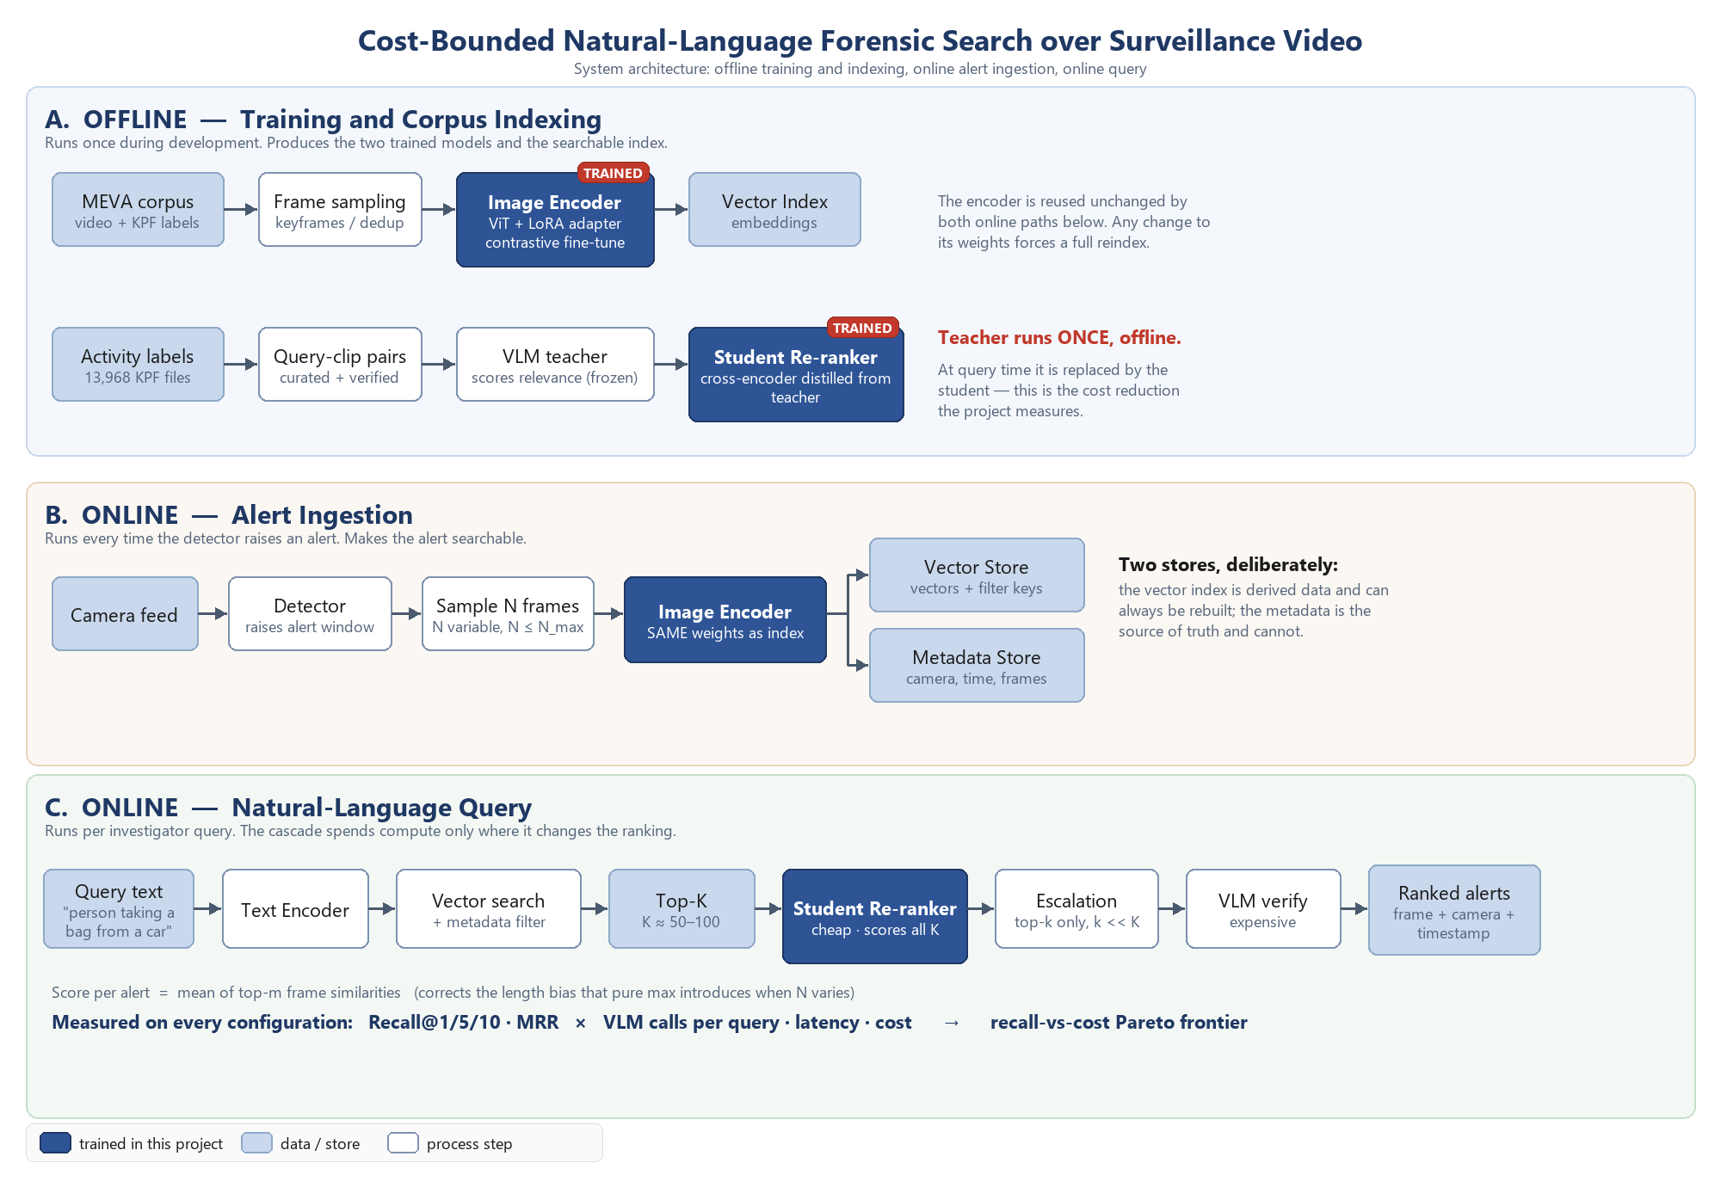
Figure 1. System architecture. Lane A is the offline path: the corpus is sampled and embedded by the domain-adapted encoder to build the index, while activity annotations yield query–clip pairs that the vision-language teacher scores in order to train the student re-ranker by distillation. Lane B is alert ingestion: when the detector raises an alert, a variable number of frames are sampled and embedded with the same encoder weights used to build the index, with vectors written to the vector store and metadata to the relational store. Lane C is the query path: the query is encoded, filtered vector search returns candidates, the student re-ranks all of them cheaply, and only a small subset is escalated to the vision-language model. Components trained in this project are shaded.

6. Expected Benefits
Technical contribution. A characterisation of the accuracy-versus-cost frontier for VLM-assisted video retrieval — an axis the surveyed literature reports almost exclusively in terms of accuracy. The distilled re-ranker is a reusable artefact independent of the surveillance domain.
Operational impact. Reduces post-incident footage review from hours of manual scrubbing to a natural-language query, without requiring the operator to know camera identifiers or timestamps in advance.
Efficiency and accessibility. By removing the per-query dependence on a large VLM, the system becomes deployable on modest on-premise hardware. This matters disproportionately for low-resource deployments — municipal authorities, campuses, small businesses — where per-query API costs would otherwise be prohibitive.
Privacy. Local inference means footage never leaves the operator's infrastructure, which is materially better than architectures that stream frames to a third-party API.
Reusable evaluation asset. The curated natural-language query set over MEVA does not currently exist and will be released alongside the project.

7. Stakeholders
Stakeholder | Interest / Impact
Security operators and investigators | Primary users. Direct reduction in time-to-evidence; can query in plain language rather than by camera and timestamp.
Facility and transport operators | Faster incident response and lower review labour cost; feasible on-premise deployment without recurring API spend.
Law enforcement / legal process | Faster evidence location. Requires that retrieval be treated as an investigative aid whose outputs are human-verified, never as automated determination of fact.
Members of the public under surveillance | Affected party. Semantic search over footage increases the power of an existing archive, which is a genuine privacy consideration; local-only inference and access logging are partial mitigations, and the system performs retrieval, not identification.
Computer vision researchers | Gain a cost-aware evaluation protocol and a natural-language query benchmark over a CC BY 4.0 corpus.
Data protection regulators | Interest in scope limitation and auditability; the design deliberately excludes biometric identification and retrieves events, not persons.

8. Timeline
Phase | Activity | Duration
0 | Dataset acquisition and verification — COMPLETE (19 September 2026). Corpus, annotations and working video subset obtained and validated. | done
1 | Manifest construction: align annotations to video; derive query–clip pairs from human activity labels; hand-verify the held-out evaluation split | Week 1
2 | Baseline: frozen dual encoder + vector index; Recall@K measured end-to-end. Establishes a complete working system and the lower bound of the cost curve. | Week 1–2
3 | Domain adaptation (LoRA contrastive fine-tuning); VLM teacher labelling; distillation of the student re-ranker | Week 2–3
4 | Ablation across five operating points; recall-versus-cost Pareto frontier; teacher-exhaustive upper bound; error analysis including per-activity recall | Week 3
5 | Alert ingestion pipeline and query interface end-to-end; report and presentation | Week 3–4

Risk control. Phase 0 is already complete, so the dataset risk that normally dominates a project of this kind has been eliminated before the proposal was submitted. Phase 2 alone then constitutes a complete, demonstrable retrieval system. Every phase after it improves the result but is not required for the project to stand, which bounds the downside if later phases overrun.

