Deep Learning Project Proposal

Cover Information
Project Title | Cost-Bounded Natural-Language Forensic Search over Surveillance Video via Distilled Vision-Language Re-Ranking
Student Name(s) & ID(s) | [INSERT FULL NAME AND STUDENT ID]
Course & Section | [INSERT COURSE & SECTION]
Date | 20 September 2026

1. Problem Definition
A modern surveillance installation produces thousands of automated alerts per day. When an incident is reported after the fact, an investigator must locate the relevant footage among them. Current practice is manual review: an operator watches hours of video, or filters only by camera and timestamp, because no index exists over what actually happens inside the frames. This is the dominant cost of video forensics and it grows linearly with the size of the archive.
This project frames that task as cross-modal text-to-video moment retrieval. The input is a free-form natural-language query — for example, "a person taking a bag from a parked car" — together with a corpus of surveillance clips. The output is a ranked list of clips, each localised to a start and end time, ordered by relevance to the query. Retrieval quality is measured by Recall@K and Mean Reciprocal Rank.
The distinguishing constraint is cost. A vision-language model applied to every candidate clip produces strong relevance judgements but is computationally infeasible at archive scale, because cost grows linearly in the number of query–clip pairs scored. The research question is therefore not only how accurate retrieval can be, but how much of the retrieval accuracy of an exhaustive vision-language system can be retained while reducing model invocations by one to two orders of magnitude.
This matters because a forensic search tool that is accurate but costly per query will not be deployed, while one that is cheap but misses the incident is worse than useless. The accuracy–cost frontier, rather than accuracy alone, determines whether such a system is practical.
The scope is an operating system rather than an offline benchmark alone. An offline path trains the models on the annotated corpus and builds the searchable index. An online path ingests alerts as they are produced — sampling frames, embedding them with the trained encoder, and recording them together with their metadata — and then serves natural-language queries against that store, returning ranked alerts with their frames, camera and timestamp. The offline path answers the research question; the online path demonstrates that the answer is usable.

2. Dataset Description & Constraint Compliance

2.1 Data Source
The dataset is MEVA (Multiview Extended Video with Activities), collected and annotated by Kitware, Inc. at the Muscatatuck Urban Training Center for the IARPA DIVA programme [9]. Video is distributed through the AWS Registry of Open Data and annotations through the project's public repository. The dataset is released under a CC BY 4.0 licence.
Kaggle compliance. MEVA is not hosted on Kaggle. It originates from an institutional research archive and is distributed via the AWS Public Dataset Program, a primary source category the assignment brief names as acceptable.
Curated extension. MEVA provides activity annotations but no natural-language query set. A retrieval query set will therefore be curated as part of this project by composing queries from the existing human-made activity annotations and hand-verifying a held-out evaluation subset. This constitutes data curated by the author, which the brief also permits explicitly.

Accessibility and suitability checks carried out during the research phase:
Check | Finding
Access model | Anonymous public access; no account, licence request or approval form required
Licence | CC BY 4.0 — permits use and redistribution with attribution
Annotation availability | Public repository provides 13,968 annotation files covering roughly 184 hours
Annotation content | KPF format: activity label, frame-level timespan, and actor identifiers per instance
Media format | 1920×1080 at 25 fps; standard codecs, decodable with OpenCV
Activity vocabulary | 36 distinct activity types spanning person, vehicle and object interactions

Prior use, stated precisely. MEVA has been used for activity detection, notably in the NIST TRECVID ActEV evaluations. It has not been used for natural-language moment retrieval; that literature is built on DiDeMo, Charades-STA and QVHighlights [10]. No natural-language query benchmark exists for MEVA. The claim made here is that the dataset is applied to a task for which it has not previously been used — not that the dataset is unused.

2.2 Data Characteristics
Property | Value
Total video | ~328 hours across 4,259 clips, multi-camera
Annotated portion | ~184 hours (evaluation and training annotation sets combined)
Activity classes | 37 activity types; 36 observed in the released annotation vocabulary
Annotation type | Bounding boxes of actors and props, with activity labels and temporal extents
Viewpoints | Multiple synchronised fixed cameras, indoor and outdoor
Collection method | Filmed with physical cameras at a physical urban training facility under IRB oversight

Non-synthetic confirmation. MEVA is real-world observed data, recorded with physical cameras at a physical site. Participants performed scripted activities under IRB oversight, but no part of the imagery is computer-generated, simulated or procedurally synthesised, so the requirement for real-world collected data is satisfied. The scripted nature of the activities is disclosed as a limitation in Section 4 rather than concealed.

2.3 Size & Balance Justification
Sufficiency. Roughly 184 annotated hours across 37 activity types yields tens of thousands of temporally localised activity instances, far above the threshold of thousands of labelled samples. For retrieval the training unit is the query–clip pair, and a single annotated instance can generate several paraphrased queries, so the effective training set is larger still. The corpus is also large enough that retrieval is genuinely difficult: a search space of thousands of clips makes Recall@1 a meaningful measurement rather than a near-trivial one.
Balance. The activity classes are naturally long-tailed, with common activities such as vehicle movements greatly outnumbering rare ones such as theft or package abandonment. Three strategies will be applied and reported:
- Class-balanced sampling of query–clip training pairs, capping the contribution of head classes.
- Macro-averaged Recall@K reported alongside micro-averaged, and per-activity recall reported separately, so that strong performance on frequent activities cannot mask failure on rare ones.
- A stratified evaluation query set built with approximately equal query counts per activity class, decoupling evaluation balance from corpus balance.
For the contrastive training objective, in-batch negatives are used, so imbalance affects sampling rather than the loss formulation itself.

3. Literature Review - Existing Work on This Problem
Seven prior works are summarised below, spanning the three lines of research this project draws on: contrastive vision-language pretraining, which makes cross-modal retrieval possible at scale; cross-encoder re-ranking and surveillance-specific retrieval systems, which achieve higher precision at a cost none of them quantify; and knowledge distillation, which provides the mechanism this project uses to remove that cost. Full citations appear in the References section.
Reference (Author, Year) | Technique Used | Key Result / Limitation
Radford et al., 2021 [1] | CLIP: contrastive image-text pretraining on ~400M web pairs; dual encoder producing a shared embedding space | Enables zero-shot cross-modal retrieval, and independent encoders allow embeddings to be precomputed for sub-linear search. Limitation: trained on web photographs, so accuracy degrades on fixed elevated surveillance viewpoints with small, distant subjects and compression artefacts.
Li et al., 2023 [2] | BLIP-2: Q-Former bridging a frozen image encoder and frozen LLM; image-text matching head used as a cross-encoder re-ranker | Substantially higher precision than dual encoders through joint query-candidate encoding. Limitation: cost grows linearly with the number of pairs scored, so exhaustive application across an archive is infeasible.
Tran et al., 2025 [3] | Unified multi-granularity framework (CLIP + BEiT-3), keyframe deduplication via TransNetV2, temporal re-ranking over neighbouring frames | Improves retrieval robustness on hour-long video. Limitation: evaluation reports accuracy metrics only; inference cost and model invocation counts are not characterised.
SurveiLens, 2026 [4] | Natural-language moment retrieval for CCTV: frame sampling, captioning, semantic similarity, temporal localisation | Demonstrates investigator-facing retrieval on real surveillance footage. Limitation: captioning every sampled frame is itself the dominant expense, and no cost model is presented.
ForeSea, 2026 [5] | Forensic search over surveillance video with multi-modal queries combining text and image exemplars | Handles heterogeneous query types in a forensic workflow. Limitation: reports retrieval quality without characterising the accuracy/compute trade-off.
Wu et al., 2024 [6] | VadCLIP: adapts CLIP for weakly supervised video anomaly detection via dual-branch prompt learning | Confirms that vision-language transfer to the surveillance domain is viable. Limitation: addresses closed-set anomaly detection rather than open-vocabulary retrieval from arbitrary free text supplied at inference time.
Hinton et al., 2015 [7]; Hofstaetter et al., 2020 [8] | Knowledge distillation; cross-architecture distillation of an expensive cross-encoder into a cheaper ranking model using a margin-based objective | Established that a teacher's ranking behaviour can be transferred to a student at a fraction of inference cost, recovering much of its effectiveness. Limitation: demonstrated for text retrieval; not applied to vision-language re-ranking over surveillance video.

4. Proposed Methodology

4.1 How the Approach Differs from Existing Work
The proposed system is a three-stage cascade in which the expensive component is progressively eliminated rather than merely reduced. Against CLIP [1], the difference is that the retrieval encoder is not used off the shelf: it is domain-adapted to fixed-camera surveillance imagery through contrastive fine-tuning with low-rank adaptation, treating the web-to-surveillance distribution shift as an explicit and separately measured problem rather than an accepted cost. Against BLIP-2 [2], the difference is where the cross-encoder runs. Instead of invoking it at query time, this project uses a vision-language model solely as a teacher during training; at inference the teacher is replaced by a distilled student, so the expensive computation is paid once offline rather than repeatedly per query.
Against the surveillance retrieval systems [3], [4], [5], the difference is what is measured. Those works optimise and report accuracy; this project treats model invocations, tokens, latency and monetary cost as first-class reported quantities, and presents the outcome as a recall-versus-cost frontier across several operating points rather than a single configuration. Against VadCLIP [6], the difference is task formulation: retrieval here is open-vocabulary, responding to arbitrary text supplied at inference time, rather than scoring against a fixed anomaly taxonomy. Against Hofstätter et al. [8], the difference is modality and domain — cross-encoder to student distillation is carried from text retrieval into vision-language retrieval over surveillance video, where the teacher is multimodal and the cost problem is considerably more severe.
Stated plainly, the cascaded retrieval architecture is established prior work and is deliberately reused. The contributions claimed are three: the distillation of a vision-language re-ranker into a deployable student for this task; the domain adaptation of the retrieval encoder to surveillance imagery; and the explicit characterisation of the accuracy-versus-cost frontier, which the surveyed literature does not report.

4.2 Why This Should Produce Good Results
Three hypotheses are advanced, each framed so that it can be rejected by the experiments rather than assumed.
The first is that domain adaptation will improve first-stage recall. CLIP is trained on web photographs while surveillance footage differs systematically in viewpoint, subject scale, illumination and compression. Contrastive fine-tuning on in-domain pairs has repeatedly recovered substantial performance in comparable out-of-distribution transfers, and low-rank adaptation permits this on a modest in-domain set without disturbing the general visual semantics learned during pretraining. The hypothesis is falsifiable: if the adapted encoder does not exceed the frozen baseline on Recall@10, it is rejected.
The second is that a distilled student will retain most of the teacher's ranking quality at a small fraction of its cost. The precedent is cross-architecture distillation in text retrieval [8], and the mechanism transfers for two reasons. The teacher supplies a dense, graded relevance signal over far more pairs than human annotation could produce, and the student is required to learn a ranking function over a narrow domain rather than general multimodal reasoning. The narrowness of the domain is an advantage for the student rather than a limitation.
The third is that the accuracy-versus-cost curve will be strongly concave. Because first-stage retrieval already places most true positives within the top-K candidates, escalating only a small subset to the teacher should capture most of the achievable gain, with sharply diminishing returns beyond that point. Should the curve prove approximately linear instead, the cascade offers no advantage over exhaustive scoring, and that negative result would itself be worth reporting.
Acknowledged limitation. MEVA activities are scripted performances by participants at a training facility rather than spontaneous incidents, so absolute retrieval figures may be optimistic relative to uncontrolled footage. Because this affects all experimental arms equally, comparisons between arms remain valid, and the limitation will be stated explicitly in the evaluation.

4.3 Tools & Techniques to Be Used
Tool / Technique | Role | Justification
PyTorch 2.x with torch.compile | Core training framework | Graph compilation gives material throughput gains on the repeated encoder passes that dominate training time.
Hugging Face Transformers / Datasets | Models and data pipeline | Canonical source for CLIP/SigLIP and open-weight vision-language checkpoints; reproducible dataset handling.
SigLIP or CLIP ViT-B/16 | First-stage dual encoder | Independent encoders allow clip embeddings to be precomputed and searched sub-linearly, which is what makes archive-scale retrieval tractable.
LoRA / QLoRA (PEFT) | Parameter-efficient domain adaptation | Adapts a large pretrained encoder on a modest in-domain set without full fine-tuning, avoiding catastrophic forgetting of general visual semantics.
Open-weights VLM as teacher | Relevance labelling for distillation | Local execution removes per-call API cost, makes large-scale label generation feasible, and avoids transmitting footage to a third party.
Knowledge distillation (margin-MSE) | Training the student re-ranker | The central technique: transfers the teacher's ranking behaviour into a model small enough to deploy.
ChromaDB | Vector index with metadata filtering | Stores embeddings alongside the filter keys needed for hybrid queries constrained by camera and time range, which vector similarity alone cannot express.
SQLite | Alert metadata store | Holds camera, timestamps, detector provenance and frame paths. Kept separate from the vector index because the index is rebuildable and the metadata is not.
Quantisation and ONNX export | Student deployment | Demonstrates the efficiency claim end to end and matches the edge-deployment techniques named in the brief.
Weights & Biases | Experiment tracking | Multi-arm ablation with cost metrics requires systematic run comparison.
Optuna | Hyperparameter optimisation | Tunes the escalation threshold and distillation temperature, which directly control the cost–accuracy trade-off.

5. System / Flow Diagram
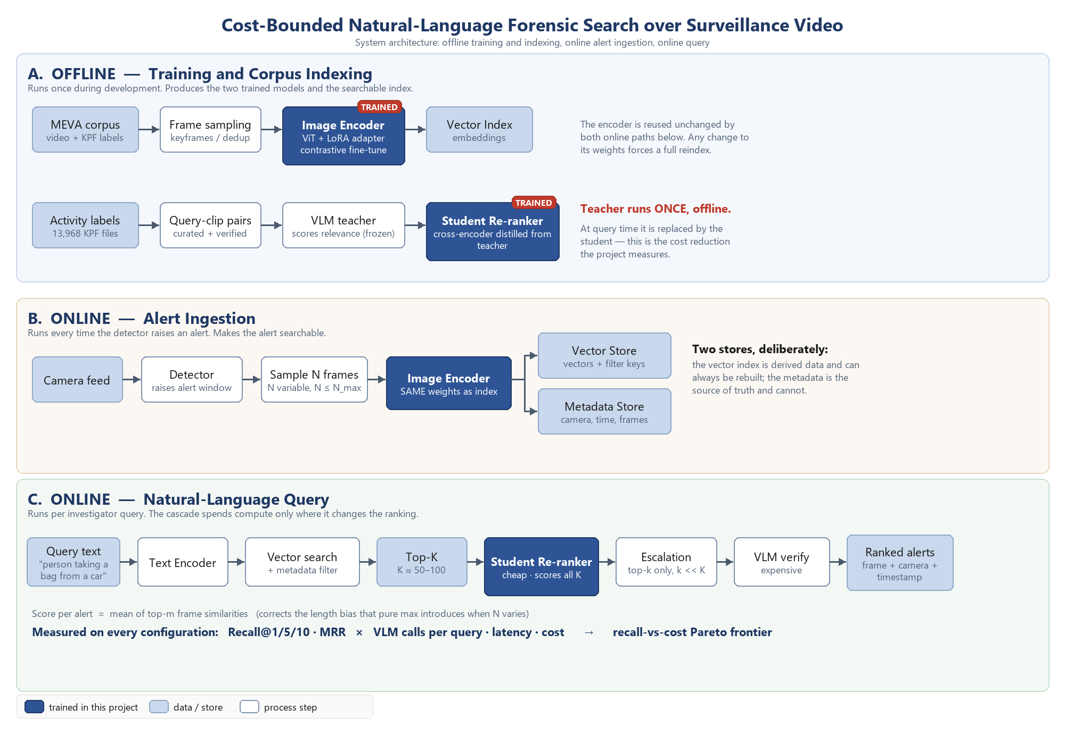
Figure 1. System architecture. Lane A is the offline path: the corpus is sampled and embedded by the domain-adapted encoder to build the index, while activity annotations yield query–clip pairs that the vision-language teacher scores in order to train the student re-ranker by distillation. Lane B is alert ingestion: when the detector raises an alert, a variable number of frames are sampled and embedded with the same encoder weights used to build the index, with vectors written to the vector store and metadata to the relational store. Lane C is the query path: the query is encoded, filtered vector search returns candidates, the student re-ranks all of them cheaply, and only a small subset is escalated to the vision-language model. Components trained in this project are shaded.

6. Possible Outcomes
The principal expected outcome is a characterisation of the accuracy-versus-cost frontier for vision-language-assisted video retrieval — an axis the surveyed literature reports almost exclusively in terms of accuracy. The distilled re-ranker produced along the way is a reusable artefact that is not specific to the surveillance domain.
A second outcome is operational. Post-incident footage review is reduced from extended manual scrubbing to a natural-language query, without requiring the operator to know camera identifiers or timestamps beforehand. Because the dependence on a large model at query time is removed, the resulting system is deployable on modest on-premise hardware, which matters disproportionately for low-resource deployments such as municipal authorities, campuses and small businesses where recurring per-query costs would otherwise be prohibitive. Local inference also means footage need never leave the operator's own infrastructure, which is materially better for privacy than architectures that transmit frames to an external service.
A third outcome is a reusable evaluation asset: a curated natural-language query set over a CC BY 4.0 surveillance corpus, which does not currently exist.
A negative result remains informative. Should the distilled student fail to approach the teacher's ranking quality, or should the accuracy-versus-cost curve prove linear rather than concave, that finding would itself constitute evidence about the limits of distillation in the vision-language setting and would be reported as such.

7. Stakeholders
Stakeholder | Interest / Impact
Security operators and investigators | Primary users. Direct reduction in time-to-evidence; queries expressed in plain language rather than by camera and timestamp.
Facility and transport operators | Faster incident response and lower review labour cost; on-premise deployment without recurring external inference spend.
Members of the public under surveillance | Affected party. Semantic search increases the practical power of an existing archive, which is a genuine privacy consideration; local-only inference is a partial mitigation, and the system retrieves events rather than identifying individuals.
Researchers and regulators | Gain a cost-aware evaluation protocol and a query benchmark over an openly licensed corpus; the design deliberately excludes biometric identification.

8. Timeline
Phase | Activity | Duration
1 | Data collection and preprocessing: corpus and annotation acquisition, alignment of annotations to video, derivation of query–clip pairs from human activity labels, and verification of the held-out evaluation split | Week 1
2 | Baseline model implementation: frozen dual encoder with vector index, Recall@K measured end to end, establishing the lower bound of the cost curve | Week 1–2
3 | Proposed technique implementation: domain adaptation by contrastive low-rank fine-tuning, teacher relevance labelling, and distillation of the student re-ranker | Week 2–3
4 | Evaluation and comparison: ablation across operating points, recall-versus-cost frontier, exhaustive-teacher upper bound, and per-activity error analysis | Week 3
5 | Alert ingestion pipeline and query interface end to end; report and presentation | Week 3–4

References
[1] A. Radford et al., "Learning Transferable Visual Models From Natural Language Supervision," in Proc. 38th Int. Conf. Machine Learning (ICML), 2021, pp. 8748–8763.
[2] J. Li, D. Li, S. Savarese, and S. Hoi, "BLIP-2: Bootstrapping Language-Image Pre-training with Frozen Image Encoders and Large Language Models," in Proc. 40th Int. Conf. Machine Learning (ICML), 2023.
[3] T. Tran et al., "Towards Efficient and Robust Moment Retrieval System: A Unified Framework for Multi-Granularity Models and Temporal Reranking," in Proc. IEEE/CVF Conf. Computer Vision and Pattern Recognition Workshops (CVPRW), 2025.
[4] "SurveiLens: Natural Language-Based Moment Retrieval for Surveillance Video Analysis," in Proc. IEEE Conf., 2026. [Online]. Available: https://ieeexplore.ieee.org/document/11400480/
[5] "ForeSea: AI Forensic Search with Multi-modal Queries for Video Surveillance," arXiv:2603.22872, 2026.
[6] P. Wu et al., "VadCLIP: Adapting Vision-Language Models for Weakly Supervised Video Anomaly Detection," in Proc. AAAI Conf. Artificial Intelligence, 2024.
[7] G. Hinton, O. Vinyals, and J. Dean, "Distilling the Knowledge in a Neural Network," arXiv:1503.02531, 2015.
[8] S. Hofstätter, S. Althammer, M. Schröder, M. Sertkan, and A. Hanbury, "Improving Efficient Neural Ranking Models with Cross-Architecture Knowledge Distillation," arXiv:2010.02666, 2020.
[9] K. Corona, K. Osterdahl, R. Collins, and A. Hoogs, "MEVA: A Large-Scale Multiview, Multimodal Video Dataset for Activity Detection," in Proc. IEEE/CVF Winter Conf. Applications of Computer Vision (WACV), 2021, pp. 1060–1068.
[10] J. Lei, T. L. Berg, and M. Bansal, "QVHighlights: Detecting Moments and Highlights in Videos via Natural Language Queries," in Proc. Advances in Neural Information Processing Systems (NeurIPS), 2021.

