CafeBonzer – Lab Management System  CafeBonzer v2 - Nematix Technology | 

Disclaimers
The information contained in this document is the proprietary and exclusive property of Nematix Technology except as otherwise indicated. No part of this document, in whole or in part, may be reproduced, stored, transmitted, or used for design purposes without the prior written permission of Nematix Technology.
The information contained in this document is subject to change without notice.
The information in this document is provided for informational purposes only. Nematix Technology specifically disclaims all warranties, express or limited, including, but not limited, to the implied warranties of merchantability and fitness for a particular purpose, except as provided for in a separate software license agreement.
Privacy Information
This document may contain information of a sensitive nature. This information should not be given to persons other than those who are involved in the Mail & Web Server System integration project or who will become involved during the lifecycle
Trademarks
Nematix Technology 1997-2006

Executive Summary

Proposal is intend to integrate lab monitoring system with equivalent infrastructure.

System Integration Technical Summary
Platform | Windows XP, 2000, 2003
Networking | TCP/IP

Technology Used on Cafebonzer
Development Platform | Win32
Programming Language | Borland Delphi
Database | MySQL, SQLLite

Lab Management System - CafeBonzer

 | CafeBonzer is a total solution for cybercafe solution, its allow administrator to take control of their cybercafe.  With ease of use and nice graphic user interface, CafeBonzer  give you more productivity.

- Easy-to-Use
- Elegant and pleasant work environment. Easy to use and operate. All network terminals and relevant information about start time, total use, present use, present billing and customer’s name appear on the screen. All these without a single click! The whole program can be operated without the use of a mouse, with keyboard shortcuts that make it easy to use. The program has been moderated to collaborate with a Barcode or magnetic reader for instant location of files.

- Network
- Client/Server architecture: the program contacts with the terminals through the network and allows their remote operation. Guaranteed and stable contact through the TCP/IP protocol. Support of countless terminals without affecting the network’s speed and performance. Encrypted data transmission between the client and the server.

- Screen Lock
- When the terminal is not being used the screen is locked with a protection shield. The customer has to go through the cash desk where the cashier and the CafeBonzer server is, to unlock the terminal. 100% guaranteed lock even if a game is running! Tested under all circumstances and on the heaviest games in the market. If, for some reason, the protection shield does not lock the terminal, or the machine is out of order, the employee is notified from the server to investigate the matter. The screen locks ONLY if there is an active CafeBonzer server in the network. If there is no active CafeBonzer server the client will reboot and leave the terminal unlocked. Once the server reverts it will automatically lock again. This is a very useful utility when, for example, the machine that CafeBonzer has been installed in, breaks down for some reason and it helps to avoid “locking out” the shop. Once the machine reverts, then everything locks again automatically.

- Remote Management
- Turns the terminals on through the server (with the use of Wake On Lan)
- Shuts down, restarts and logs off a terminal or the network as a whole.
- Allows remote change of screen resolution. Allows remote volume control.
- Sends text messages to the customers. Allows management/projection/killing of applications that are being executed in the terminals.

- Security
- Program data can either be located in the local machine that runs the CafeBonzer server or in a different machine in the local network or even on the internet! Each employee has his own entry password in the program, a factor that increases the security levels of use and control. Limited functions for the employees and extended functions of control and economical data projection only for the business owner. The program notifies the employee when a terminal has been disconnected from the network with an icon alteration (shutdown).
- It does not allow the alteration of the system clock.

- Session
- When entering the program, each employee starts a new session. All debits that are made during his shift are written in this session. The session simply finishes when the employee logs out of the program by clicking “Close Session”. The new session begins when the next user logs into the program. The session will not be lost if the program is mistakenly shut down or the server restarts. The session is not affected if the program administrator (owner of the business) wishes to log into the program. He logs out the employee without providing a turnover and logs in with his password. Money that is collected during the administrator’s logging in, shall be recorded in the employee’s cashbook. When the dministrator wishes to log out, the employee logs in again and continues his session. In case the employee forgets to close his session and the next user logs in, the program notifies the user that the previous employee forgot to close his session. It asks if he definitely wants to close the previous session and start a new one.

- Interchangeable parameters
- 100% interchangeable parameters in all levels of settings in order to function and satisfy the needs of each business individually. Different colors in the terminal display, according to the debit system (play and pay, prepayment, no charge e.t.c).

- Time charge
- Supports fixed charges per hour or time zones for different charges during the day. Calculates approximate sums, minimum charge and charge after a few minutes. Everything is parameter interchangeable according to the owner of the business. Supports three ways of payment: Play and pay, Prepayment and Tickets. Charges the customer even if the terminal has for some reason been disconnected from the network. Allows different charges and discounts for members and visitors. Allows 100% discount for free use of the terminals from employees, e.t.c.

- Play and pay
- Customers use the terminal and pay after they are finished with its use.

- Prepayment
- Customers prepay their usage time. Members can use as much of their prepaid time as they want and the remaining time is stored in their account for future use. The program allows countless promotional prepayment packages for the members. For example, while an hour costs RM 2, the promotional package can provide them with 10 hours for RM 5. Promotional packages can be bought by members only. Members that have prepaid time in their account can unlock the terminal using a username and a password. Ergo, they avoid going to the cashiers to be served. Prepaid time can also be added when the customer is already using the terminal. Once the prepaid time is exhausted, the terminal automatically locks.

- Moving Terminals
- Easy charge movement from one terminal to the other (if the customer asks to change to another terminal). In this case, the program locks the first terminal and unlocks a new one. Possibility to exchange two terminals (swap terminals).

- Statistics
- Full statistics report on all program data. More pleased customers with the possibility to insert discount by a simple click. Daily turnover and average daily turnover. Weekly turnover and average weekly turnover. Monthly turnover and average monthly turnover. Yearly turnover and average yearly turnover.
- Statistics in the level of charge (play and pay, prepayment, tickets). Statistics for the bar, popular items, categories, rush hours, flat days, flat hours. Statistics per employee. All statistics accept filters (dates e.t.c). Discount or export at any format.

- Cafebonzer Client
- The program that has been installed in the network terminals and allows the screen lock and remote management, while it provides you with so many choices. It is 100% independent, does not require any DLL or OCX to run.
- It is very light, does not consume too much memory and does not affect the terminal’s performance or the games (for instance, some clients affect the games’ frames). It is invisible to the customers (runs in the backround).
- It does not make any changes to the Windows software or to the system. You can use any Windows security software to protect the terminals and control their security level. It can kill all applications running before locking the screen, delivering to the next client a fine and fully operational terminal. It also makes sure that that all programs that consume bandwidth (kazaa, downloads, e.t.c) will shut down. This solution is faster than trying to reboot which has the same effect. In the locking section, CafeBonzer Client uses the most efficient technology and the fastest routines than any other program client in the world. The antagonistic programs we have used did not offer us more than 50% success.

Hardware for Network Infrastructure
- Basic Hardware Requirement
For optimal performance we recommend basic minimum hardware requirement.

Desktop Computer
Processor | Pentium 3 Above
Memory | 128 Mb
HDD | Min 10Gb

Server Computer
Processor | Pentium 4 Above
Memory | 256 Mb
HDD | Min 20Gb

- Proposed Architectured
Proposed architecture is refering on standard lab basic requirement.

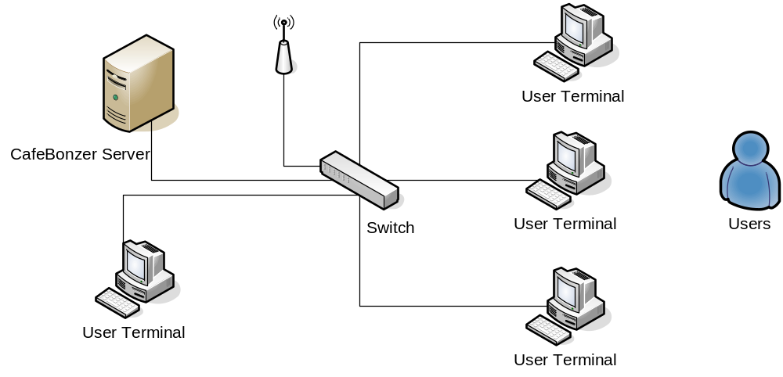

System Integration Fees

Proposed is the financial proposal, figured is the optimum price inclusive installation, configuration, software update and online support.

Software License

Option 1 – Site License
Server Installation | 1 Per Site
Client Installation | Unlimited
Training | 1 Day Operating Training
Support | 1 Year On-Site\Online Support
Service Coverage | National
RM 2,500.00

Option 2 – Bulk License
Server Installation | Unlimited
Client Installation | Unlimited
Training | 1 Day Operating Training
Support | 1 Year On-Site\Online Support
Service Coverage | National
RM 72,000.00

Appendix 1

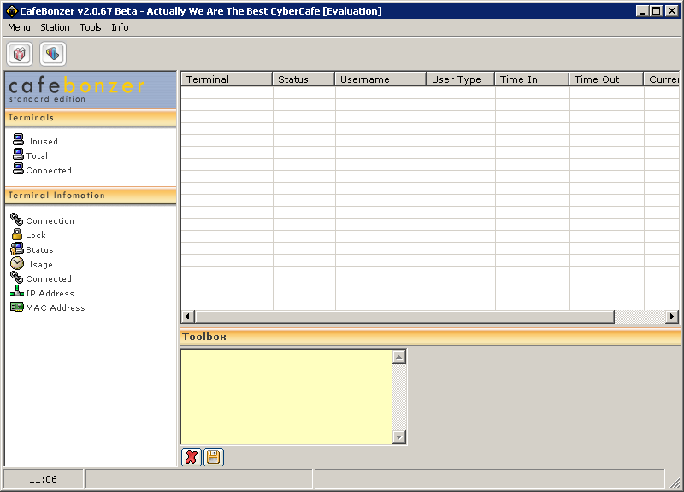
Main Controller

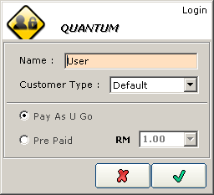
Customer Login
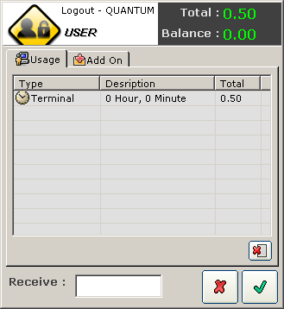
Customer Logout

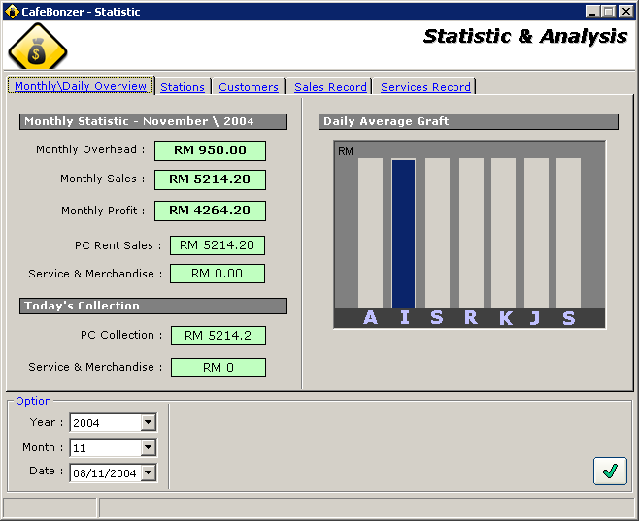
Usage Staistic

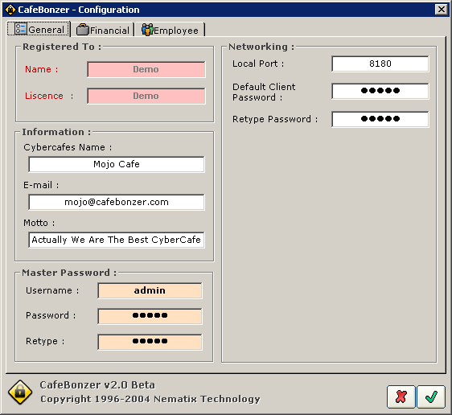
Controller Panel

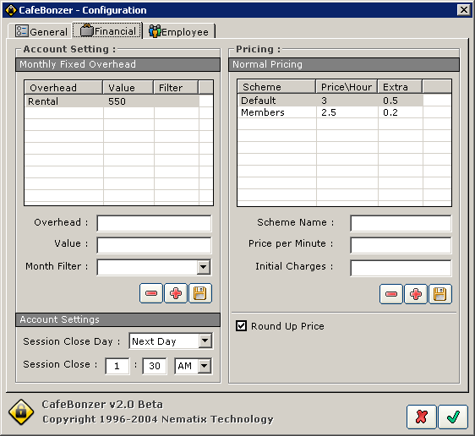
Controller Panel

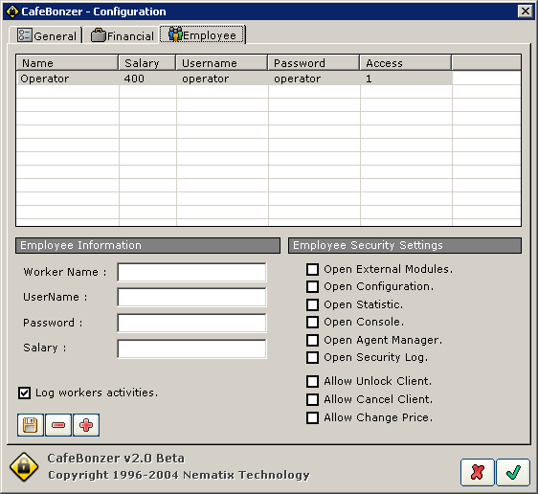
Controller Panel

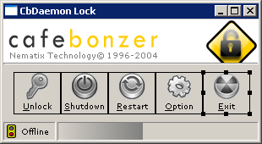
Customer Lock
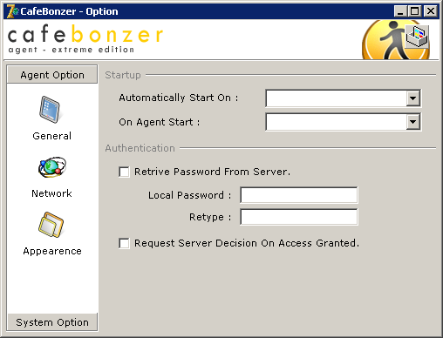
Client Configuration

