
COMSATS UNIVERSITY ISLAMABAD , ATTOCK CAMPUS
SUBMITTED BY :
Wajeeha HAbib
FA21-BSE-016 SUBMITTED TO:
SIR KAMRAN
ASSIGNMENT NO : 04

Store /actions.js:
export const setUser = (user) => ({
type: 'SET_USER',
payload: user,
});

export const logoutUser = () => ({
type: 'LOGOUT_USER',
});

export const setLocation = (location) => ({
type: 'SET_LOCATION',
payload: location,
});

Store/reducers.js:
import { combineReducers } from 'redux';
import userReducer from './userReducer';

const rootReducer = combineReducers({
user: userReducer,
});

export default rootReducer;

Store/userReducer.js:
const initialState = {
userName: '',
email: '',
password: '',
location: '',
isLoggedIn: false,
};

const userReducer = (state = initialState, action) => {
switch (action.type) {
case 'SET_USER':
return { ...state, ...action.payload, isLoggedIn: true };
case 'LOGOUT_USER':
return initialState;
case 'SET_LOCATION':
return { ...state, location: action.payload };
default:
return state;
}
};

export default userReducer;

Screens:
Registration.js
import React, { useState } from 'react';
import { View, TextInput, Button, Alert, StyleSheet } from 'react-native';
import { useDispatch } from 'react-redux';
import { setUser } from '../store/actions';

const FIREBASE_API_ENDPOINT = 'https://mad-14-default-rtdb.firebaseio.com';

export default function RegistrationScreen({ navigation }) {
const dispatch = useDispatch();
const [userName, setUserName] = useState('');
const [email, setEmail] = useState('');
const [password, setPassword] = useState('');
const [confirmPassword, setConfirmPassword] = useState('');

const registerUser = async () => {
if (!userName || !email || !password || !confirmPassword) {
Alert.alert('Error', 'All fields are required!');
return;
}
if (password !== confirmPassword) {
Alert.alert('Error', 'Passwords do not match!');
return;
}

try {
const user = { userName, email, password };
const response = await fetch(`${FIREBASE_API_ENDPOINT}/users.json`, {
method: 'POST',
body: JSON.stringify(user),
headers: { 'Content-Type': 'application/json' },
});

if (response.ok) {
dispatch(setUser(user));
Alert.alert('Success', 'Registration successful!');
navigation.navigate('Login');
} else {
Alert.alert('Error', 'Failed to register user in Firebase.');
}
} catch (error) {
console.error(error);
Alert.alert('Error', 'Something went wrong.');
}
};

return (
<View style={styles.container}>
<TextInput
style={styles.input}
placeholder="User Name"
value={userName}
onChangeText={setUserName}
/>
<TextInput
style={styles.input}
placeholder="Email"
value={email}
onChangeText={setEmail}
/>
<TextInput
style={styles.input}
placeholder="Password"
value={password}
secureTextEntry
onChangeText={setPassword}
/>
<TextInput
style={styles.input}
placeholder="Confirm Password"
value={confirmPassword}
secureTextEntry
onChangeText={setConfirmPassword}
/>
<Button title="Register" onPress={registerUser} />
</View>
);
}

const styles = StyleSheet.create({
container: { flex: 1, justifyContent: 'center', padding: 20 },
input: { borderWidth: 1, padding: 10, marginBottom: 15, borderRadius: 5 },
});

OUTPUT:

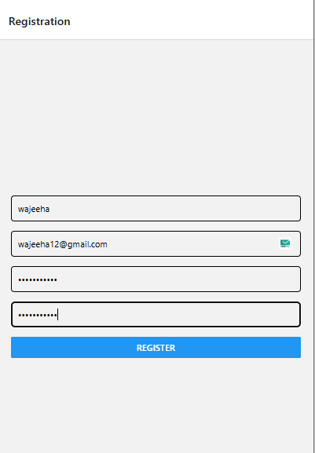

Login.js
import { useState } from 'react';
import { View, TextInput, Button, Alert, StyleSheet } from 'react-native';
import { useDispatch } from 'react-redux';
import { setUser, setLocation } from '../store/actions';
import Geolocation from 'react-native-geolocation-service';

const FIREBASE_API_ENDPOINT = 'https://mad-14-default-rtdb.firebaseio.com';

export default function LoginScreen({ navigation }) {
const dispatch = useDispatch();
const [email, setEmail] = useState('');
const [password, setPassword] = useState('');

const loginUser = async () => {
try {
const response = await fetch(`${FIREBASE_API_ENDPOINT}/users.json`);
const data = await response.json();
const user = Object.keys(data)
.map((key) => ({ id: key, ...data[key] }))
.find((item) => item.email === email && item.password === password);

if (user) {
dispatch(setUser(user));
fetchLocation();
Alert.alert('Success', 'Login successful!');
navigation.navigate('Home');
} else {
Alert.alert('Error', 'Invalid email or password.');
}
} catch (error) {
console.error(error);
Alert.alert('Error', 'Something went wrong.');
}
};

const fetchLocation = () => {
Geolocation.getCurrentPosition(
(position) => {
const location = `${position.coords.latitude}, ${position.coords.longitude}`;
dispatch(setLocation(location));
},
(error) => {
console.error(error);
Alert.alert('Error', 'Unable to fetch location.');
},
{ enableHighAccuracy: true }
);
};

return (
<View style={styles.container}>
<TextInput
style={styles.input}
placeholder="Email"
value={email}
onChangeText={setEmail}
/>
<TextInput
style={styles.input}
placeholder="Password"
value={password}
secureTextEntry
onChangeText={setPassword}
/>
<Button title="Login" onPress={loginUser} />
</View>
);
}

const styles = StyleSheet.create({
container: { flex: 1, justifyContent: 'center', padding: 20 },
input: { borderWidth: 1, padding: 10, marginBottom: 15, borderRadius: 5 },
});

OUTPUT:

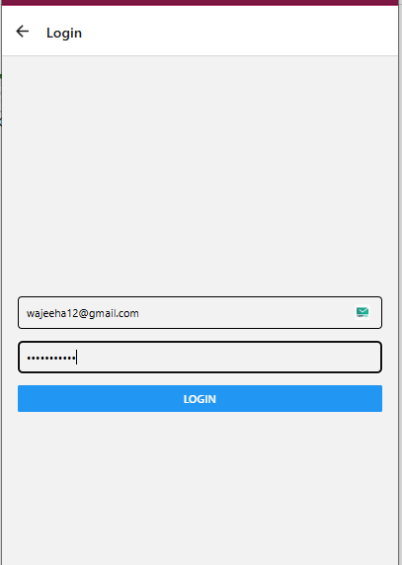

Homepage.js:
import { useState } from 'react';
import { SafeAreaView, StyleSheet, View, Text, TextInput, FlatList, Image, TouchableOpacity, ScrollView } from 'react-native';
import { useSelector } from 'react-redux';
import Icon from 'react-native-vector-icons/Ionicons';

const recentOrders = [
{
id: '1',
title: 'Beef Burger, Ice Cream, Berries',
date: '21 Thu 10:00',
price: '$38.15',
image: require('../burger.jfif'),
},
{
id: '2',
title: 'Beef Burger, Peparini Moo, Cheese Bust',
date: '15 Fri 18:00',
price: '$38.15',
image: require('../burger.jfif'),
},
{
id: '3',
title: 'Beef Burger, Ketchup, French Fries',
date: '11 Mon 10:00',
price: '$30.50',
image: require('../burger.jfif'),
},
];

const categories = [
{ id: '1', name: 'Burgers', icon: 'fast-food' },
{ id: '2', name: 'Pizza', icon: 'pizza' },
{ id: '3', name: 'Drinks', icon: 'beer' },
];

const popularItems = [
{ id: '1', name: 'Beef Burger', price: '$5.99', image: require('../burger.jfif') },
{ id: '2', name: 'Beef Burger', price: '$5.99', image: require('../burger.jfif') },
{ id: '3', name: 'Beef Burger', price: '$5.99', image: require('../burger.jfif') },
];

const HomeScreen = () => {
const [search, setSearch] = useState('');
const user = useSelector((state) => state.user);

const renderCategory = ({ item }) => (
<TouchableOpacity style={styles.categoryCard}>
<Icon name={item.icon} size={30} color="#fff" />
<Text style={styles.categoryText}>{item.name}</Text>
</TouchableOpacity>
);

const renderPopularItem = ({ item }) => (
<View style={styles.popularCard}>
<Image source={item.image} style={styles.popularImage} />
<View style={styles.popularDetails}>
<Text style={styles.popularName}>{item.name}</Text>
<Text style={styles.popularPrice}>{item.price}</Text>
</View>
</View>
);

if (!user.isLoggedIn) {
return (
<View style={styles.container}>
<Text>No user logged in.</Text>
</View>
);
}

return (
<SafeAreaView style={styles.container}>
<ScrollView showsVerticalScrollIndicator={false}>
<View style={styles.userCard}>
<Text>User Name: {user.userName}</Text>
<Text>Email: {user.email}</Text>
<Text>Location: {user.location}</Text>
</View>

<View style={styles.header}>
<Text style={styles.title}>Welcome to Foodies!</Text>
<Text style={styles.subtitle}>Find the best food around you</Text>
</View>

{/* Search Bar */}
<View style={styles.searchBar}>
<Icon name="search-outline" size={20} color="#888" style={styles.searchIcon} />
<TextInput
placeholder="Search for food, drinks, etc."
value={search}
onChangeText={setSearch}
style={styles.searchInput}
/>
</View>

{/* Categories Section */}
<View style={styles.categoriesSection}>
<Text style={styles.sectionTitle}>Categories</Text>
<FlatList
data={categories}
renderItem={renderCategory}
keyExtractor={(item) => item.id}
horizontal
showsHorizontalScrollIndicator={false}
/>
</View>

{/* Popular Items Section */}
<View style={styles.popularSection}>
<Text style={styles.sectionTitle}>Popular Items</Text>
<FlatList
data={popularItems}
renderItem={renderPopularItem}
keyExtractor={(item) => item.id}
horizontal
showsHorizontalScrollIndicator={false}
/>
</View>

</ScrollView>
</SafeAreaView>
);
};

const styles = StyleSheet.create({
container: { flex: 1, backgroundColor: '#f9f9f9' },
header: { padding: 20, backgroundColor: '#28a745', borderBottomLeftRadius: 20, borderBottomRightRadius: 20 },
title: { fontSize: 28, fontWeight: 'bold', color: '#fff' },
subtitle: { fontSize: 16, color: '#fff', marginTop: 5 },
searchBar: { flexDirection: 'row', backgroundColor: '#fff', borderRadius: 10, marginHorizontal: 20, marginTop: -20, paddingHorizontal: 10, paddingVertical: 5, shadowColor: '#000', shadowOpacity: 0.1, shadowRadius: 5, elevation: 5 },
searchIcon: { marginRight: 10, alignSelf: 'center' },
searchInput: { flex: 1, fontSize: 16 },
categoriesSection: { marginTop: 20, paddingHorizontal: 20 },
sectionTitle: { fontSize: 20, fontWeight: 'bold', marginBottom: 10 },
categoryCard: { alignItems: 'center', justifyContent: 'center', backgroundColor: '#28a745', borderRadius: 10, width: 80, height: 80, marginRight: 10 },
categoryText: { marginTop: 5, color: '#fff', fontSize: 14, fontWeight: 'bold' },
popularSection: { marginTop: 20, paddingHorizontal: 20 },
popularCard: { flexDirection: 'row', backgroundColor: '#fff', borderRadius: 10, marginRight: 10, padding: 10, shadowColor: '#000', shadowOpacity: 0.1, shadowRadius: 5, elevation: 5 },
popularImage: { width: 80, height: 80, borderRadius: 10 },
popularDetails: { marginLeft: 10, justifyContent: 'center' },
popularName: { fontSize: 16, fontWeight: 'bold' },
popularPrice: { fontSize: 14, color: '#28a745', marginTop: 5 },
userCard: { borderWidth: 1, borderColor: '#ccc', padding: 10, marginVertical: 5, borderRadius: 5, marginTop: 20 },
});

export default HomeScreen;

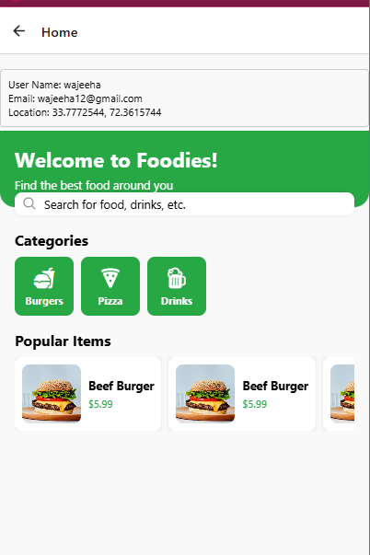

App.js:
import React from 'react';
import { NavigationContainer } from '@react-navigation/native';
import { createStackNavigator } from '@react-navigation/stack';
import { Provider } from 'react-redux';
import { createStore } from 'redux';
import rootReducer from './store/reducers'; // Import your root reducer

import RegistrationScreen from './screens/RegistrationScreen';
import LoginScreen from './screens/LoginScreen';
import HomeScreen from './screens/HomeScreen';

const Stack = createStackNavigator();

// Create Redux store
const store = createStore(rootReducer);

export default function App() {
return (
<Provider store={store}>
<NavigationContainer>
<Stack.Navigator initialRouteName="Registration">
<Stack.Screen name="Registration" component={RegistrationScreen} />
<Stack.Screen name="Login" component={LoginScreen} />
<Stack.Screen name="Home" component={HomeScreen} />
</Stack.Navigator>
</NavigationContainer>
</Provider>
);
}

FIREBASE OUTPUT:
