PUNJAB UNIVERSITY OF INFORMATION AND TECHNOLOGY
20-DECEMBER-2023



PROJECT REPORT

[CAMPUS MANAGEMENT SYSTEM]

SUBMITTED TO
PROF. ASIF SOHAIL
GROUP MEMBERS
AFIFA MASOOD (BSEF21M004)
ALSA MUNIR (BSEF21M030)
ASHFIA TANVEER(BSEF21M025)
WAJEEHA YASEEN (BSEF21M042)

I. Introduction
II. ERD OF THE SYSTEM
III. Top-DOWN/BOTTOM-UP APPROACH
IV. DESCRIPTION OF THE RELATIONS
V. CREATE TABLE STATEMENTS
VI. tWO VIEWS
VII. RELATIONAL DATA MODEL
VIII. FIVE COMMON REPORTS
IX. FUNCTIONS, PROCEDURES, TRIGGERS

- Introduction

A Campus Management System (CMS) is a complete software solution designed to streamline and automate various administrative and educational processes within educational institutions. This gadget is commonly used by universities, schools,and other educational corporations to manage a wide variety of activities effectively. The number one aim of a Campus Management System is to beautify the general effectiveness of academic and administrative operations.

Key Components and Features of a Campus Management System:

Student Information Management:
Enrollment and admissions management.
Student profiles with non-public information, instructional data, and attendance monitoring.
Class and phase undertaking.

Course Management:
Creation and management of courses and academic programs.
Management of route substances, syllabus, and educational sources.

Faculty Management:
Assignment of courses and training to instructors.
Faculty overall performance assessment.

Attendance and Timetable Management:
Tracking student attendance.
Generation and control of class timetables.

Examination and Grading System:
Exam scheduling and control.
Grading and result processing.
Generation of transcripts.

Finance and Fee Management:
Manage faculty and student accounts
Financial useful resource and scholarship control.

- ERD OF THE SYSTEM

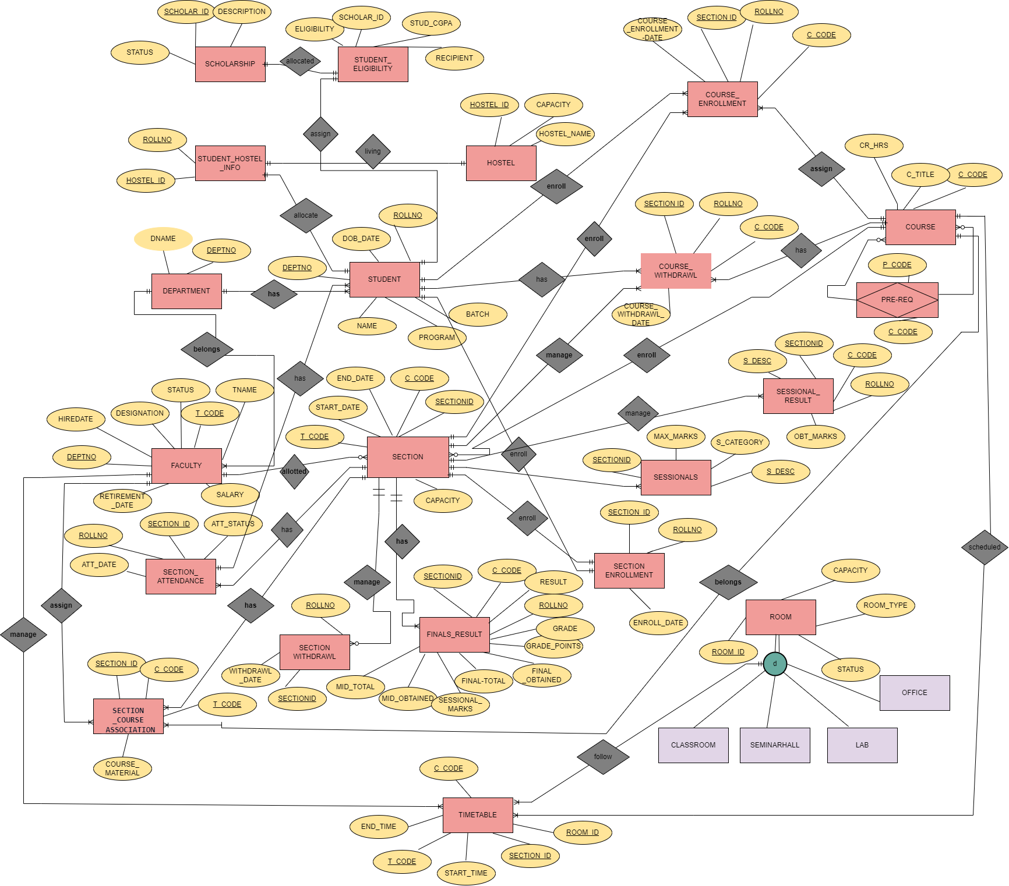

- BOTTOM-UP AND TOP DOWN

BOTTOM-UP APPROACH

Following is the relation to be normalized.

R (Rollno, Name, Prog, Batch,Dob, Deptno, Dname, T-Code, T-Name, Desig, T_Status, C-Code, C-Title, Crs-Hrs, P-Code, Sectionid, Semester, Enrollment-Date, Att-Date, Att Status, Sess-Des, Sess_Category, Max_Marks, Withdraw_Date, Grade, Grade_Pts, Room-Id, Room-Capacity, Room _Status, Roomtype, Start-Time, End-Time, Hiredate, Retirement-Date, Salary, Scho_id, Scho_Des, Scho_Criteria, Sch-Status, Eligibility, Hostel-Id, Name, Section_Start Date, Section_End Date, Sec-Capacity, Hostel-Capacity, Course-Withdrawl, Obt-Marks, Fin-Tot, Final Obt, Mid Tot,Mid-Obt, Sess-Marks, Course-Enrollment-Date)

1NF:
Normalizing the table using flattening approach.
R(Rollno, Name, Prog, Batch, Dob, Deptno, Dname, T-Code, T-Name, Desig, T_Status, C-Code, C-Title, Uhrs, P-Code, Sectionid, Semester, Enrollment-Date, Att-Date, Att Status, Sess-Des, Sess_Category, Max_Marks, Withdraw_Date, Grade, Grade_Pts, Room-Id, Room-Capacity, Room _Status, Roomtype, Start-Time, End-Time, Hiredate, Retirement-Date, Salary, Scho_id, Scho_Des, Scho_Criteria, Sch-Status, Eligibility, Hostel-Id, Name, Section_Start_Date, Section_End Date, Sec-Capacity, Hostel-Capacity, Course-Withdrawl, Obt-Marks, Fin-Tot, Final Obt, Mid Tot,Mid-Obt, Sess-Marks, Course-Enrollment-Date)

2NF:

The given relation is not in 2NF as it has partial dependency. In order to convert it into 2NF we will divide this relation into multiple relations.
Relation after conversion in 2NF
Student (Rollno, Name, Prog, Dob, Batch, Deptno (FK))
Department (Deptno, Dname)
Faculty (T-Code,T-Name, Ret_Date, Hiredate, Desig, Status, Salary, Deptno(FK))
Course (C-code, C-title, Crs-hours)
Prereq_course ( C-Code (FK), P-Code)
Section(Section-Id, Semester, Start-Date, End-Date, Sec-Capacity)
Section_course_association(Sectionid (FK), C-Code(FK), T-Code(FK), Course_material)
Section- Enrollment ( Section Id(FK), Rollno(FK), Enrollment-Date)
Course-enrollment(Sectionid(FK), Rollno(FK),C-Code(FK), Course-Enrollment-Date)
Room (Room-Id, Room-Capacity, Room Status, Room-Type)
Scholarship( Scho-Id, Scho-Des, Sch-Status)
Student_eligibility( Scho-Id(FK), Rollno(FK) , Eligibility, Student_cgpa)
Hostel( Hostel-Id, Name, Hostel-Capacity)
Student_Hostel_Info( Hostel-Id(FK), Rollno(FK))
Finals-Result (Rollno(FK), Sectionid(FK), C-Code(FK), Finaltot, Final-Obt, Midtotal,Mid-Obt, Sess-Marks, Grade, Grade_Points, Result)
Section-withdrawl ( Sectionid(FK), Rollno(FK), With_Drawl)
Course_Withdrawl(Sectionid (FK), Rollno(FK), C-Code(FK), Course_Withdrawl_Date)
Section-Attendance(Sectionid(FK), Rollno(FK), Att-Date, Att-Status)
Sessionals (Sectionid(FK), S-Desc, Sess_Category, Max_Marks)
Timetable (Roomid, Sectionid, C-Code, T-Code, Start_Time, Endtime)
Sessional- Result (Sectionid, S-Desc, C-Code, Rollno, Obt-Marks)

3NF:
As no transitive dependency exists in the table. So all the above tables are normalized.

TOP DOWN APPROACH

Students (Rollno, Deptno(FK), Name, DOB, Program, Batch)

- 1NF (remove multivalued attribute) This table is already in 1NF because there is no multivalued attribute in the table.

- 2NF(remove partial dependency) This table is already in 2NF because no partial dependency in this table. All non-key attributes are fully functional dependent on primary key.

- 3NF(remove transitive dependency) The table is already in 3NF because no transitive dependency exists in this table.

Final normalized form:
Students (Rollno, Name, DOB, Deptno(FK), Program, Batch)

Department (Deptno, Dname).

- 1NF (remove multivalued attribute) This table is already in 1NF because there is no multivalued attribute in table.

- 2NF(remove partial dependency) This table is already in 2NF because no partial dependency exists in table

- 3NF(remove transitive dependency) The table is already in 3NF because no transitive dependency exists in this table.

Final normalized form:
Department (Deptno, Dname).

Faculty (T_Code, Tname, Ret_date,Hire_date,Desig, Status,Salary, Deptno(FK))

- 1NF (remove multivalued attribute) This table is already in 1NF because there is no multivalued attribute in table.

- 2NF(remove partial dependency) This table is already in 2NF because no partial dependency exists in table

- 3NF(remove transitive dependency) The table is already in 3NF because no transitive dependency exists in this table.

Final normalized form:
Faculty (T_Code, Tname, Ret_date,Hire_date,Desig, Status,Salary,Deptno(FK))

(4)
Course (C_Code,C_Title, Crs_Hours)

- 1NF (remove multivalued attribute) This table is already in 1NF because there is no multivalued attribute in table.

- 2NF(remove partial dependency) This table is already in 2NF because no partial dependency exists in table

- 3NF(remove transitive dependency) This table is already in 3NF because no transitive dependency exists in table

Final normalized form:
Course (C_Code,C_Title,Crs_hours)

5)
Prereq_crs (C_code(FK), P_code)

- 1NF (remove multivalued attribute) This table is already in 1NF because there is no multivalued attribute in table.

- 2NF(remove partial dependency) This table is already in 2NF because no partial dependency exists in table

- 3NF(remove transitive dependency) The table is already in 3NF because no transitive dependency exists in this table.

Final normalized form:
Prereq_crs (C_code(FK), P_code)

6)
Section (Sec_id, Start_date, End_date, Capacity, T-Code , C_ Code, Semester)

- 1NF (remove multivalued attribute) This table is not in 1NF because it contains multivalued attributes.

T_Code and C_code are the multivalued attributes.

Section(Sec_id, Start_date, End_date, Capacity ,Semester)
Section_course_association(Sec_id(FK), C_ Code(FK), T-Code(FK), Course_material)

- 2NF(remove partial dependency) This table is already in 2NF because no partial dependency exists in table

- 3NF(remove transitive dependency) The table is already in 3NF because no transitive dependency exists in this table.

Final normalized form:
Section(Sec_id, Start_date, End_date, Capacity ,Semester)
Section_course_association(Sec_id(FK), C_ Code(FK) , T-Code(FK), Course_material)

7)

Section_enrollment (Sec_Id(FK), Rollno(FK), Enroll_ Date)

- 1NF (remove multivalued attribute) This table is already in 1NF because there is no multivalued attribute in table.

- 2NF(remove partial dependency) This table is already in 2NF because no partial dependency exists in table

- 3NF(remove transitive dependency) The table is already in 3NF because no transitive dependency exists in this table.

Final normalized form:
Section_enrollment (Sec_Id(FK), Rollno(FK), Enroll_ Date)

8)
Course_Enrollment(Sectionid(FK),Rollno(FK),C_Code(FK),Course_Enroll_Date)

- 1NF (remove multivalued attribute) This table is already in 1NF because there is no multivalued attribute in table.

- 2NF(remove partial dependency) This table is already in 2NF because no partial dependency exists in table

- 3NF(remove transitive dependency) The table is already in 3NF because no transitive dependency exists in this table.

Final normalized form:
Course_Enrollment(Sectionid(FK),Rollno(FK),C_Code(FK),Course_Enroll_Date)

9)
Section_attendance (Secid(FK), Rollno(FK), Att_Date(FK), Att_Status)

- 1NF (remove multivalued attribute) This table is in 1NF because it contains no multivalued attributes.

- 2NF(remove partial dependency) This table is already in 2NF because no partial dependency exists in table

- 3NF(remove transitive dependency) The table is already in 3NF because no transitive dependency exists in this table.

Final normalized form:
Section_attendance (Secid(FK), Rollno(FK), Att_Date(FK), Att_Status)

10)
Sessionals (Secld(FK), S-Desc(FK), S-Category,Max Marks)

- 1NF (remove multivalued attribute) This table is already in 1NF because there is no multivalued attribute in table.

- 2NF(remove partial dependency) This table is already in 2NF because no partial dependency exists in table

- 3NF(remove transitive dependency) The table is already in 3NF because no transitive dependency exists in this table.

Final normalized form:
Sessionals (Secld(FK), S_Desc(FK), S-Category,Max Marks)

11)
Section_Withdrawl (Sec_Id(FK), Rollno(FK), Withdrawl_Date)

- 1NF (remove multivalued attribute) This table is already in 1NF because there is no multivalued attribute in table.

- 2NF(remove partial dependency) This table is already in 2NF because no partial dependency exists in table

- 3NF(remove transitive dependency) The table is already in 3NF because no transitive dependency exists in this table.

Final normalized form:
Section_Withdrawl (Sec_Id(FK), Rollno(FK), Withdrawl_Date)

12)
Course_withdrawl(Sectionid(FK),Rollno(FK),C_Code(FK),Course_Withdrawl_Date)

- 1NF (remove multivalued attribute) This table is already in 1NF because there is no multivalued attribute in table.

- 2NF(remove partial dependency) This table is already in 2NF because no partial dependency exists in table

- 3NF(remove transitive dependency) The table is already in 3NF because no transitive dependency exists in this table.

Final normalized form:
Course_withdrawl(Sectionid(FK),Rollno(FK),C_Code(FK),Course_Withdrawl_Date)

13)
Room (Room-Id, Capacity, Status, Room_Type)

- 1NF (remove multivalued attribute) This table is already in 1NF because there is no multivalued attribute in table.

- 2NF(remove partial dependency) This table is already in 2NF because no partial dependency exists in table

- 3NF(remove transitive dependency) The table is already in 3NF because no transitive dependency exists in this table.

Final normalized form:
Room (Room-Id, Capacity, Status, Room_Type)

14)
Timetable(Roomid(FK), Secld(FK), C-Code(FK), Tcode(FK), Start_Time, End_Time)

- 1NF (remove multivalued attribute) This table is already in 1NF because there is no multivalued attribute in table.

- 2NF(remove partial dependency) This table is already in 2NF because no partial dependency exists in table

- 3NF(remove transitive dependency) The table is already in 3NF because no transitive dependency exists in this table.

Final normalized form:
Timetable(Roomid(FK), Secld(FK), C-Code(FK), Tcode(FK) , Start_Time, End_Time)

15)
Scholarship (Scholarship-Id, Recipient (FK), Desc, Status, Eligibility)

- 1NF (remove multivalued attribute) This table is already in 1NF because there is no multivalued attribute in table.

- 2NF(remove partial dependency) This table is not in 2NF because it has partial dependency.

Scholarship(scholarship-id, status, desc)
Student_Eligibility (Scholarship-id(FK), recipient(FK),Student_cgpa ,eligibility)

- 3NF(remove transitive dependency) The table is already in 3NF because no transitive dependency exists in this table.

Final normalized form:
Scholarship(scholarship-id, status, desc)
Student_Eligibility (Scholarship-id(FK), recipient(FK), Student_cgpa, Eligibility)

16)
Hostel (H_Id, Rollno(FK), H_Name, Capacity)

- 1NF (remove multivalued attribute) This table is already in 1NF because there is no multivalued attribute in table.

- 2NF(remove partial dependency) This table is not in 2NF because partial dependency exists in table.

HOSTEL (h_id, rollno)
HOSTEL_Info(hid, hname, cap)

- 3NF(remove transitive dependency) The table is already in 3NF because no transitive dependency exists in this table.

Final normalized form:
Student_Hostel_Info(h_id, rollno(FK))
Hostel(hid, hname, cap)

17)
Sessionnal_Res (Secid(FK), S-Desc, C-Code, Rollno, Obt_Marks)

- 1NF (remove multivalued attribute) This table is already in 1NF because there is no multivalued attribute in table.

- 2NF(remove partial dependency) This table is already in 2NF because no partial dependency exists in table

- 3NF(remove transitive dependency) The table is already in 3NF because no transitive dependency exists in this table.

Final normalized form:
Sessional_Res (Secid, S-Desc, C-Code, Rollno, Obt_Marks)

18)
Finals_Result(Secid(FK), C-Code(FK), Rollno(FK), Mid-Tot, Mid-Obt, Fin-Tot, Fin-Obt, Sess_Marks, Grade, Grade_Points, Result)

- 1NF (remove multivalued attribute) This table is already in 1NF because there is no multivalued attribute in table.

- 2NF(remove partial dependency) This table is already in 2NF because no partial dependency exists in table

- 3NF(remove transitive dependency) The table is already in 3NF because no transitive dependency exists in this table.

Final normalized form:
Finals_Result(Secid(FK), C-Code(FK), Rollno(FK), Mid-Tot, Mid-Obt, Fin-Tot, Fin-Obt, Sess_Marks)

4. Description of the Relations

STUDENTS:

ATTRIBUTE | DATA TYPE | SIZE | CONSTRAINTS
ROLLNO | CHAR | 11 | PRIMARY KEY
NAME | VARCHAR2 | 25 | NOT NULL
PROGRAM | CHAR | 10
BATCH | CHAR | 20
DEPTNO | NUMBER | 3 | FOREIGN KEY (REFERENCES DEPARTMENT TABLE)
DOB | DATE |  | CAN BE GREATER THAN  01/01/2000

DEPARTMENT:

ATTRIBUTE | DATA TYPE | SIZE | CONSTRAINTS
DEPTNO | NUMBER | 3 | PRIMARY KEY
DNAME | VARCHAR2 | 25 | NOT NULL

FACULTY:

ATTRIBUTE | DATA TYPE | SIZE | CONSTRAINTS
T_CODE | CHAR | 4 | PRIMARY KEY
NAME | VARCHAR2 | 25 | NOT NULL
DESIGNATION | VARCHAR2 | 15
STATUS | CHAR | 10 | CAN BE REGULAR , VISITING
DEPTNO | NUMBER | 3 | FOREIGN KEY (REFERENCES DEPARTMENT TABLE)
HIREDATE | DATE |  | DEFAULT SYSDATE
RETIREMENT_DATE | DATE
SALARY | NUMBER |  | CAN BE GREATER THAN 0

COURSE:

ATTRIBUTE | DATA TYPE | SIZE | CONSTRAINTS
C_CODE | CHAR | 8 | PRIMARY KEY
C_TITLE | VARCHAR2 | 25 | NOT NULL
CR_HRS | NUMBER | 2 | CHECK IN 0.5,1,2,3,4

PRE_REQ COURSE:

ATTRIBUTE | DATA TYPE | SIZE | CONSTRAINTS
C_CODE | CHAR | 8 | PRIMARY KEY ,  FOREIGN KEY (REFERENCES COURSE)
P_CODE | CHAR | 8 | PRIMARY KEY

SECTION:

ATTRIBUTE | DATA TYPE | SIZE | CONSTRAINTS
SECTIONID | VARCHAR2 | 10 | PRIMARY KEY
START_DATE | DATE |  | DEFAULT SYSDATE
CAPACITY | NUMBER | 3 | GREATER THAN 0
END_DATE | DATE
SEMESTER | VARCHAR2 | 15 | NOT NULL

SECTION_COURSE_ASSOCIATION:

ATTRIBUTE | DATA TYPE | SIZE | CONSTRAINTS
SECTIONID | VARCHAR2 | 10 | PRIMARY KEY,  FOREIGN KEY ( REFERENCES SECTION TABLE )
C_CODE | CHAR | 8 | PRIMARY KEY ,  FOREIGN KEY (REFERENCES COURSE)
T_CODE | CHAR | 4 | PRIMARY KEY,  FOREIGN KEY ( REFERENCES FACULTY)
COURSE_MATERIAL | VARCHAR2 | 30

SECTION_ENROLLMENT:

ATTRIBUTE | DATA TYPE | SIZE | CONSTRAINTS
SECTIONID | VARCHAR2 | 10 | PRIMARY KEY,  FOREIGN KEY ( REFERENCES SECTION TABLE )
ROLLNO | CHAR | 11 | PRIMARY KEY,  FOREIGN KEY (  REFERENCES STUDENTS)
ENROLL_DATE | DATE |  | NOT NULL

SECTION_ATTENDENCE:

ATTRIBUTE | DATA TYPE | SIZE | CONSTRAINTS
SECTIONID | VARCHAR2 | 10 | PRIMARY KEY,  FOREIGN KEY ( REFERENCES SECTION TABLE )
ROLLNO | CHAR | 11 | PRIMARY KEY,  FOREIGN KEY (  REFERENCES STUDENTS)
ATT_DATE | DATE |  | PRIMARY KEY,  DEFAULT SYSDATE
ATT_STATUS | CHAR | 1 | DEFAULT ‘P’,  CAN BE IN ‘P’,’A’

SESSIONALS

ATTRIBUTE | DATA TYPE | SIZE | CONSTRAINTS
SECTIONID | VARCHAR2 | 10 | PRIMARY KEY,  FOREIGN KEY ( REFERENCES SECTION TABLE )
S_DESC | VARCHAR2 | 25 | PRIMARY KEY
S_CATEGORY | VARCHAR2 | 10 | NOT NULL
MAX_MARKS | NUMBER | 2 | NOT NULL

COURSE_ENROLLMENT

ATTRIBUTE | DATA TYPE | SIZE | CONSTRAINTS
SECTIONID | VARCHAR2 | 10 | PRIMARY KEY,  FOREIGN KEY ( REFERENCES SECTION TABLE)
ROLLNO | CHAR | 11 | PRIMARY KEY,  FOREIGN KEY (  REFERENCES STUDENTS)
COURSE_ENROLL_DATE | DATE |  | DEFAULT SYSDATE

SECTION_WITHDRAWL

ATTRIBUTE | DATA TYPE | SIZE | CONSTRAINTS
SECTIONID | VARCHAR2 | 10 | PRIMARY KEY,  FOREIGN KEY ( REFERENCES SECTION TABLE )
ROLLNO | CHAR | 11 | PRIMARY KEY,  FOREIGN KEY (  REFERENCES STUDENTS)
WITHDRAWL | DATE |  | DEFAULT SYSDATE

COURSE_WITHDRAWL

ATTRIBUTE | DATA TYPE | SIZE | CONSTRAINTS
SECTIONID | VARCHAR2 | 10 | PRIMARY KEY,  FOREIGN KEY ( REFERENCES SECTION TABLE )
ROLLNO | CHAR | 11 | PRIMARY KEY,  FOREIGN KEY (  REFERENCES STUDENTS)
WITHDRAWL | DATE |  | DEFAULT SYSDATE
C_CODE | CHAR | 8 | PRIMARY KEY,  FOREIGN KEY  (REFERENCES COURSE)

ROOM:

ATTRIBUTE | DATA TYPE | SIZE | CONSTRAINTS
ROOMID | NUMBER | 3 | PRIMARY KEY
CAPACITY | NUMBER | 4 | GREATER THAN OR EQUAL TO 1
STATUS | VARCHAR2 | 10 | CAN BE ‘AVAILABLE’,  ‘BLOCKED’
ROOM_TYPE | VARCHAR2 | 20 | CAN BE ‘LAB’,’OFFICE’,  ‘CLASSROOM’, ‘SEMINAR HALL’

TIMETABLE:

ATTRIBUTE | DATA TYPE | SIZE | CONSTRAINTS
ROOMID | NUMBER | 3 | PRIMARY KEY,  FOREIGN KEY (REFERENCES ROOM)
SECTIONID | VARCHAR2 | 10 | PRIMARY KEY,  FOREIGN KEY ( REFERENCES SECTION TABLE )
C_CODE | CHAR | 8 | PRIMARY KEY,  FOREIGN KEY  (REFERENCES COURSE)
T_CODE | CHAR | 4 | PRIMARY KEY,  FOREIGN KEY ( REFERENCES FACULTY)
START_TIME | NUMBER | (4,2)
END_TIME | NUMBER | (4,2)

SCHOLARSHIP

ATTRIBUTE | DATA TYPE | SIZE | CONSTRAINTS
SCHOLAR_ID | VARCHAR2 | 10 | PRIMARY KEY
DESCRIPTION | VARCHAR2 | 40 | NOT NULL
STATUS | VARCAH2 | 20 | CAN BE ‘AVAILABLE’,  ‘NOT AVAILABLE’

STUDENT_ELIGIBILTY

ATTRIBUTE | DATA TYPE | SIZE | CONSTRAINTS
SCHOLAR_ID | VARCHAR2 | 10 | PRIMARY KEY
RECEPITENT | CHAR | 11 | PRIMARY KEY,  FOREIGN KEY (  REFERENCES STUDENTS)
ELIGIBILITY | VARCHAR2 | 20 | CAN BE ‘ELIGIBLE’,  ‘NOT ELIGIBLE’
STUD_CGPA | NUMBER | (3,2) | GREATER THAN 0 AND LESS THAN EQUAL TO 4

HOSTEL

ATTRIBUTE | DATA TYPE | SIZE | CONSTRAINTS
HOSTEL_ID | NUMBER | 5 | PRIMARY KEY
HOSTEL_NAME | VARCHAR2 | 20 | NOT NULL
CAPACITY | NUMBER | 5 | GREATER THAN OR EQUAL TO 1

STUDENT_HOSTEL_INFO

ATTRIBUTE | DATA TYPE | SIZE | CONSTRAINTS
HOSTEL_ID | NUMBER | 5 | PRIMARY KEY,  FOREIGN KEY (REFERENCES HOSTEL)
ROLLNO | CHAR | 11 | PRIMARY KEY,  FOREIGN KEY (  REFERENCES STUDENTS)

SESSIONAL_RESULT

ATTRIBUTE | DATA TYPE | SIZE | CONSTRAINTS
SECTIONID | VARCHAR2 | 10 | PRIMARY KEY,  FOREIGN KEY ( REFERENCES SECTION TABLE )
S_DESC | VARCHAR2 | 25 | PRIMARY KEY,  FOREIGN KEY ( REFERENCES SECTION)
C_CODE | CHAR | 8 | PRIMARY KEY,  FOREIGN KEY  (REFERENCES COURSE)
ROLLNO | CHAR | 11 | PRIMARY KEY,  FOREIGN KEY (  REFERENCES STUDENTS)
OBT_MARKS | NUMBER | (4,2)

FINALS_ RESULT

ATTRIBUTE | DATA TYPE | SIZE | CONSTRAINTS
SECTIONID | VARCHAR2 | 10 | PRIMARY KEY,  FOREIGN KEY ( REFERENCES SECTION TABLE )
C_CODE | CHAR | 8 | PRIMARY KEY,  FOREIGN KEY  (REFERENCES COURSE)
ROLLNO | CHAR | 11 | PRIMARY KEY,  FOREIGN KEY (  REFERENCES STUDENTS)
MID_TOTAL | NUMBER | 3
MID_OBTAINED | NUMBER | (5,2)
FINAL_TOTAL | NUMBER | 3
FINAL_OBTAINED | NUMBER | (5,2)
SESSIONAL_MARKS | NUMBER | (5,2)
RESULT | NUMBER | 3
GRADE | CHAR | 2 | NOT NULL
GRADE_POINTS | NUMBER | (3,2) | NOT NULL

- Create table Statements

STUDENTS:
CREATE TABLE STUDENTS (
ROLLNO CHAR(11) CONSTRAINT ROLLNO_PK PRIMARY KEY,
NAME VARCHAR2(25) NOT NULL,
DOB DATE,
DEPTNO NUMBER(3),
PROGRAM CHAR(10),
BATCH CHAR(20),
CONSTRAINT DEPTNO_FK FOREIGN KEY(DEPTNO) REFERENCES DEPARTMENT(DEPTNO),
CONSTRAINT DOB_CK CHECK (DOB >= TO_DATE('2000-01-01', 'YYYY-MM-DD')));

DEPARTMENT:
CREATE TABLE DEPARTMENT (
DEPTNO NUMBER(3) CONSTRAINT DEPARTMENT_DEPTNO_PK PRIMARY KEY,
DNAME VARCHAR2(25) NOT NULL );

FACULTY:
CREATE TABLE FACULTY (
T_CODE CHAR(4) CONSTRAINT FC_T_CODE_PK PRIMARY KEY,
NAME VARCHAR2(25) NOT NULL,
DESIGNATION VARCHAR2(15),
STATUS CHAR(10),
DEPTNO NUMBER(3),
HIREDATE DATE DEFAULT SYSDATE,
RETIREMENT_DATE DATE,
SALARY NUMBER(8),
CONSTRAINT SAL_CK CHECK (SALARY > 0),
CONSTRAINT STATUS_CK CHECK (STATUS IN ('REGULAR', 'VISITING')),
CONSTRAINT FC_DEPTNO_FK FOREIGN KEY (DEPTNO) REFERENCES DEPARTMENT (DEPTNO));

COURSE
CREATE TABLE COURSE (
C_CODE CHAR(8) CONSTRAINT C_CODE_PK PRIMARY KEY,
C_TITLE VARCHAR2(25) NOT NULL ,
CR_HRS NUMBER(2),
CONSTRAINT CR_HRS_CK CHECK ( CR_HRS IN (0.5,1,2,3,4)) );

PRE_REQ_COURSE
CREATE TABLE PRE_REQ_COURSE (
C_CODE CHAR(8),
P_CODE CHAR(8),
CONSTRAINT COMP_PK PRIMARY KEY (C_CODE,P_CODE),
CONSTRAINT PRE_REQ_FK FOREIGN KEY (C_CODE) REFERENCES COURSE(C_CODE) );

SECTION
CREATE TABLE SECTION (
SECTIONID VARCHAR2(10),
START_DATE DATE DEFAULT SYSDATE,
CAPACITY NUMBER(3),
END_DATE DATE,
SEMESTER VARCHAR2(15) CONSTRAINT SEMESTER_NOT_VALID NOT NULL,
CONSTRAINT CAPACITY_CK CHECK ( CAPACITY > 0),
CONSTRAINT SECTION_PK PRIMARY KEY (SECTIONID));

SECTION-COURSE_ASSOCIATION
CREATE TABLE SECTION_COURSE_ASSOCIATION (
SECTIONID VARCHAR2(10),
C_CODE CHAR(8),
T_CODE CHAR(4),
COURSE_MATERIAL VARCHAR2 (30),
CONSTRAINT SECTION_CPK PRIMARY KEY(SECTIONID,C_CODE),
CONSTRAINT SECTION_FK1 FOREIGN KEY (C_CODE) REFERENCES COURSE (C_CODE),
CONSTRAINT SECTION_FK2 FOREIGN KEY (T_CODE) REFERENCES FACULTY (T_CODE) );

SECTION_ENROLLMENT
CREATE TABLE SECTION_ENROLLMENT (
SECTIONID VARCHAR2(10),
ROLLNO CHAR(11),
ENROLL_DATE DATE NOT NULL,
CONSTRAINT ENROLLMENT_PK PRIMARY KEY (SECTIONID,ROLLNO),
CONSTRAINT ENROLLMENT_FK1 FOREIGN KEY (SECTIONID) REFERENCES SECTION (SECTIONID),
CONSTRAINT ENROLLMENT_FK2 FOREIGN KEY (ROLLNO) REFERENCES STUDENTS (ROLLNO) );

COURSE_ENROLLMENT
CREATE TABLE COURSE_ENROLLMENT (
SECTIONID VARCHAR2(10),
ROLLNO CHAR(11),
C_CODE CHAR(8),
COURSE_ENROLL_DATE DATE DEFAULT SYDATE,
CONSTRAINT CR_ENROLLMENT_PK PRIMARY KEY (SECTIONID,ROLLNO,C_CODE),
CONSTRAINT CR_ENROLLMENT_FK1 FOREIGN KEY (SECTIONID) REFERENCES SECTION (SECTIONID),
CONSTRAINT CR_ENROLLMENT_FK2 FOREIGN KEY (ROLLNO) REFERENCES STUDENTS (ROLLNO),
CONSTRAINT CR_SECTION_FK1 FOREIGN KEY (C_CODE) REFERENCES COURSE (C_CODE));

SECTION_ATTENDENCE
CREATE TABLE SECTION_ATTENDANCE (
SECTIONID VARCHAR2(10),
ROLLNO CHAR(11),
ATT_DATE DATE DEFAULT SYSDATE,
ATT_STATUS CHAR(1) DEFAULT 'P' CONSTRAINT INVALID_ATTENDANCE CHECK (ATT_STATUS IN ('P', 'A')),
CONSTRAINT ATTENDANCE_PK PRIMARY KEY (SECTIONID, ROLLNO, ATT_DATE),
CONSTRAINT ATTENDANCE_FK1 FOREIGN KEY (SECTIONID) REFERENCES SECTION (SECTIONID),
CONSTRAINT ATTENDANCE_FK2 FOREIGN KEY (ROLLNO) REFERENCES STUDENTS (ROLLNO) );

SESSIONALS
CREATE TABLE SESSIONALS (
SECTIONID VARCHAR2(10),
S_DESC VARCHAR2(25),
S_CATEGORY VARCHAR2(10) CONSTRAINT NULL_CATEGORY_ENTERED NOT NULL,
MAX_MARKS NUMBER(2) CONSTRAINT NO_MARKS_ENTERED NOT NULL,
CONSTRAINT SESSIONALS_PK PRIMARY KEY(SECTIONID , S_DESC),
CONSTRAINT SESSIONALS_FK FOREIGN KEY(SECTIONID) REFERENCES SECTION(SECTIONID) );

SECTION_WITHDRAWL
CREATE TABLE SECTION_WITHDRAWL (
SECTIONID VARCHAR2(10),
ROLLNO CHAR(11),
WITHDRAWL DATE DEFAULT SYSDATE,
CONSTRAINT SECTIONWD_PK PRIMARY KEY (SECTIONID, ROLLNO),
CONSTRAINT SECTIONWD_FK1 FOREIGN KEY (SECTIONID) REFERENCES SECTION (SECTIONID),
CONSTRAINT SECTIONWD_FK2 FOREIGN KEY (ROLLNO) REFERENCES STUDENTS (ROLLNO) );

COURSE WITHDRAWL
CREATE TABLE COURSE_WITHDRAWL (
SECTIONID VARCHAR2(10),
ROLLNO CHAR(11),
C_CODE CHAR(8),
COURSE_WITHDRAWL DATE,
CONSTRAINT COURSEWD_PK PRIMARY KEY (SECTIONID, ROLLNO,C_CODE),
CONSTRAINT COURESWD_FK1 FOREIGN KEY (SECTIONID) REFERENCES SECTION (SECTIONID),
CONSTRAINT COURSEWD_FK2 FOREIGN KEY (C_CODE) REFERENCES COURSE (C_CODE),
CONSTRAINT COURSEWD_FK3 FOREIGN KEY (ROLLNO) REFERENCES STUDENTS (ROLLNO));

ROOM
CREATE TABLE ROOM (
ROOM_ID NUMBER(3) CONSTRAINT ROMM_ID_PK PRIMARY KEY,
CAPACITY NUMBER(4) CONSTRAINT INVALID_CAPACITY_INPUT CHECK (CAPACITY >= 1),
STATUS VARCHAR2(10) CONSTRAINT ROOM_STATUS_CK CHECK (STATUS IN ('AVAILABLE','BLOCKED')),
ROOM_TYPE VARCHAR2(20) CONSTRAINT ROOM_TYPE_CK CHECK (ROOM_TYPE IN ('CLASSROOM','OFFICE','SEMINAR HALL','LAB')) );

TIMETABLE
CREATE TABLE TIMETABLE (
ROOM_ID NUMBER(3),
SECTIONID VARCHAR2(10),
C_CODE CHAR(8),
T_CODE CHAR(4),
START_TIME NUMBER(4,2),
END_TIME NUMBER(4,2),
CONSTRAINT TIMETABLE_PK PRIMARY KEY (ROOM_ID, SECTIONID, C_CODE, T_CODE),
CONSTRAINT TIMETABLE_FK1 FOREIGN KEY (SECTIONID) REFERENCES SECTION (SECTIONID),
CONSTRAINT TIMETABLE_FK2 FOREIGN KEY (ROOM_ID) REFERENCES ROOM (ROOM_ID),
CONSTRAINT TIMETABLE_FK3 FOREIGN KEY (C_CODE) REFERENCES COURSE (C_CODE),
CONSTRAINT TIMETABLE_FK4 FOREIGN KEY (T_CODE) REFERENCES FACULTY (T_CODE) );

SCHOLARSHIP
CREATE TABLE SCHOLARSHIP (
SCHOLAR_ID VARCHAR2(10),
DESCRIPTION VARCHAR2(40) NOT NULL,
STATUS VARCHAR2(20),
CONSTRAINT SCH_PK PRIMARY KEY (SCHOLAR_ID),
CONSTRAINT SCH_STATUS_CK CHECK (STATUS IN ('AVAILABLE','NOT AVAILABLE')));

STUDENT_ELIGIBILTY
CREATE TABLE STUDENT_ELIGIBILITY (
SCHOLAR_ID VARCHAR2(10),
RECIPIENT CHAR(11),
STUD_CGPA NUMBER(3,2),
ELIGIBILITY VARCHAR2(20),
CONSTRAINT STU_ELG_PK PRIMARY KEY (SCHOLAR_ID, RECIPIENT),
CONSTRAINT SCH_FK1 FOREIGN KEY (SCHOLAR_ID) REFERENCES SCHOLARSHIP (SCHOLAR_ID),
CONSTRAINT SCH_FK2 FOREIGN KEY (RECIPIENT) REFERENCES STUDENTS (ROLLNO),
CONSTRAINT CRITERIA_CK CHECK (STUD_CGPA > 0 AND STUD_CGPA <= 4),
CONSTRAINT ELIGIBILITY_CK CHECK (ELIGIBILITY IN ('ELIGIBLE', 'NOT ELIGIBLE')));

HOSTEL
CREATE TABLE HOSTEL (
HOSTEL_ID NUMBER(5),
HOSTEL_NAME VARCHAR2(20) NOT NULL,
CAPACITY NUMBER(5),
CONSTRAINT HOSTEL_PK PRIMARY KEY (HOSTEL_ID),
CONSTRAINT CAPACITY_CK CHECK (CAPACITY >= 1) );

STUDENT_HOSTEL_INFO
CREATE TABLE STU_HOSTEL_INFO (
HOSTEL_ID NUMBER(5),
ROLLNO CHAR(11),
CONSTRAINT STD_HOSTEL_PK PRIMARY KEY (HOSTEL_ID, ROLLNO),
CONSTRAINT STD_HOSTEL_FK1 FOREIGN KEY (HOSTEL_ID) REFERENCES HOSTEL (HOSTEL_ID),
CONSTRAINT TD_HOSTEL_FK2 FOREIGN KEY (ROLLNO) REFERENCES STUDENTS (ROLLNO) );

SESSIONAL_RESULT
CREATE TABLE SESSIONAL_RESULT (
SECTIONID VARCHAR2(10),
S_DESC VARCHAR2(15),
C_CODE CHAR(8),
ROLLNO CHAR(11),
OBT_MARKS NUMBER(4,2),
CONSTRAINT SESSIONALRES_PK PRIMARY KEY(SECTIONID,S_DESC,C_CODE,ROLLNO),
CONSTRAINT SESSIONAL_FK1 FOREIGN KEY (SECTIONID, S_DESC) REFERENCES SESSIONALS(SECTIONID,S_DESC),
CONSTRAINT SESSIONAL_FK2 FOREIGN KEY (C_CODE) REFERENCES COURSE (C_CODE),
CONSTRAINT SESSIONAL_FK3 FOREIGN KEY (ROLLNO) REFERENCES STUDENTS (ROLLNO) );

FINALS_RESULT
CREATE TABLE FINALS_RESULT (
SECTIONID VARCHAR2(10),
C_CODE CHAR(8),
ROLLNO CHAR(11),
MID_TOTAL NUMBER(3),
MID_OBTAINED NUMBER(5,2),
FINAL_TOTAL NUMBER(3),
FINAL_OBTAINED NUMBER(5,2),
SESSIONAL_MARKS NUMBER(5,2),
RESULT NUMBER(3),
GRADE CHAR(2) NOT NULL,
GRADE_POINTS NUMBER (3,2) NOT NULL,
CONSTRAINT FINALS_RESULT_PK PRIMARY KEY (SECTIONID,C_CODE,ROLLNO),
CONSTRAINT FINALS_RESULT_FK1 FOREIGN KEY (SECTIONID) REFERENCES SECTION (SECTIONID),
CONSTRAINT FINALS_RESULT_FK2 FOREIGN KEY (C_CODE) REFERENCES COURSE (C_CODE),
CONSTRAINT RESULT_CK CHECK ( RESULT > 0 ),
CONSTRAINT FINALS_RESULT_FK3 FOREIGN KEY (ROLLNO) REFERENCES STUDENTS(ROLLNO) );

- VIEWS

STUDENT COURSE ENROLLMENT VIEW:

CREATE VIEW StudentCourseEnrollment AS
SELECT SE.SECTIONID, SE.ROLLNO, S.NAME AS STUDENT_NAME, C.C_CODE, CO.C_TITLE AS COURSE_TITLE
FROM SECTION_ENROLLMENT SE
JOIN STUDENTS S ON SE.ROLLNO = S.ROLLNO
JOIN COURSE_ENROLLMENT CE ON SE.SECTIONID = CE.SECTIONID AND SE.ROLLNO = CE.ROLLNO
JOIN COURSE C ON CE.C_CODE = C.C_CODE
JOIN COURSE CO ON C.C_CODE = CO.C_CODE;

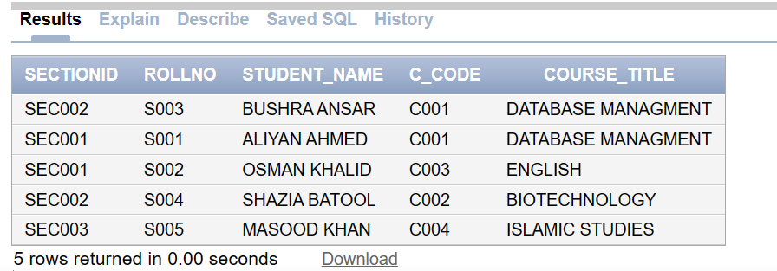

FACULTY TIMETABLE

CREATE VIEW FacultyTimetable AS
SELECT TT.ROOM_ID, TT.SECTIONID, TT.C_CODE, TT.T_CODE, F.NAME AS FACULTY_NAME, R.STATUS AS ROOM_STATUS, R.ROOM_TYPE,
TT.START_TIME, TT.END_TIME
FROM TIMETABLE TT
JOIN FACULTY F ON TT.T_CODE = F.T_CODE
JOIN ROOM R ON TT.ROOM_ID = R.ROOM_ID;

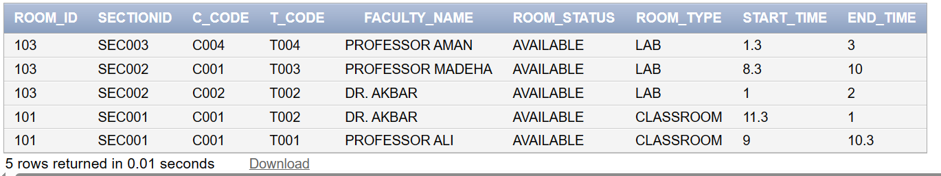

- RELATIONAL SCHEMA

DEPARTMENT
DEPTNO | DNAME

STUDENT
ROLLNO | NAME | DOB_DATE | DEPTNO | PROGRAM | BATCH

HOSTEL
HOSTEL_ID | HOSTEL_NAME | CAPACITY

SCHOLARSHIP
SCHOLAR_ID | DESCRIPTION | STATUS

FACULTY
T_CODE | DEPTNO | DESIGNATION | STATUS | TNAME
 |  | RETIREMENT_DATE | HIREDATE | SALARY

TIMETABLE
ROOM_ID | SECTIONID | C_CODE | T_CODE | START_TIME | END_TIME

COURSE
C_CODE | C-TITLE | CR_HRS

PRE_REQ_COURSE
C-CODE | P_CODE

SECTION
SECTIONID | C_CODE | SEMESTER | T-CODE | START_DATE | END_DATE

SECTION_ENROLLMENT
SECTIONID | ROLLNO | ENROLL_DATE

SECTION_ATTENDANCE
SECTIONID | ROLLNO | ATT_DATE | ATT_STATUS

SESSIONALS
SECTIONID | S_DESC | S_CATEGORY | MAX_MARKS

SECTION_WITHDRAWL
SECTIONID | ROLLNO | WITHDRAWL_DATE | C_CODE

SESSIONAL_RESULT
SECTIONID | S_DESC | C_CODE | ROLLNO | OBT_MARKS

FINALS_RESULT
SECTIONID | C_CODE | ROLLNO | MID_TOTAL | MID_OBTAINED | FINAL_TOTAL | FINAL_OBTAINED | SESSIONAL_MARKS
 |  |  |  |  | RESULT | GRADE | GRADE_POINTS

ROOM
ROOM_ID | CAPACITY | STATUS | CLASSROOM | OFFICE | SEMINARHALL | LAB

COURSE_ENROLLMENT
SECTIONID | ROLLNO | C_CODE | COURSE_ENROLL_DATE

SECTION-COURSE_ASSOCIATION
SECTIONID | T_CODE | C_CODE | COURSE_MATERIAL

COURSE_WITHDRAWL
SECTIONID | ROLLNO | C_CODE | COURSE_WITHDRAWL  _DATE

STUDENT_ELIGIBILITY
SCHOLAR_ID | STUD_CGPA | RECIPIENT | ELIGIBILITY

STUDENT_HOSTEL_INFO
ROLLNO | HOSTEL_ID

8. REPORTS

STUDENT_ENROLLMENT_REPORT:
SELECT C.C_CODE, CO.C_TITLE AS COURSE_TITLE, COUNT(DISTINCT SE.ROLLNO) AS ENROLLED_STUDENTS
FROM COURSE C
JOIN COURSE_ENROLLMENT CE ON C.C_CODE = CE.C_CODE
JOIN SECTION_ENROLLMENT SE ON CE.SECTIONID = SE.SECTIONID
JOIN COURSE CO ON C.C_CODE = CO.C_CODE
GROUP BY C.C_CODE, CO.C_TITLE;

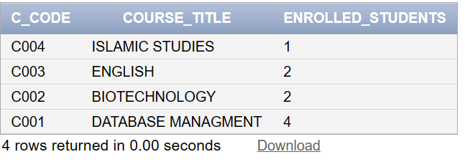

FACULTY ASSIGNED COURSES REPORT
SELECT F.T_CODE, F.NAME AS FACULTY_NAME, COUNT(DISTINCT C.C_CODE) AS ASSIGNED_COURSES
FROM FACULTY F
JOIN TIMETABLE TT ON F.T_CODE = TT.T_CODE
JOIN COURSE C ON TT.C_CODE = C.C_CODE
GROUP BY F.T_CODE, F.NAME;

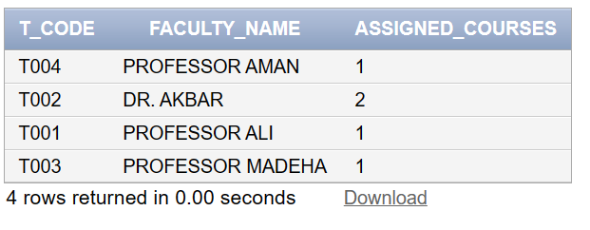

ROOM OCCUPANCY REPORT
SELECT R.ROOM_ID, R.STATUS, R.ROOM_TYPE, COUNT(TT.SECTIONID) AS OCCUPIED_SECTIONS
FROM ROOM R
LEFT JOIN TIMETABLE TT ON R.ROOM_ID = TT.ROOM_ID
GROUP BY R.ROOM_ID, R.STATUS, R.ROOM_TYPE;
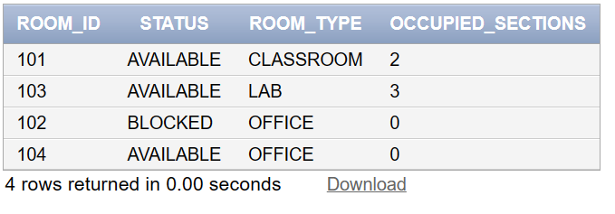

STUDENT SCHOLARSHIP REPORT
SELECT SE.SCHOLAR_ID, S.NAME AS STUDENT_NAME, SE.STUD_CGPA, SC.DESCRIPTION, SE.ELIGIBILITY
FROM STUDENT_ELIGIBILITY SE
JOIN SCHOLARSHIP SC ON SE.SCHOLAR_ID = SC.SCHOLAR_ID
JOIN STUDENTS S ON SE.RECIPIENT = S.ROLLNO;
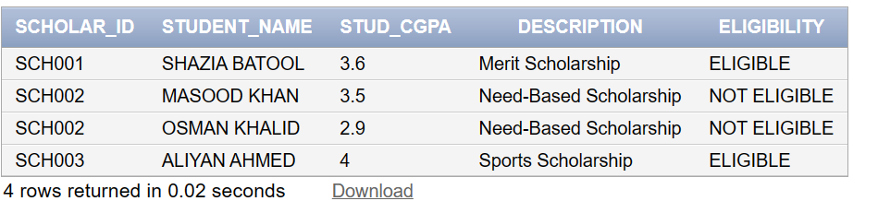

STUDENT_TRANSCRIPT
SELECT S.NAME AS STUDENT_NAME, CO.C_TITLE AS COURSE_TITLE, F.final_obtained, F.mid_obtained, F.sessional_marks,F.RESULT, F.GRADE, F.GRADE_POINTS
FROM FINALS_RESULT F
JOIN SECTION_ENROLLMENT SE ON F.SECTIONID = SE.SECTIONID AND F.ROLLNO = SE.ROLLNO
JOIN STUDENTS S ON SE.ROLLNO = S.ROLLNO
JOIN COURSE C ON F.C_CODE = C.C_CODE
JOIN COURSE CO ON C.C_CODE = CO.C_CODE

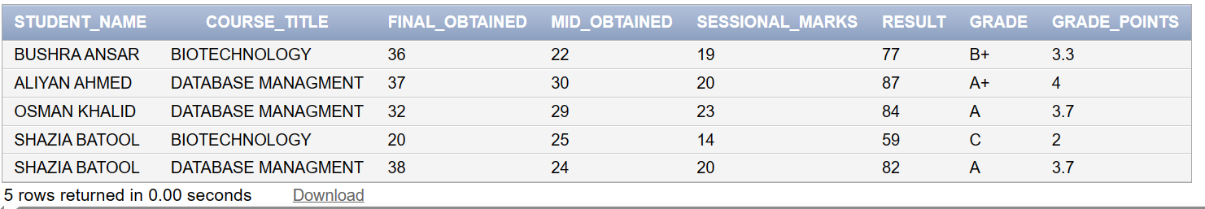

- TRIGGERS

CREATE OR REPLACE TRIGGER SCHOLARSHIP_TRIGGER
BEFORE INSERT OR UPDATE ON STUDENT_ELIGIBILITY
FOR EACH ROW
BEGIN
IF :NEW.STUD_CGPA > 3.5 THEN
:NEW.ELIGIBILITY := 'ELIGIBLE';
ELSE
:NEW.ELIGIBILITY := 'NOT ELIGIBLE';
END IF;
END;

2:
CREATE OR REPLACE TRIGGER CALCULATE_RESULT
BEFORE INSERT OR UPDATE ON FINALS_RESULT
FOR EACH ROW
DECLARE
total_obtained NUMBER(5, 2);
BEGIN
total_obtained := :NEW.SESSIONAL_MARKS + :NEW.MID_OBTAINED + :NEW.FINAL_OBTAINED;

:NEW.RESULT := total_obtained;

IF total_obtained >= 85 THEN
:NEW.GRADE := 'A+';
:NEW.GRADE_POINTS := 4.00;
ELSIF total_obtained >= 80 THEN
:NEW.GRADE := 'A';
:NEW.GRADE_POINTS := 3.70;
ELSIF total_obtained >= 75 THEN
:NEW.GRADE := 'B+';
:NEW.GRADE_POINTS := 3.30;
ELSIF total_obtained >= 70 THEN
:NEW.GRADE := 'B';
:NEW.GRADE_POINTS := 3.00;
ELSIF total_obtained >= 65 THEN
:NEW.GRADE := 'B-';
:NEW.GRADE_POINTS := 2.70;
ELSIF total_obtained >= 61 THEN
:NEW.GRADE := 'C+';
:NEW.GRADE_POINTS := 2.30;
ELSIF total_obtained >= 58 THEN
:NEW.GRADE := 'C';
:NEW.GRADE_POINTS := 2.00;
ELSIF total_obtained >= 58 THEN
:NEW.GRADE := 'C-';
:NEW.GRADE_POINTS := 1.70;
ELSIF total_obtained >= 50 THEN
:NEW.GRADE := 'D';
:NEW.GRADE_POINTS := 1.00;
ELSE
:NEW.GRADE := 'F';
:NEW.GRADE_POINTS := 0.00;
END IF;
END;

FUNCTIONS:
1)
CREATE OR REPLACE FUNCTION get_student_details(student_roll char) RETURN VARCHAR2 IS
student_details VARCHAR2(500);
BEGIN
SELECT RollNo || ', ' || Name || ', ' || Program || ', ' || Batch || ', ' || Dob || ', ' || DeptNo
INTO student_details
FROM Students
WHERE RollNo = student_roll;

RETURN student_details;
EXCEPTION
WHEN NO_DATA_FOUND THEN
RETURN 'Student not found';
END
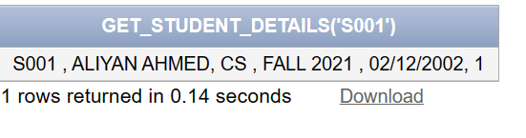

2)
CREATE OR REPLACE FUNCTION get_total_enrolled_students(
p_section_id VARCHAR2
) RETURN NUMBER
AS
v_total_students NUMBER;
BEGIN
SELECT COUNT(*)
INTO v_total_students
FROM SECTION_ENROLLMENT
WHERE SECTIONID = p_section_id;

RETURN v_total_students;
EXCEPTION
WHEN NO_DATA_FOUND THEN
RETURN 0;

END get_total_enrolled_students;

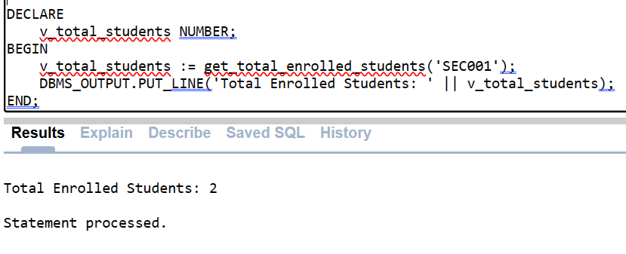

PROCEDURES:
1)
CREATE OR REPLACE PROCEDURE enroll_student(
p_section_id VARCHAR2,
p_rollno CHAR,
p_enroll_date DATE
) AS
BEGIN
INSERT INTO SECTION_ENROLLMENT (SECTIONID, ROLLNO, ENROLL_DATE)
VALUES (p_section_id, p_rollno, p_enroll_date);

COMMIT;
DBMS_OUTPUT.PUT_LINE('Student enrolled successfully.');

END enroll_student;
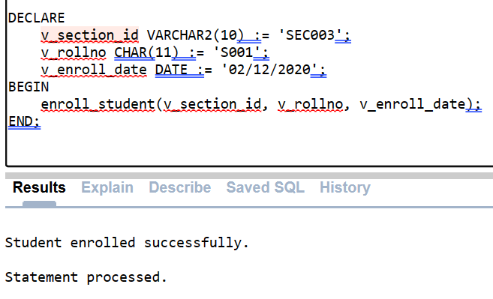

2)

CREATE OR REPLACE PROCEDURE update_withdrawal_date(
section_id VARCHAR2,
student_roll CHAR,
withdrawal_date DATE
) AS
BEGIN
UPDATE SECTION_WITHDRAWL
SET withdrawl = withdrawal_date
WHERE rollno = student_roll AND sectionid = section_id;

COMMIT;
END update_withdrawal_date;

