Wajeeha Yaseen
BSEF21M042

Online Bus Ticket Booking System

Description:
I developed an online bus ticket booking system(Fakhar Transport) where users can browse buses, select seats, and book tickets across predefined routes such as Multan to Lahore, Sialkot to Lahore, Lahore to Multan, Rahim Yar Khan to Karachi, Multan to Rahim Yar Khan, and Islamabad to Lahore. The project implements clean architecture, SignalR for real-time seat updates, and RESTful services for efficient data handling ,AJAX for partially refreshing pages. I integrated authentication and authorization, allowing only users from Pakistan to book tickets. Passengers can add information, select a bus, and choose seats, with availability updated in real-time. The system also supports asynchronous operations and is optimized with memory caching for improved performance.

Github Link:

https://github.com/pupucit/se21-scd-project-wajeehacom

Home Page:

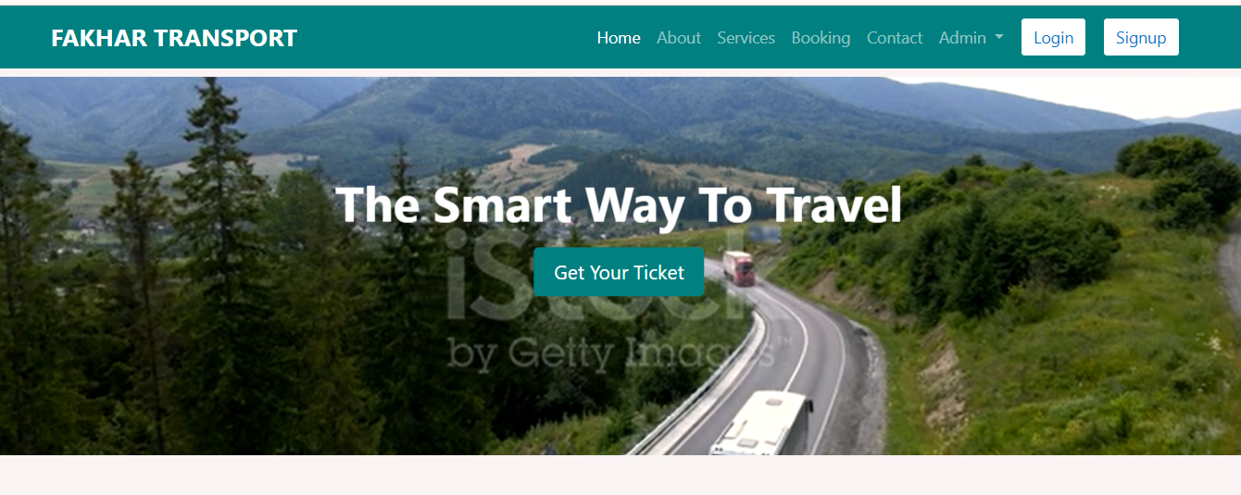
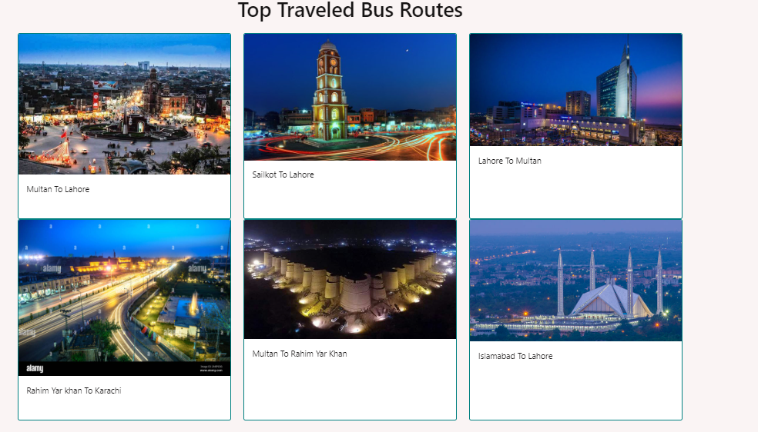
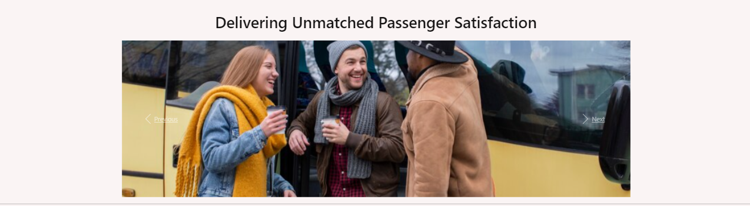
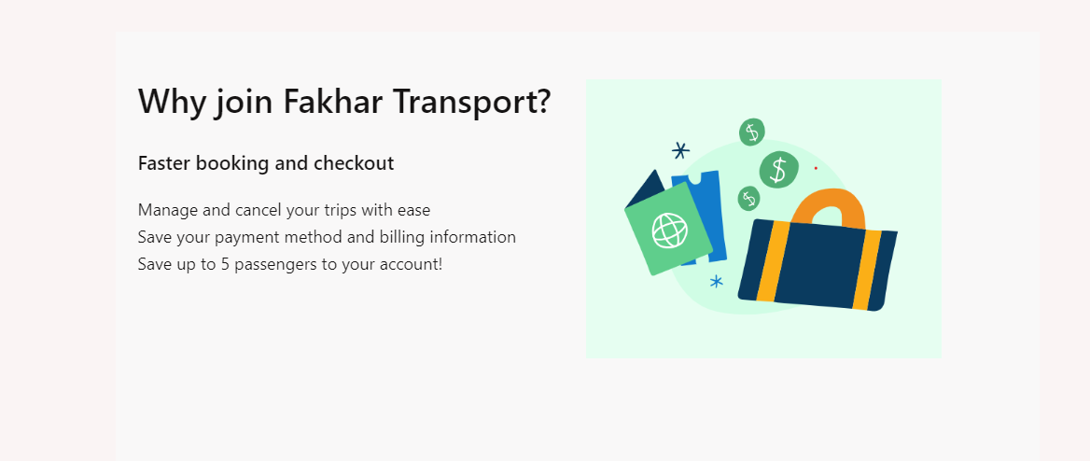
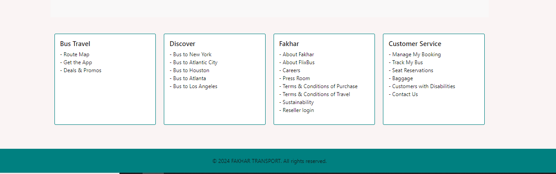

About Page:

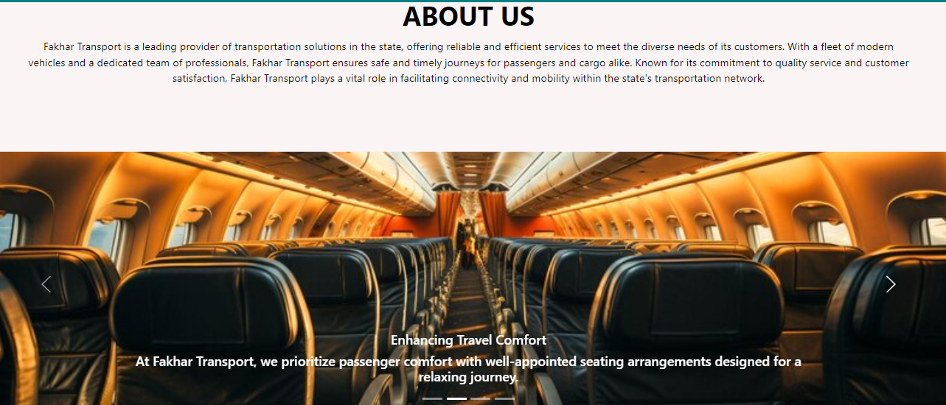

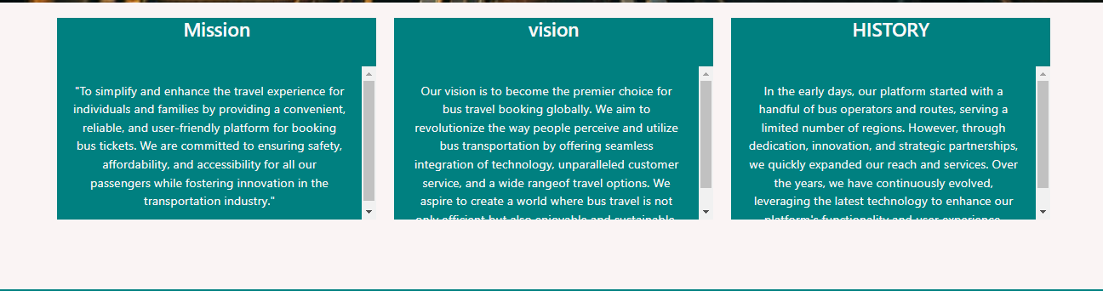

Services:

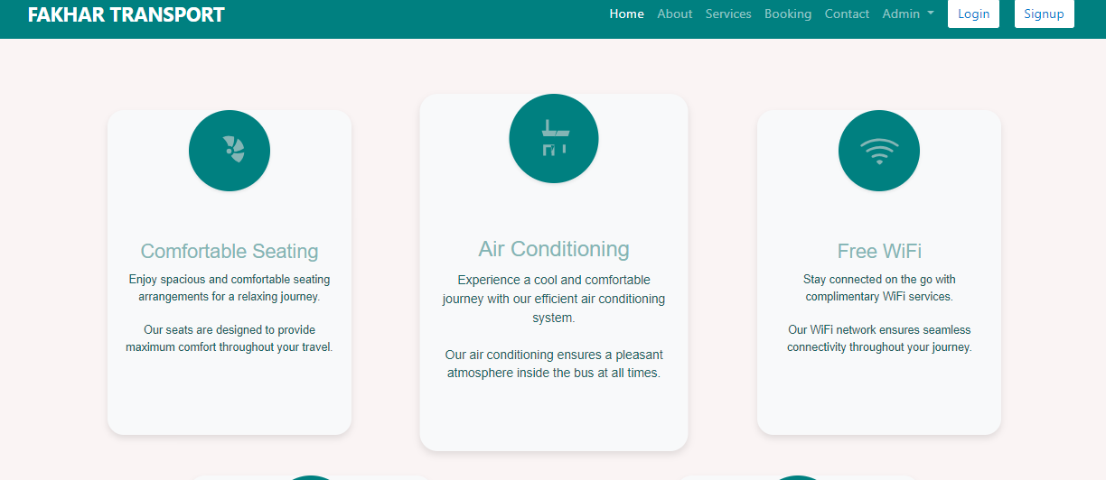

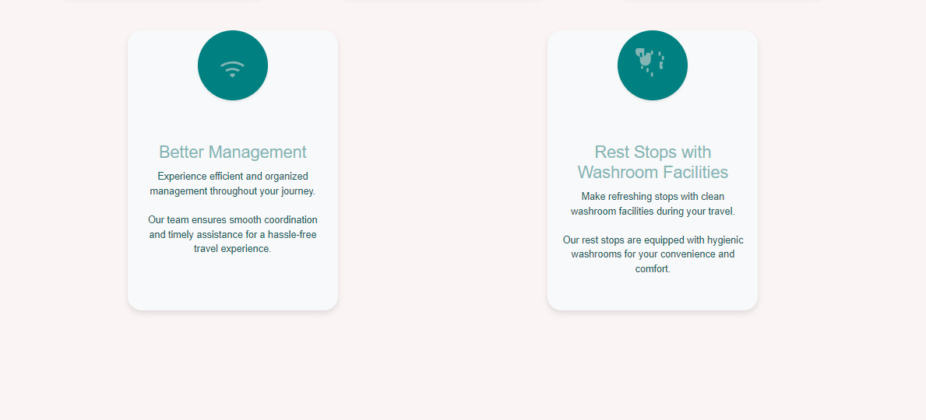

Contact:

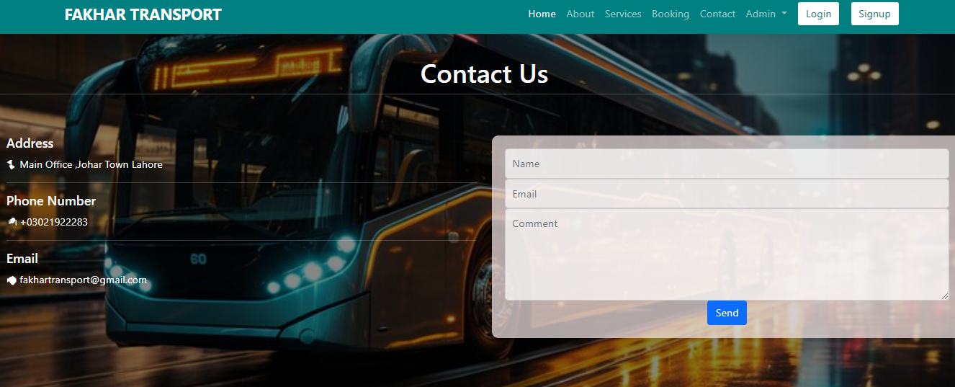

Login Page:
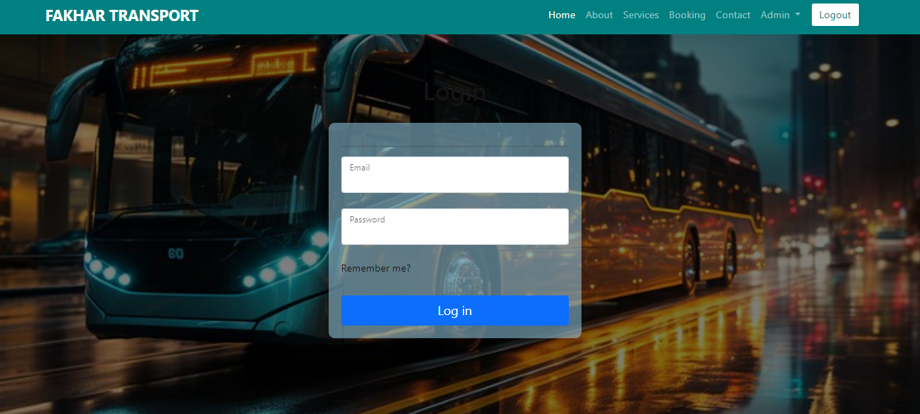

Sign Up Page:

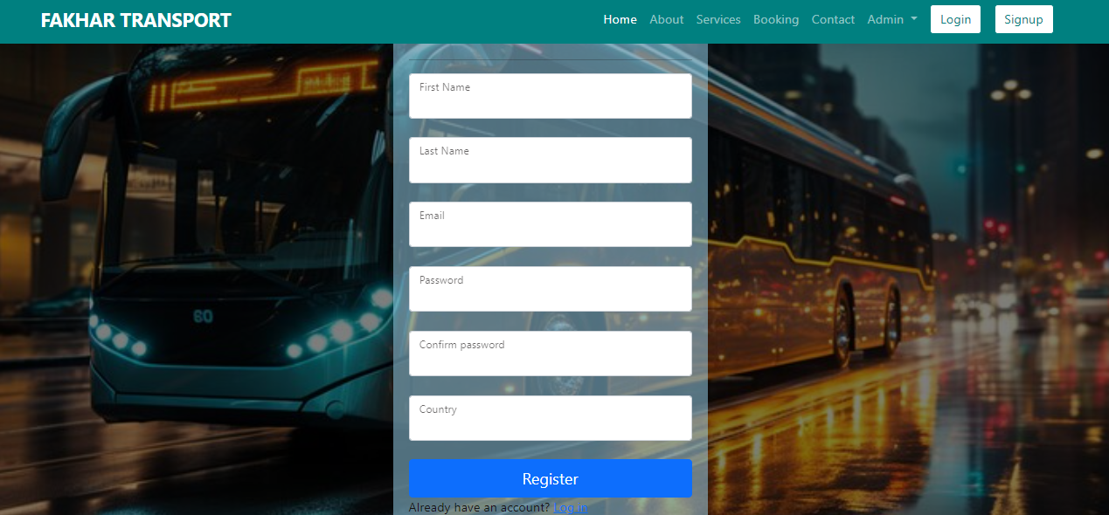

Get Your Ticket Button:
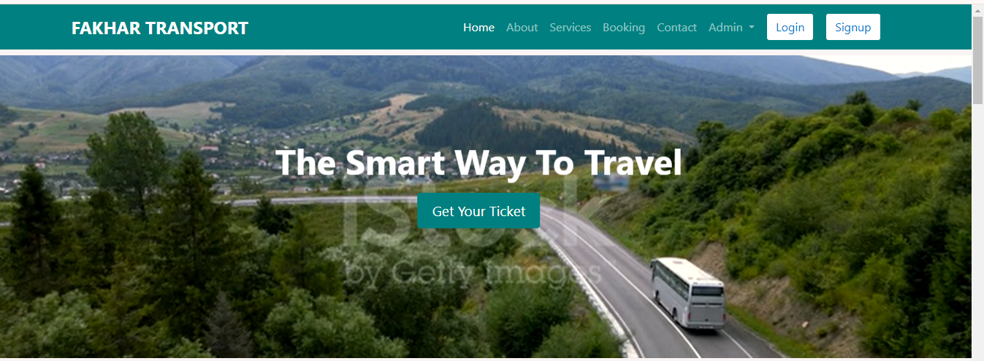

If the user clicks the "Get Ticket" button and searches for a bus, it will display the buses that match the search fields.

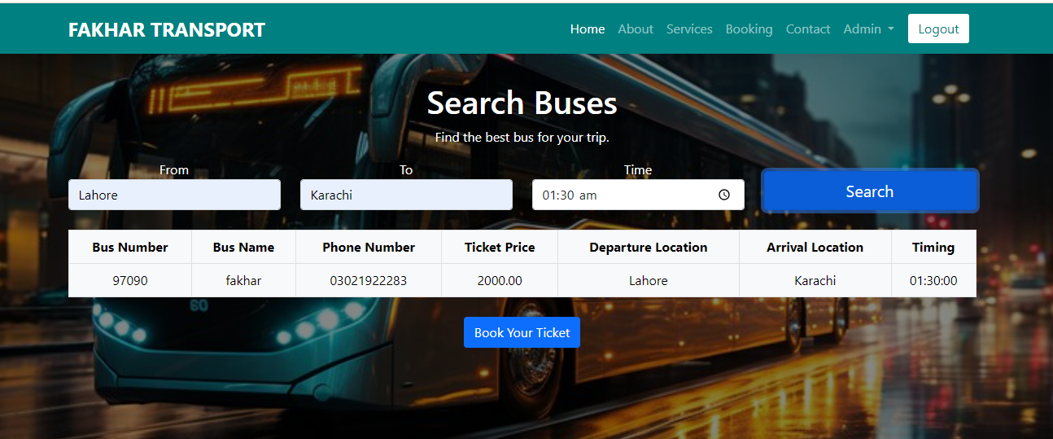

Booking Page:

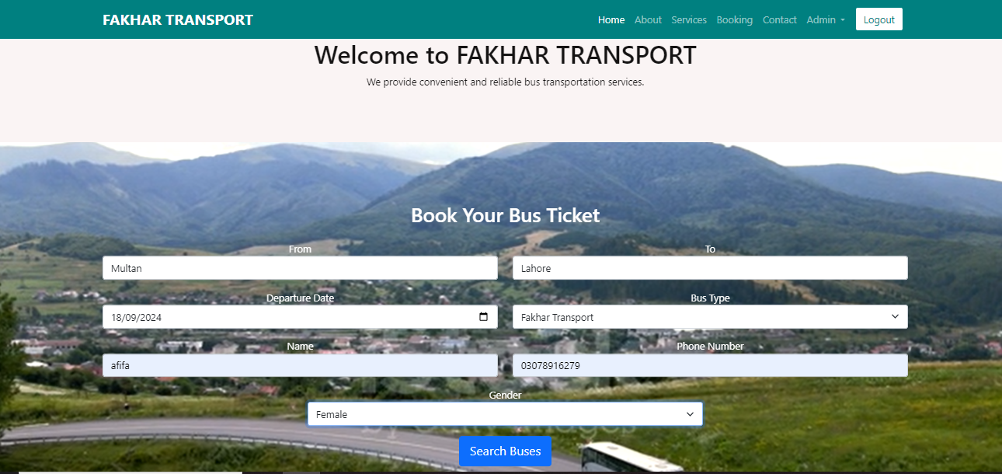

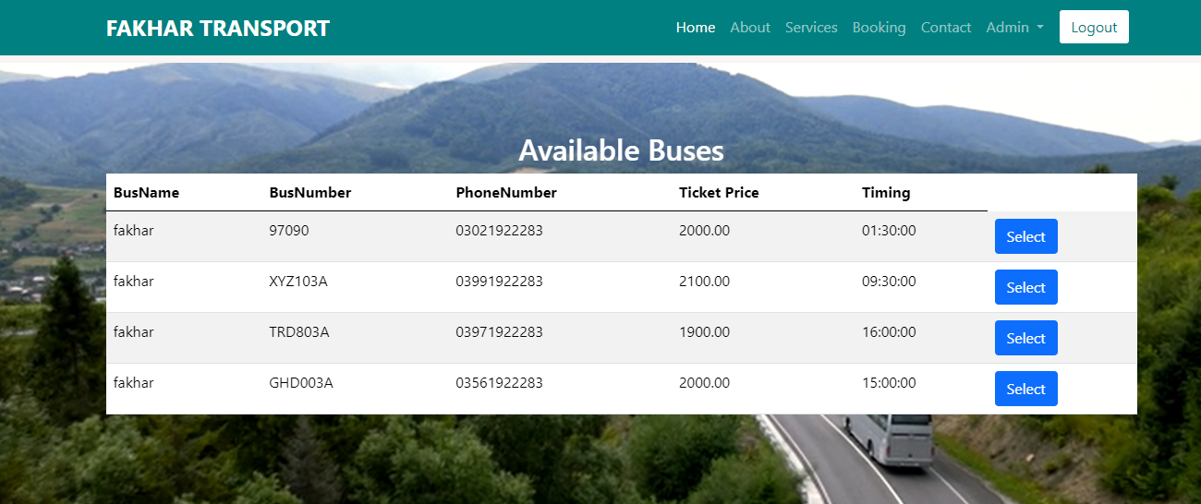

Seat Number:

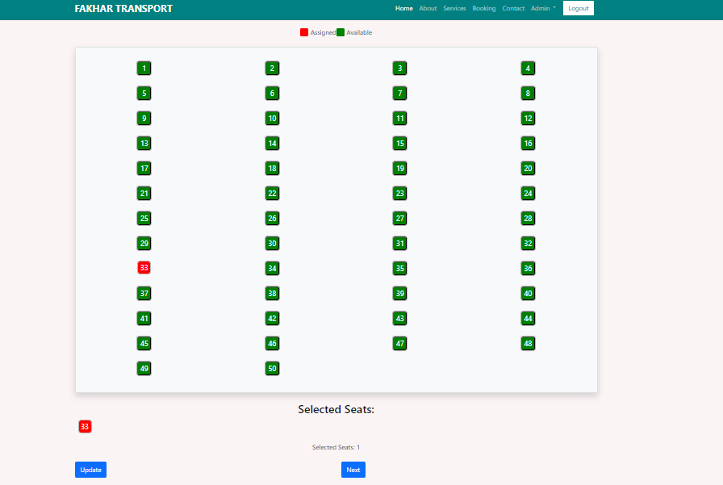

After selecting the seat number, the user confirms the booking.
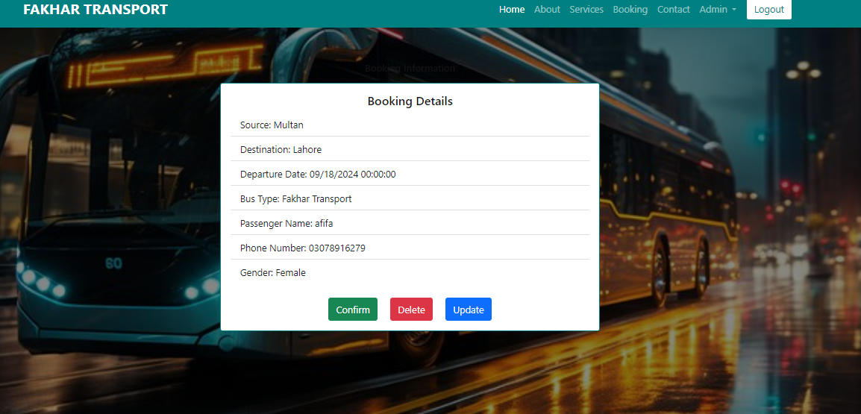

If the user clicks "Confirm," the ticket is confirmed; otherwise, the user can delete or update the ticket.

Confirm Ticket:

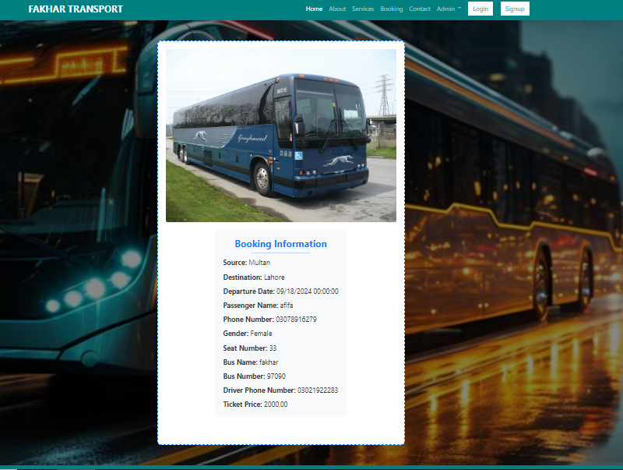
Admin Side:
Add Buses:

