

**Submitted to:**

**Ma’am Maheen Arshad**

**Group members:**

|  |  |  |
| --- | --- | --- |
| **Serial. No** | **Roll Number** | **Names** |
| **1.** | **I18-0666** | **Sundus Khalid** |
| **2.** | **I18-0660** | **Zeeshan Ikram** |
| **3.** | **I18-1587** | **Wajeeha Malik** |

Contents

ABSTRACT 4

INTRODUCTION 5

BASIC CONCEPT: 5

ADVANTAGES: 7

GOALS: 7

SCOPE 7

STAKEHOLDERS 7

HIGHLEVEL GOALS OF STAKEHOLDERS 8

Extractor: 8

GOALS: 8

Distributor: 8

GOALS: 8

Restaurants: 8

GOALS: 9

MIS FEATURES 9

FUNCTIONAL REQUIREMENTS 10

NON-FUNCTIONAL REQUIREMENTS 10

HIGH LEVEL USECASES 11

USECASE 01: 11

USECASE 02: 11

USECASE 03: 11

USECASE 04: 11

USECASE 05: 11

USECASE 06: 11

USECASE 07: 12

USECASE 08: 12

USECASE 09: 12

USECASE 10: 12

USECASE 11: 12

USECASE 12: 13

USECASE 13: 13

USECASE 14: 13

USECASE 15: 13

EXPANDED USE-CASES 14

PLACING ORDER: 14

GENERATING BILL: 15

VIEWING INVENTORY: 16

ADDING EXTRACTOR: 17

MODIFYING BY RESTAURANT: 19

DOMAIN MODEL 21

SYSTEM SEQUENCE DIAGRAM 22

PLACING ORDER: 22

VIEWING INVENTORY: 23

ADDING EXTRACTOR: 23

BILLING: 24

UPDATING DISTRIBUTOR: 24

SEQUENCE DIGRAMS 25

PLACING ORDER: 25

ADDING EXTRACTOR: 26

GENERATING BILL: 27

VIEWING INVENTORY: 28

*MODIFYING DISTRIBUTOR:* 29

CLASS DIAGRAM 30

Database: 31

Querying Language: 31

Seafood Supply Chain Management System database overview 31

• Seafood: 32

• User: 32

# ABSTRACT

This report in broad-spectrum explains our project. The world is moving towards digitization and people are moving towards applications to ensure both the transparency and timeliness. The seafood business is one the largest businesses of the world and the people who deal with this business need an efficient software to help them run the business.

**SEAFOOD SUPPLY CHAIN MANAGEMENT SYSTEM**

# INTRODUCTION

In the era where everything is being digitized and companies are competing with each other to satisfy the customer needs and their demands. There is a need to properly deal with the customers in order to boost the business and gain more customers. This can only happen when supply chain is being managed properly. There must be properly developed and managed software to handle it.

Similar is the case of seafood supply chain. Customers nowadays are more interested in quality than quantity. So, the demand has now changed to whether the seafood they’re paying for, to eat in some restaurant or some shop is fresh or not.

To cater this, we will allow the users to trace the seafood so that they know they get what they’re paying for.

## BASIC CONCEPT:

So, what we’re doing is Seafood Supply chain management. The basic concept of it is that the customer should get fresh product.

This supply chain consists of three major sections

* Extractor (they extract fishes from the sea or fish-farm and sell them to Distributors)
* Distributor (they buy the fishes from Extractors and sell it to Restaurants)
* Restaurants (They buy fishes from the Distributors)

Transfer of Information

**Restaurant**

**Extractor**

**Distributor**

Cash flow

Cash flow

Transfer of Product

Information flows in both ways i.e. Extractor to Distributor to Restaurant and vice versa to maintain the demand of seafood. Similar is the case with the products. If Restaurant feels that the products they’re getting are not up to standards they can return it to the Distributor. Similarly, if the Distributor has these reservations on Extractor it can return the product to Extractor and there is a cash flow from Restaurants to Distributer and Distributer to Extractor.

## ADVANTAGES:

* As customer knows what they’re buying and its condition it will develop better customer relationship and service.
* When the customer knows that they are getting exactly what they’re paying for, they will recommend it to other users too. It will increase the customers.
* Right products will be shipped / transported at the right time.
* It will assist the companies in minimizing the waste, driving out costs, and achieving efficiencies throughout the supply chain process.
* It will improve the productivity of a business.
* Financial success of a business.

## GOALS:

* Partners within supply chain will work collectively to maximize resource productivity.
* Products to be standardized.
* Satisfaction of Customer as he will be getting what he’s paying for.
* Value creating for the customers
* Lessen the wastage of food with proper management.

# SCOPE

Seafood Supply Chain Management System (SSCMS)

# STAKEHOLDERS

* Extractor (they extract fishes from the sea or fish-farm and sell them to Distributors)
* Distributor (they buy the fishes from Extractors and sell it to Restaurants)
* Restaurants (They buy fishes from the Distributors)

# HIGHLEVEL GOALS OF STAKEHOLDERS

## Extractor:

When the Seafood is extracted from some farm or from the sea, the time will be noted along with the other info like type, length, weight and other required details. Extractor will sell this seafood to Distributor and the selling time will be noted by Extractor to keep the record. Distributor will request the seafood from Extractor based on their demand.

### GOALS:

* Authenticating.
* Generating bill for distributer.
* Adding seafood data.

## Distributor:

When products from Extractor arrive at the Distributors’, its timewill be noted by the Distributor along with other required info. to keep the record. Distributor will only buy the fresh seafood and if they feel that the product they’re getting is not fresh, they will return it to the Extractor. Restaurants will request the fishes, crabs and shrimps from Distributors based on their demand. time of dispatch will be noted to keep the record.

### GOALS:

* Authenticating.
* Getting Order of seafood.
* Buying seafood from extractor.
* Generating bill for Restaurants.
* Paying bill to extractor.
* Adding, deleting or updating extractor.
* Checking the quality of seafood buying.
* Tracking an order placed.

## Restaurants:

Time of arrival of the product will be noted by Restaurant. Moreover, they will have the access to both the Extractors’ time and Distributors’ time**.** To make sure that the customer is getting the fresh seafood, the Restaurant will only accept if they’re fresh and will not accept in case it is not.

When the user demands what they need from the restaurant the whole timeline will be provided to the user and they can choose the fishes they want.

### GOALS:

* Authenticating.
* Ordering seafood from distributer.
* Paying bill to distributer.
* Adding, deleting or updating distributer.
* Checking the quality of seafood buying.
* Tracking order placed.
* Checking inventory.

# MIS FEATURES

* Role-based authentication.
* Role-based authorization.
* Invoice generation.
* Bill generation.
* Placing order.
* Information management.
* Inventory availability reporting.
* Return management.
* Analyzing information to get best quality seafood.

# FUNCTIONAL REQUIREMENTS

* Authentication based on their respective roles.
* Authorization based on their respective roles.
* Creating invoice for the seafood being sold.
* Placing seafood order.
* Managing the information.
* Reporting based on the availability of inventory.
* Managing inventory.
* Getting best quality seafood based on the information available.

# NON-FUNCTIONAL REQUIREMENTS

* Quick response.
* Scalable.
* User-friendly interface.
* Maintainable.
* Reliable.
* Secure.
* Available.
* Data integrity.

# HIGH LEVEL USECASES

## USECASE 01:

|  |  |
| --- | --- |
| Use case Name | Billing |
| Actors | Extractor, Distributor |
| Type | Primary |
| Description | Distributer places order for the required items. Extractor generates an invoice for the items. Distributer pays the Extractor online. |

## USECASE 02:

|  |  |
| --- | --- |
| Use case Name | Billing |
| Actors | Distributor, Restaurant |
| Type | Primary |
| Description | Restaurant places order for the seafood that it needs. Distributor generates an invoice for the items. Restaurant pays the Distributor online. |

## USECASE 03:

|  |  |
| --- | --- |
| Use case Name | Adding Extractor |
| Actors | Distributor |
| Type | Primary |
| Description | Upon hiring a new extractor, the Distributor adds his/her details in the system provided the extractor record does not exist in the system already. |

## USECASE 04:

|  |  |
| --- | --- |
| Use case Name | Deleting Extractor |
| Actors | Distributor |
| Type | Primary |
| Description | Distributor deletes extractor record when the extractor leaves his/her job. |

## USECASE 05:

|  |  |
| --- | --- |
| Use case Name | Updating Extractor |
| Actors | Distributor |
| Type | Primary |
| Description | When the extractor details change, Distributor updates the extractor details in the system. |

## USECASE 06:

|  |  |
| --- | --- |
| Use case Name | Adding Distributor |
| Actors | Restaurant |
| Type | Primary |
| Description | Upon hiring a new distributor, the restaurant adds his/her details in the system. |

## USECASE 07:

|  |  |
| --- | --- |
| Use case Name | Deleting Distributor |
| Actors | Restaurant |
| Type | Primary |
| Description | Restaurant deletes distributor details when the distributer leaves his/her job. |

## USECASE 08:

|  |  |
| --- | --- |
| Use case Name | Updating Distributor |
| Actors | Restaurant |
| Type | Primary |
| Description | Restaurant updates distributor details in the system when his/her details change. |

## USECASE 09:

|  |  |
| --- | --- |
| Use case Name | Checking Quality |
| Actors | Restaurant |
| Type | Primary |
| Description | Restaurant checks the quality of the seafood by checking the time when it was caught by the extractor, the temperature it was stored on the extractor side, the time it was sold to the distributor, the temperature of the vehicle used for transportation to the restaurant and the time it arrived at the restaurant. |

## USECASE 10:

|  |  |
| --- | --- |
| Use case Name | Checking Quality |
| Actors | Distributor |
| Type | Primary |
| Description | Distributor checks the quality of the seafood by checking the time when the seafood was caught by the extractor, the temperature at which the extractor stored the seafood, the time when the seafood is sent off to the restaurant and the temperature of the vehicle used for transferring the seafood. |

## USECASE 11:

|  |  |
| --- | --- |
| Use case Name | Ordering seafood |
| Actors | Restaurant, Distributor |
| Type | Primary |
| Description | Restaurant checks the inventory and places order for the required items with the distributor. The distributor purchases the ordered items and delivers them to the restaurant. |

## USECASE 12:

|  |  |
| --- | --- |
| Use case Name | Ordering seafood |
| Actors | Distributor, Extractor |
| Type | Primary |
| Description | Distributor receives a list of required items from the restaurant. Distributor places order with the extractor according to the list. Extractor delivers the required items to the distributor. |

## USECASE 13:

|  |  |
| --- | --- |
| Use case Name | Tracking Order |
| Actors | Restaurant |
| Type | Primary |
| Description | When restaurant places order with the distributor, the restaurant tracks its order by checking the time, the temperature of the seafood and the locations from when the seafood is caught by the extractor to when the restaurant receives the seafood. |

## USECASE 14:

|  |  |
| --- | --- |
| Use case Name | Tracking Order |
| Actors | Distributor |
| Type | Primary |
| Description | When Distributor places order with the extractor, the distributor can track the placed order by viewing the time, the temperature at which the seafood is stored and the locations the seafood has passed through till it is delivered to the distributor. |

## USECASE 15:

|  |  |
| --- | --- |
| Use case Name | Checking Inventory |
| Actors | Restaurant |
| Type | Primary |
| Description | Restaurant checks the inventory to know about the type of seafood available, the amount of seafood available and the degree of freshness of the seafood in the inventory. |

# EXPANDED USE-CASES

## PLACING ORDER:

|  |  |
| --- | --- |
| **Use Case Name :** | Placing order by restaurant |
| **Scope :** | Seafood Supply chain management |
| **Level :** | Primary |
| **Primary Actors :** | Restaurant System Manager |
| **Stakeholders and Interest :** | Restaurant System Manager  **Restaurant System Manager:** Restaurant System Manager is the person responsible for handling Restaurant System. He/She can check the inventory and order the specific type of packages of Seafood from the distributor. |
| **Pre-condition :** | Person must be authentic and the system must be logged in.  Distributor from which seafood is to be ordered is already in the system. |
| **Post-Condition :** | Seafood is ordered. |
| **Main-Success Scenario :** | |  |  | | --- | --- | | **Actor action** | **System response** | | 1. Restaurant System Manage checks if distributor is present in the system. 2. Restaurant System Manager asks for list of seafood items available 3. Manager selects items from the lists. 4. Manager selects place order option. 5. Manager confirms the order. | 2) System confirms the presence.   1. System displays the list along with information about the quality and quantity of food. 2. System asks for confirmation. 3. Order is placed successfully. | |

## GENERATING BILL:

|  |  |
| --- | --- |
| **Use Case Name :** | Billing of Restaurant for Distributor |
| **Scope :** | Seafood Supply chain management |
| **Level :** | Primary |
| **Primary Actors :** | Restaurant System Manager, Distributor System Manager |
| **Stakeholders and Interest :** | Restaurant System Manager, Restaurant Manager,  **Restaurant System Manager**: The restaurant system manager is the person responsible for handling the system Restaurant. He/she will check the order from the Distributor and generate the billing (pay).  **Restaurant Manager:** The Manager of the restaurant can also check the order and generate the billing (pay). |
| **Pre-condition :** | Person must be authentic and the system must be logged in. |
| **Post-Condition :** | The order is received by the Restaurant and the bill is paid. |
| **Main-Success Scenario :** | |  |  | | --- | --- | | Actor action | System Response | | 1. The product is arrived and bill is received by restaurant. 2. The data of the seafood arrived is entered into the system. 3. Restaurant System Manager clicks on “pay the bill”. | 1. Data entered successfully.     5) Billing  Successful | |

## VIEWING INVENTORY:

|  |  |
| --- | --- |
| **Use Case Name :** | Viewing inventory by distributor |
| **Scope :** | Seafood Supply chain management |
| **Level :** | Primary |
| **Primary Actors :** | Distributor System Manager |
| **Stakeholders and Interest :** | Distributor System Manager.  **Distributor System Manager**: TheDistributor system manager is the person responsible for handling the system of Distributor. It can checks the quality of the seafood by checking the time when the seafood was caught by the extractor, the temperature at which the extractor stored the seafood, the time when the seafood is sent off to the restaurant and the temperature of the vehicle used for transferring the seafood. |
| **Pre-condition :** | Person must be authentic and the system must be logged in. |
| **Post-Condition :** | Inventory is viewed. |
| **Main-Success Scenario :** | |  |  | | --- | --- | | Actor action | System response | | 1. Distributor System Manager requests the list of seafood items available. | 1. System displays the list of the items available. 2. System displays information about the time of extraction, temperature of the vehicle, the time of arrival, temperature of the storage and the degree of freshness. | |

## ADDING EXTRACTOR:

|  |  |
| --- | --- |
| **Use Case Name :** | Adding Extractor by Distributor |
| **Scope :** | Seafood Supply chain management |
| **Level :** | Primary |
| **Primary Actors :** | Distributor System Manager , Extractor’s System Manager |
| **Stakeholders and Interest :** | Distributor’s Manager, Distributor System Manager.  **Distributor’s System Manager:** Distributor’s System Manager is the person responsible for handling Distributor’s System. He/She can Add the Extractor to Extractor’s list to buy Seafood from them, in the system.  **Distributor’s Manager:** The manager of distributor can also add the Extractor to buy Seafood from them. |
| **Pre-condition :** | Person must be authentic and the system must be logged in.  Extractor to be added is not already in the System. |
| **Post-Condition :** | Extractor is added. |
| **Main-Success Scenario :** | |  |  | | --- | --- | | Actor Response | System Response | | 1. Distributor System Manager will check if Extractor is not already present in the system. 2. Distributor System Manager adds the Extractor’s info into the system and saves it. | 2) System displays that it is Not Present.  4) Information is saved. Extractor is added. | |

## MODIFYING BY RESTAURANT:

|  |  |
| --- | --- |
| **Use Case Name:** | Modifying Distributor information by Restaurant |
| **Scope:** | Seafood Supply chain management |
| **Level:** | Primary |
| **Primary Actors:** | Restaurant System Manager |
| **Stakeholders and Interest:** | Restaurant Manager, Restaurant System Manager.  **Restaurant System Manager:** Restaurant’s System Manager is the person responsible for handling Restaurant’s System. He can modify the Distributor’s information in their system.  **Restaurant Manager:** The manager of Restaurant can also modify the Distributor’s information. |
| **Pre-condition:** | Person must be authentic and the system must be logged in.  Distributor to be modified is already in the System. |
| **Post-Condition:** | Distributor is modified. |
| **Main-Success Scenario:** | |  |  | | --- | --- | | Actor action | System response | | 1. Restaurant System Manager will check if distributor is already present in the system. 2. Restaurant System Manager requests to update the information.   5) Manager enters new information.  6) Manager requests to save the new information. | 2) System confirms the presence.  4) System grants permission to update.  7) System saves the updated information. | |

# DOMAIN MODEL

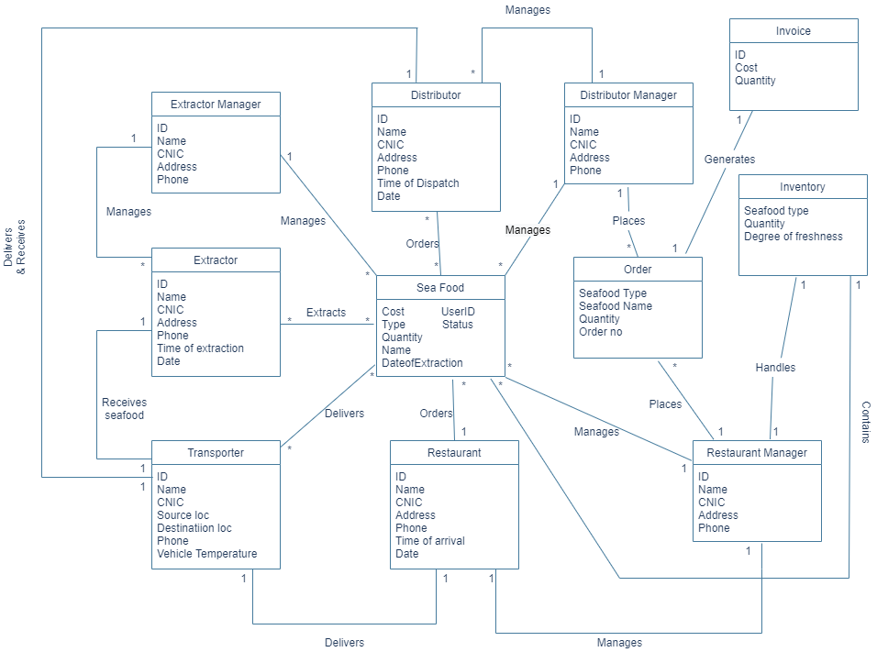

# SYSTEM SEQUENCE DIAGRAM

## PLACING ORDER:

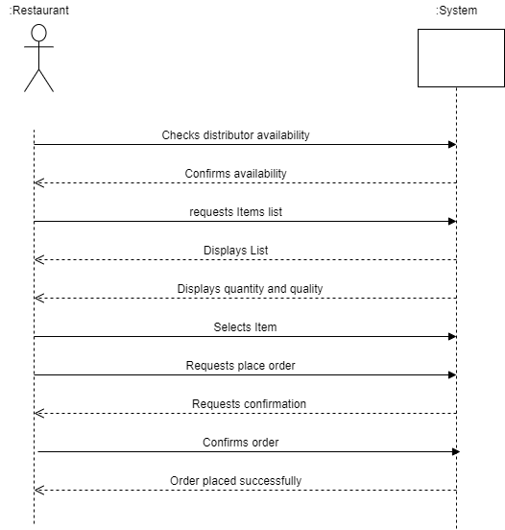

## VIEWING INVENTORY:

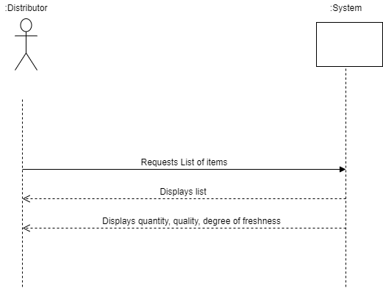

## ADDING EXTRACTOR:

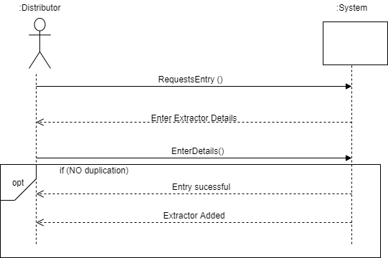

## BILLING:

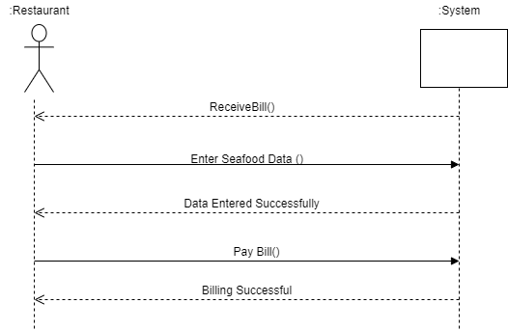

## UPDATING DISTRIBUTOR:

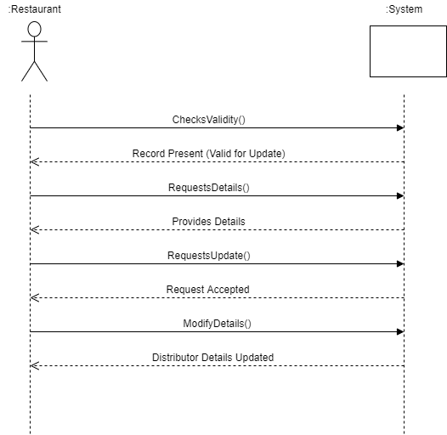

# SEQUENCE DIGRAMS

## PLACING ORDER:

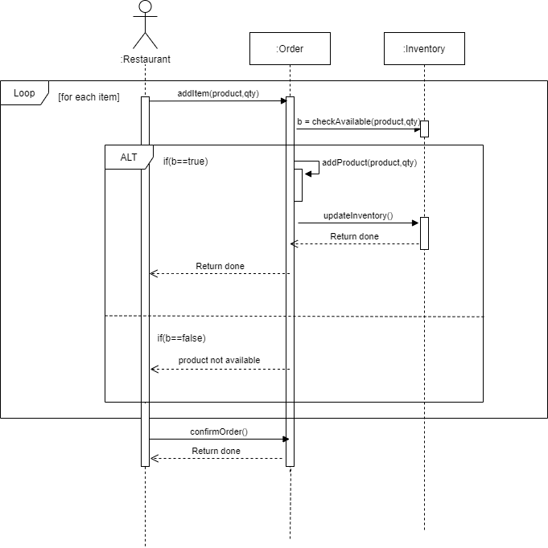

## ADDING EXTRACTOR:

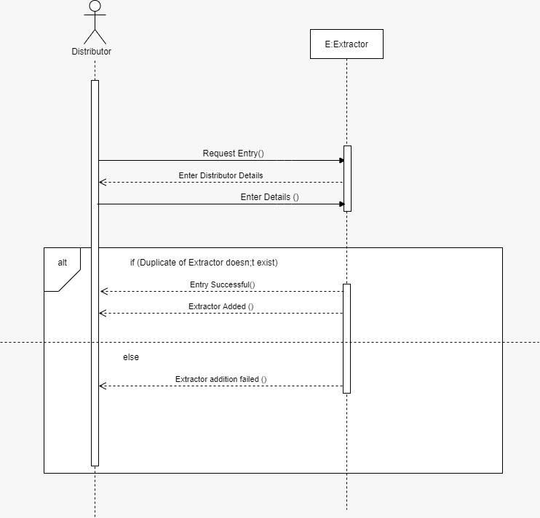

## GENERATING BILL:

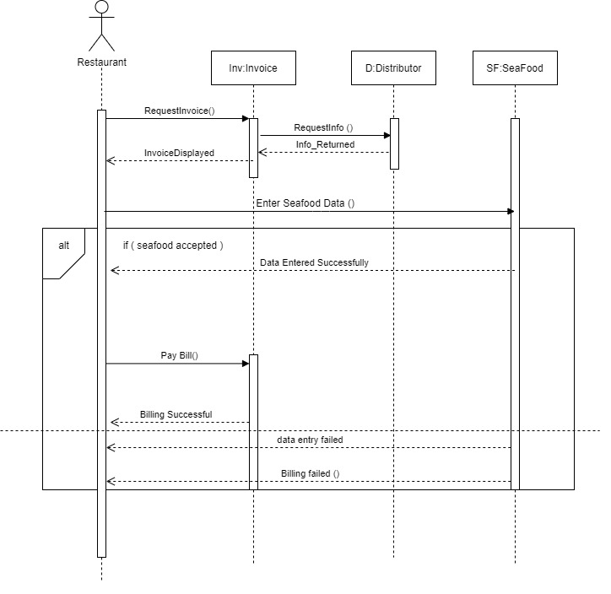

## VIEWING INVENTORY:

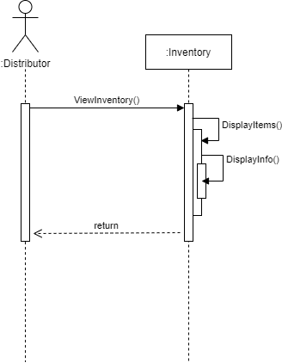

## *MODIFYING DISTRIBUTOR:*

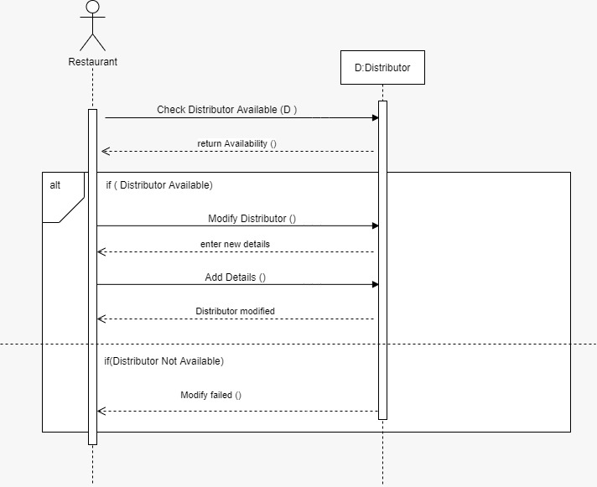

# CLASS DIAGRAM

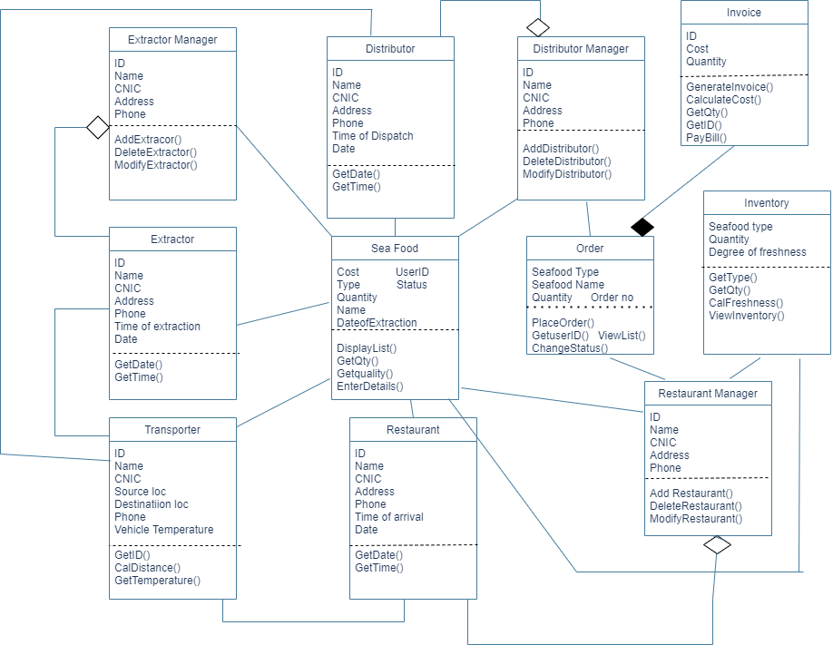

# Database:

We used Firebase Firestore as our database. It is horizontally scaling noSQL database. It is a schema less which means there are not any database level restriction around what kind of data you can put at any point of database. The biggest advantage of using noSQL database over traditional database is that it is able to distribute its data across multiple machines easily by scaling horizontally across several servers.

Firestore is a collection of objects stored in tree like hierarchical structure. It has documents like JSON objects within a certain collection. Each document can have multiple fields.

## Querying Language:

Firestore is noSQL so it does not have specific set of statement to retrieve data.Data retrieval from firestore can be done using process called “Querying”. It provides powerful querying functionality for documents you want to retrieve from a collection or collection group. These queries are used to get data and get real-time updates.

## Seafood Supply Chain Management System database overview

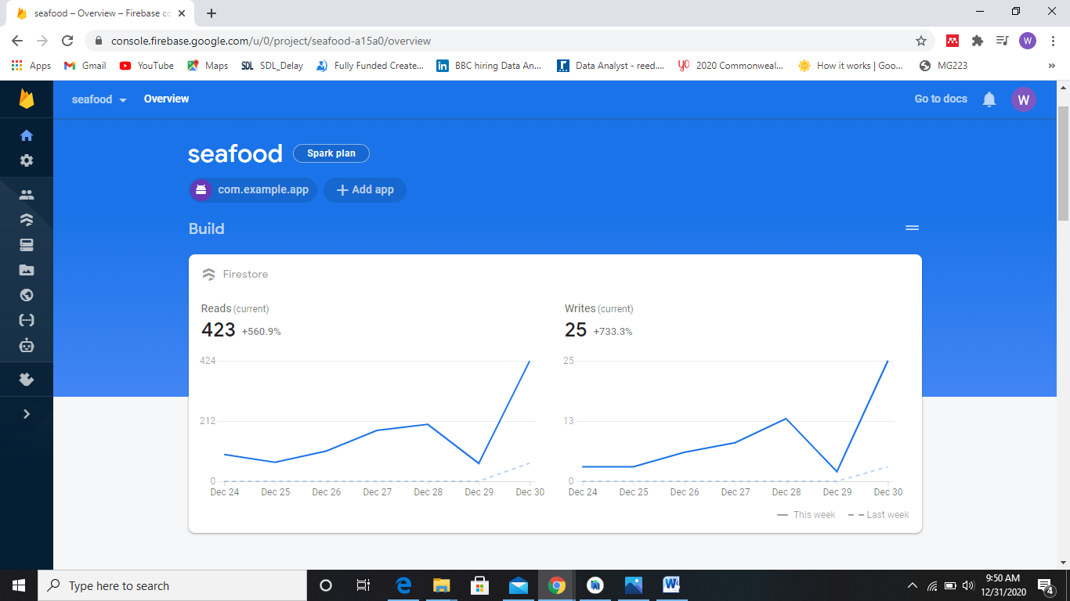

**COLLECTIONS:**

### Seafood:

In Seafood Collection we have all necessary fields used in app performance.

The seafood information along with date of Extraction to get the quality idea and status field which tells who has the particular batch of seafood at the time. User id tells which extractor added seafood or which restaurant manager or distributor purchased which batch.

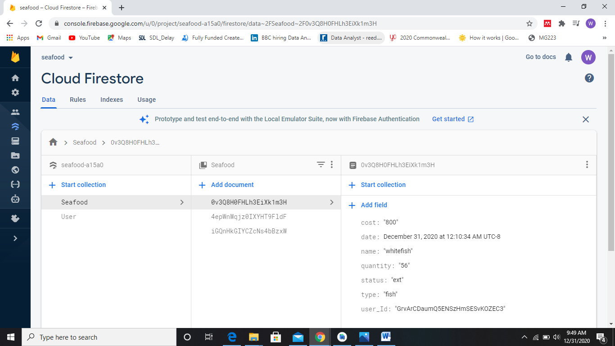

### User:

In user we have user id name email of user along with that we have a field of access which helps in role-base authentication and authorization.

