NAME: WAJEH UL HASSAN
REG NO: SP24_BSE_176
GAME DEVELOPMENT

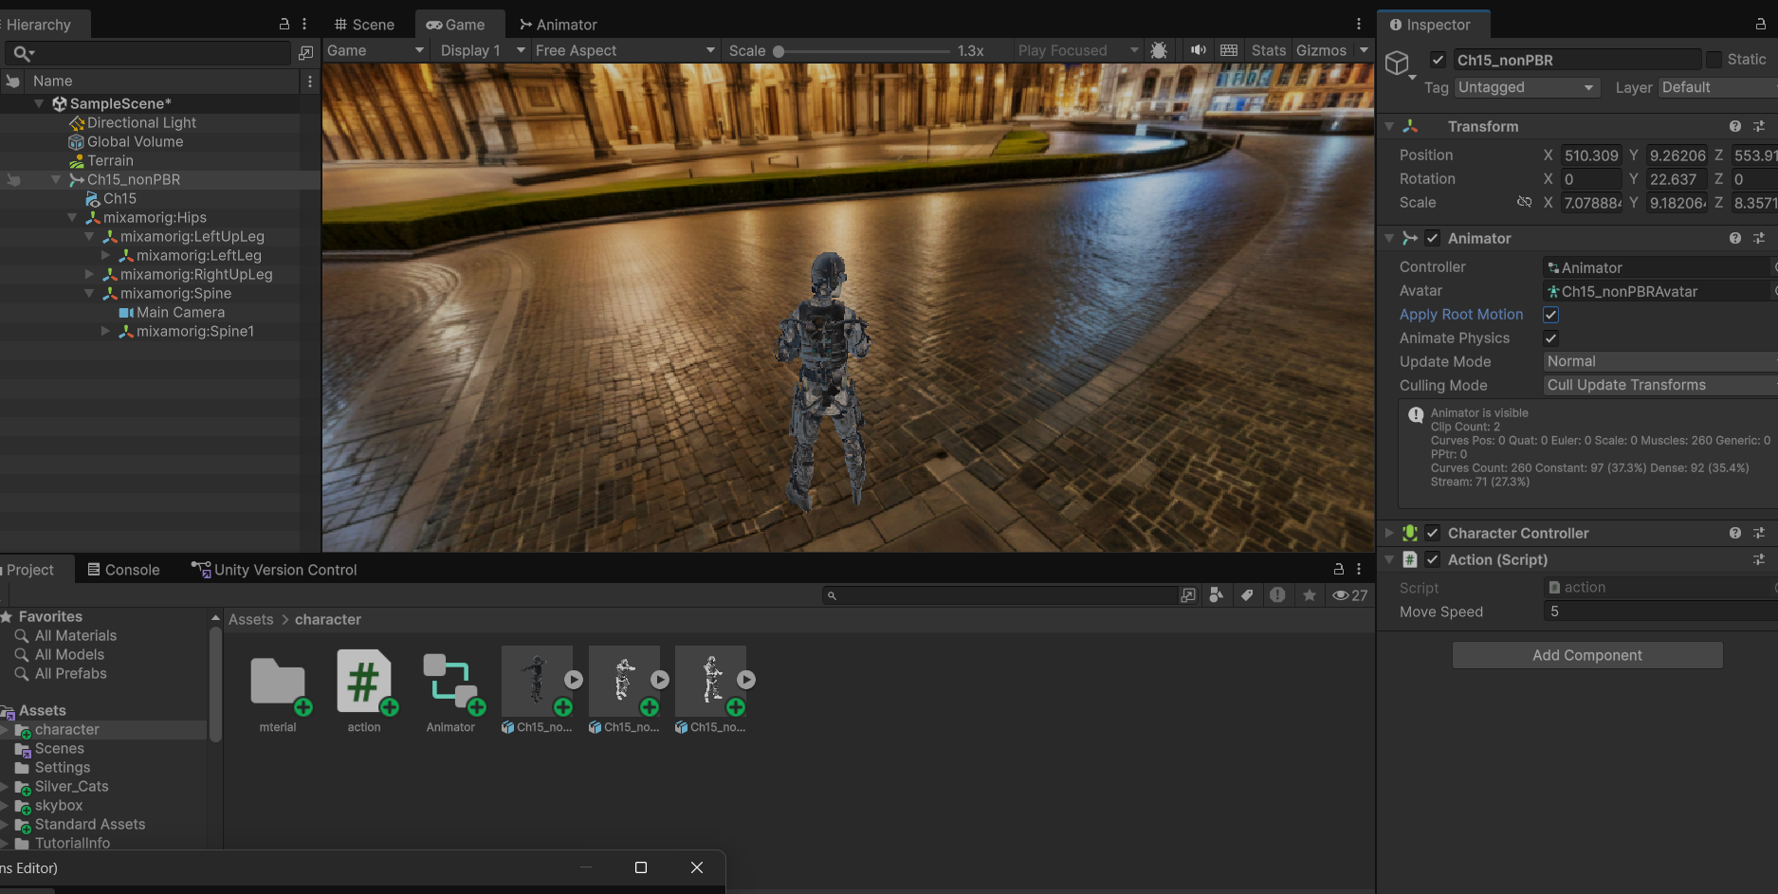
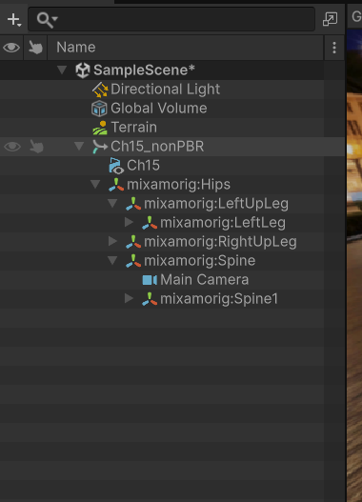

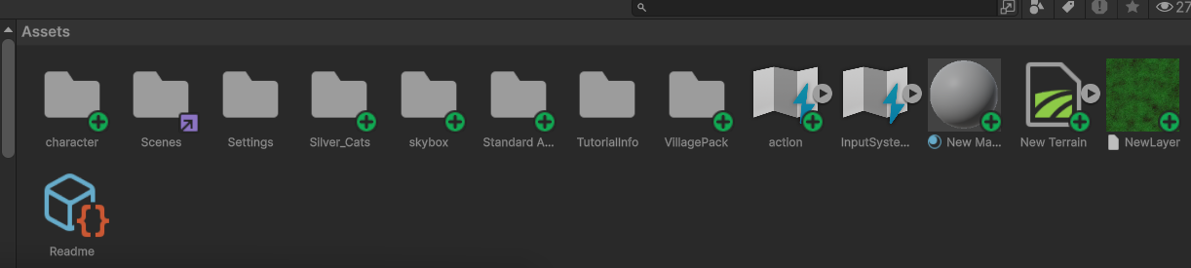

SCRIPT FILE:

using UnityEngine;
using UnityEngine.InputSystem;

public class action : MonoBehaviour
{
public float moveSpeed = 5f;

private Animator animator;

void Start()
{
animator = GetComponent<Animator>();
}

void Update()
{
Vector2 input = Vector2.zero;

// Up Arrow = Forward
if (Keyboard.current.upArrowKey.isPressed)
input.y = 1f;

// Down Arrow = Backward
if (Keyboard.current.downArrowKey.isPressed)
input.y = -1f;

// Left Arrow = Left
if (Keyboard.current.leftArrowKey.isPressed)
input.x = -1f;

// Right Arrow = Right
if (Keyboard.current.rightArrowKey.isPressed)
input.x = 1f;

Vector3 movement = new Vector3(input.x, 0f, input.y);

// Move character
transform.Translate(movement * moveSpeed * Time.deltaTime);

// Animator
animator.SetFloat("Speed", movement.magnitude);
}
}

