Web Design and Development Assignment

Waji-ul-basit

**Value:**

values() is an inbuilt method in Python programming language that returns a view object. The view object contains the values of the dictionary, as a list. If you use the type() method on the return value, you get “dict_values object”. It must be cast to obtain the actual list.

**Pip:**

Pip is one of the most famous and widely used package management system to install and manage software packages written in Python and found in Python Package Index (PyPI). Pip is a recursive acronym that can stand for either "Pip Installs Packages" or "Pip Installs Python".

**Python Module**

A Python module is a file containing Python definitions and statements. A module can define functions, classes, and variables. A module can also include runnable code. Grouping related code into a module makes the code easier to understand and use. It also makes the code logically organized.

**Create a simple Python module**

Let’s create a simple calc.py in which we define two functions, one **add** and another **subtract.**

# A simple module, calc.py

**def** add(x, y):

**return** (x**+**y)

**def** subtract(x, y):

**return** (x**-**y)

**Built in modules:**

* os module.
* random module.
* math module.
* time module.
* sys module.
* collections module.
* statistics module

**Pre define modules:**

* print()
* round()
* abs()
* pow()
* int()
* float()

**Comments:**

Comments in Python are identified with a hash symbol, #, and extend to the end of the line. Hash characters in a string are not considered comments, however. There are three ways to write a comment - as a separate line, beside the corresponding statement of code, or as a multi-line comment block.

* **Example:**

#This is a comment  
print("Hello, World!")

**Functions :**

A function is a block of code which only runs when it is called. You can pass data, known as parameters, into a function. A function can return data as a result.

* **Example:**

def my_function():  
  print("Hello from a function")  
  
**my_function()**

**List:**

List. Lists are **used to store multiple items in a single variable**. Lists are one of 4 built-in data types in Python used to store collections of data, the other 3 are Tuple, Set, and Dictionary, all with different qualities and usage.

**Mutable and Immutable :**

Mutable is a fancy way of saying that the internal state of the object is changed/mutated. So, the simplest definition is: **An object whose internal state can be changed is mutable.** **On the other hand, immutable doesn't allow any change in the object once it has been created**.

**set:**

et is **one of 4 built-in data types in Python used to store collections of data**, the other 3 are List, Tuple, and Dictionary, all with different qualities and usage. A set is a collection which is unordered, unchangeable*, and unindexed. * Note: Set items are unchangeable, but you can remove items and add new items.

* 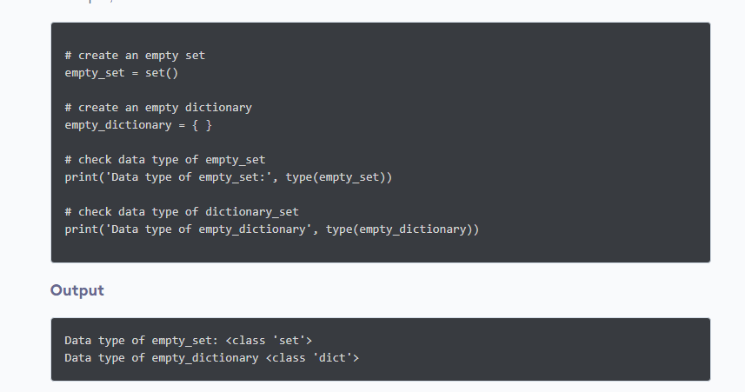**Example**