Department Knowledge Hub — Full Stack Project Report

1. Abstract
The Department Knowledge Hub (LearnBox) is a full-stack web application that provides a centralized platform for academic resource sharing. Students can view and download study materials and previous-year question papers, while admins manage content through a separate portal. Built with Angular (student portal), React (admin portal), Node.js/Express (backend), and MongoDB (database).

2. Introduction
Academic resources in most colleges are shared informally through messaging apps or physical copies, leading to inconsistency and unequal access. LearnBox solves this by providing a structured, role-based digital repository accessible to all students and faculty.
Objectives: 1. Centralize study materials and question papers in one online platform. 2. Implement secure, role-based access for students and admins. 3. Allow admins to upload and manage files; students to search and download. 4. Deploy the system on cloud platforms for 24/7 availability.

3. Literature Survey

3.1 Existing Systems
System | Description
Google Classroom | A learning management system for assignment distribution and communication between teachers and students.
Moodle | An open-source LMS widely used in universities for course management, quizzes, and file sharing.
College ERP Portals | Institution-specific portals (e.g., EduSmart, iCampus) that manage attendance, marks, and sometimes material uploads.
WhatsApp/Telegram Groups | Informal but widely used by students to share notes and question papers among peers.
Google Drive / OneDrive | General-purpose cloud storage used by faculty to share PDFs and presentations via shared links.

3.2 Limitations of Current Solutions
System | Limitation
Google Classroom | Requires a Google Workspace account managed by the institution; not always available to all colleges.
Moodle | Complex to set up and maintain; requires dedicated server infrastructure and IT support.
College ERP Portals | Usually built for administrative tasks (fees, attendance), not academic content management; materials section is often poorly designed.
WhatsApp / Telegram | No structure or categorization; files expire or get lost; quality is unverified; no search capability.
Google Drive | No role-based access; anyone with a link can share further; no department-specific organization.

4. Why This Project Is Needed
Problem | LearnBox Solution
Resources scattered across multiple platforms | Single centralized repository
Students miss question papers before exams | Dedicated, searchable question paper archive
Anyone can upload incorrect content | Admin-only upload; students are read-only
No easy way to filter by subject or semester | Built-in search and filter
Physical handouts are lost or damaged | Permanent digital storage with download links
Existing tools are too complex for small departments | Lightweight, purpose-built for one department

5. System Design

5.1 Architecture
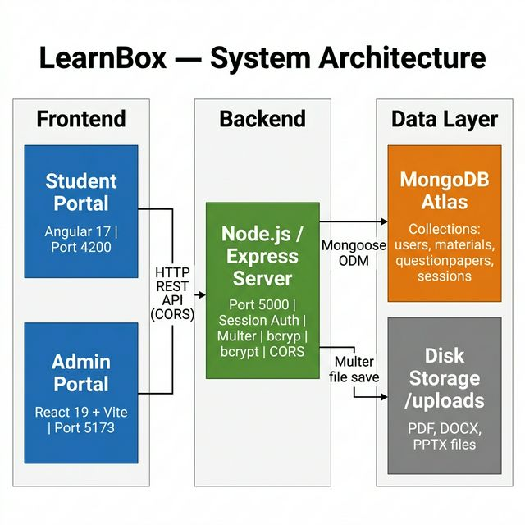

5.2 Sequence Diagram — Login Flow
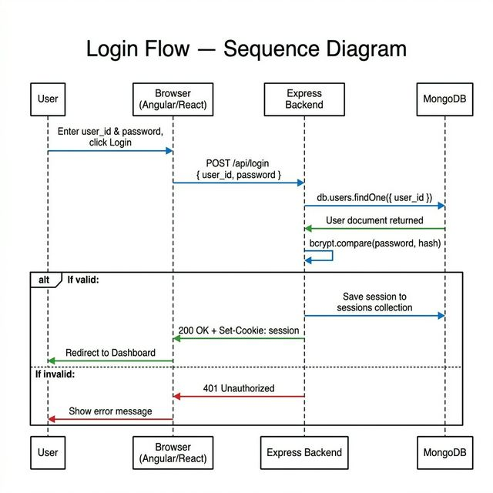

5.3 Sequence Diagram — File Upload (Admin)
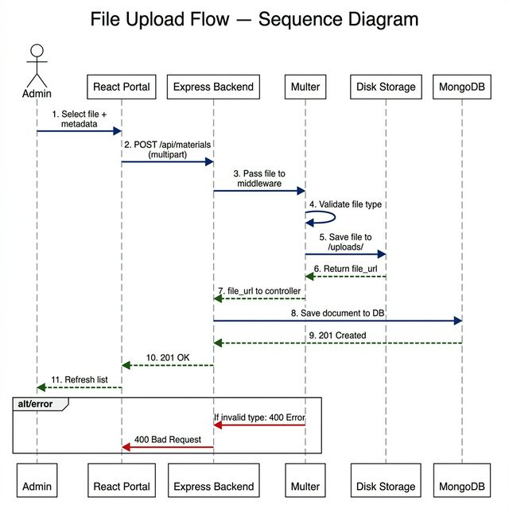

6. Database Design
Database: MongoDB | ODM: Mongoose

Collection: users
Field | Type | Description
user_id | String (unique) | Roll number or admin ID
name | String | Full name
password | String | bcrypt-hashed
role | Enum: student / admin | Access level
department | String | Department name

Collection: materials
Field | Type | Description
title | String | Material title
subject | String | Subject name
semester | String | e.g., “3rd Semester”
file_url | String | Path to uploaded file
uploaded_by | String | Uploader’s user_id
upload_date | Date | Auto-set to now

Collection: questionpapers
Field | Type | Description
subject | String | Subject name
year | String | Exam year
semester | String | Semester
file_url | String | Path to uploaded file
uploaded_by | String | Uploader’s user_id
Sessions are stored automatically in a sessions collection by connect-mongo.

7. Technology Stack

Frontend
Portal | Technology
Student Portal | Angular 17 (TypeScript), Bootstrap 5
Admin Portal | React 19 (JSX), Vite, Bootstrap 5

Backend
Technology | Purpose
Node.js + Express 4 | REST API server
express-session + connect-mongo | Session-based authentication
bcryptjs | Password hashing
multer | File upload handling
cors | Cross-origin request handling

Database & Tools
Technology | Purpose
MongoDB Atlas | Cloud-hosted NoSQL database
Mongoose | Database ODM
Git + VS Code | Version control and development

8. Implementation

8.1 Student Portal Pages (Angular 17)
Page | Route | Purpose
Login | /login | Student authentication
Register | /register | New account creation
Dashboard | /dashboard | Overview and navigation
Materials | /materials | Browse and download study materials
Question Papers | /question-papers | Browse and download past papers
Search | /search | Search across all resources

8.2 Admin Portal Pages (React 19)
Page | Purpose
Login | Admin authentication
Register | Create student/admin accounts
Dashboard | Overview with resource counts
Materials | Upload, view, delete study materials
Question Papers | Upload, view, delete question papers

8.3 API Endpoints

Auth (/api)
Method | Endpoint | Description
POST | /api/login | Login
POST | /api/register | Register user
POST | /api/logout | Logout
GET | /api/me | Get current user

Materials (/api/materials)
Method | Endpoint | Description
GET | /api/materials | Get all materials
GET | /api/materials/search?q= | Search materials
POST | /api/materials | Upload material (admin)
DELETE | /api/materials/:id | Delete material (admin)

Question Papers (/api/questionpapers)
Method | Endpoint | Description
GET | /api/questionpapers | Get all papers
GET | /api/questionpapers/search?q= | Search papers
POST | /api/questionpapers | Upload paper (admin)
DELETE | /api/questionpapers/:id | Delete paper (admin)

9. Module Descriptions

9.1 Student Module
Students can log in, browse study materials and question papers, search by keyword, and download files. They cannot upload or delete any content. Route guards enforce access control on the Angular side.

9.2 Admin Module
Admins log in to a separate React portal with full content management rights. They can upload materials (PDF, DOCX, PPTX) and question papers (PDF, DOCX), delete existing entries, and register new student or admin accounts. All sessions expire after 24 hours.

10. Results & Screenshots
Student:
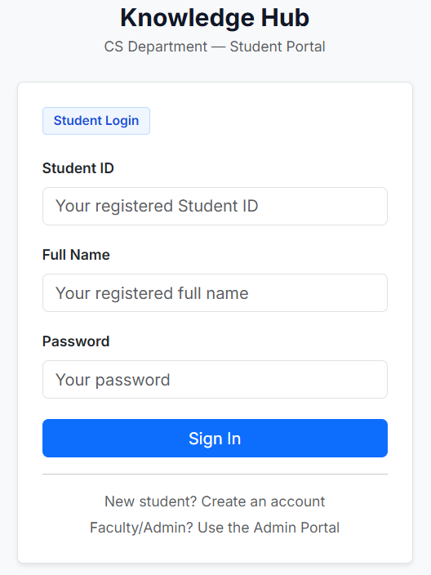
Login form with user ID and password

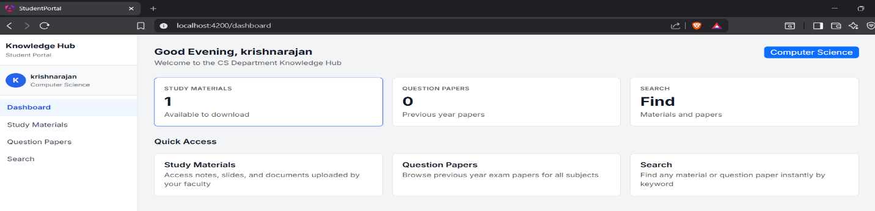
Navigation sidebar
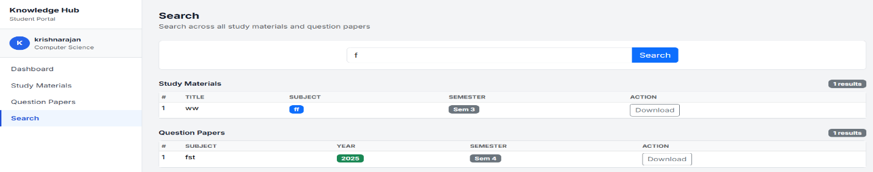
Keyword search with live results
Admin:

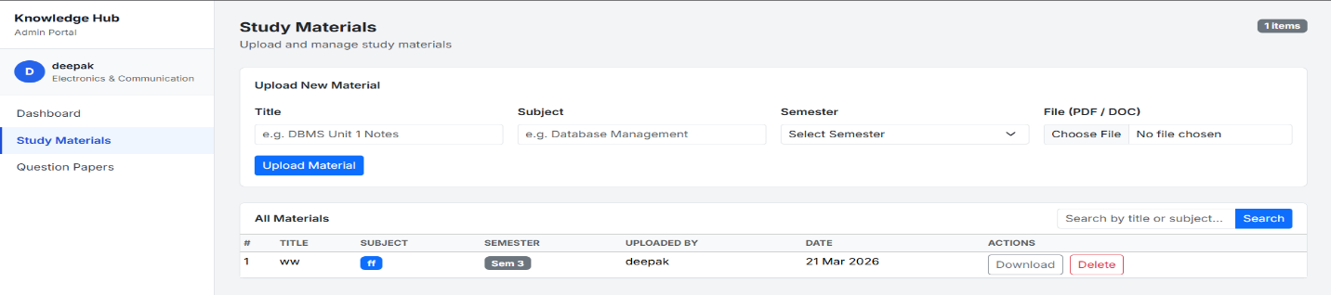
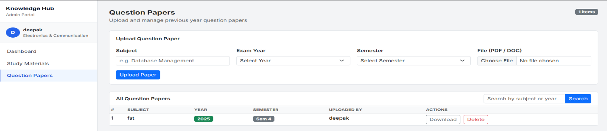
Upload form and table with delete button

11. Testing

Test Cases Used
Test Case | Description
TC-01 | Valid student login
TC-02 | Invalid credentials login
TC-03 | Admin login
TC-04 | Upload a valid material file (admin)
TC-05 | Upload an invalid file type
TC-06 | Delete a material (admin)
TC-07 | Student blocked from uploading
TC-08 | Search materials by keyword
TC-09 | Search question papers
TC-10 | Logout
TC-11 | Register new student
TC-12 | Duplicate user registration
TC-13 | Access protected route without login
TC-14 | Session persistence after tab reopen
TC-15 | Download a material file

12. Advantages & Limitations

Advantages
- Dual-portal architecture for clear separation of roles
- Single shared backend reduces infrastructure complexity
- Session-based auth — no token management on the frontend
- File type validation prevents invalid uploads
- Deployed on cloud (MongoDB Atlas, Railway, Netlify)
- Keyword search with case-insensitive filtering

Limitations
- Files stored on server disk — not persistent on cloud without a volume
- No email verification during registration
- No pagination for large content lists
- Supports only a single department currently

13. Future Enhancements
- Cloud File Storage (AWS S3) — Replace disk storage for scalable file hosting.
- Email/OTP Verification — Validate users during registration.
- Pagination — Handle large datasets efficiently.
- Notifications — Alert students when new materials are added.
- Ratings & Comments — Let students rate and review materials.
- Multi-Department Support — Scale to multiple departments.
- Mobile App — React Native companion app for students.
- Admin Analytics — Show download counts and popular resources.

14. Conclusion
The Department Knowledge Hub (LearnBox) successfully delivers a centralized, role-based academic resource platform for a Computer Science department. The dual-portal design with Angular and React, backed by a shared Node.js/Express server and MongoDB, demonstrates a practical full-stack application. All core objectives — authentication, file management, search, and cloud deployment — were achieved and tested. LearnBox lays a strong foundation for future enhancements that can scale it to larger institutions.

