Islamic Center of Greater Phoenix
Masjid Bilal

We still owe $290,000.00 on the property.

Alhamdulillah, we have successfully transformed this Church into a beautiful Masjid where daily Salat and Friday Jummah are being held. The construction and renovation is progressing well.
Please contribute towards this noble cause and help clear the remaining dues on this property. Your donations will go a long way in supporting the growth and development of this sacred place of worship. May Allah SWT reward you abundantly for your generosity.

Before | After
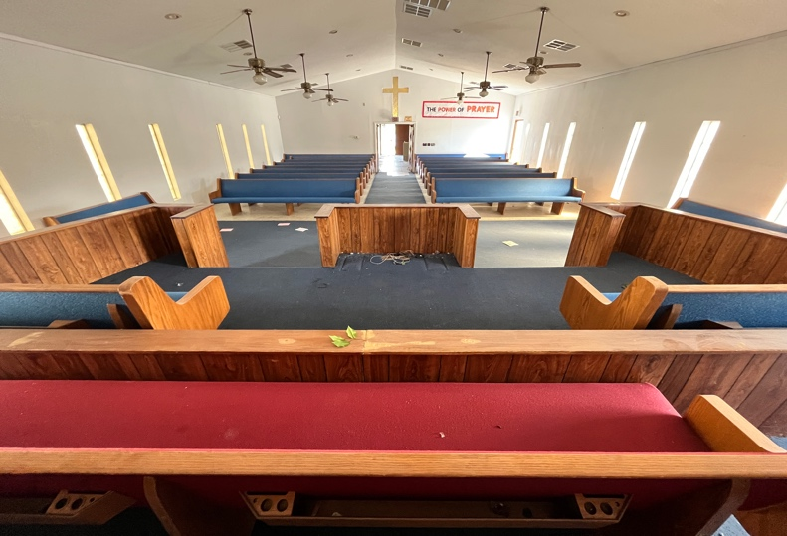 | 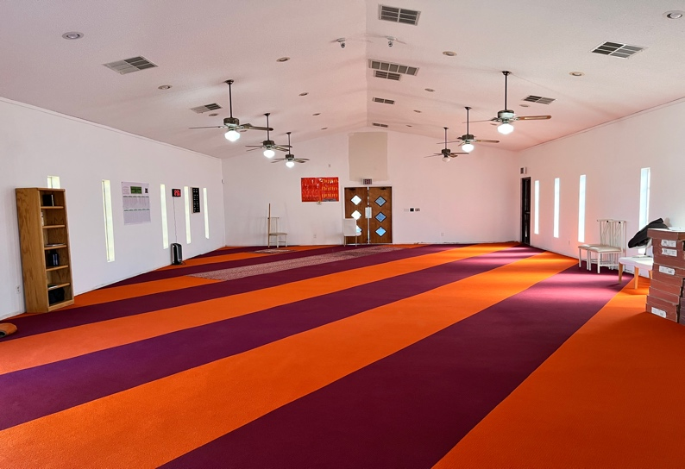
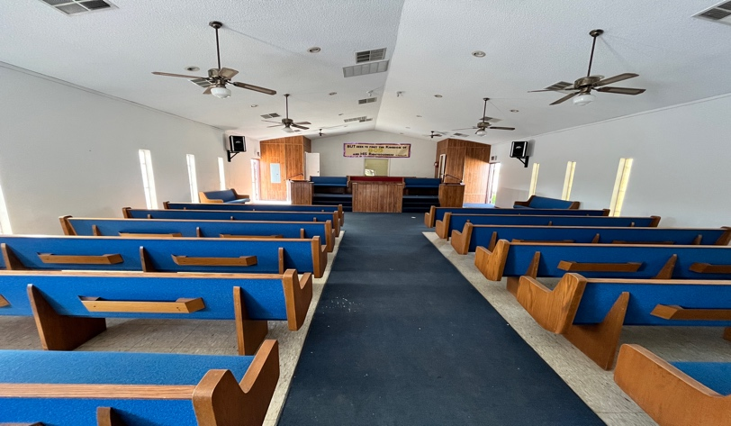 | 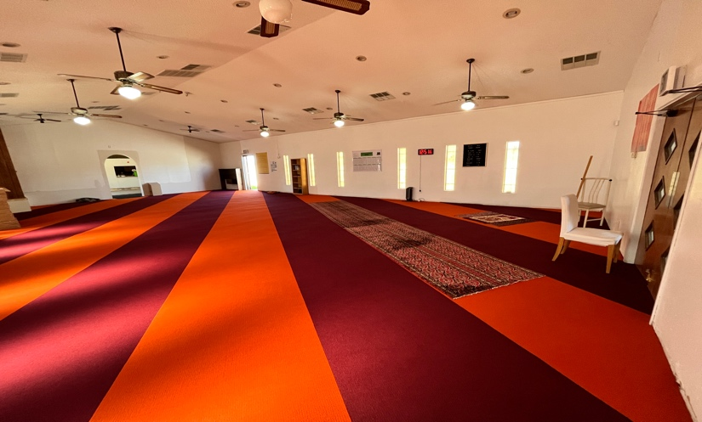
Your donations will be tax deductible.  Make checks payable to: Islamic Center of Greater Phoenix (A Nonprofit Religious Organization)  8016 South 12th Street, Phoenix AZ 85042 | 