**NAME : WAJID ALI KHAN.**

**REG NO : 20PWBCS 0739.**

**SECTION : A.**

**LAB TASK : 01.**

**DATE : 3 MARCH 2023.**

**1. Which of the following protocols are shown as appearing (i.e., are listed in the**

**Wireshark “protocol” column) in your trace file: TCP, QUIC, HTTP, DNS, UDP,**

**TLSv1.2?**

**ANSWER:**

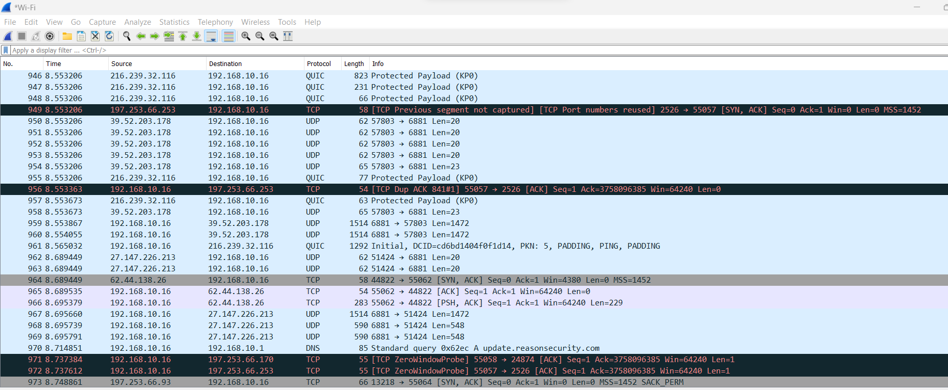

1. TCP

2. TLSv1.2

3. HTTP

4. UDP

5. SSDP

6. QUIC

**2. How long did it take from when the HTTP GET message was sent until the HTTP**

**OK reply was received? (By default, the value of the Time column in the packet-**

**listing window is the amount of time, in seconds, since Wireshark tracing began.**

**(If you want to display the Time field in time-of-day format, select the Wireshark**

**View pull down menu, then select Time Display Format, then select Time-of-day.)**

**ANSWER : TIME: 4.395844**

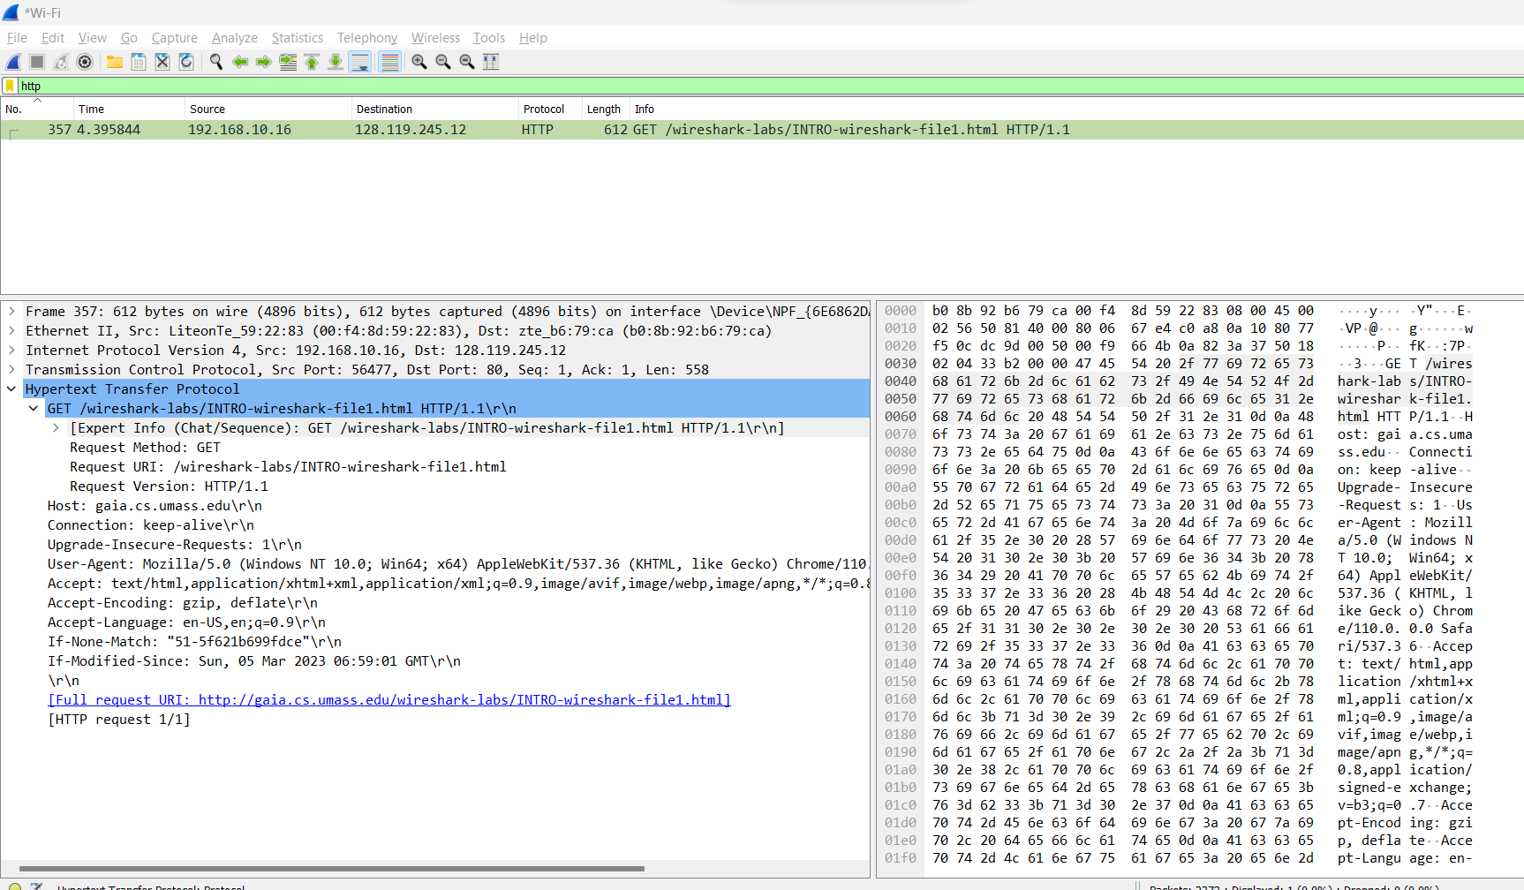

**3. What is the Internet address of the gaia.cs.umass.edu (also known as www-**

**net.cs.umass.edu)? What is the Internet address of your computer or (if you are**

**using the trace file) the computer that sent the HTTP GET message?**

**To answer the following two questions, you’ll need to select the TCP packet containing**

**the HTTP GET request (hint: this is packet number 286 6 ). The purpose of these next two**

**questions is to familiarize you with using Wireshark’s “Details of selected packet**

**window”; see Figure 3. To do this, click on Packet 286 (your screen should look similar**

**to Figure 3). To answer the first question below, then look in the “Details of selected**

**packet” window toggle the triangle for HTTP (your screen should then look similar to**

**Figure 5); for the second question below, you’ll need to expand the information on the**

**Transmission Control Protocol (TCP) part of this packet.**

**ANSWER:**

The internet address of the gaia.cs.umass.edu is: 128.119.245.12

The internet address of the my computer is: 192.168.10.16



**4. Expand the information on the HTTP message in the Wireshark “Details of**

**selected packet” window (see Figure 3 above) so you can see the fields in the**

**HTTP GET request message. What type of Web browser issued the HTTP**

**request? The answer is shown at the right end of the information following the**

**“User-Agent:” field in the expanded HTTP message display. [This field value in**

**the HTTP message is how a web server learns what type of browser you are**

**using.]**

**• Firefox, Safari, Microsoft Internet Edge, Other**

**ANSWER:**

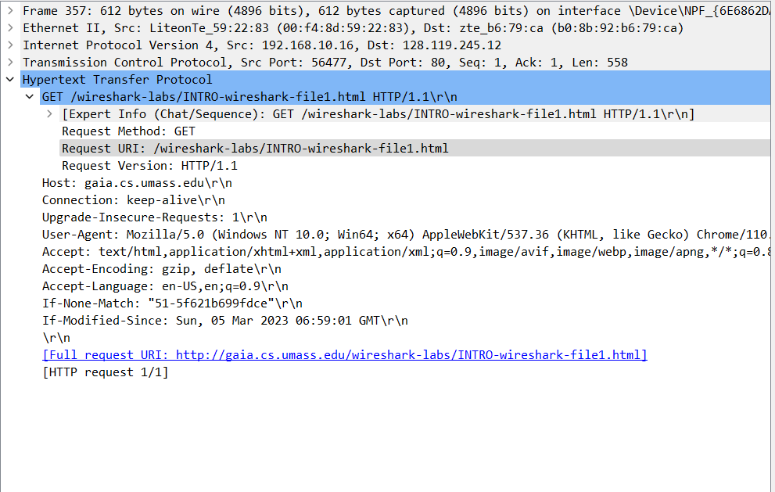

**5. Expand the information on the Transmission Control Protocol for this packet in**

**the Wireshark “Details of selected packet” window (see Figure 3 in the lab**

**writeup) so you can see the fields in the TCP segment carrying the HTTP**

**message. What is the destination port number (the number following “Dest Port:”**

**for the TCP segment containing the HTTP request) to which this HTTP request is**

**being sent?**

**ANSWER: PORT : 80.**

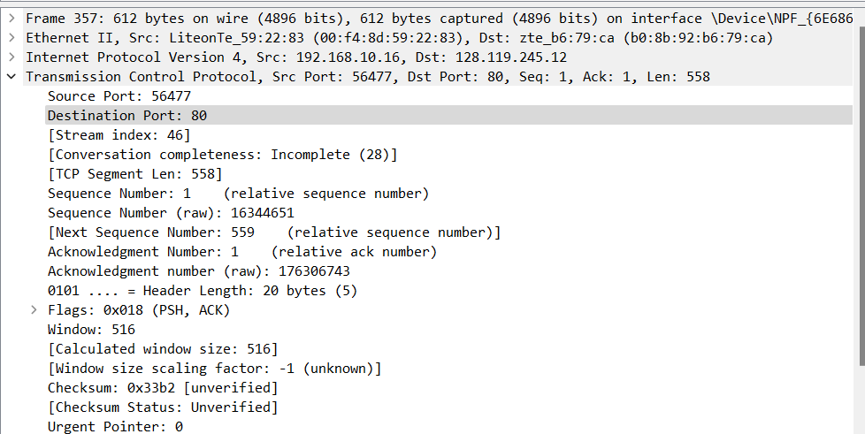

**6. Print the two HTTP messages (GET and OK) referred to in question 2 above. To**

**do so, select Print from the Wireshark File command menu, and select the**

**“Selected Packet Only” and “Print as displayed” radial buttons, and then click**

**OK.**

**ANSWER:**

