THE UNIVERSITY OF AZAD JAMMU & KASHMIR
DEPARTMENT OF SOFTWARE ENGINEERING

Student Name | Raja WajihUllah khan | 
Roll Number | 2024-SE-28
Course Name | Digital Image Processing Lab
Course Code | SE-3104
Session | 2024-2028 (BS SE - 5th Sem)
Department Name | Department of Software Engineering
Task / Assignment No. | Lab Task #02 Report
Instructor Name | Engr. Fahad Nisar
Submission Date | October 29, 2026
Topic / Title | Python Setup, Fundamentals, & Imports

LAB REPORT 02

Objective:
To use NumPy, OpenCV, and Matplotlib to load, inspect, display, analyze, transform, and save digital images while correctly handling coordinates, color channels, histograms, resolution, and bit depth.
2. Step-by-Step Practical Implementation
Step 1: Project & Virtual Environment Setup
1. Created project directory named dip-lab-02 using Windows Command Prompt.
2. Opened directory in VS Code and generated virtual environment: python -m venv .venv.
3. Activated environment using .venv\Scripts\activate.bat.
4. Installed required packages: pip install numpy opencv-python matplotlib.
5. Created .gitignore file and added .venv/ to prevent committing virtual environment dependencies.

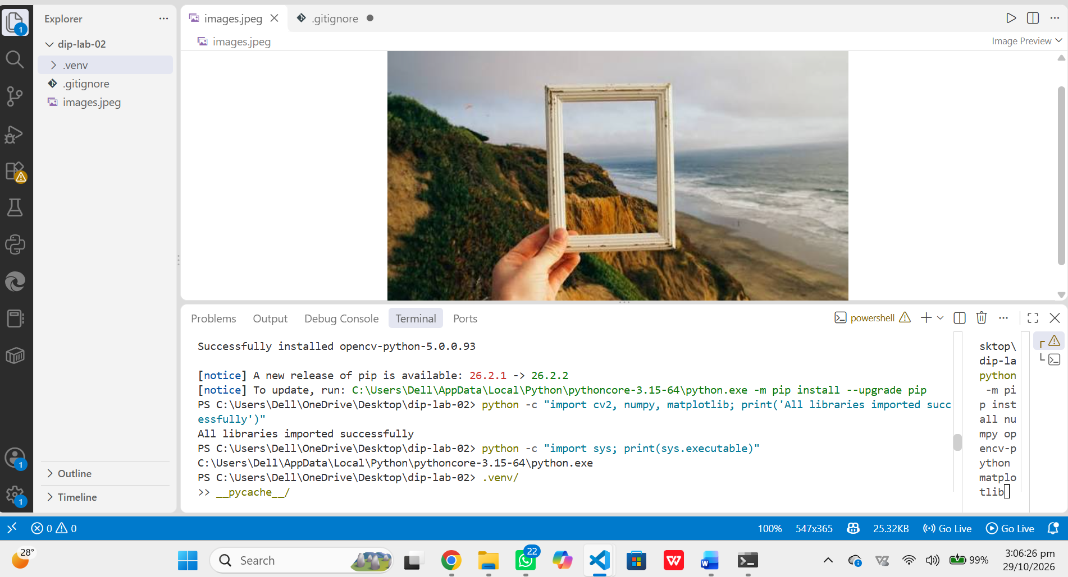

Step 2: Load the Image
The image was loaded with cv.imread(). If OpenCV cannot find or decode the file it returns None, so the script raises FileNotFoundError instead of failing later with a confusing error.
Code:
print("\n" + "=" * 60)
print("STEP 2: LOAD THE IMAGE")
print("=" * 60)
image = cv.imread(IMAGE_PATH) # OpenCV loads color images in BGR order
if image is None:
raise FileNotFoundError(f"Image not found or unreadable: {IMAGE_PATH}")
print("Image shape (H, W, C):", image.shape)
print("Image data type :", image.dtype)

Step 3: Inspect the Image
Pixels are accessed with [row, column] indexing, i.e. image[y, x]. Row is the vertical position and column is the horizontal position. The center pixel is [height // 2, width // 2]. OpenCV stores channels in B, G, R order, so every printed pixel is (B, G, R).
Code:
print("\n" + "=" * 60)
print("STEP 3: INSPECT THE IMAGE")
print("=" * 60)
height, width, channels = image.shape
print("Height :", height, "pixels")
print("Width :", width, "pixels")
print("Channels :", channels)

center_row, center_col = height // 2, width // 2
print("Top-left pixel [0, 0] (B, G, R) :", image[0, 0])
print(f"Center pixel [{center_row}, {center_col}] (B, G, R) :",
image[center_row, center_col])

print("Global minimum value :", image.min())
print("Global maximum value :", image.max())
for idx, name in enumerate(["Blue", "Green", "Red"]):
print(f"{name:5s} channel -> min: {image[:, :, idx].min():3d}, "
f"max: {image[:, :, idx].max():3d}")

Property | Value | Meaning
Height × Width | 480 × 640 | Rows × columns of pixels
Channels | 3 | Blue, Green, Red
Pixel [0, 0] | B=200, G=121, R=38 | Top-left: blue sky
Pixel [240, 320] | B=93, G=70, R=61 | Center: dark mountain
Global min / max | 3 / 255 | Across all channels
Blue min / max | 3 / 221 | Per-channel range
Green min / max | 18 / 240 | Per-channel range
Red min / max | 7 / 255 | Per-channel range

Step 4: Color Conversion and Channel Separation
OpenCV reads images as BGR, but Matplotlib expects RGB. cv.cvtColor() with COLOR_BGR2RGB swaps the first and third channels. A grayscale version was made with COLOR_BGR2GRAY, and the R, G, B channels were separated by slicing the last axis of the RGB array. Individual channels are single-channel arrays, so they are displayed with the gray colormap (vmin=0, vmax=255).

Code:
print("\n" + "=" * 60)
print("STEP 4: COLOR CONVERSION AND CHANNEL SEPARATION")
print("=" * 60)
rgb = cv.cvtColor(image, cv.COLOR_BGR2RGB)
gray = cv.cvtColor(image, cv.COLOR_BGR2GRAY)
red, green, blue = rgb[:, :, 0], rgb[:, :, 1], rgb[:, :, 2]
print("RGB shape :", rgb.shape)
print("Gray shape :", gray.shape)

fig, axes = plt.subplots(2, 3, figsize=(15, 8))
panels = [
(rgb, "RGB (correct colors)", None),
(red, "Red channel", "gray"),
(green, "Green channel", "gray"),
(blue, "Blue channel", "gray"),
(gray, "Grayscale", "gray"),
(image, "Unconverted BGR shown by Matplotlib (wrong colors)", None),
]
for ax, (data, title, cmap) in zip(axes.ravel(), panels):
ax.imshow(data, cmap=cmap, vmin=0 if cmap else None, vmax=255 if cmap else None)
ax.set_title(title, fontsize=11)
ax.axis("off")
plt.tight_layout()
plt.savefig("channels_figure.png", dpi=120)
plt.close()
print("Saved figure: channels_figure.png")

r, g, b = (int(v) for v in rgb[center_row, center_col])
hex_value = "#{:02X}{:02X}{:02X}".format(r, g, b)
print(f"Center pixel RGB : ({r}, {g}, {b})")
print("Center pixel HEX :", hex_value)

Observations
- In the red channel the sun and the orange horizon glow are bright (high red), while the blue lake is dark.
- In the blue channel the lake and the upper sky are bright, while the sun, house, and trees are dark.
- In the green channel the grass and trees are brighter than in the other channels.
- The unconverted BGR panel shows wrong colors: the blue upper sky turns orange, the red house turns blue, and the blue lake turns orange, because Matplotlib treats the first channel (blue) as red.
HEX conversion: The center pixel in RGB is (61, 70, 93). Each value is written as a two-digit hexadecimal number: 61 = 3D, 70 = 46, 93 = 5D, giving #3D465D.

Step 5: Crop, Resize, and Save
NumPy slicing image[y_start:y_end, x_start:x_end] extracts a rectangular region. The end index is excluded, so rows 100:200 and columns 250:350 give exactly 100 × 100 pixels. The crop was enlarged to 200 × 200 with cv.resize() (note: cv.resize takes size as (width, height)). Because Matplotlib works in RGB, the resized image was converted back to BGR with COLOR_RGB2BGR before cv.imwrite(), since imwrite expects BGR.
print("\n" + "=" * 60)
print("STEP 5: CROP, RESIZE, AND SAVE")
print("=" * 60)
y_start, y_end = 100, 200
x_start, x_end = 250, 350
crop = rgb[y_start:y_end, x_start:x_end]
print(f"Crop region: rows {y_start}:{y_end}, cols {x_start}:{x_end}")
print("Crop shape :", crop.shape)

resized = cv.resize(crop, (200, 200), interpolation=cv.INTER_LINEAR)
print("Resized crop shape:", resized.shape)

original_marked = rgb.copy()
cv.rectangle(original_marked, (x_start, y_start), (x_end, y_end), (255, 0, 0), 3)

fig, axes = plt.subplots(1, 3, figsize=(15, 5.5), layout="constrained")
axes[0].imshow(original_marked)
axes[0].set_title(f"Original {width}x{height} (crop region in red)")
axes[1].imshow(crop)
axes[1].set_title("Crop 100x100")
axes[2].imshow(resized)
axes[2].set_title("Resized 200x200")
for ax in axes:
ax.axis("off")
plt.savefig("crop_resize_figure.png", dpi=120)
plt.close()
print("Saved figure: crop_resize_figure.png")

resized_bgr = cv.cvtColor(resized, cv.COLOR_RGB2BGR)
saved = cv.imwrite("resized_crop.png", resized_bgr)
print("cv.imwrite() saved resized_crop.png successfully:", saved)

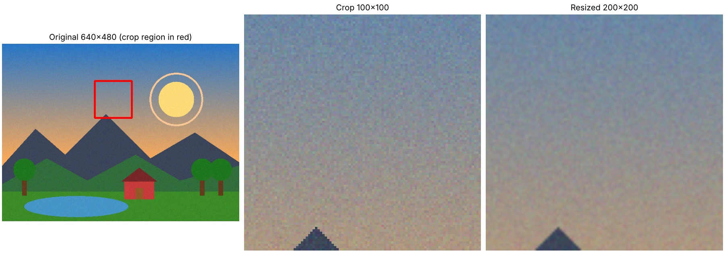
Original image (crop area marked in red), the 100 × 100 crop, and the 200 × 200 resized crop.
Resizing to double the size does not add real detail; it interpolates new pixels between existing ones, so the enlarged image looks smoother but not sharper. The saved file resized_crop.png was written successfully (imwrite returned True).
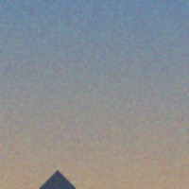

Step 6: Grayscale Histogram
The 2-D grayscale image was flattened into a 1-D array and plotted with 256 bins over the range 0–256, so each bin represents one intensity level.
Code:
print("\n" + "=" * 60)
print("STEP 6: GRAYSCALE HISTOGRAM")
print("=" * 60)
flat = gray.flatten()
plt.figure(figsize=(9, 5))
plt.hist(flat, bins=256, range=(0, 256), color="gray", edgecolor="none")
plt.title("Grayscale Histogram (256 bins)")
plt.xlabel("Pixel intensity (0 = black, 255 = white)")
plt.ylabel("Number of pixels")
plt.xlim(0, 255)
plt.grid(alpha=0.3)
plt.tight_layout()
plt.savefig("grayscale_histogram.png", dpi=120)
plt.close()
print("Saved plot: grayscale_histogram.png")
print("Total pixels :", flat.size)
print("Mean intensity :", round(float(flat.mean()), 2))
print("Median intensity :", float(np.median(flat)))
print("Pixels < 85 (dark) : {:.1f}%".format(100 * np.mean(flat < 85)))
print("Pixels 85-170 (mid) : {:.1f}%".format(100 * np.mean((flat >= 85) & (flat <= 170))))
print("Pixels > 170 (bright) : {:.1f}%".format(100 * np.mean(flat > 170)))

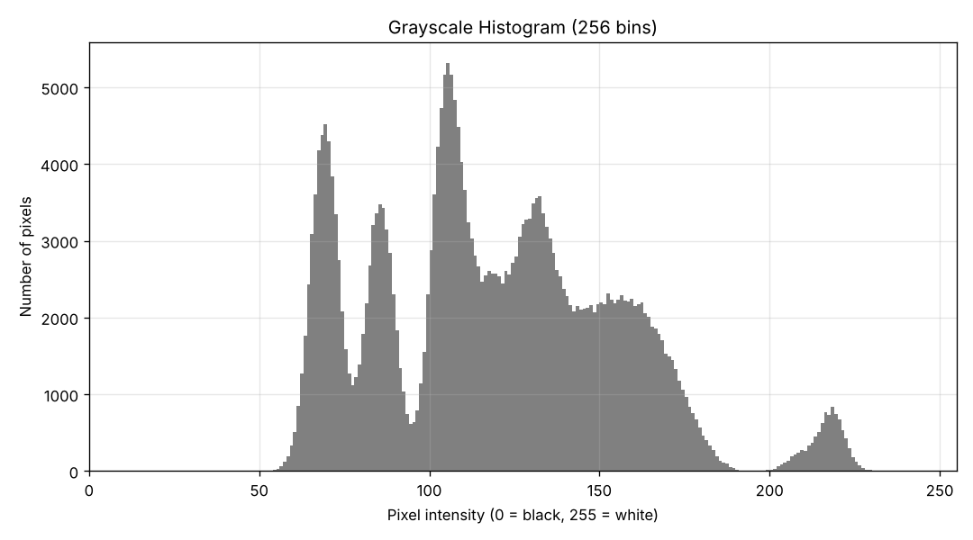

Interpretation
The image is mainly balanced with a slight lean toward the mid-tones. The mean intensity is about 119 and the median is 116, close to the middle of the 0–255 scale, and about 73% of pixels lie between 85 and 170. Only about 21% of pixels are dark (below 85) and about 7% are bright (above 170), and almost no pixels are near pure black or pure white, which means the image has fairly low contrast.
What a histogram shows and does not show: A histogram shows how many pixels have each intensity, so it reveals overall brightness, contrast, and the presence of clipping. It does not show where the pixels are located, so two completely different images can have the same histogram. It also hides shapes, edges, textures, and (for a grayscale histogram) color information.

Step 7: Bit Depth Demonstration
An 8-bit horizontal gradient (100 × 256) was created with np.linspace and np.tile. It was then quantized to 1, 2, and 4 bits, i.e. 2, 4, and 16 gray levels. The function divides each pixel by the step size (256 / levels) to get a level number, then multiplies back so the levels span 0–255 for display.
a level number, then multiplies back so the levels span 0–255 for display.
Code:
print("\n" + "=" * 60)
print("STEP 7: BIT DEPTH DEMONSTRATION")
print("=" * 60)
row = np.linspace(0, 255, 256).astype(np.uint8) # 0..255
gradient_8 = np.tile(row, (100, 1)) # 100 x 256, 8-bit

def quantize(img, bits):
"""Reduce an 8-bit image to 2**bits gray levels, scaled back to 0-255."""
levels = 2 ** bits
step = 256 // levels
q = (img // step).astype(np.uint8) # 0 .. levels-1
return (q * (255 // (levels - 1))).astype(np.uint8) # stretch to 0..255

gradient_1 = quantize(gradient_8, 1)
gradient_2 = quantize(gradient_8, 2)
gradient_4 = quantize(gradient_8, 4)

fig, axes = plt.subplots(4, 1, figsize=(9, 7))
for ax, data, title in zip(
[gradient_8, gradient_4, gradient_2, gradient_1],
["8-bit (256 levels)", "4-bit (16 levels)", "2-bit (4 levels)", "1-bit (2 levels)"],
):
ax.imshow(data, cmap="gray", vmin=0, vmax=255, aspect="auto")
ax.set_title(title, fontsize=11)
ax.set_xticks([]) # keep a thin frame so white bands stay visible
ax.set_yticks([])
plt.tight_layout()
plt.savefig("bit_depth_figure.png", dpi=120)
plt.close()
print("Saved figure: bit_depth_figure.png")

print("Unique values in 8-bit gradient:", len(np.unique(gradient_8)))
print("Unique values in 1-bit gradient:", len(np.unique(gradient_1)))
print("Unique values in 2-bit gradient:", len(np.unique(gradient_2)))
print("Unique values in 4-bit gradient:", len(np.unique(gradient_4)))

print("\n" + "=" * 60)
print("STEP 8: ALL STEPS COMPLETED WITHOUT ERRORS")
print("=" * 60)

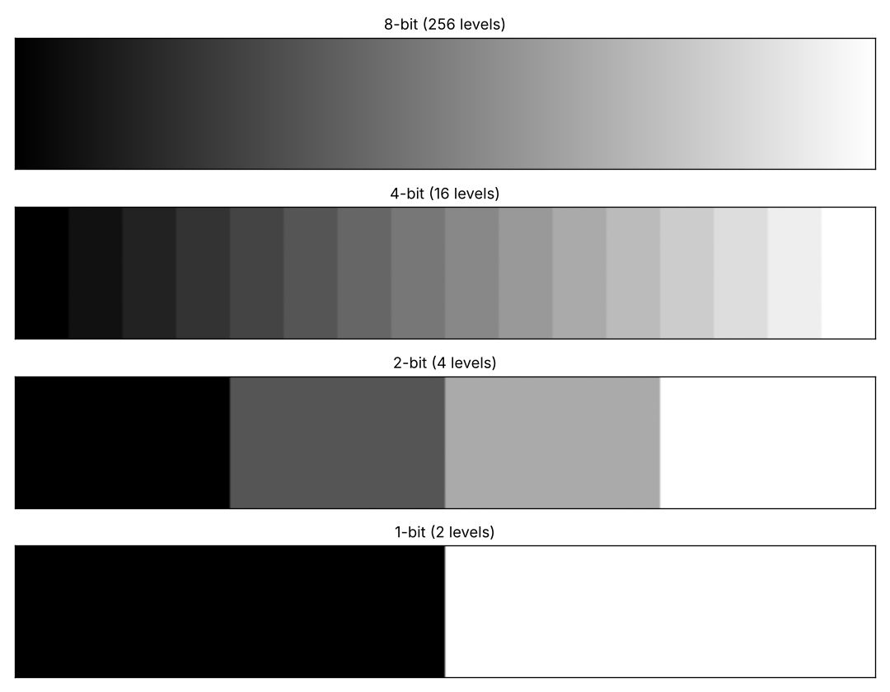

Original 8-bit gradient and its 4-bit, 2-bit, and 1-bits
Bit depth | Gray levels (2^n) | Unique values counted | Visual result
8-bit | 256 | 256 | Smooth gradient
4-bit | 16 | 16 | Visible bands
2-bit | 4 | 4 | Four wide blocks
1-bit | 2 | 2 | Pure black and white

Step 8: Final Successful Run
lab02.py was run from the activated virtual environment with the command below. All steps completed without errors, and every output file was produced.
Command:
python lab02.py
Complete program output:
============================================================
STEP 1: ENVIRONMENT CHECK
============================================================
Python executable : /home/claude/dip-lab-02/.venv/bin/python
OpenCV version : 5.0.0
NumPy version : 2.5.3
Matplotlib version: 3.11.2

============================================================
STEP 2: LOAD THE IMAGE
============================================================
Image shape (H, W, C): (480, 640, 3)
Image data type : uint8

============================================================
STEP 3: INSPECT THE IMAGE
============================================================
Height : 480 pixels
Width : 640 pixels
Channels : 3
Top-left pixel [0, 0] (B, G, R) : [200 121 38]
Center pixel [240, 320] (B, G, R) : [93 70 61]
Global minimum value : 3
Global maximum value : 255
Blue channel -> min: 3, max: 221
Green channel -> min: 18, max: 240
Red channel -> min: 7, max: 255

============================================================
STEP 4: COLOR CONVERSION AND CHANNEL SEPARATION
============================================================
RGB shape : (480, 640, 3)
Gray shape : (480, 640)
Saved figure: channels_figure.png
Center pixel RGB : (61, 70, 93)
Center pixel HEX : #3D465D

============================================================
STEP 5: CROP, RESIZE, AND SAVE
============================================================
Crop region: rows 100:200, cols 250:350
Crop shape : (100, 100, 3)
Resized crop shape: (200, 200, 3)
Saved figure: crop_resize_figure.png
cv.imwrite() saved resized_crop.png successfully: True

============================================================
STEP 6: GRAYSCALE HISTOGRAM
============================================================
Saved plot: grayscale_histogram.png
Total pixels : 307200
Mean intensity : 118.68
Median intensity : 116.0
Pixels < 85 (dark) : 20.7%
Pixels 85-170 (mid) : 72.7%
Pixels > 170 (bright) : 6.6%

============================================================
STEP 7: BIT DEPTH DEMONSTRATION
============================================================
Saved figure: bit_depth_figure.png
Unique values in 8-bit gradient: 256
Unique values in 1-bit gradient: 2
Unique values in 2-bit gradient: 4
Unique values in 4-bit gradient: 16

============================================================
STEP 8: ALL STEPS COMPLETED WITHOUT ERRORS

3. Conceptual Explanations & Theory Questions
3.1 Color Formats: BGR vs. RGB
- BGR Format (OpenCV Default): OpenCV uses BGR ordering due to early historical hardware conventions in digital video and graphics adapters (such as camera frame grabbers). When OpenCV reads an image, channel index 0 represents Blue, channel index 1 represents Green, and channel index 2 represents Red.
- RGB Format (Standard Display): RGB is the universal standard for modern displays, graphics frameworks, Matplotlib, and web standards. Channel index 0 represents Red, index 1 represents Green, and index 2 represents Blue.
- Visual Consequence of Mis-mapping: If an un-converted BGR image array is passed directly into Matplotlib's imshow() function, the Red and Blue color channels become inverted. Red objects appear blue, and blue objects appear red or orange, resulting in unnatural color distortion.
- unnatural color distortion.
3.2 Spatial Resolution vs. Bit Depth
- Spatial Resolution: Spatial resolution refers to the total number of pixels along the spatial grid of the image (Width × Height, e.g., 1920 × 1080). Higher spatial resolution enables fine spatial details, sharp edges, and textures to be captured.
- Bit Depth (Color Resolution): Bit depth specifies the number of bits allocated to represent the intensity value of each pixel or color channel. An n-bit image can represent 2^n distinct intensity levels (e.g., 8-bit = 256 levels, 1-bit = 2 levels). Higher bit depth allows smooth tonal transitions and subtle shading variations. Decreasing bit depth induces posterization and visual false-contouring artifacts.
What a histogram shows and does not show:
A histogram shows how many pixels have each intensity, so it reveals overall brightness, contrast, and the presence of clipping. It does not show where the pixels are located, so two completely different images can have the same histogram. It also hides shapes, edges, textures, and (for a grayscale histogram) color information.

