THE UNIVERSITY OF AZAD JAMMU & KASHMIR
DEPARTMENT OF SOFTWARE ENGINEERING

Student Name | Raja WajihUllah khan | 
Roll Number | 2024-SE-28
Course Name | Software Construction & Development
Course Code | SE-3101
Session | 2024-2028 (BS SE - 5th Sem)
Department Name | Department of Software Engineering
Task / Assignment No. | Lab Task #02
Instructor Name | Engr. Dr Asma Javed
Submission Date | October 27, 2026
Topic / Title | Food Panda Activity Diagram, Toaster Diagram, Elevator/Lift Machine Diagram

LAB TASK 2: DIAGRAM ANALYSIS & EXPLANATION
Question 1: FoodPanda Activity Diagram with Swimlanes
An Activity Diagram using Swimlanes partitions activities into separate columns representing organizational units or system roles responsible for performing specific actions. Below is the multi-swimlane workflow breakdown for the FoodPanda application.
Swimlane Role / Partition | Responsibilities & Key Activities
Customer | Browses restaurants, selects food items, inputs delivery address, places order, chooses payment method, tracks order status, receives delivery, and rates service.
FoodPanda Platform | Validates payment details, authenticates order, routes order to restaurant, assigns delivery rider, streams real-time GPS tracking data, and processes feedback.
Restaurant & Delivery | Accepts order, prepares meal, packages order, hands over food to assigned rider, dispatches item, and completes final delivery to customer door.

SWIMLANE COLOR CODING PATTERN
Visual Design & Color Pattern:
• Customer Lane (Teal #008080): User-facing UI events.
• System Lane (Navy #182B49): Backend processing and orchestration.
• Restaurant Lane (Amber / Gold): Kitchen operations and prep milestones.
• Rider Lane (Coral / Orange): Transit, GPS navigation, and physical handover.

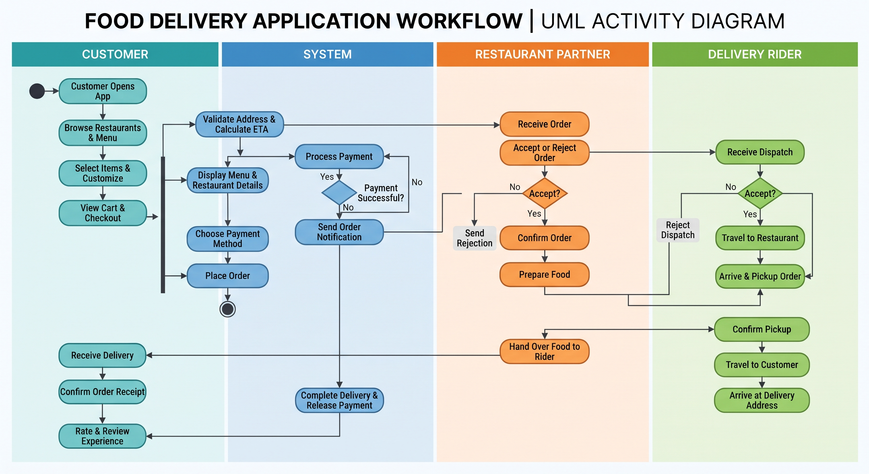

Question 2: State Machine Diagram for a Toaster
A State Diagram models the dynamic life cycle of a system by depicting its states, internal activities, and transitions triggered by external events or conditions.
1. Internal Activities within Each State (UML Notation)
State | UML Activity Type | Description / Executed Action
IDLE | entry /  do /  exit / | display 'Ready'  wait for lever push  engage lever lock mechanism
HEATING | entry /  do /  exit / | energize electromagnet  supply power to heating coils & run timer countdown  cut power to coils & release spring lever

2.1 States and Internal Activities
1. Idle (Off / Standby) State
The toaster is plugged in with the carriage lever in the up position and heating elements unpowered. Internal activities include monitoring electrical continuity and maintaining the mechanical latch unlatched.
2. Bread Loaded (Ready) State
Bread slices are inserted into slots, resting on the wire carriage. Internal activities include optical/mechanical bread presence detection and browning dial level scanning (1 to 5).
3. Toasting (Active Heating) State
Carriage lever depressed, mechanical latch engaged, internal circuit closed, nichrome wire heating elements glowing red, and thermal timer counting down. Internal activities include radiant heat generation, timer countdown, and ambient chassis temperature monitoring.
4. Completed / Popped-Up State
Timer expired or cancel button pressed, releasing the magnetic/mechanical latch, causing spring tension to push carriage upward. Internal activities include power cut-off to heating elements, mechanical release, and optional audio buzzer activation.

2. Triggered vs. Triggerless Events & Actions
• Triggered Events: Explicitly initiated by an external user or sensor input.
- push_lever_down: User manually presses the handle down (Triggers transition from IDLE to HEATING).
- press_cancel_button: User interrupts the cycle (Triggers immediate pop up).
• Triggerless Events / Actions: Automatic completion transitions executed internally when condition/timer expires.
- timer_expired: System automatically transitions from HEATING back to IDLE without external intervention.
- pop_up_toast & sound_beep: Automatic actions executed upon completing heating.

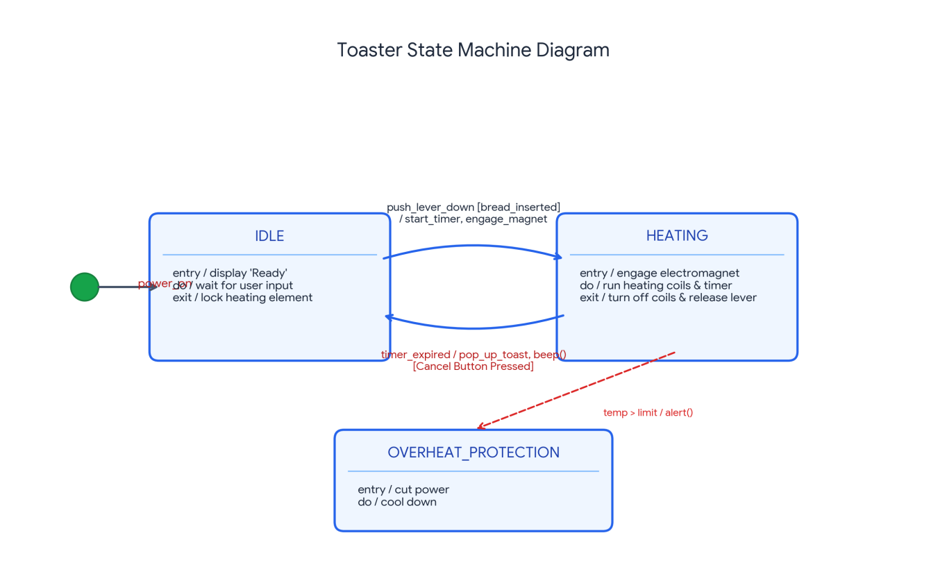

Question 3: State Machine Diagram of Elevator / Lift System
The elevator system coordinates movement across multiple floors based on user floor selection and hall calls. It operates through distinct state transitions governed by directional control logic.
Elevator System States Description
Elevator State | Description & State Behavior
IDLE | The lift is stationary at a floor with doors closed, waiting for floor call requests.
MOVING UP | The motor drives the car upward towards higher target floors, continuously updating floor position indicators.
MOVING DOWN | The motor drives the car downward towards lower target floors, continuously updating position metrics.
DOORS OPEN | The lift has reached the destination floor; doors open for passenger ingress/egress for a set duration (e.g., 5 seconds) before closing automatically.

