THE UNIVERSITY OF AZAD JAMMU & KASHMIR
DEPARTMENT OF SOFTWARE ENGINEERING

Student Name | Raja WajihUllah Khan | 
Roll Number | 2024-SE-28
Course Name | Software Construction & Development
Course Code | SE-3101
Session | 2024-2028 (SE - 5th Sem)
Department Name | Department of Software Engineering
Task / Assignment No. | Lab Task #01
Instructor Name | Engr. Dr Asma Javed
Submission Date | October 27, 2026
Topic / Title | UML Use Case Diagram

1. Introduction to UML Use Case Diagram
A Use Case Diagram is a behavioral Unified Modeling Language (UML) diagram used to specify, analyze, and document the functional requirements of a system. It provides a high-level visual representation of how users (actors) interact with the system to perform specific operations (use cases).

Component | Notation | Description
Actor | Stick Figure | Represents an external entity (user, external hardware, or secondary system) that interacts with the system.
Use Case | Horizontal Oval | Represents a specific functionality or goal achieved by an actor interacting with the system.
System Boundary | Rectangle Box | Defines the scope of the system. Use cases lie inside, while actors remain outside.
Association | Solid Line | Connects an actor to a use case, showing their communication or interaction.

2. Question 1: Online Ticket Reservation System
Actor Name | Actor Type | Role & Description
Customer / Passenger | Primary Actor | Initiates search, selects seats, completes ticket bookings, and downloads e-tickets.
System Administrator | Secondary Actor | Manages schedules, updates routes/fare prices, and monitors system reports.
Payment Gateway | External System Actor | Authorizes payments, processes bank transactions, and returns authorization status.

Identified Components:
Actors:
• Customer / User: Searches events/trips, selects seats, books tickets, makes payments, and views/downloads tickets.
• Payment Gateway (Secondary Actor): Processes payment transactions securely.
• System Admin: Manages schedules, updates ticket availability, and manages pricing/rates.
Use Cases:
1. Search Tickets / Events
2. Select Seats / Date
3. Book Ticket
4. Make Payment
5. Cancel Reservation
6. Download / View Ticket
7. Manage Schedule & Rates
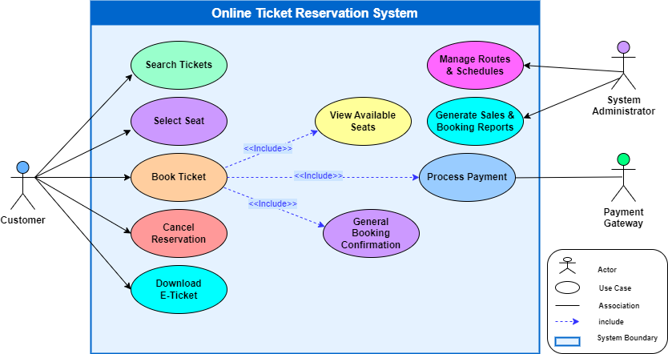

Question 2: Credit Card Processing System
Case Study Summary: Customer buys an item from a shopping mall via credit card. Vendor generates the bill, customer provides the card to swap. The card reader processes the transaction amount, prints a receipt, and customer signs the receipt and returns it to the vendor.

Part (a): Identification of Actors and Use Cases
Category | Identified Elements
Actors | 1. Customer (Primary User)  2. Vendor / Shopkeeper (Primary User)  3. Card Reader / Credit Card Machine (External System Actor)
Use Cases | 1. Select Item  2. Generate Bill  3. Swipe Credit Card  4. Process Amount Transaction  5. Print Balance Receipt  6. Sign Receipt
System Boundary | Credit Card Processing System

3. Identified Actors
Actor Name | Actor Type | Role & Description
Customer | Primary Actor | Selects items, provides payment card, and signs printed transaction receipt.
Vendor | Secondary Actor | Generates bill/invoice, handles payment terminal interaction, and hands receipt to customer.
Credit Card Machine (POS) | System / Hardware Actor | Processes amount transaction, verifies balance limits, and prints receipt/statement.

