**1. UserCredentials**

Description: The "Login" table stores user login credentials.

| **Column** | **Data Type** | **Description** |
| --- | --- | --- |
| Id_User | nchar(50) | Primary key for the user |
| Username | nchar(50) | User's login username |
| Password | nchar(50) | User's login password |

Key(s):

- Primary Key: `Id_User` is the primary key of the "Login" table, which uniquely identifies each user record.

**2. ClientInformation**

Description: The "Customer" table contains customer information.

| **Column** | **Data Type** | **Description** |
| --- | --- | --- |
| Id_Customer | int (PK) | Primary key for the customer |
| Fullname | nchar(50) | Customer's full name |
| Address1 | nchar(100) | Customer's primary address |
| Address2 | nchar(100) | Customer's secondary address (if any) |
| City | nchar(100) | City where the customer resides |
| State | nchar(2) | State abbreviation (e.g., CA, NY) |
| Zipcode | nchar(9) | Customer's postal/ZIP code |
| Id_User | nchar(50) | Foreign key referencing "Id_User" in the "Login" table |

Key(s):

- Primary Key: `Id_Customer` is the primary key of the "Customer" table, uniquely identifying each customer record.

- Foreign Key: `Id_User` is a foreign key that references the "Id_User" column in the "Login" table, establishing a relationship between customers and their respective users.

**3. FuelQuote**

Description: The "Information" table stores details about gas delivery requests.

| **Column** | **Data Type** | **Description** |
| --- | --- | --- |
| Id_Inf | int (PK) | Primary key for the information record |
| Galon_request | int | Gallons of gas requested |
| Delivary_Address | nchar(200) | Combined address from "Address1" and "Address2" in the "Customer" table |
| Delivery_Date | time(7) | Time of gas delivery |
| Id_Price | int (FK) | Foreign key referencing "Id_Price" in the "Price" table |
| Id_User | nchar(50) | Foreign key referencing "Id_User" in the "Login" table |

Key(s):

- Primary Key: `Id_Inf` is the primary key of the "Information" table, uniquely identifying each record.

- Foreign Key: `Id_Price` is a foreign key that references the "Id_Price" column in the "Price" table, linking gas delivery information to the corresponding price.

- Foreign Key: `Id_User` is a foreign key that references the "Id_User" column in the "Login" table, associating gas delivery information with the relevant user.

**4. Price**

Description: The "Price" table contains gas price information for different periods.

| **Column** | **Data Type** | **Description** |
| --- | --- | --- |
| Id_Price | int (PK) | Primary key for the price record |
| Start_Date | time(7) | Starting time of the price period |
| End_Date | time(7) | Ending time of the price period |
| Amount | int | Price of gas for the period |

Key(s):

- Primary Key: `Id_Price` is the primary key of the "Price" table, uniquely identifying each price record.

In this section, we present the database schema diagram along with comprehensive details for each table and its relationships.

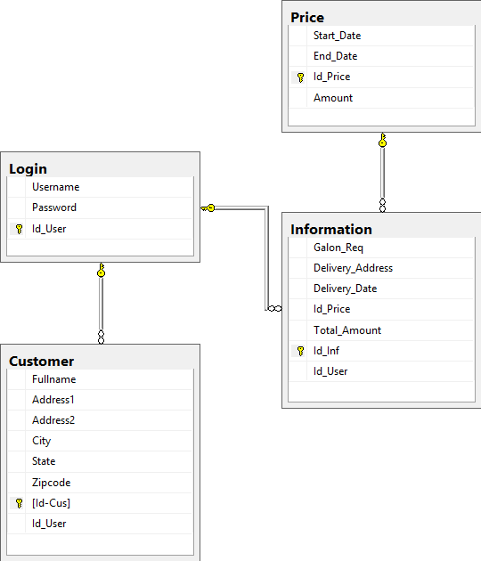

**Code**

USE [Asia]

GO

SET ANSI_NULLS ON

GO

SET QUOTED_IDENTIFIER ON

GO

CREATE TABLE [dbo].[ClientInformation](

[Fullname] [nchar](50) NOT NULL,

[Address1] [nchar](100) NOT NULL,

[Address2] [nchar](100) NOT NULL,

[City] [nchar](100) NOT NULL,

[State] [nchar](2) NOT NULL,

[Zipcode] [nchar](9) NOT NULL,

[Id-Cus] [int] IDENTITY(1,1) NOT NULL,

[Id_User] [nchar](50) NOT NULL,

CONSTRAINT [PK_ClientInformation] PRIMARY KEY CLUSTERED

(

[Id-Cus] ASC

)WITH (PAD_INDEX = OFF, STATISTICS_NORECOMPUTE = OFF, IGNORE_DUP_KEY = OFF, ALLOW_ROW_LOCKS = ON, ALLOW_PAGE_LOCKS = ON) ON [PRIMARY]

) ON [PRIMARY]

GO

ALTER TABLE [dbo].[ClientInformation] WITH CHECK ADD CONSTRAINT [FK_ClientInformation_UserCredentials] FOREIGN KEY([Id_User])

REFERENCES [dbo].[UserCredentials] ([Id_User])

GO

ALTER TABLE [dbo].[ClientInformation] CHECK CONSTRAINT [FK_ClientInformation_UserCredentials]

GO

USE [Asia]

GO

SET ANSI_NULLS ON

GO

SET QUOTED_IDENTIFIER ON

GO

CREATE TABLE [dbo].[FuelQuote](

[Galon_Req] [int] NOT NULL,

[Delivery_Address] [nchar](200) NOT NULL,

[Delivery_Date] [time](7) NOT NULL,

[Id_Price] [int] NOT NULL,

[Total_Amount] [int] NOT NULL,

[Id_Inf] [int] IDENTITY(1,1) NOT NULL,

[Id_User] [nchar](50) NOT NULL,

CONSTRAINT [PK_FuelQuote] PRIMARY KEY CLUSTERED

(

[Id_Inf] ASC

)WITH (PAD_INDEX = OFF, STATISTICS_NORECOMPUTE = OFF, IGNORE_DUP_KEY = OFF, ALLOW_ROW_LOCKS = ON, ALLOW_PAGE_LOCKS = ON) ON [PRIMARY]

) ON [PRIMARY]

GO

ALTER TABLE [dbo].[FuelQuote] WITH CHECK ADD CONSTRAINT [FK_FuelQuote_Price] FOREIGN KEY([Id_Price])

REFERENCES [dbo].[Price] ([Id_Price])

GO

ALTER TABLE [dbo].[FuelQuote] CHECK CONSTRAINT [FK_FuelQuote_Price]

GO

ALTER TABLE [dbo].[FuelQuote] WITH CHECK ADD CONSTRAINT [FK_FuelQuote_UserCredentials] FOREIGN KEY([Id_User])

REFERENCES [dbo].[UserCredentials] ([Id_User])

GO

ALTER TABLE [dbo].[FuelQuote] CHECK CONSTRAINT [FK_FuelQuote_UserCredentials]

GO

USE [Asia]

GO

SET ANSI_NULLS ON

GO

SET QUOTED_IDENTIFIER ON

GO

CREATE TABLE [dbo].[Price](

[Start_Date] [time](7) NOT NULL,

[End_Date] [time](7) NOT NULL,

[Id_Price] [int] IDENTITY(1,1) NOT NULL,

[Amount] [int] NOT NULL,

CONSTRAINT [PK_Price] PRIMARY KEY CLUSTERED

(

[Id_Price] ASC

)WITH (PAD_INDEX = OFF, STATISTICS_NORECOMPUTE = OFF, IGNORE_DUP_KEY = OFF, ALLOW_ROW_LOCKS = ON, ALLOW_PAGE_LOCKS = ON) ON [PRIMARY]

) ON [PRIMARY]

GO

USE [Asia]

GO

SET ANSI_NULLS ON

GO

SET QUOTED_IDENTIFIER ON

GO

CREATE TABLE [dbo].[UserCredentials](

[Username] [nchar](50) NOT NULL,

[Password] [nchar](50) NOT NULL,

[Id_User] [nchar](50) NOT NULL,

CONSTRAINT [PK_UserCredentials] PRIMARY KEY CLUSTERED

(

[Id_User] ASC

)WITH (PAD_INDEX = OFF, STATISTICS_NORECOMPUTE = OFF, IGNORE_DUP_KEY = OFF, ALLOW_ROW_LOCKS = ON, ALLOW_PAGE_LOCKS = ON) ON [PRIMARY]

) ON [PRIMARY]

GO