A Target Cross-linking Tool
for
the 2020 biodiversity targets

Concept and roadmap for implementation
BISE-CHM technical working group

Contributors:
Rania Spyropoulou (EEA project manager)
Han de Koeijer (Belgium)
Rob Hendriks (Netherlands)
Eric Wiedmer (ETC/BD – Switzerland)
Sabine Roscher (ETC/BD)
Anne Teller (DG ENV)
Michael Norén (EEA)
Mette Lund (EEA)

Date: 21 September 2015

Contents
Background 2
Aim 3
Functionality of the TCT 3
Parallel developments – the CBD online reporting tool 4
Synergies between the TCT and the CBD online reporting tool 4
Dissemination 4
Annex: TCT specifications 5

Background

In 2010, the 10th Conference of the Parties (COP) to the Convention on Biological Diversity (CBD) adopted the global Strategic Plan for Biodiversity 2011–2020 with its five goals and twenty Aichi Biodiversity Targets. The Strategic Plan was subsequently endorsed and/or supported by the governing bodies of other biodiversity-related conventions. For first time, a universal framework for action on biodiversity has therewith been agreed for all stakeholders.
The goals and targets of the global Strategic Plan for Biodiversity are expected to be reached through the implementation of National Biodiversity Strategies and Action Plans (NBSAPs), regional strategies and targets, such as with the EU Biodiversity strategy to 2020, as well as through the strategies and targets developed by other biodiversity-related conventions.
Effective information services are needed to facilitate the monitoring of implementation of NBSAPs at the national level; they are also needed to facilitate sharing of relevant information at regional level, such as with the EU Biodiversity strategy to 2020 and the global level (e.g. CBD and other biodiversity related agreements such as the Convention on Migratory Species).
The information on the implementation of NBSAPs is the basis for reporting to all other levels, however relevant information needs to be organised and retrieved according to multiple sets of targets. While this type of work is often done manually by different actors at the national level, it is now recognised that specific IT support tools are needed to facilitate the cross-linkages of targets and the organisation of information in order to avoid duplication of efforts and therewith effectively reduce the reporting burden.
Following a notification of the EIONET-Biodiversity NRC network, the national Clearing-House Mechanism (CHM) Focal Points and the EU CGBN members, a BISE-CHM expert meeting was organised in late 2014, where country representatives, the European Commission and the European Environment Agency discussed a Target Cross-linking Tool as part of the overall support of the assessment of the 2020 biodiversity targets.

Aim

The Target Crosslinking Tool (TCT) for the 2020 biodiversity targets is a self-standing working tool developed by the European Environment Agency for the BISE-CHM network of Europe (http://biodiversity.europa.eu/chm-network) but that can be used by any Party and CBD. The TCT enables cross-linkages between biodiversity-related targets from the national to the EU and the global levels, in order to support national and regional assessment of progress and facilitate related reporting obligations.

Functionality of the TCT

The TCT supports national reporters in the preparation of reports to CBD and other biodiversity-related conventions such as CMS, AEWA, Ramsar.
Key information on the implementation of NBSAPs, e.g. the list of national objectives/targets and indicators, are often used in several national reports. Therefore the knowledge on how the national objective/targets are related the targets on European and global level is quite crucial for streamlining the national reporting process including the associated burden.
By means of the TCT, the following information for national reports can be maintained and structured
- national objectives/targets, including a short description
- their cross-linkages to European and global targets
- indicators used on national level to measure progress to the national biodiversity strategies, as well as
- text modules/information blocks to be used under multiple biodiversity related conventions.

The tool provides
- ready to use cross linkages between the targets of the European biodiversity strategy and global Aichi targets
- export functionalities are foreseen to generate report templates, which can be used by the reporter to further work on a specific report.

The added value of the TCT is to support the national reporter in the efficient organization, maintenance and updating of key components for national reports under several biodiversity-related agreements. The TCT is adapted to European needs.
It is foreseen that the next version of the tool will facilitate the export of selected key components into a document, which can be used by the national reporter to further prepare the final report. See the Annex for further details on the user requirements and an envisaged roadmap for development.

Parallel developments – the CBD online reporting tool

The CHM of the CBD developed recently an online reporting tool allowing Parties to report progress towards each of the Aichi Targets and/or national targets set in line with the Strategic Plan for Biodiversity 2011–2020 and the Aichi Targets as well as indicators or other tools developed for measuring progress towards these targets. The CHM also allows for Parties to submit online, among other categories of records, National Reports, National Biodiversity Strategies and Action Plans (NBSAPs), National Targets and National Indicators. The respective common formats are currently being developed. For further information on the CBD online reporting tool see https://www.cbd.int/chm/doc/chm-latest-guide-online-reporting.pdf.

Synergies between the TCT and the CBD online reporting tool
The TCT and the CBD online reporting portal both root in the same process, i.e. the delivery of national/regional information towards the global Strategic Plan for Biodiversity 2011 - 2020 and its Aichi Biodiversity Targets. Synergies between both tools are identified especially regarding the common formats for the submission of information to the CBD. In case countries are interested in using the TCT, further effort is required to optimise the information transfer between the tools and further streamline the reporting requirements.
However, whereas the CBD online reporting tool is tailored for the needs of the reporting to the CBD, the TCT aims at supporting users/countries in the maintenance and organisation of key components such as cross-linkages between national, European and Global biodiversity strategies and indicators used at national level, thus facilitating reporting not only to the CBD but also to other biodiversity-related conventions.

Dissemination

This concept note is intended to be communicated to DGENV in view of the CGBN meeting of 24 September 2015, and prior to an invitation by EEA-ETC/BD for setting up a voluntary working group on the synergy between the CBD tool and the TCT tool.

It is also intended to be communicated to the CHM Informal Advisory Committee of CBD in October 2015.

In 2016, a meeting of the CHM network and EIONET NRCs for biodiversity data and information will discuss next steps in the light of the outcomes of SBSTTA 20 in relation to reporting guidelines for the next CBD report.

Annex: TCT specifications

Actors
The actors that TCT provide support for are:
- National reporter – A person who organises and writes the reports on behalf of a country in response to various reporting obligations.
- EU reporter – A person who organises and writes the reports on behalf of the EU in response to various reporting obligations.
- BISE content editor – A person who is maintaining the content on the Biodiversity Information System for Europe (BISE) website, http://biodiversity.europa.eu/.
- Administrator – A person who is administrating the TCT.

Information model
Reading the requirements, it might be difficult to digest all the information objects referred to, and how those relate to each other. For discussions on the requirements it is also important to have an established terminology. This basic model is providing support for that, here from the perspective of the national reporter and the NBSAP (as the perspective of the EU-reporter is in principle a subset of the national reporter’s view).
From a reporting perspective, there is an obligation to report which the NBSAP needs to relate to. The NBSAP has a strategic part, supported by a concrete implementation and indicators to measure the progress. The strategic part of the NBSAP supports the global and EU targets/actions, for which progress is again measured using the respective indicators.
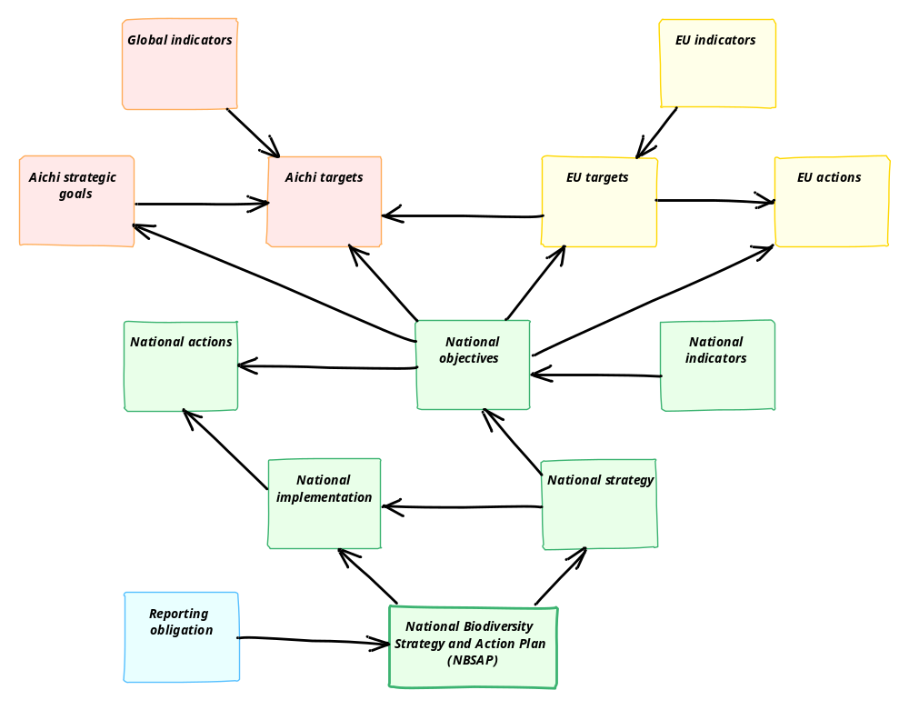

Functional requirements
Here the requirements put on the functionality of TCT are described. Please note that no distinction is made in this listing between already implemented requirements and new requirements. The requirements are in principle the same for the two main actors, so for the sake of readability, what is described for a national reporter with a national perspective is also valid for the European perspective, i.e. an EU reporter working on the EU strategy, objectives, actions or indicators, unless stated. The main difference is that the strategic part consists of “objectives” on the national level, while the EU level deals with “targets”.
Organising national information
As a national reporter I want to:
- Add my national objectives in the tool, so that I can keep track of which objectives I have to support the global and the EU goals/targets/actions. (US1)
- Add my national actions in the tool, so that I can keep track of which actions I support towards my objectives. (US2)
- Add my national indicators in the tool, so that I can keep track of the progress I make on my national objectives. (US3)
- Insert a short description of the national objectives, actions and indicators I add in the tool, so that I don’t have to look them up in other documentation sources to understand their purpose when using them in the tool. (US4)
- Insert common text modules/information blocks, so that I can re-use them when writing a report under multiple biodiversity related conventions. (US5)
- Link my national objectives to my national indicators, so that I can keep track of what indicators I used to follow up progress on the objectives. (US6)
- Link my national objectives to my national actions, so that I can keep track of what actions I have to set up to reach the objectives. (US7)
- Categorise my national objectives into primary objectives and sub-objectives of those, so that I can produce a more fine grained set of information and linkages. (US8)
- Categorise my national actions into primary actions and sub-actions of those, so that I can produce a more fine grained set of information and linkages. (US9)
- To categorise my national indicators into headline indicators and other indicators, so that I can produce a more fine grained set of information and linkages. (US10)
- Categorise my national actions into sub-national level regions, so that I can keep track of what is relevant both for the whole country, and for specific administrative areas only. (US11)

Crosslinking national, regional (EU) and global targets
As a national reporter I want to:
- Have the updated CBD global goals, targets and indicators in the tool, so I can see how they relate to each other, and so that I can relate my national strategy to those. (US12)
- Have the updated EU targets, actions and indicators in the tool, so I can see how they relate to each other, and so that I can relate my national strategy to those. (US13, national only)
- Link my national objectives to the EU targets, so that I can show how my national objectives contribute towards the EU targets. (US14, national only)
- Link my national objectives to the EU actions, so that I can show how my national objectives contribute towards the EU actions. (US15, national only)
- Link my national objectives to the Aichi strategic goals, so that I can show how my national objectives contribute towards the global goals. (US16)
- Link my national objectives to the Aichi targets, so that I can show how my national objectives contribute towards the global targets. (US17)
- Label the meaning of the relations I make between national and EU/global items, so that I keep track of and show the significance of these relations. (US18)

Assessing national implementation
As a national reporter I want to:
- See a list of my national objectives, called “National strategy”, including information on how those relate to my national actions, so that I can get an overview on what objectives I have set up to reach the global and the EU goals, targets and actions. (US19)
- See a list of my national actions, called “National implementation”, including information on how those relate to my national objectives, so that I can get an overview on what actions I have set up to reach my objectives. (US20)

Supporting national reporting
As a national reporter I want to:
- Export a document containing the relations I have created between my national strategy items and the EU- and global level strategies, so that I can use this as a template for writing my national report on the Aichi targets and the national implementation. (US21)
- Link the relations I create between my national strategy and the EU/global goals, targets, actions and indicators to one or more reporting obligations, so that I can use the tool for organising these relations for the different reports I produce. (US22)
- Select a specific reporting obligation when exporting my reporting template document to only get the relations that I previously linked to this reporting obligation in the export, so that I can use the tool for producing reports for multiple reporting obligations. (US23)
- Tag the relations I have at a certain time and for a certain reporting obligation as a specific report/reporting round, so that I have a history state saved for comparisons. (US24)
- Get a list of changes made in the relations I have created in the tool between two different reports, so that I can see what has changed and follow up on that in the report I’m about to write. (US25)

Supporting information exchange among countries
As a national reporter I want to:
- See which indicators are used by other countries, and how the other countries link their indicators to the Aichi goals and the targets of the EU biodiversity strategy, so that I can benefit from the knowledge and experience that other countries have in developing national strategies. (US26)
- See what other countries have reported to the CBD and made available for the ‘country part’ of the review of the European biodiversity strategy so that I can benefit from the knowledge and experience that other countries have in developing national strategies. (US27)

From a European perspective
As a BISE content editor I want to:
- Be able to easily retrieve the linkages created by the countries, so that I can feed this information into the BISE portal, displaying these linkages. (US28)

Implementation roadmap

Version 1
Many of the basic requirements are already implemented in the first version of the tool. The aim for the last iterations of development for this version is to add the currently missing features in having the whole workflow implemented for the relevant stakeholders. This involves:

- Export data into reporting templates (see US21).
- Export data to the BISE portal (see US28).

In connection with finalizing the first version, a sub-set of national instances were created and pre-filled by ETC/BD with information provided by countries. An EU instance was also created. Countries are invited to look at the instances at https://taskman.eionet.europa.eu/projects/nbsap/wiki/Instances.

Version 2
A version 2 would include a re-think of the application design, so that all goals, targets, relations as well as reference to earlier reported information could be defined by a user directly, and also to allow for multiple countries working in the same instance. This should provide:

- A more cost-effective maintenance.
- Very low threshold for the addition of other reporting obligations to re-use of the national strategy items and relations for multiple reporting obligations (see US22, US23).
- Sharing of data and knowledge with other countries using the tool (see US12, US13, US26, US27, and US28).
The specific user stories and the order of them to be implemented for the second version would be decided upon in time for the actual implementation, allowing feedback from the countries using version 1 of tool to be incorporated into the decisions.

