Issues:

1: When Add full amount check in one order and then we go in 2nd order and click on add credit and select full it display error and same process for check as well

<https://www.loom.com/share/3ac37bf4436644808e0e9aee964e871c>

7: DSR return, DSR CSS, DSR total, check on qty

<https://www.loom.com/share/ca794dc901584445a612c9ee3628dbc7>

8: Cancelled products are not showing

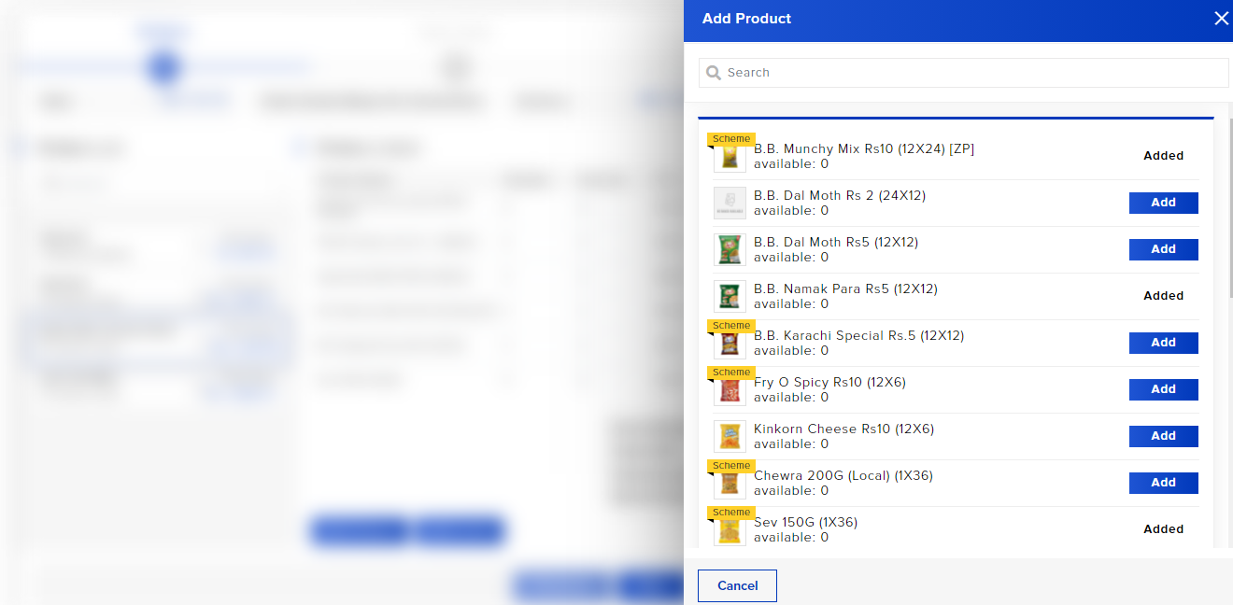

9: If we don’t save the spot sale order and cancel it, it’s product show in next order

<https://www.loom.com/share/8baf3964a637466faca8596ccda58946>

10: 12+4 trade offer is not working

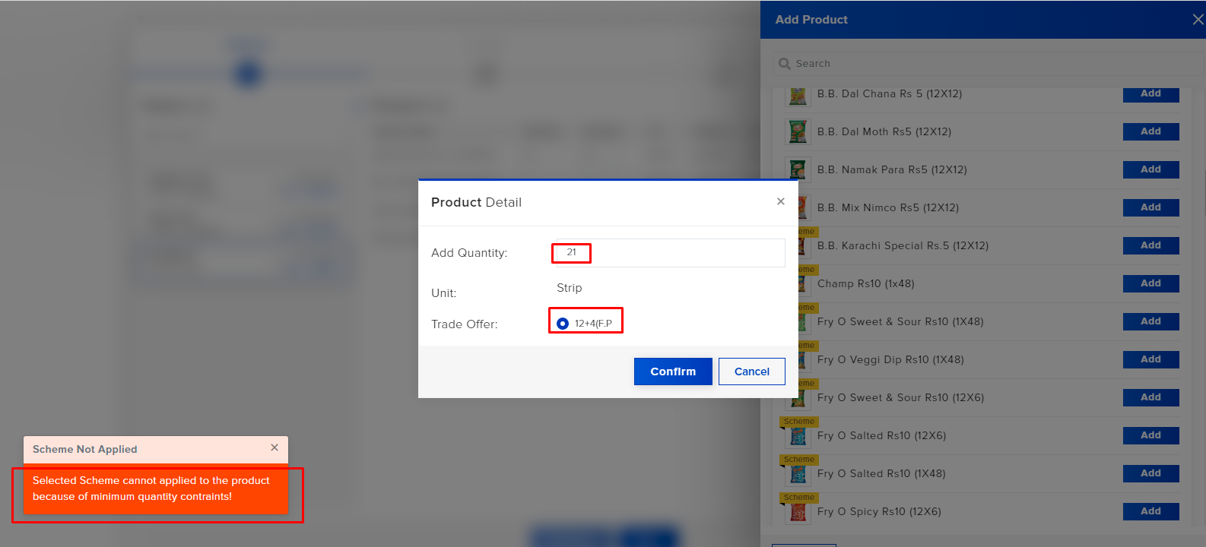

12: Payments are not getting add due to point issue

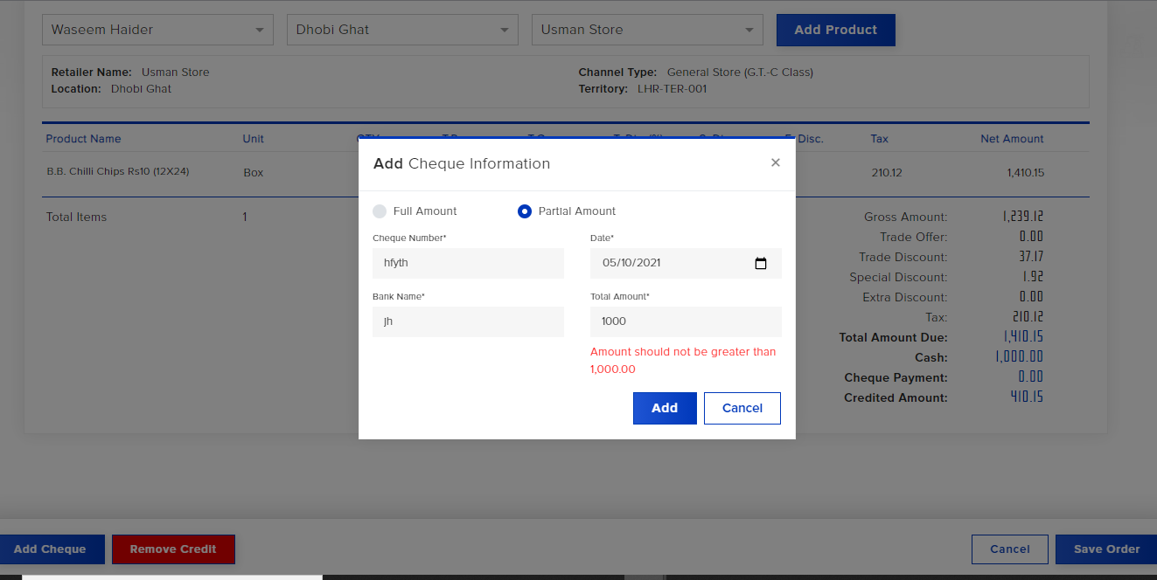

14: Quantity is not showing

