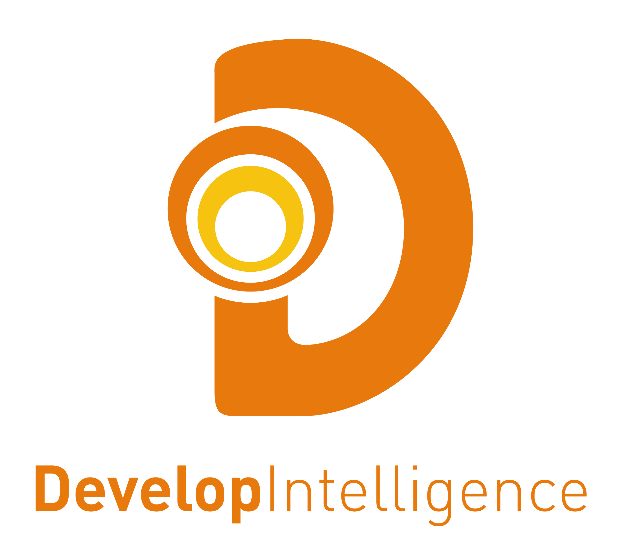

**Core Python - Pre-training Setup Requirements**

Pre-reqs:

Please download and install the following software prior to the start of the Core Python training:

­- For the Core Python course, the students can have a Mac or a PC running either

Windows, Mac OS X, or Ubuntu.

­- They should have installed Python 2.7 and Python 3.4 on their computer. (The Mac

already has Python 2.7 installed.) They should install shortcuts to IDLE for both of these,

and should rename the shortcuts to the name of the version, e.g., IDLE_343, or

IDLE_276. This will allow them to switch between the two versions of Python during the

course, and try out the code in both versions of Python.

-­ They should confirm that Python is installed on their computer by typing:

**python ­­--version** # for Python 2, and

**python3 --­­version** # for Python 3, and ensure they can see both versions of Python are

installed.

­ - Also, they should confirm that IDLE is correctly installed by launching each version of

IDLE, and typing

**li = ['c', 'a', 'b']**

**li.sort()**

**print(li) # or print li for Python 2**

and confirm that the list is printed in alphabetical order.

Please contact Julie Halbersberg or Carmel Ulbrick with any questions:

julie@developintelligence.com

carmel@developintelligence.com