多主题的流程结构分解 Weaving multiple aspects

UML sequence diagram

Jacques Klein, Franck Fleurey, Jean-Marc Jézéquel. Weaving Multiple Aspects in Sequence Diagrams.LNCS Transactions on Aspect-Oriented Software Development, 2007, pp.167-199.

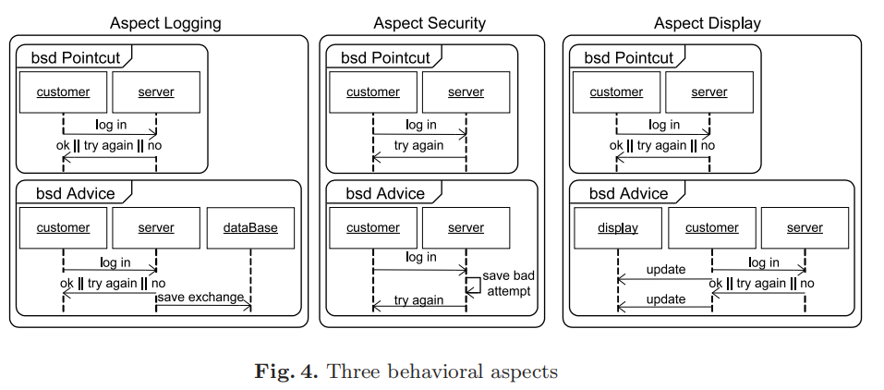

结构分解

翟鹏珺, 方贤文, 刘祥伟. 基于接口变迁的交互流程模型挖掘方法[J]. 计算机科学, 2018, 45(3): 1-5.

AALST W M P. A General Divide and Conquer Approach for Process Mining [J]. Computer Science and Information Systems ,2011,12(2) :1-10.

VAN DER WERF J M E M,KAATS E. Discovery of Functional Architectures From Event Logs[C] // International Workshop on Petri Nets and Software Engineering.2015 :227-243.

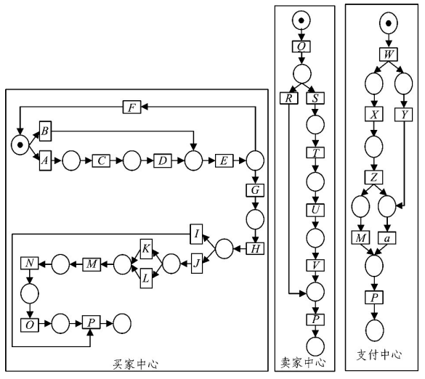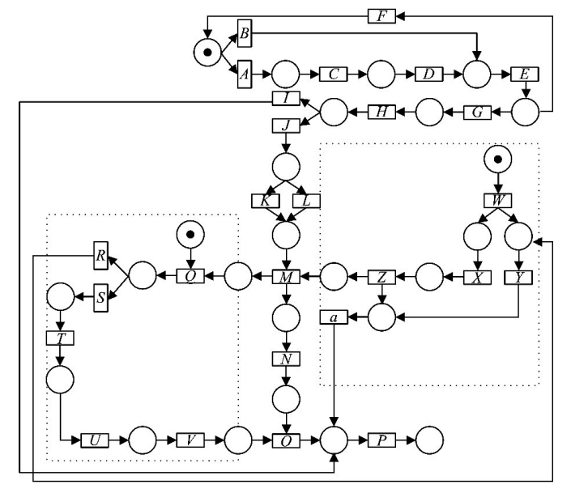

领域知识

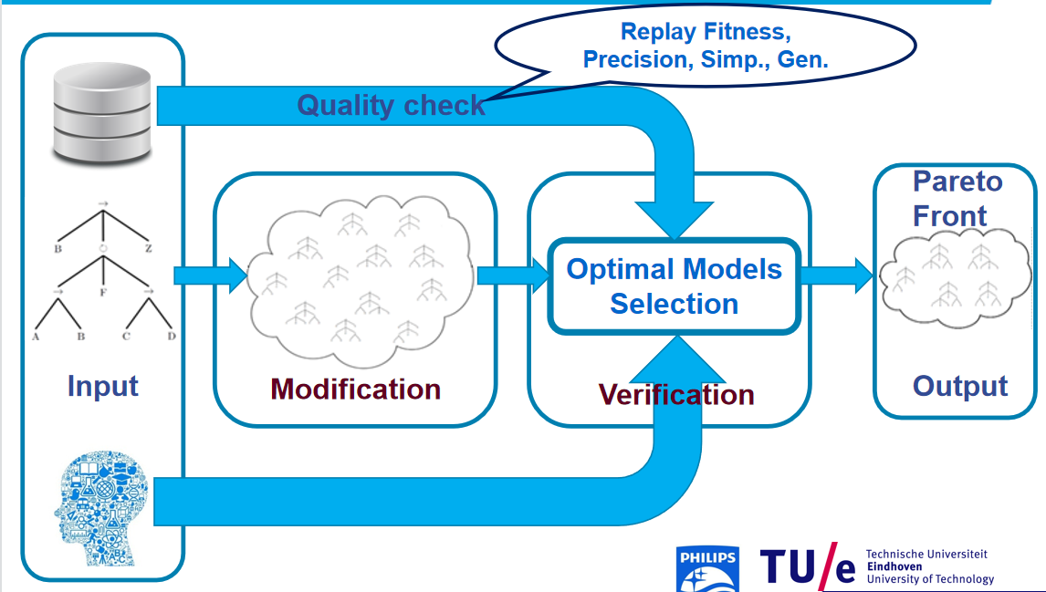

Dixit, P.M., Buijs, J.C.A.M., van der Aalst, W.M.P., Hompes, B.F.A., Buurman. Using Domain Knowledge to Enhance Process Mining Results[J]. Data-Driven Process Discovery and Analysis, 2017, (244)76-104.

直接修改，遗传修改，以及特定约束

Rembert A J , Omokpo A , Mazzoleni P , et al. Process Discovery Using Prior Knowledge[J]. Springer Berlin Heidelberg, 2013.

Schuster D , Zelst S , Aalst W . Utilizing domain knowledge in data-driven process discovery: A literature review[J]. Computers in Industry, 2022, 137:103612-.

Revoredo, K. On the use of domain knowledge for process model repair [J]. Software System Model (2022). https://doi.org/10.1007/s10270-022-01067-0

