University Database Project
Project Title: University Student Database using MySQL
Prepared By: Wakeel Ahmad
Instructor: Mam Rubab Batool
Introduction
This project focuses on designing and implementing a University Student Database using MySQL.The purpose of this database is to efficiently store and manage student and department information in a structured manner.
Objectives
- To understand relational database design
- To implement primary and foreign keys
- To create relationships between tables
- To perform SQL queries for data retrieval
Tools and Technologies:
- MySQL Server
- MySQL Workbench
- GitHub
Database Design
Tables:
Departments
Students
Keys:
primary Key: DeptID, StudentID
Foreign Key: DeptID in Students table

SQL Implementation
- Database creation
- Table creation
- Primary and Foreign keys
- Sample data insertion
SQL Queries
- SELECT
- WHERE
- JOIN
- COUNT
Results and Output
some outputs with queries
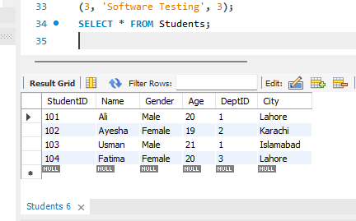

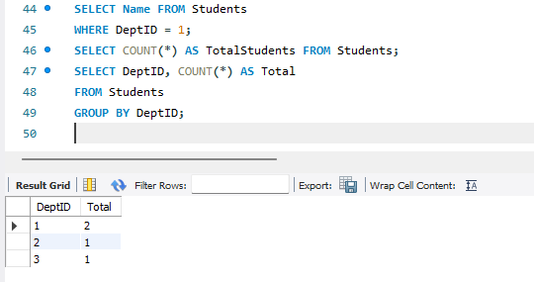
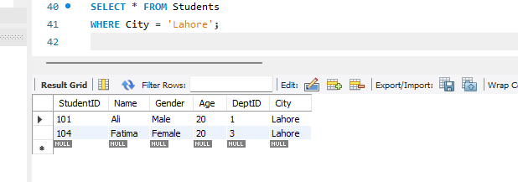
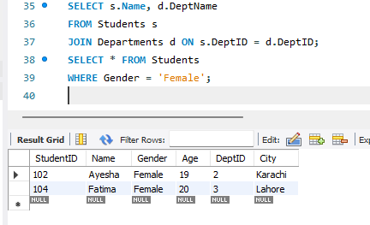
Conclusion
This project helped in understanding the fundamentals of relational databases, including table relationships, data integrity, and SQL query execution using MySQL.

