PREDICTION USING R

By

Waqas Ahmed

Independent Study
Submitted to the

Faculty of Computing & Engineering Sciences
Shaheed Zulfikar Ali Bhutto Institute of Science and Technology
In partial fulfilment of the requirements
Of the degree of
Master of Science

July, 2015

ACKNOWLEDGEMENTS
Thanks to Almighty who blessed me with skills and guided me to complete this Independent study research. Also I would like to express my sincere gratitude to my supervisor Prof. Dr. Tariq Rahim Soomro who provided me with the aspiring guidance and valuable advice regarding my area of studies for this Master’s degree. I also appreciate all the suggestions and constructive criticism made by my friends and family on issues relating to my topic.
I acknowledge that whatever good is in this study is by the grace of Almighty and all mistakes are due to me, the servant of Almighty.

Waqas Ahmed
147301

ABSTRACT
One of the most exciting areas in all of data science right now is wearable. Companies like Fitbit, Nike, and Jawbone Up are racing to develop the most advanced algorithms to attract new users. In this study, analysis on two datasets has been done, which are 1) Titanic: learning from natural disaster, 2) Smartphone user activity prediction. In section 1, a brief introduction about data science is discussed, followed by section 2 where materials and methods described that were used to analyze and make precise predictions. In section 3, results are shown which were obtained from the participated kaggle competition. In the last section, conclusion and the room for improvement is briefly mentioned.

TABLE OF CONTENTS
ACKNOWLEDGEMENTS iii
ABSTRACT iv
TABLE OF CONTENTS v
1. INTRODUCTION 1
1.1 About Data Science 1
1.2 Topic Exploration & Literature reviews 3
1.3 Literature Review 3
2. MATERIAL AND METHODS 5
2.1 Learning Sources 5
2.2 Datasets 6
2.3 Methods 6
3. RESULT AND FINDINGS 10
4. CONCLUSION AND FUTURE WORK 14
5. REFERENCES 15

6. PLAGARISM REPORT (TURNITIN DIGITAL RECEIPT) 17
7. RESUME 20

TABLE OF FIGURES

Figure 1.1: Data Scientist skills 1
Figure 1.2: Data Science process 2
Figure 1.3: What does Data Scientist do 3
Figure 2.1: Decision tree of titanic dataset 8
Figure 2.2: Importance of various factors in predicting the survival rate of passengers by applying random forest 9
Figure 3.1: Snapshot of kaggle competition ‘Titanic: Machine Learning from Disaster’ leaderboard initial screen 10
Figure 3.2: Snapshot of kaggle competition ‘Titanic: Machine Learning from Disaster’ leaderboard highlighted rank screen 11
Figure 3.3: Snapshot of kaggle competition ‘Titanic: Machine Learning from Disaster’ leaderboard last screen 11
Figure 3.4: Snapshot of kaggle competition ‘Smartphone User Activity Prediction’ leaderboard initial screen 12
Figure 3.5: Snapshot of kaggle competition ‘Smartphone User Activity Prediction’ leaderboard rank and last screen 13

CHAPTER 1
- INTRODUCTION

  - About Data Science
Generally, Data Science is learning from data by the extraction of knowledge from it. [1][2] Data scientists today are people who have a blend of many different skills. The Venn diagram in Figure 1.1 shows a definition of a data scientist beautifully.
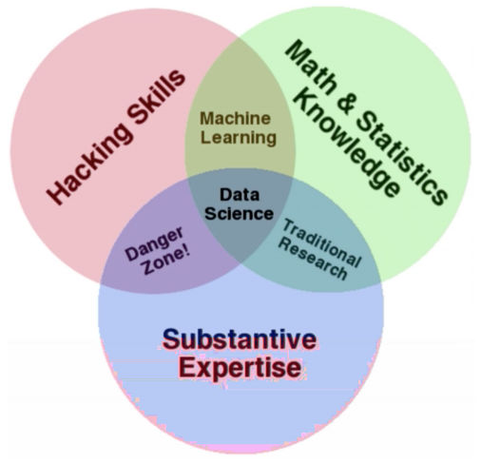
Figure 1.1: Data Scientist skills
A data scientist is the one who possess mathematics and statistics skills, which allows them to identify interesting insights in a sea of data. They also have the programming skills to code up statistical models and get data from a variety of different data sources. Furthermore, a data scientist is someone who knows how to ask the right questions and translate those questions into a sound analysis. After doing the analysis, they have the communication skills to report their findings in a way that people can easily understand. In other words, data scientists have the ability to perform complicated analysis on huge data sets. Once they've done this, they also have the ability to write and make informative graphs to communicate their findings to others. Also, a data scientist is a team player where other members have similar or more knowledge and skills that improves his or hers [3].

Looking at data science from the business angle, it is an integral part of competitive intelligence, a recently developing field that envelops various exercises, such as data mining and data analysis [4], as shown in Figure 1.2.

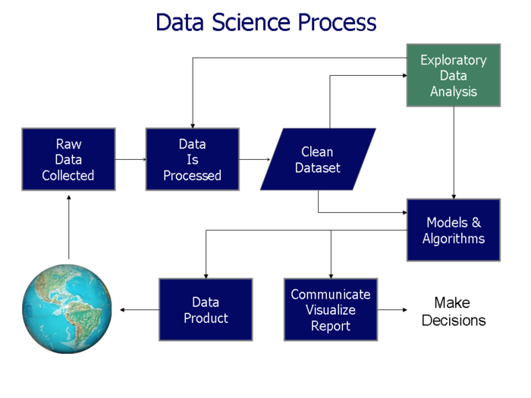
Figure 1.2: Data Science Process

Here are some things that a data scientist may do in his or her daily work as shown in Figure 1.3. They might wrangle data. That is:
- collect data from the real world
- process the collected data, and
- clean and tidy the data set such that it can be analyzed.
- After having tidy data set, trends may be analyzed in the existing data or they try to make data driven predictions about the future using the data at hand.

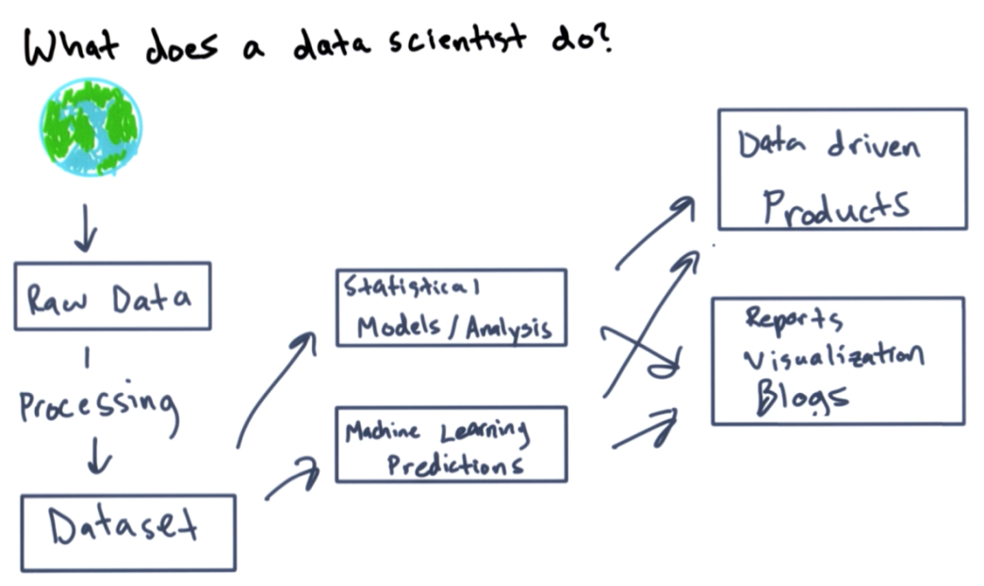
Figure 1.3: What does Data Scientist do
On the basis of these models or predictions, building data driven products is possible moreover, data scientists can communicate their findings with others, data scientists and the general public alike. File visualizations, charts, blog posts or reports.

  - Topic Exploration & Literature reviews
One of the most exciting areas in all of data science right now is wearable computing - according to this article [5]. Companies like Fitbit, Nike, and Jawbone Up are racing to develop the most advanced algorithms to attract new users. The dataset to be used to demonstrate independent study represents data collected from the accelerometers from the Samsung Galaxy S smartphone. A full description is available at the site where the data was obtained [6].

  - Literature Review

Human Activity Recognition (HAR) is playing a central role in extending the range of possibilities of human-computer interaction by offering the input for the development of more interactive and cognitive environments [7]. A compilation of the recent proposals in the Human Activity and Motion Disorder Recognition were exposed accompanied by the results of the contest calling for innovative approaches to recognize activities of daily living (ADL) from a recently published data set [8].
Moreover, various systems, theories, models etc.[9][10] have been presented for human physical Activity Recognition (AR or HAR) using smartphone inertial sensors, mainly when these sensors are attached to the subject’s body, since they allow continuous monitoring of numerous physiological signals such as walking, running, sitting, lying etc.

CHAPTER 2
- MATERIAL AND METHODS
This Independent study was divided into weekly studies and meanwhile carry on with the analysis of the dataset for smartphone human activity prediction or recognition. Below is the breakdown of how the whole study was scheduled:
  - Learning Sources
Learning the “Intro to Data Science” (The Data Scientist’s Toolbox) included the following:
- Introduction to basic tools
  - R
  - Rstudio
  - Git
  - Github
- Types of data questions
- Steps in a data analysis
- Putting the science in data science

Learning “R programming” included the following:
- Overview of R, R data types and objects, reading and writing data
- Control structures, functions, scoping rules, dates and times
- Loop functions, debugging tools
- Simulation, code profiling

Learning “Getting and Cleaning Data” (Data Analysis with R) included the following:
- Data collection
  - Raw files (.csv,.xlsx)
  - Databases (mySQL)
  - APIs
- Data formats
  - Flat files (.csv,.txt)
  - XML
  - JSON
- Making data tidy
- Distributing data
- Scripting for data cleaning

Learning “Exploratory Data Analysis” included the following:

- summarizing data techniques
  - complex statistical models
  - techniques to eliminate or sharpen potential hypotheses using data to express the world
  - how to plot using R, also fundamental rules of constructing data graphics and more.

2.2 Datasets
    - Kaggle Competition - Titanic: Machine Learning from Disaster (Predicting Survival Rate of Passengers) [7]

    - Kaggle Competition - Human Activity Recognition Using Smartphones (Predicting user activity from smartphone accelerometer and gyroscope data) [8]

  - Methods
For the independent study, exploratory data analysis was conducted and R scripts file were created that explores the variables, structure, patterns, oddities, and underlying relationships of the chosen data sets.
The analysis was almost like a stream-of-consciousness as data analyst ask questions, create visualizations, and explore the data.
The purpose of this project was to demonstrate the ability to collect, work with, and clean a data set. The goal was to learn how to explore data and predict the outcome using machine learning.

    - Data Collection
The data consisted of accelerometer and gyroscope measurements from a Samsung Galaxy IIS phone taken from a sample of 30 test subjects. Each record consisted of 561 time-and frequency-domain variables and the activity that the user was engaged in at the time of measurement, which may be: “standing”, “sitting”, “laying”, “walk”, “walk downwards”, “walk upwards.”

    - Data Subsets

The data were split into two subsets–TRAINING, TEST–based on subject IDs.

    - Exploratory Analysis
Applied Machine Learning using Random Forest Analysis
Exploratory analysis was used to
(1) Identify any missing values and
(2) Identify biases in the original dataset and each of the subsets, and
(3) Determine any necessary transformations to be made on the data.

There were no missing values left in the dataset after this analysis.

    - Decision Trees
First all the slicing was done and then efforts were made to find subsets that have a higher chance of surviving. A decision tree automates this process, and outputs a flowchart-like structure that is easy to interpret.
Conceptually, the decision tree algorithm starts with all the data at the root node and scans all the variables for the best one to split on. Once a variable is chosen, split is done and the next step is to go down one level (or one node) and repeat. The final nodes at the bottom of the decision tree are known as terminal nodes, and the majority vote of the observations in that bucket determine how to predict for new observations that end up in that terminal node.
To create the first decision tree, R's rpart package was used. R packages are a collection of functions, data and compiled code that make the life of data analyst easier. Namely, instead of needing to write the algorithm from scratch just the ‘rpart’ R package can be used and its included decision tree algorithm, as shown in Figure 2.1.
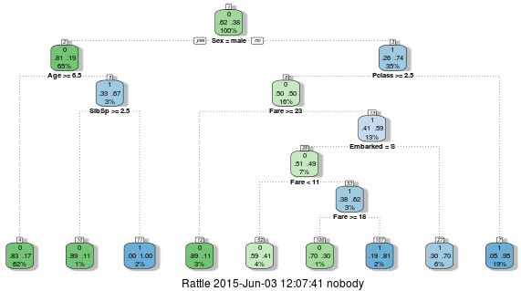
Figure 2.1: Decision tree of titanic dataset

    - What is a Random Forest Analysis
A brief study of Random Forests was done. However, since it's an often used machine learning technique, a general understanding and illustration of how to apply the technique using R was studied as well.

In layman terms, the Random Forest technique handles the over-fitting problem data analyst faces with decision trees. It grows multiple (very deep) classification trees using the training set. At the time of prediction, each tree is used to come up with a prediction and every outcome is counted as a vote. For example, if it has been trained 3 trees with 2 saying a passenger in the test set will survive and 1 says he will not, the passenger will be classified as a survivor. This approach of overtraining trees, but having the majority's vote count as the actual classification decision, avoids over-fitting, as show in Figure 2.2.
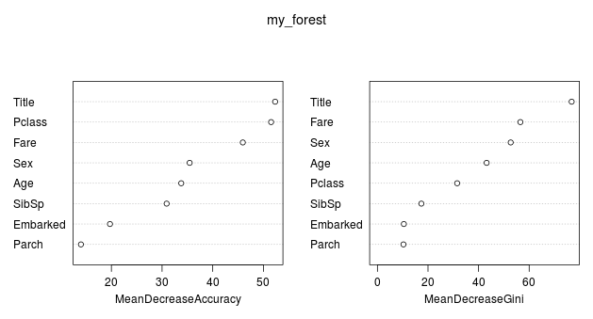
Figure 2.2:Importance of various factors in predicting the survival rate of passengers by applying random forest

    - Applied Machine Learning using Random Forest Analysis
After exploratory analysis, machine learning was introduced on the training datasets to predict required parameter, in this case survival rate of passengers and smartphone user activity.

CHAPTER 3
- RESULT AND FINDINGS

Classification tree was made on the dataset of titanic disaster to find out the survival rate of the passengers onboard, which resulted in 80% correctness. Random forest analysis on the same dataset didn’t improve the prediction precision. Moreover, participation in kaggle competition for the same ranked the model at 455th among 2972 participants [11], as shown in Figure 3.1 to 3.3.

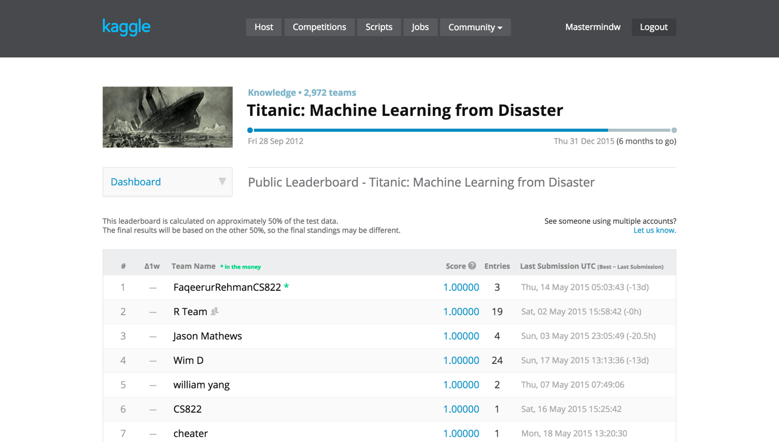
Figure 3.1: Snapshot of kaggle competition “Titanic: Machine Learning from Disaster” leaderboard initial screen
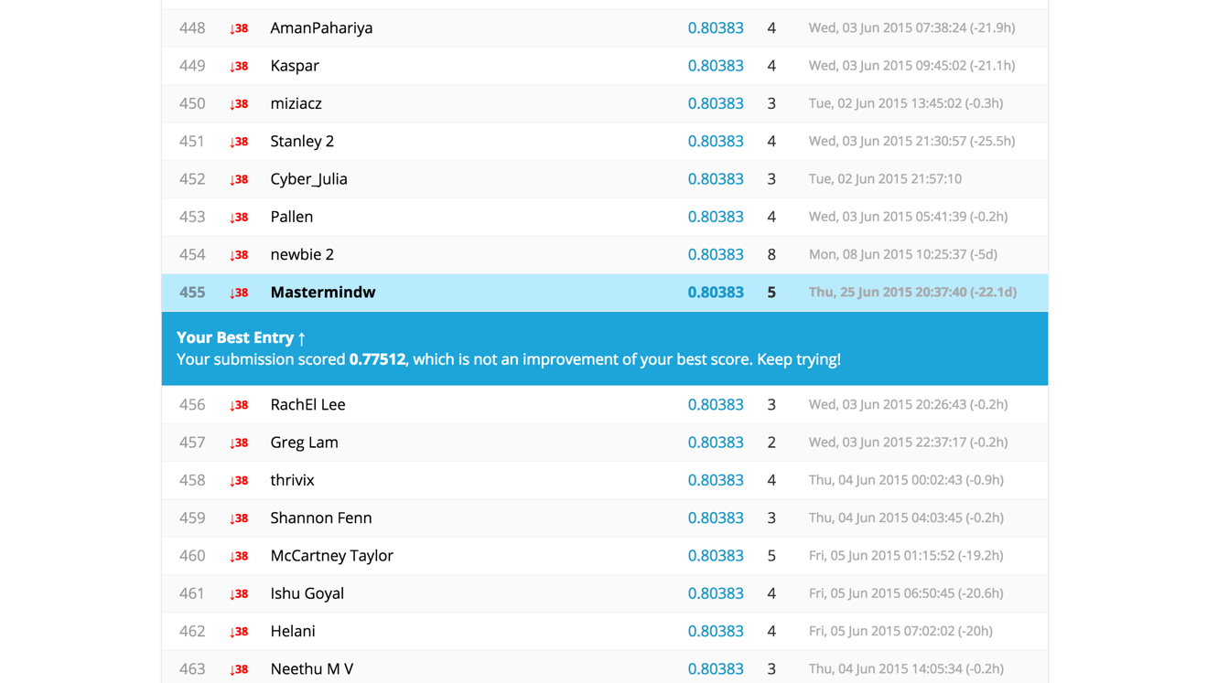
Figure 3.2: Snapshot of kaggle competition “Titanic: Machine Learning from Disaster” leaderboard highlighted rank screen

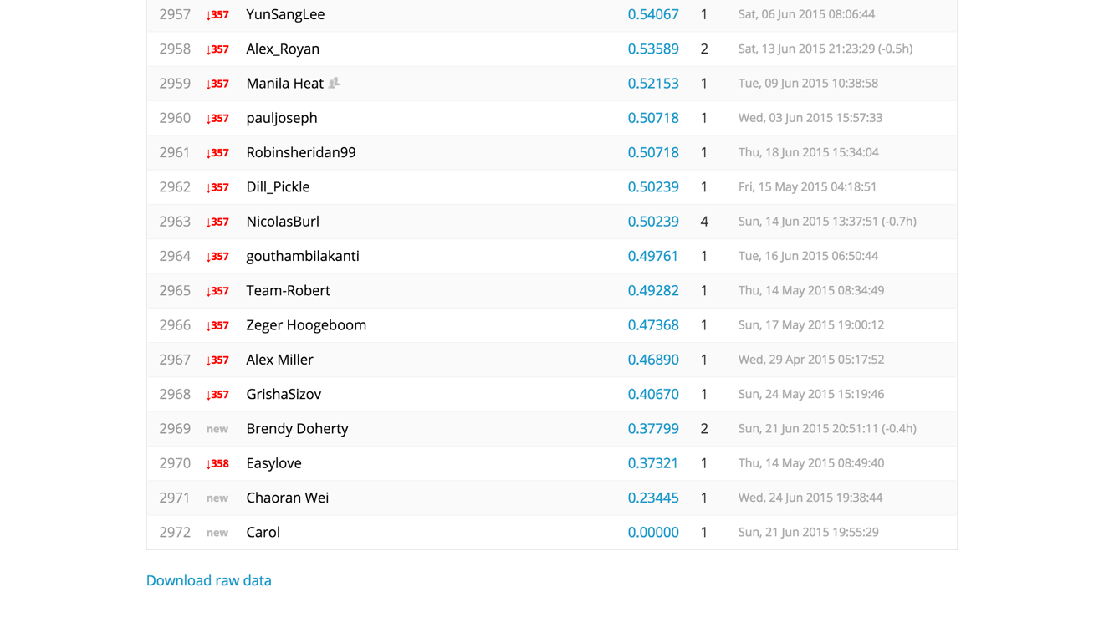
Figure 3.3: Snapshot of kaggle competition “Titanic: Machine Learning from Disaster” leaderboard last screen

Classification tree was made on the dataset of users’ smartphone to predict the user activity, which resulted in 82% correctness. Random forest analysis on the same dataset improved the prediction precision by 8% and became 90%. Moreover, participation in kaggle competition for the same ranked the model at 21st among 30 participants [12], as shown in Figure 3.4 and Figure 3.5.
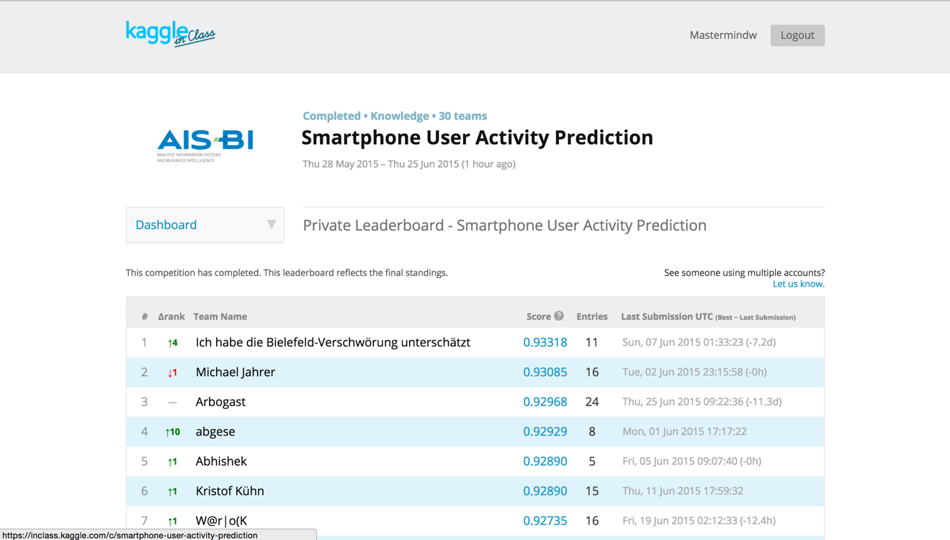
Figure 3.4: Snapshot of kaggle competition “Smartphone User Activity Prediction” leaderboard initial screen

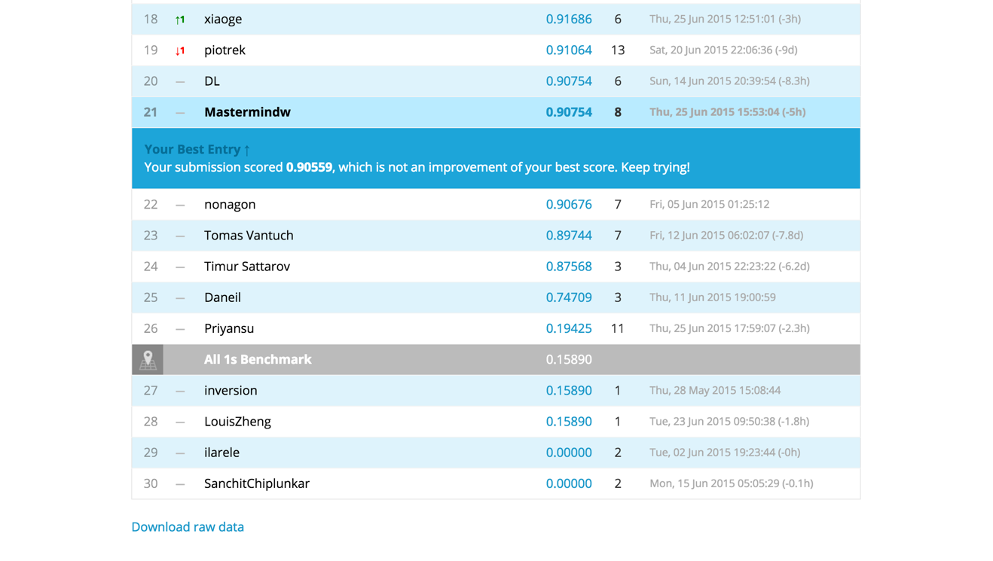
Figure 3.5: Snapshot of kaggle competition “Smartphone User Activity Prediction” leaderboard rank and last screen

Random forest technique was found to be the most efficient to make prediction on the selected datasets.

CHAPTER 4
- CONCLUSION AND FUTURE WORK

The proposed model still leaves much room for improvement. More factors can be analyzed to improve the produced model to increase the prediction precision. For instance, survival rate of passengers can be improved by taking into account the cabin numbers of the passengers because it describes data analyst how close or far the individual is from the split area and exits. Similarly, user activity from smartphone prediction can also be improved by applying different statistical modeling techniques with increased number of iterations and large data set.

Moreover, with the rise of sun every single day there are more and more datasets that are being analyzed by data analysts around the world. Studied datasets were just to get the hands dirty, since there is a plethora of datasets to conclude and get the answers to real life problems.

REFERENCES

- V. Dhar, 'Data Science and Prediction', Cacm.acm.org, 2013. [Online]. Available: http://cacm.acm.org/magazines/2013/12/169933-data-science-and-prediction/fulltext. [Accessed: 24- Apr- 2015].
- J. Leek, 'The key word in “Data Science” is not Data, it is Science | Simply Statistics', Simplystatistics.org, 2013. [Online]. Available: http://simplystatistics.org/2013/12/12/the-key-word-in-data-science-is-not-data-it-is-science/. [Accessed: 24- Apr- 2015].
- Villanova University, 'Careers in Big Data'. [Online]. Available: http://www.villanovau.com/university-online-programs/careers-in-big-data/. [Accessed: 24- Apr- 2015].
- AOL Jobs, 'Data Scientist: The Hottest Job You Haven't Heard Of', 2011. [Online]. Available: http://jobs.aol.com/articles/2011/08/10/data-scientist-the-hottest-job-you-havent-heard-of/. [Accessed: 24- Apr- 2015].
- 2012. [Online]. Available: http://www.insideactivitytracking.com/data-science-activity-tracking-and-the-battle-for-the-worlds-top-sports-brand/. [Accessed: 24- Apr- 2015].
- Archive.ics.uci.edu, 'UCI Machine Learning Repository: Human Activity Recognition Using Smartphones Data Set', 2012. [Online]. Available: http://archive.ics.uci.edu/ml/datasets/Human+Activity+Recognition+Using+Smartphones. [Accessed: 24- Apr- 2015].
- Reyes-Ortiz, Jorge Luis et al. 'Human Activity And Motion Disorder Recognition: Towards Smarter Interactive Cognitive Environments.'. 21st European Symposium On Artificial Neural Networks, Computational Intelligence And Machine Learning, ESANN 2013. Available: https://www.elen.ucl.ac.be/Proceedings/esann/esannpdf/es2013-11.pdf. [Accessed: 10- Apr- 2015]
- Davide Anguita, Alessandro Ghio, Luca Oneto, Xavier. Parra, and Jorge-Luis. Reyes-Ortiz. ‘A public domain dataset for human activity recognition using smartphones’. European Symposium on Artificial Neural Networks, Computational Intelligence and Machine Learning (ESANN), 2013.
Available:https://www.elen.ucl.ac.be/Proceedings/esann/esannpdf/es2013-84.pdf. [Accessed: 10- Apr- 2015]
- Anguita, Davide et al. 'Human Activity Recognition On Smartphones Using A Multiclass Hardware-Friendly Support Vector Machine'. 4thInternational Workshop Of Ambient Assisted Living (IWAAL 2012). 2012.
Available: http://www.icephd.org/sites/default/files/IWAAL2012.pdf[Accessed: 17- Apr- 2015]
- Anguita, Davide et al. 'Energy Efficient Smartphone-Based Activity Recognition Using Fixed-Point Arithmetic.'. Journal of Universal Computer Science 19.9 (2013)
Available:http://www.jucs.org/jucs_19_9/energy_efficient_smartphone_based/jucs_19_09_1295_1314_anguita.pdf. [Accessed: 17- Apr- 2015]
- Kaggle Titanic. Available:https://www.kaggle.com/c/titanic [Accessed: 20-May-2015]
- Kaggle Smartphone. Available:https://inclass.kaggle.com/c/smartphone-user-activity-prediction [Accessed: 02-Jun-2015]

PLAGARISM REPORT (TURNITIN DIGITAL RECEIPT)

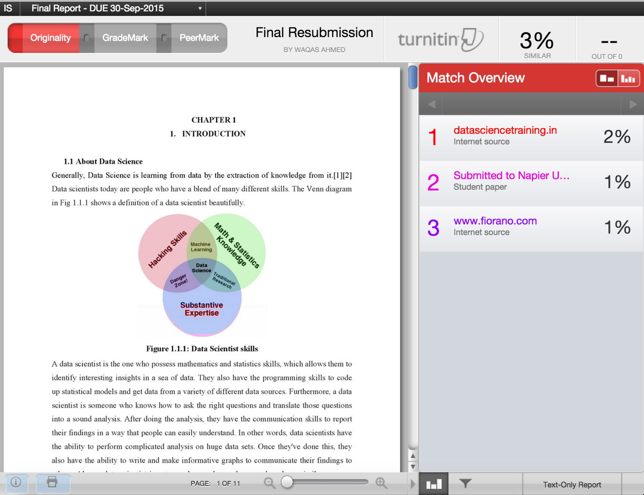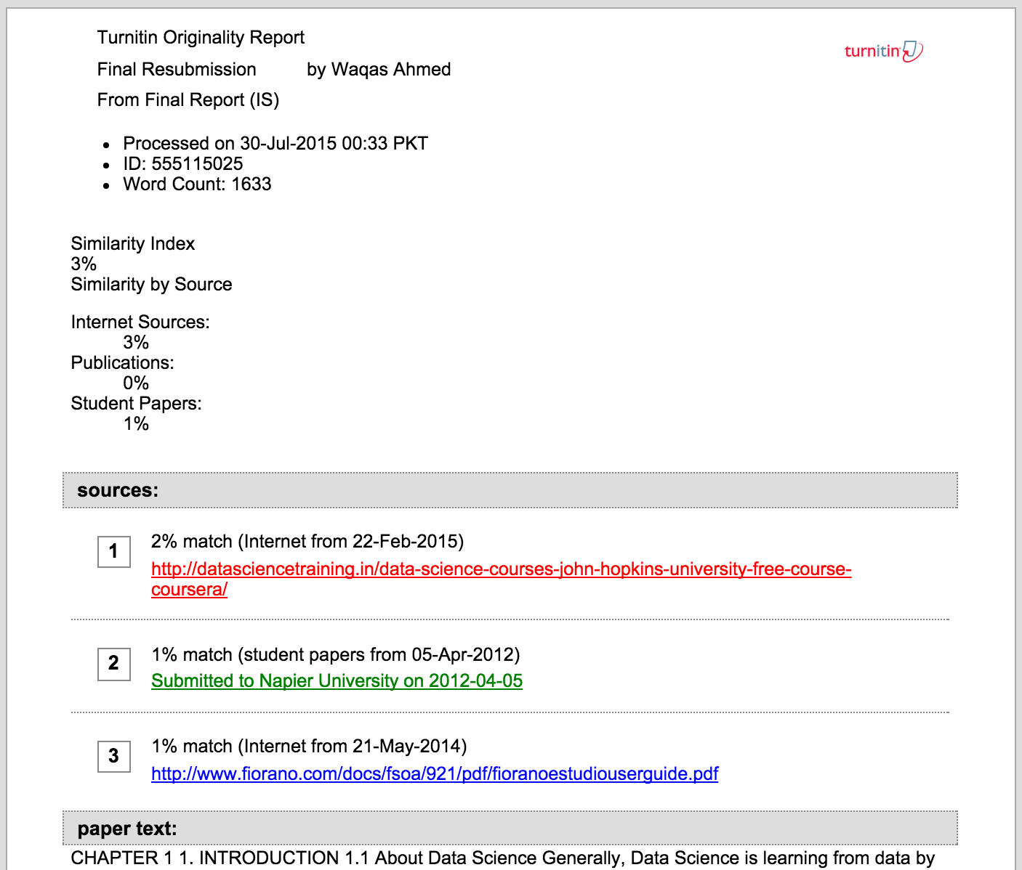

RESUME
