# Python Study

## Turtorial

### Indent

Python is sensitive with spaces and indented block(缩进). So please be very careful when writing codes.

A simple example:

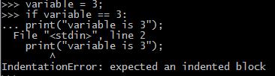 #need an indented block

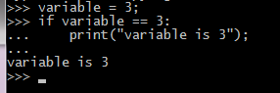 #added an indented block

## Using Python Interpreter

Python use UTF-8 by default, while the standard library uses ASCII character identifiers only.

## An Informal Introduction to Python

### comment

#Comments in python is started with hash character ‘#’ until the end of a physical line;

### New operator

#Division in python always returns a float number; But if you want an integer, you can use // instead of / to get a floor division which returns an integer;

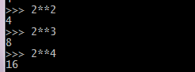#In python, power is much simpler: ** is used to represent power (maybe we could also realize this in C++ with operator override);

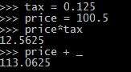#In interactive mode, the last printed expression is assigned to the variable _.

### Print()

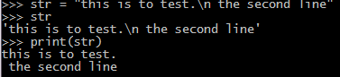#print is similar to printf/cout in C/C++;

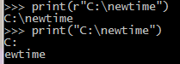#use ‘r’ to interpret ‘\’ as normal character;

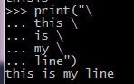#use \ as connecting symbols(like we use in C++ macro);

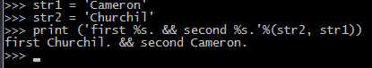#print can use the old % style. But do remember to put all variables in one %, like this.



### String

#string can be multipled by number, and be added with string.

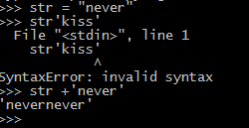#do remember use + to connect string,

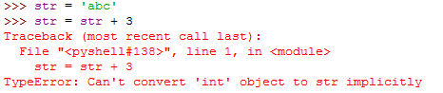#variable and constant string can’t be connected together;

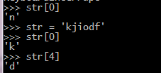#string is equal to char[]? Seems.

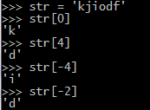#python expands great function: a negative index could be located in a string; Negative index starts from -1 not -0, because -0 is viewed equal as 0;

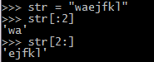# this is like matlab.

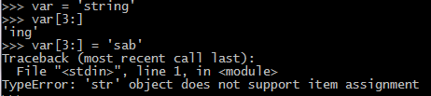#python string is constant, unmodifiable rvalue;

#string has method **lower().**

#and also the method **upper().**

### Len()

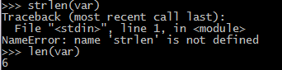#len() replaces strlen(), or sizeof?

### List

#asd is a list, which can use combound data type;

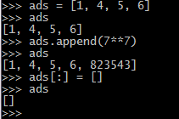#List can add new members with .append(), and can be cleared with =[];

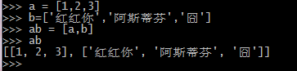#List can be nested

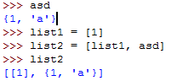#list can be nested with other data types.

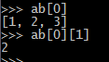#members can be located as in an array;

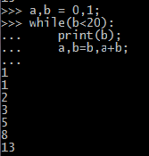#Right-hand side expressions take place first;

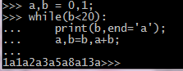#can use end=’’ to illustrate end of print, which is set to ‘\n’ defaultly;

## Control Flow Statements

### Range()

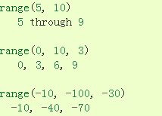#range can be used

#range can be printed, but the result…

### Else(for loop)

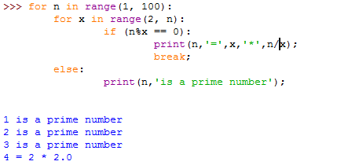#It’s a great improvement that loop statements in python have an ‘else’ condition, which is satisfied when out of range(for), or becomes false(while).

#here I pressed a keyboard. Pass is busy-wait for keyboard interrupt(ctrl+c). Tip: here is a mistake: should’ve used **True** instead of true, but everything in python except 0, is all set to True;

### pass

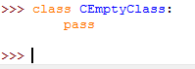#pass can also be used for creating a minimal class;

### def

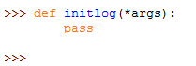#can also be used as unimplemented words in func;

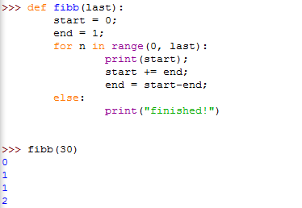#**def** keyword introduces a function definition.

### DocString & annotations

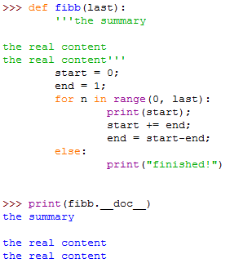#function documentation, just so so…

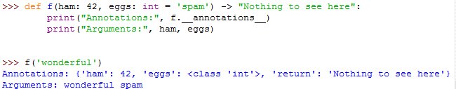#function annotation, honestly speaking, I’ve not figured out the differences with docString except with parameters.

## Date Structure

### stack

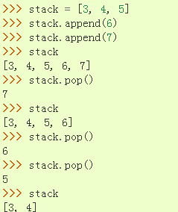#seems stack is a special kind of List, FILO;

### queue

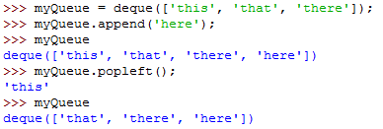#queue is FIFO, to implement a queue, should import **deque** from **collections** module;

### list

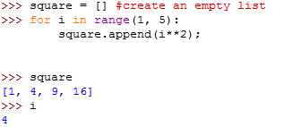#create an empty List with []…Besides, notice that the variable i always exists. To make it a local variable , we can do the upper like this:

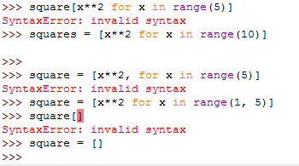#see? You must use **=[]** to init a List, not a **[]**, cause it can’t be explained as an constructor operator; And a comma symbol should not appear before the **for** loop.

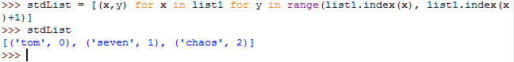#a senior example of **List Comprehension.** Which is equal to this:

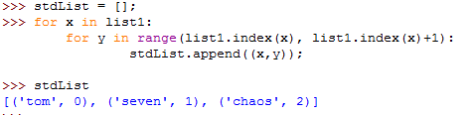

### del

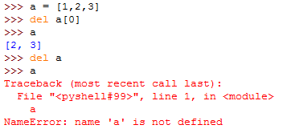#**del** could be used as delete, to delete members or a whole variable(Wonder if it’s like **delete** critical word in C++?)

### List & tuple

**#List is mutable, tuple is unmutable!!!**

List is often homogeneous accessed via iterator, while tuple is often heterogeneous, accessed via unpacking;

### Tuple

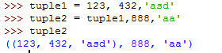#be aware of the **()** that tuple has.

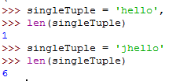#to create a tuple with only 1 element;

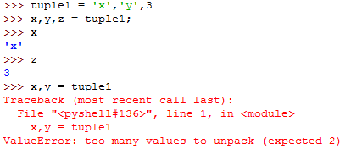#tuple can be packed and unpacked, but unpack needs appropriate parameters.

### set

#notice that the init of a set must be **=set(),** different from tuple or list; While the view of a set is contained with **{} not ()**.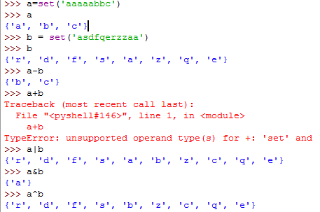#basic operators of –(in a but not in b), |(in a or in b), &(in a while in b), ^(in a or in b but not both)

### Dictionary

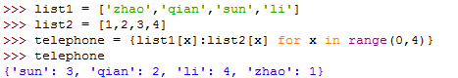#dictionary is **unordered!**

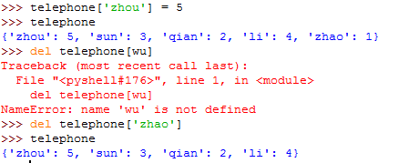#add new members with simple statement, delete members with **del** critical word;

### Looping techniques

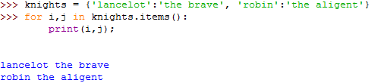#dictionary key:value can be returned at the same time using items();

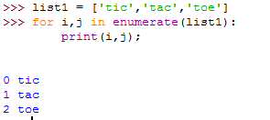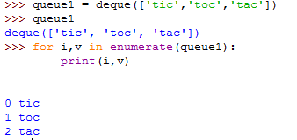#looping through an sequence(ordered structure such as list or deque), the index and value can be retrieved at the same time using enumerate();

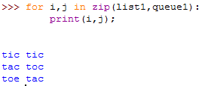

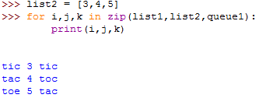#use **zip()** to pair two or more sequences.

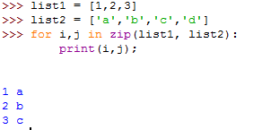#unbalanced sequences can also be paired

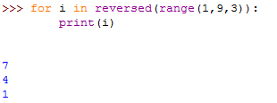#loop in reverse, the critical word is **reversed()** not reverse().

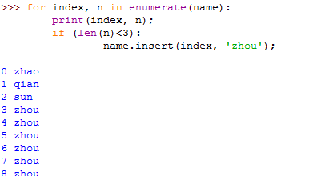#always remember to make a copy of original sequence in loop statement, or else will be like upper. The following is recommended:

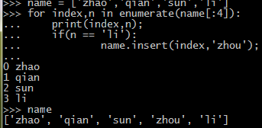

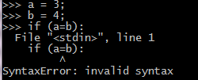#in python, value can not be assigned within an expression, avoiding the common error: typing a = while intended a ==;

## Modules

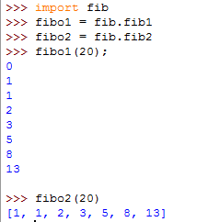#the imported module should be under sysPath or current directory(on my PC it’s C:\\python34\\). You can edit the module with pythonIDE or Notepad++ (I recommend this).

#can also import like this

#and this, to import all names **except those beginning with an underscore (_)**. Don’t use this randomly cause it introduces an unknown set of names into the interpreter, possibly hiding sth you’ve already defined;

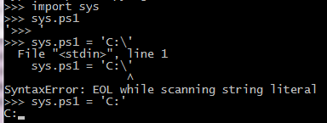#can import modules

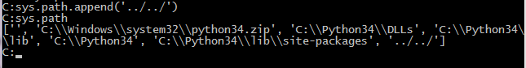#sys.path is a list of strings. Which is initialized to a default path, and which can be modified.

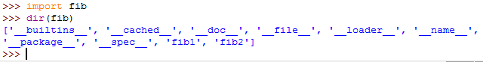#built-in function **dir()** is used to find out which names a module defines, including variables, modules, functions, etc.

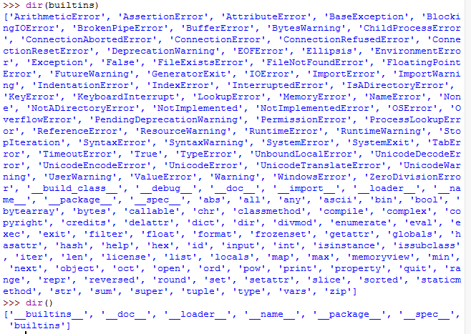

#**dir()** doesn’t list the names of built-in functions and variables.

## Input & Output

### Basic string methods

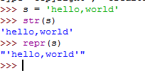#use **str()** or **repr()** to convert any value to a string;

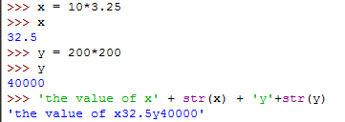#change number to string;

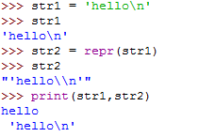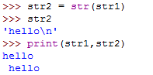#**str()** is different from **repr()** as repr() always try to explain the parameters to the interpreter, while str() always try to explain the parameter to a string which human easily understands.

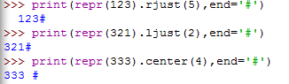#string.rjust(), ljust(), center()

#fill the string left with ‘0’

### Str.format()

#only {} is useful in str.format(), not [] or ();

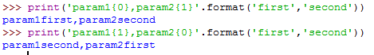#params in {}

Indicates the index of the parameters in format();

#params can also be indexed with their corres names;

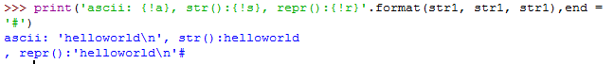#use !a !s !r to represent **ascii, str(), repr()**;

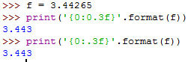#format

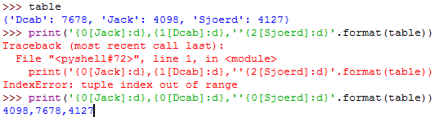#always remember the meaning of the index is the position of the parameter in **format();** And we can reference the var by name instead of index;

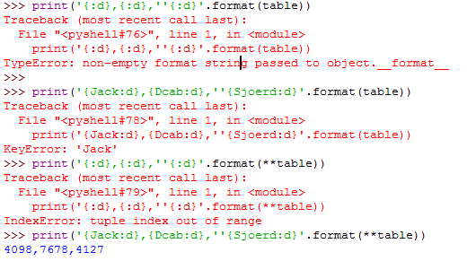#only the last format is right. Here **table is used as keyword argument;

#old printf style, but it seems only one %param is supported.

### File operations

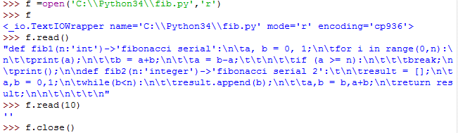#file contains **open(), read(), close(), readline().**

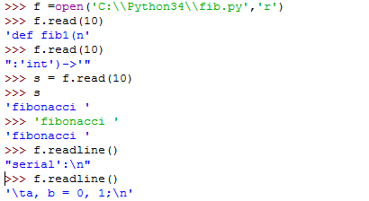#readline() ends with \n, if readline() returns an empty string, the end of the file is reached.

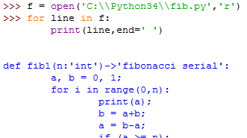#you can loop over the file object for reading lines from a file. This is memory efficient, fast, and leads to simple code;(**Why??**)

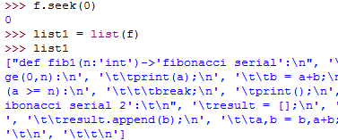#**list()** is a function which returns all the lines of a file in a list.

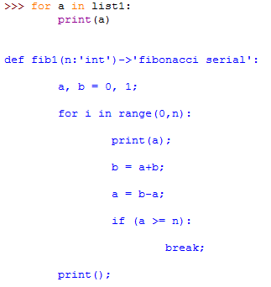#**list()** returns a whole line as a member, like r**eadline()**;

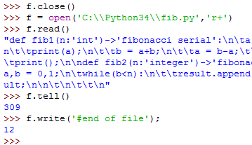#**tell()** and **write()**

#**with** keyword is a good practice when dealing with file objects.

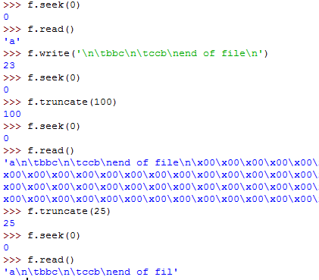#**truncate()** truncates the file with only the first int(parameters) characters left.

### JSON

#U can view json string representation of an object with **dumps().**

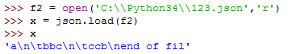**#**JSON also has **dump()** and **load()** functions in pair to write and read.

## errors and exceptions

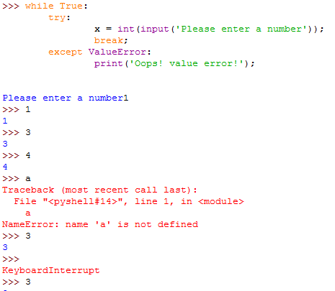#**try{} except{}** statements

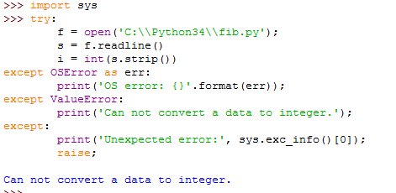#multi **except**

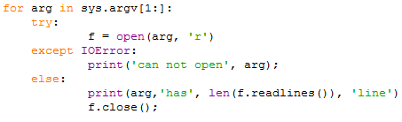#**except** has an **else** statement, for code that must be executed if try has no exception.

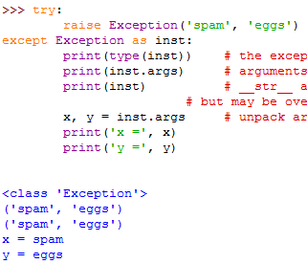#exception can be organized as a class.

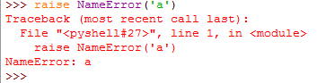#using **raise**, one can force an exception to happen.

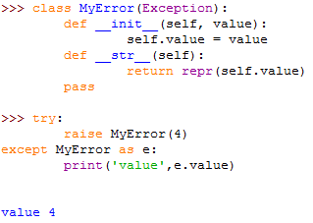#U can construct a new class which public Exception, and overwrite __init__().

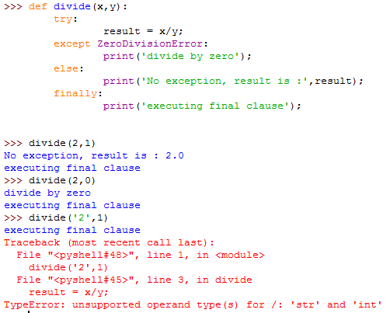#**else** clause will be executed when no Exception error occurs, while **finally** clause will be executed under every condition. The **finally** clause is useful for releasing existing resources.

### Predefined clean-up actions

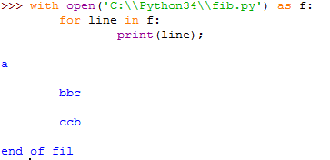#using **with** as a programmer predefined clean-up action to avoid closing files after operation. It’s very useful in large programs.

## Classes

### Scopes and namespaces

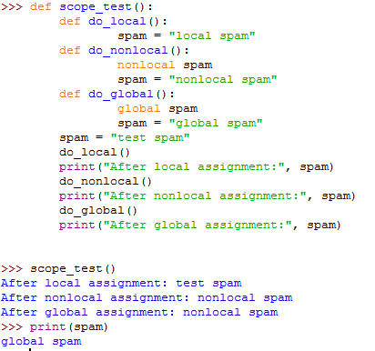#local is the function’s inner var; nonlocal is used to reference outer vars, while global is used to set the var as a global var.

### Class

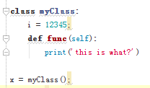#class in python is similar to C++, while creating an object pretends that the class object is a parameterless function that returns a new instance of the class.

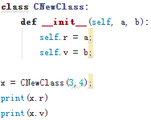#creating an instance with **__init__(self).**

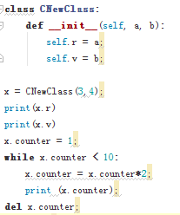#a class instance need not be declared, they spring into existence when they are first assigned to.