HW1 Group 18
  - DD2360/FDD3360 Applied GPU Programming

Question 1 Vector Addition
Experiments were performed on a Tesla T4 GPU using Google Colab. The implementation uses float data and 256 threads per block.

Q1.1 Floating point operations and global memory reads
For a vector of length N, the kernel executes c[i] = a[i] + b[i] for each element. Therefore, the number of floating-point operations is N, and the number of global memory reads is 2N.

Q1.2 Threads and blocks for N equal to 512
For N = 512, this implementation uses 256 threads per block. The number of blocks is ceil(512 / 256) = 2. Therefore, 2 blocks and 512 CUDA threads are launched.

Q1.3 Achieved occupancy for N equal to 512
Achieved Occupancy = 24.76%.
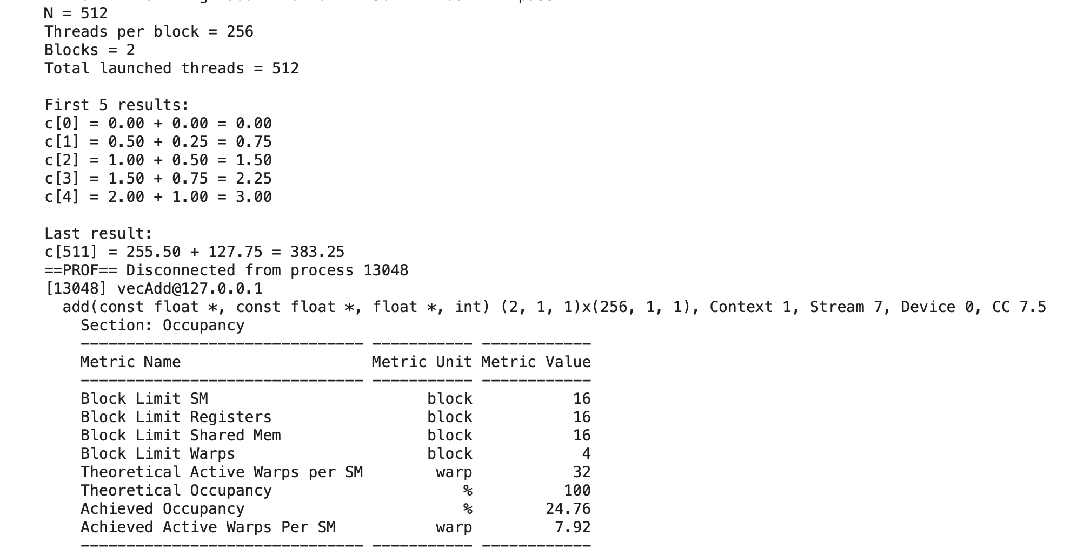
Figure 1. Nsight Compute output for N = 512.

Q1.4 Correctness for N equal to 263149
The program still runs correctly and no repairs are needed.

Q1.5 Threads and blocks for N equal to 263149
Blocks: 1028. Threads: 1028 × 256 = 263168.

Q1.6 Achieved occupancy for N equal to 263149
Achieved Occupancy = 80.17%.
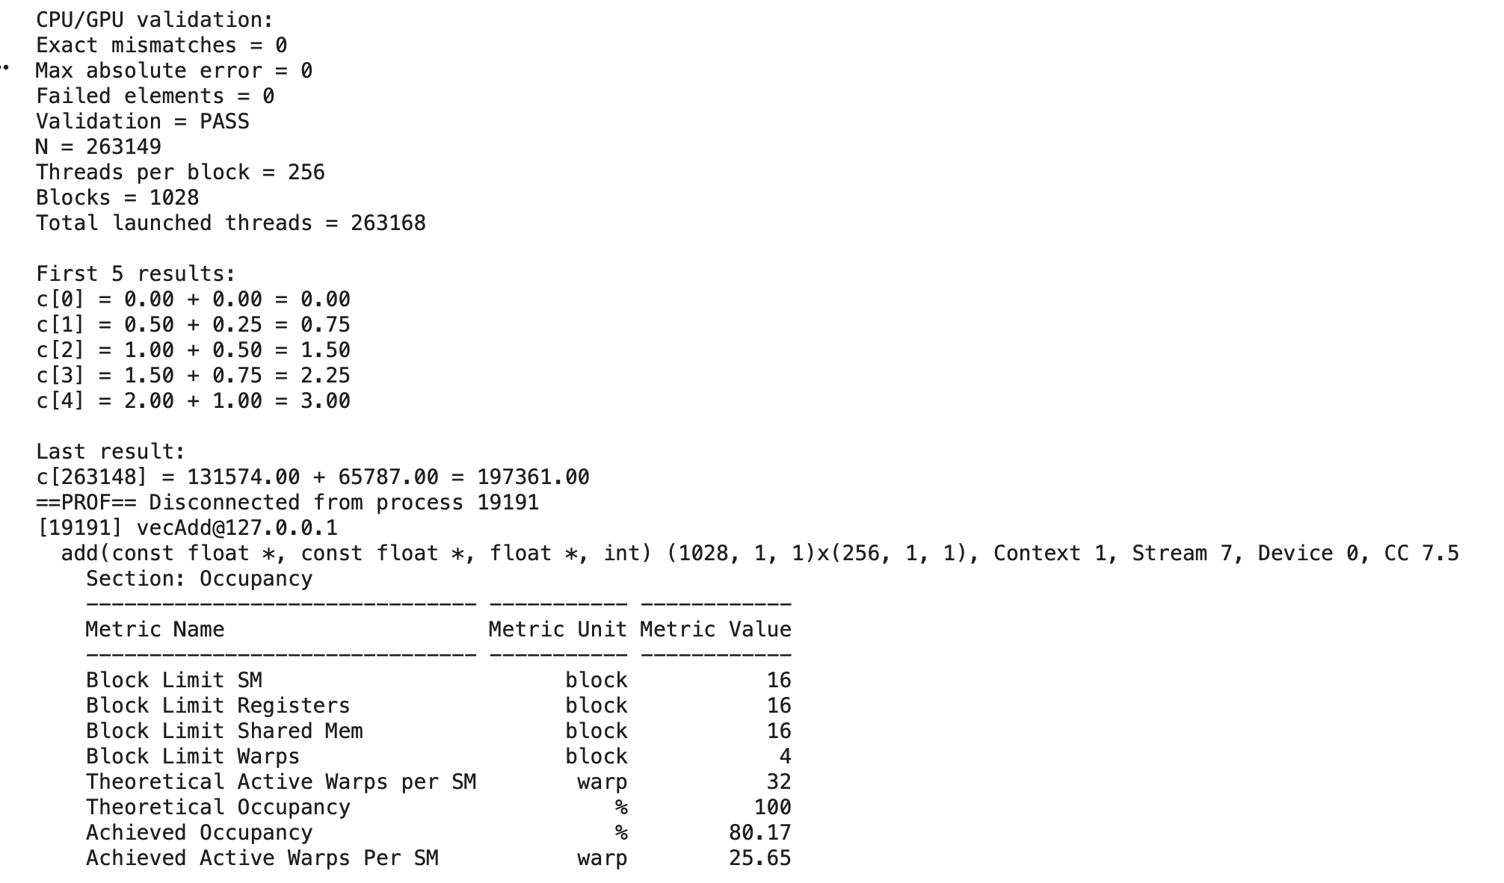
Figure 2. Validation and Nsight Compute output for N = 263149.

Q1.7 Time breakdown for different vector lengths
Twelve vector lengths were tested. For each length, one warm-up was followed by 10 measured repetitions. The figure shows the average host-side time for copying both input vectors from host to device, executing the CUDA kernel, and copying the output vector from device to host.
The CPU timer uses gettimeofday, as in the course tutorial. Kernel timing includes launch and synchronization overhead. Memory allocation, initialization, CPU reference computation, and result validation are excluded from the three timed regions.
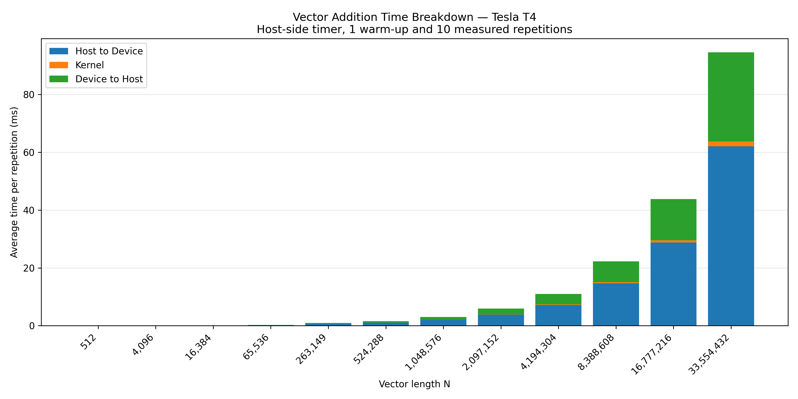
Figure 3. Mean H2D, kernel, and D2H times for 12 vector lengths on the Tesla T4.

Q1.8 Comparison of CPU and GPU results
The calculation results of CPU and GPU are exactly the same.
I think this is because the CPU and GPU use the same float data and the same calculation method, so their results are the same in this experiment. Although the GPU uses multiple threads, each thread does not affect the calculations of the other threads. Therefore, the GPU and CPU results are the same in this experiment.

