Predictive Churn Analysis

Amanda Wright

17th June 2025

Table of Contents

Executive Summary 5

Research Background and Objectives 6

Profitability of Reducing Churn 6

Research Goals 7

Report Structure 7

Description of Sample 9

Last Campaign Summary 9

Renewals Last Campaign 9

Model Predictor Variables 10

Model Dependent Variable 10

Data Preparation 11

Methodological Approach 13

Logistic Regression Modelling 13

Advantages of Logistic Regression 13

Model Building Process 13

Model 1 13

Local Model Evaluation Criteria Model 1 14

Local Model Evaluation Summary 16

Actions for Model 1 16

Model 2 17

Local Model Evaluation Criteria Model 2 17

Local Model Evaluation Model 2 Summary 18

Global Model Evaluation 19

Nagelkerke R² - Logistic Regression 19

ANOVA test 19

Hosmer-Lemeshow Test 20

Predictive Accuracy of Model 2 21

Results 22

Overall Model 2 Evaluation 22

Research Goal 1 23

Research Goal 2 26

Implications for Campaign 28

Research Goal 3 28

Research Goal 4 29

Conclusion 31

References 34

Appendices 35

Appendix A –Last Campaign Variables 35

Appendix B – Final Model 36

Appendix C – Model Interpretations 37

Odds-Ratio (OR) Model 2 37

Standardisation of Variable Coefficients Model 2 37

Appendix E - New Campaign Targeted Approach Key Measures 38

Appendix F - Campaign Cost Financial Analysis 38

Appendix G - R-Code 39

# Executive Summary

SY has conducted an analysis aimed at identifying factors influencing customer contract renewals, using data from a recent telemarketing campaign. The goal being to develop a logistic regression model that predicts the probability of customer renewal in future campaigns and to assess the effectiveness of a targeted marketing approach compared to previous untargeted methods.

The analysis concludes that a targeted marketing approach, informed by predictive modelling, can significantly enhance customer renewal rates and profitability. Key factors influencing renewals at SY include tenure, monthly charges, and contract type. The methodology and findings provide a framework for future campaigns and strategies to reduce churn.

For marketing managers, it is recommended to focus on renegotiating costs and refining the targeted approach for ongoing campaigns to maximize profitability and customer retention.

For senior executives, it is recommended that further research be undertaken to uncover what may be influencing increased churn of longer-term customers and reduced churn rates of those who spend more on telecommunications at SY, among strategically incentivizing churn reduction across the organization.

# Research Background and Objectives

Profitability of Reducing Churn

Definition of Churn – “The [number](https://dictionary.cambridge.org/dictionary/english/number) of [customers](https://dictionary.cambridge.org/dictionary/english/customer) who [decide](https://dictionary.cambridge.org/dictionary/english/decide) to [stop](https://dictionary.cambridge.org/dictionary/english/stop) using a [service](https://dictionary.cambridge.org/dictionary/english/service) [offered](https://dictionary.cambridge.org/dictionary/english/offer) by one [company](https://dictionary.cambridge.org/dictionary/english/company) and to use another [company](https://dictionary.cambridge.org/dictionary/english/company), usually because it [offers](https://dictionary.cambridge.org/dictionary/english/offer) a [better](https://dictionary.cambridge.org/dictionary/english/better) [service](https://dictionary.cambridge.org/dictionary/english/service) or [price](https://dictionary.cambridge.org/dictionary/english/price)”(Ossian, 2020)

Figure ‑ Median Churn Rate By Industry (What’s the Average Churn Rate by Industry?, 2025)

The advantages of reducing churn, and increasing retention, of customers are well-documented in the business world.

Studies suggest the cost of customer acquisition is five to twenty-five times the cost of retaining your existing customers, and improving retention by just 5% can lead to significantly higher profit margins from 25% to 95%.(Gallo, 2014)

The telecommunications industry has formidable competition for customers with one of the highest rates of churn across all industries (Fig. 1).

Research Goals

Our goal is to build a model to:

1. Identify factors contributing to customer contract renewal at SY, based on the data from the last telemarketing campaign.
2. Predict the probability of renewal for SY customers in the new campaign to classify customers as “targeted” and “untargeted” whilst covering the advertising-to-sales ratio.

Analyse the success of the strategy by:

1. Comparing the predicted profitability in the new campaign’s targeted approach vs. actual profitability of the previous campaign’s untargeted approach.
2. Using the model to quantify the impact of the cost in upcoming re-negotiations with the call centre.

Report Structure

* A description of the sample data and the steps needed for preparation of the data for analysis in R.
* A detailed description of the methodological approach undertaken to build the logistic regression model, advantages of logistic regression modelling, and evaluation of the model outputs.
* Draw conclusions on what factors influence customer renewal at SY based on the model.
* Use the model to create a “targeted approach” for the new campaign based on the probability a customer will renew their contract with us.
* Discuss the business implications of the modelling including comparing key success metrics of the two marketing approaches.

# Description of Sample

## Last Campaign Summary

In the last telemarketing campaign:

* SY cold called *all* 4140 customers to renew their contract via a call centre, with 1086 customers renewing their contract
* Renewal rate = 26.23% last campaign, below the industry average retention of 69% in 2025 in Fig. 1

## Renewals Last Campaign

Figure ‑ Renewals last campaign 1086/4140 = 26.23%

* The dataset from the last campaign included 4140 observations, a statistically valid sample size, with 12 variables as per Table 1.

|  |  |
| --- | --- |
| Variable | Description |
| Customer ID | Identification of a customer |
| SeniorCitizen | Whether the customer is retired (Yes/No) |
| Partner | Whether the customer is married (Yes/No) |
| Dependents | Whether the customer has dependents (Yes/No) |
| Tenure | Number of months a person has been a customer of the company |
| PhoneService | Whether the telephone service is connected (Yes/No) |
| PaperlessBilling | Whether the customer uses paperless billing (Yes/No) |
| MonthlyCharges | Current monthly payment |
| TotalCharges | The total amount that the client paid for the services for the entire time |
| Gender | Customer gender (Male / Female) |
| Contract | Type of customer contract (Long Term/Short Term) |
| Renew | **Whether the customer renewed contract after call centre contact (Yes/No)** |

Table ‑ Description of variables captured in the last campaign

## Model Predictor Variables

Table 1 describes the variables available for selection in the model to predict “Renew” including:

* The variable name
* The variable description

## Model Dependent Variable

**Dependent Variable = “Renew”**

* “Renew” is the *dependent variable* we want to predict in the logistic regression model.
* Modelling will give us insights into the factors that affect whether our customers “Renew” or not.
* Whilst reducing churn is our ultimate goal, for the purposes of calculating profits, and additionally the “Renew” variable is in the dataset already, predicting “Renew” will be the aim of the model.
* We can infer that increasing “Renew” will ultimately reduce churn.

## Data Preparation

Step 1: Recode the categorial variables in the dataset to numerical variables for analysis in R.

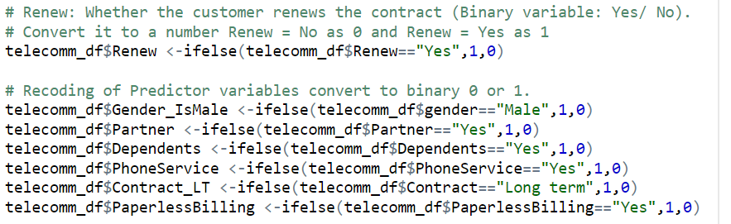

Figure ‑ Recoding of variables in R for Logistic Regression Modelling

* “Gender” and “Contract” have descriptive names “Male/Female” and “LongTerm/ShortTerm” rather than just “Yes/No
* Recoded to “Gender_IsMale” and “Contract_LT” for easier reference in future analyses

Step 2: Remove the following variables:

* “Customer ID”, is a unique identifier and not impactful on “Renew”
* “Gender” and “Contract” has been recoded as “Gender_IsMale” and “Contract_LT”, therefore can be removed



Figure ‑ Drop unnecessary columns, assign to “LastCampaign”

* Data preparation is complete with all variables data types numeric/integer

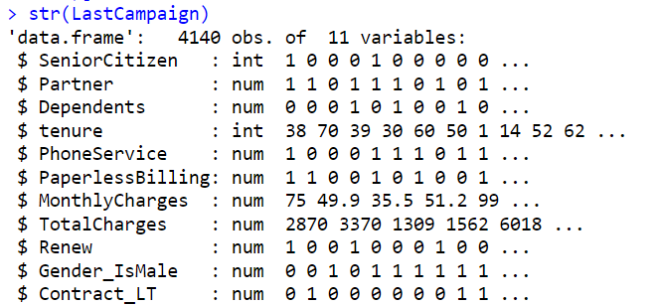

Figure ‑ Sample of finalised “LastCampaign” predictor variables - 4140 observations and 11 variables

Next steps are:

* build a logistic regression model
* evaluate the effectiveness of the model

# Methodological Approach

## Logistic Regression Modelling

Logistic regression uses predictor variables to model the probability of the occurrence of a binary outcome – for example yes or no, and to renew or not to renew.

The process entails building, evaluating, refining and re-evaluating the model until it satisfies specific statistical criteria.

## Advantages of Logistic Regression

If we can predict the probability a customer says yes to “Renew”, then we can:

1. “Target” ***only*** the customers with a predicted probability to “Renew” above the advertising-to-sales ratio of $7/$50 = 0.14, leaving the remainder “untargeted.”
2. Maximise the efficiency of our marketing efforts and improving profits at SY with less customers for the call centre to call, whilst covering our advertising-to-sales-ratio of $7 a contact for $50 revenue.

## Model Building Process

## Model 1

* First attempt will include all the variables in the modified dataset “LastCampaign” (Table 2), to predict “Renew” 

Figure ‑ Build” model1” to predict “Renew” with all variables from ”LastCampaign” dataset (noted by Renew ~ . )

|  |  |  |
| --- | --- | --- |
| Variable | Description | Outcomes |
| SeniorCitizen | Whether the customer is retired | No = 0 Yes = 1 |
| Partner | Whether the customer is married (Yes/No) | No = 0 Yes = 1 |
| Dependents | Whether the customer has dependents (Yes/No) | No = 0 Yes = 1 |
| Tenure | Number of months a person has been a customer of the company | N/A |
| PhoneService | Whether the telephone service is connected (Yes/No) | No = 0 Yes = 1 |
| PaperlessBilling | Whether the customer uses paperless billing (Yes/No) | No = 0 Yes = 1 |
| MonthlyCharges | Current monthly payment | N/A |
| TotalCharges | The total amount that the client paid for the services for the entire time | N/A |
| Gender_IsMale | Customer gender (Male / Female) | No = 0 Yes = 1 |
| Contract_LT | Type of contract (Long Term/Short Term) | No = 0 Yes = 1 |

Table ‑ “LastCampaign” Predictor Variables to predict "Renew"

## Local Model Evaluation Criteria Model 1

Criteria at the local level:

1. Evaluating the Variance Inflation Factors (VIF) to ensure no variables have a strong relationship with another variable, which would adversely affect the validity of the model, or no VIF > 10.

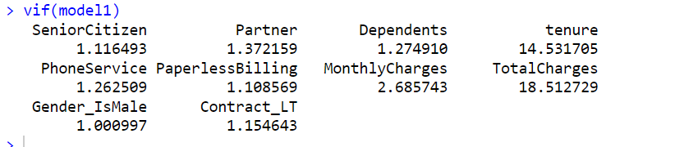

Figure ‑ VIF Model 1 shows “Tenure” > 10 and” TotalCharges” > 10, they have multicollinearity

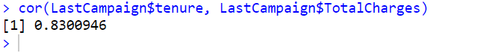

Figure ‑ Correlation analysis "Tenure" and "TotalCharges" confirms high correlation close to 1

1. Ensuring all predictor variables coefficient estimates in the model to be statistically significant in the variance of “Renew”, |z| < 0.05 (denoted by * - ***)

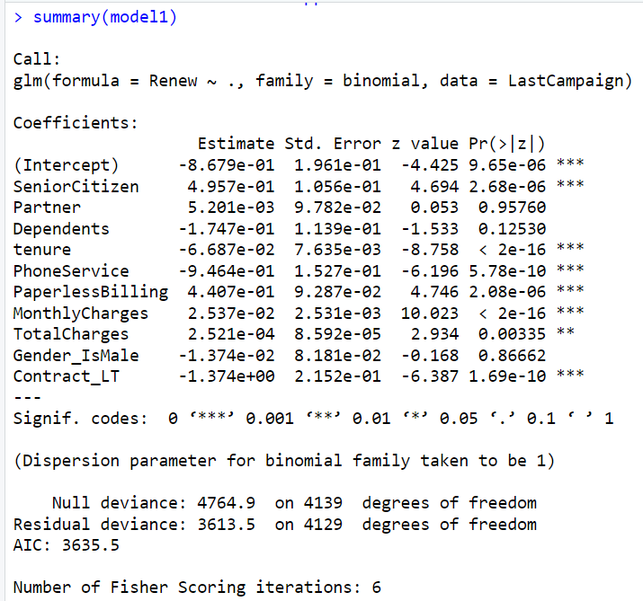

Figure ‑ Summary Output Model 1 in R

## Local Model Evaluation Summary

**Local model evaluation results in Table 3 suggests Model 1 is *not* a good model for predicting “Renew” and needs adjustment.**

|  |  |  |  |  |  |  |
| --- | --- | --- | --- | --- | --- | --- |
| Model Evaluation Criteria | Interpretation | | Results | | Pass/Fail | |
| Variance Inflation Factors (VIF) < 10 | | VIF > 10 = Variable multicollinearity | | “Tenure” = 14.53  “TotalCharges” = 18.51 | | Fail |
| Correlation analysis of high VIF variables | | 0 = No correlation  1 = Perfect correlation | | “Tenure” vs  “TotalCharges” = 0.83 | | Fail |
| All predictor variables significance level < 0.05 | | Predictor variables are < 0.05 | | “Partner” > 0.05  “Gender_IsMale” > 0.05  “Dependents” > 0.05 | | Fail |

Table ‑ Local Model Evaluation Criteria Summary Model 1

## Actions for Model 1

* Drop *either* “Tenure” or “Total Charges” due to multicollinearity
  + Drop “Total Charges”, highest VIF and the lowest significance in the model
* Drop “Partner”, “Dependents”, “Gender_IsMale”, insignificance in Model 1

## Model 2

* Refine the model to only include the following predictor variables to predict “Renew”:A computer screen shot of text

  AI-generated content may be incorrect.

Figure ‑ Adjusted variable set Model 2

|  |  |  |
| --- | --- | --- |
| Variable | Description | Recode as Numerical |
| SeniorCitizen | Whether the customer is retired | No = 0 Yes = 1 |
| Tenure | Number of months a person has been a customer of the company | N/A |
| PhoneService | Whether the telephone service is connected (Yes/No) | No = 0 Yes = 1 |
| PaperlessBilling | Whether the customer uses paperless billing (Yes/No) | No = 0 Yes = 1 |
| MonthlyCharges | Current monthly payment | N/A |
| Contract_LT | Type of contract (Long Term/Short Term) | No = 0 Yes = 1 |

Table ‑ Model 2 variables to predict "Renew"

## Local Model Evaluation Criteria Model 2

As before:

1. Evaluate the Variance Inflation Factors (VIF).
2. All predictor variables in the model need to be statistically significant.

Figure 11 Variance Inflation Factor(VIF) for Model 2

Figure 12 Summary output for Model 2

## Local Model Evaluation Model 2 Summary

|  |  |  |  |  |  |  |
| --- | --- | --- | --- | --- | --- | --- |
| Model Evaluation Criteria | Interpretation | | Results | | Pass/Fail | |
| Variance Inflation Factors (VIF) < 10 | | VIF > 10 | | Nil > 10 | | Pass |
| Correlation analysis of high VIF variables | | 0 = No correlation  1 = Perfect correlation | | N/A | | Pass |
| All predictor variables significance level < 0.05 | | Predictor variables are < 0.05 | | All predictor variables < 0.05 | | Pass |

Table ‑ Model 2 Local Evaluation Criteria for Model 2

## Global Model Evaluation

## Nagelkerke R² - Logistic Regression

* When a dependent variable is categorical, Nagelkerke R² can we used as a pseudo-R² which approximates the proportion of the variance in the dependent variable explained by the model from 0 to 1, with higher values indicating a better fit. (*IBM SPSS Statistics*, 2021)
* A Nagelkerke R² 0.10 - 0.50 is considered acceptable if the predictor variables are significant in research involving social sciences due to the unpredictability of human behaviour. (Ozili, 2022)
* Model 2 explains approximately 35% of the variation in “Renew”.

Figure 13 Nagelkerke R² indicating 35% of variation in “Renew” explained by Model 2

## ANOVA test

* ANOVA (Analysis of Variance) tests whether adding certain predictors significantly improves the model
* A significance level < 0.05 after the last variable is added, “Tenure”, indicates Model 2 is significant in explaining the variance in “Renew” 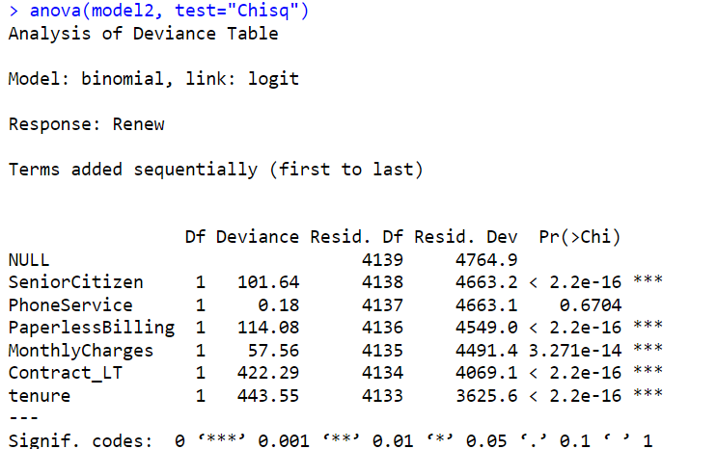

Figure 14 Model 2 ANOVA Test, last variable "Tenure" and model is significant < 0.05

## Hosmer-Lemeshow Test

* The Hosmer-Lemeshow test assesses the goodness of fit for logistic regression models. (‘Hosmer–Lemeshow test’, 2025)
* A p-value of > 0.05 indicates the predicted values of Model 2 and the actual values of the last campaign are not significantly different, or they are similar.
* Unfortunately, the Hosmer-Lemeshow test indicates value 0.01828, indicating the model is *not* a great predictor of “Renew”
* Hosmer-Lemeshow literature suggests that it does not take over-fitting into account, and has limitations in describing goodness- of-fit for logistic regression (‘Hosmer–Lemeshow test’, 2025)

Figure 15 Model 2 - Hosmer-Lemeshow goodness-of-fit test results

## Predictive Accuracy of Model 2

* The confusion matrix of *predictions vs. actuals* on the last campaign data gives us Model 2 predictive accuracy = (1007 + 1537) / 4140 = 61.45%
* The cut-off set at 0.14 means customers below the advertising-to-sales ratio $7/$50 won’t be contacted.

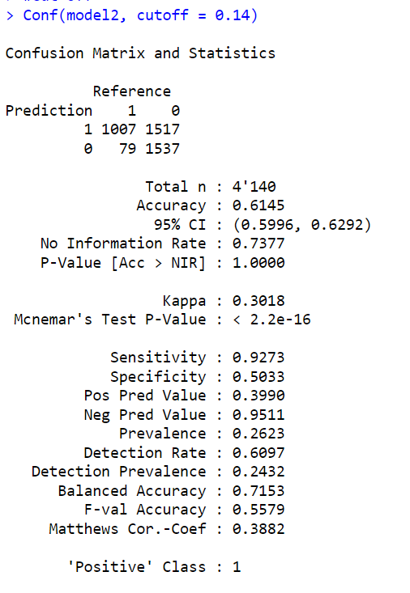

Figure 16 Model 2 - Confusion matrix reflecting predictive accuracy

* Model 2 predicted 1007 customers would renew, and 1537 customers as non-renewals, both accurately
* The model would have incorrectly predicted 1517 renewals as non-renewals, and 79 renewals who did not renew, both incorrectly.
* The model is very good at predicting non-renewals at 1537/(1537+79) = 95%, however only 1007/(1007+1517) = 39.8% accurate at predicting renewals.
* The swing here is because we have set the cut-off at 0.14, which gives us more customers to contact, opportunity for more renewals whilst covering costs, which is what we want the model to do.

# Results

## Overall Model 2 Evaluation

|  |  |  |  |  |  |  |
| --- | --- | --- | --- | --- | --- | --- |
| Criteria | Interpretation | | Results | | Pass/Fail | |
| Nagelkerke R2 | | 0.10 – 0.50 | | 0.35 | | Pass |
| ANOVA test | | Significance < 0.05 | | < 2.2e-16 | | Pass |
| Homer-Lemeshow | | Significance > 0.05 | | 0.0128 | | Fail* |
| Variance Inflation Factors (VIF) < 10 | | VIF > 10 | | Nil > 10 | | Pass |
| Correlation analysis of high VIF variables | | 0 = No correlation  1 = Perfect correlation | | N/A | | Pass |
| All predictor variables significance levels < 0.05 | | Predictor variables are < 0.05 | | All predictor variables< 0.05 | | Pass |
| Predictive Accuracy | | Accuracy to predict based on training data | | 61.45% | | Pass |

Table ‑ Local and global model evaluation Model 2. Failure on Homer-Lemeshow does not indicate failure of the model.

**Model 2 is a good model, and statistically useful to predict “Renew” for our research goals**

## Research Goal 1

**Identify the factors that contribute to customers renewing contract at SY, using the data from the last telemarketing campaign**

* Use the identified contributing factors to build a logistic regression model to predict the probability of customer renewal in the new campaign.

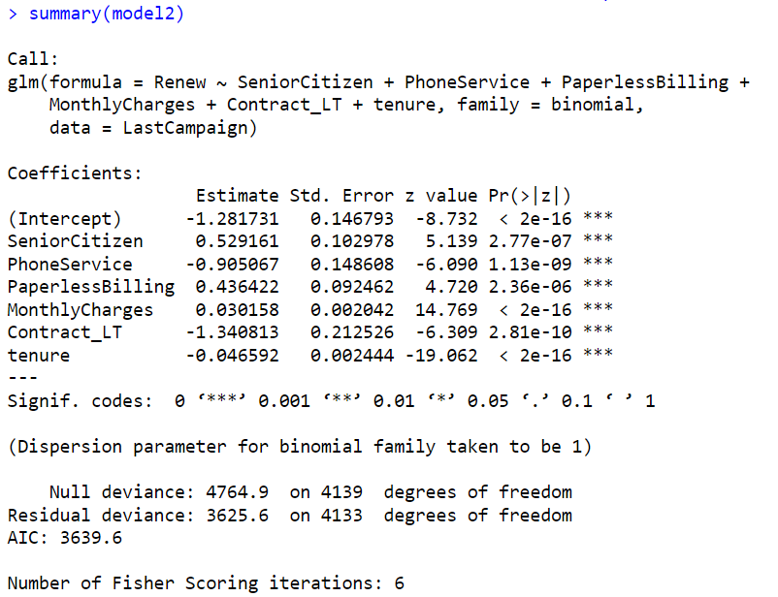

Figure 17 Summary output of Logistic Regression Model to predict "Renew"

We will interpret the output of model 2 in two ways:

1. Odds-Ratio (OR) – how the coefficients for each predictor can be translated in how they impact likelihood of a renewal to occur.
2. Coefficient Standardisation – how we can compare the importance of the coefficients on “renew” by placing them on the same scale.

Impact of Predictor Variables on Odds-Ratio for “Renew”

Figure 18 Multiplicative effect on odds to "Renew" by a 1-Unit increase in the predictor variable

* Being retired means 70% higher odds to renew than someone not retired
* Customer on a long-term contract is 75% lower odds to renew than a short-term contracted customer
* Tenure and monthly charges are measured by an increase in 1 month and $1 change accordingly

Relative Importance of Predictor Variables

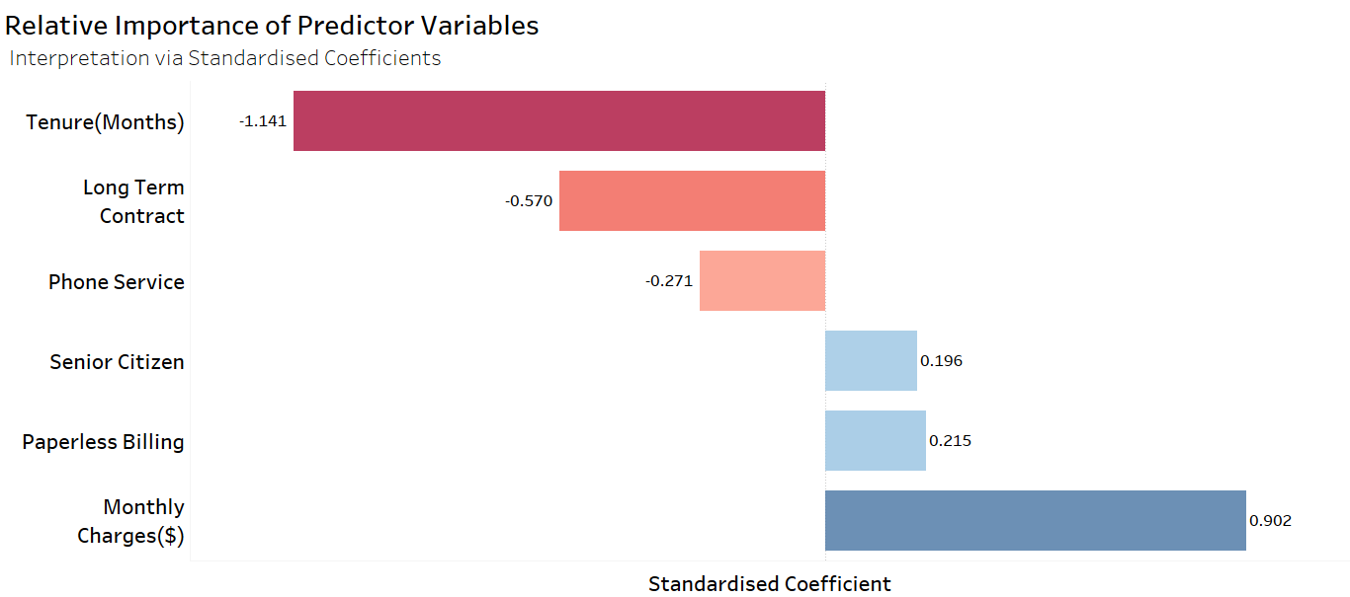

Figure 19 The effect of a variance of one standard deviation increase

in the predictor variable and its relative impact on "Renew"

Standardization of the model coefficient estimates in Figure 19 allows us to:

1. Compare the impact on **“Renew”** of continuous variables like **“Tenure”** and **“Monthly Charges”** on the same scale as categorical variables, such as **“SeniorCitizen”**.
2. Assess which variables have the *strongest effect* on the likelihood of renewal

* **Positive standardized coefficient** → A **higher-than-average** value of this predictor **increases** the likelihood of renewal
* **Negative standardized coefficient** → A **higher-than-average** value of this predictor **decreases** the likelihood of renewal
* **Magnitude of coefficient** → Larger absolute values indicate stronger effects on renewal probability

Conclusion

**The variables that contribute the most to contract renewal at SY are:**

* **Tenure - longer tenure strongly decreases the probability of the renewal.**
* **Monthly Charges - higher monthly charges have the strongest positive effect on the probability renewal**
* **Long Term Contract - longer contracts decrease the probability of the renewal.**

## Research Goal 2

**Predict the probability of renewal for SY customers in the new campaign to classify customers as “targeted” and “untargeted” whilst covering the advertising-to-sales ratio.**

* Use the identified contributing factors to build a logistic regression model to predict the probability of customer renewal in the new campaign.

Data Preparation and Modelling

* Read in the “NewCampaign” dataset of 1835 observations
* Prepare categorical data as numerical variables as before,
* Apply Model 2 to “New Campaign” data as “Predicted.Renew” 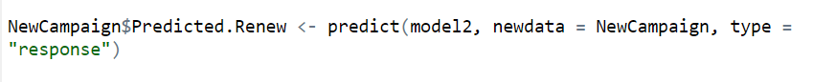

Figure 20 Calculating probability of renewal based on the model

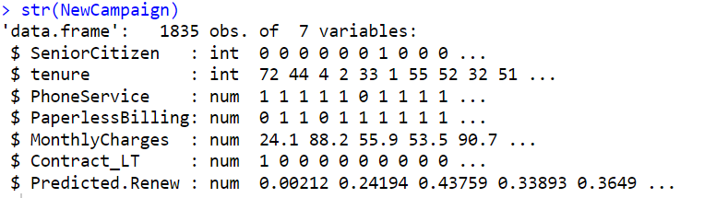

Figure 21 "NewCampaign" including "Predicted.Renew"

Classification of Target Customers

The campaign will *only* target customers that cover the advertising-to-sales ratio:

* Each customer will be “targeted” if their predicted probability of renewal is greater than the breakeven threshold of the advertising-to-sales ratio of $7 cost to $50 revenue, or > 0.14
* Remaining customers will be “Untargeted” as the model predicts probability of renewal < 0.14 and likely an unprofitable contact

Predicted Renewal Rate By Customer – New Campaign

Figure ‑ Classification of ‘targeted” v “untargeted” for new campaign

Conclusion

**The new campaign will target 1118 (60.9%) of customers, with 717 (39.1%) untargeted.**

Figure 23 Efficiency of the new campaign in time and costs

# Implications for Campaign

## Research Goal 3

**Compare predicted profitability of the new campaign to the previous campaign’s actual profits.**

Total Profit By Campaign

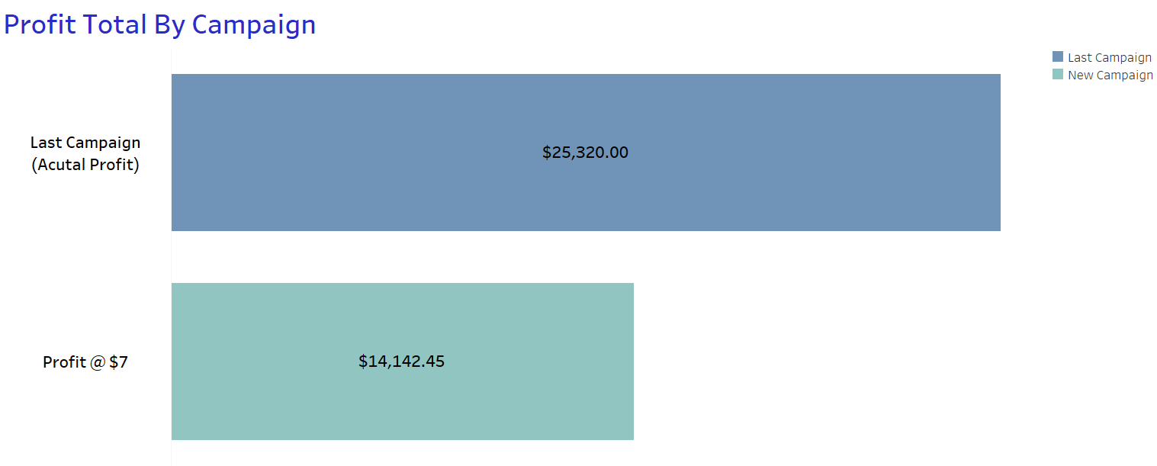

Figure 24 Actual Profits vs. Predicted Profits using logistic regression model

* The previous campaign was ***more*** profitable overall, however ***fewer*** customers were available to be contacted (1835 vs. 4140) in the new campaign and ***only 1118 “targeted” by the model***
* Therefore, comparison of ***profit by “targeted” customers*** gives greater insight

Profit Per Customer By Campaign

Figure 25 Predicted Profit By "Targeted" Approach more than 2 times "Untargeted" approach

Conclusion

**Predicted profits per target customer in the new campaign are more than double the last campaigns actual profits per customer due to efficiency of the process.**

**For a full financial analysis refer to Appendix C**

## Research Goal 4

**Use the data in re-negotiations for costs with the call centre.**

Effect of Costs on Number of “Targeted” Customers

Figure ‑6 Lower costs = lower threshold to breakeven = higher number of target customers

* The model calculates the number of customers contacted in the upcoming campaign by covering the advertising-to-sales ratio.
* The predicted profits at $6 a customer contact and $5 a customer contact are compared below, to both the current $7 contract and last campaign profit per customer.

Effect of Call Centre Costs vs. Predicted Profit Per Customer

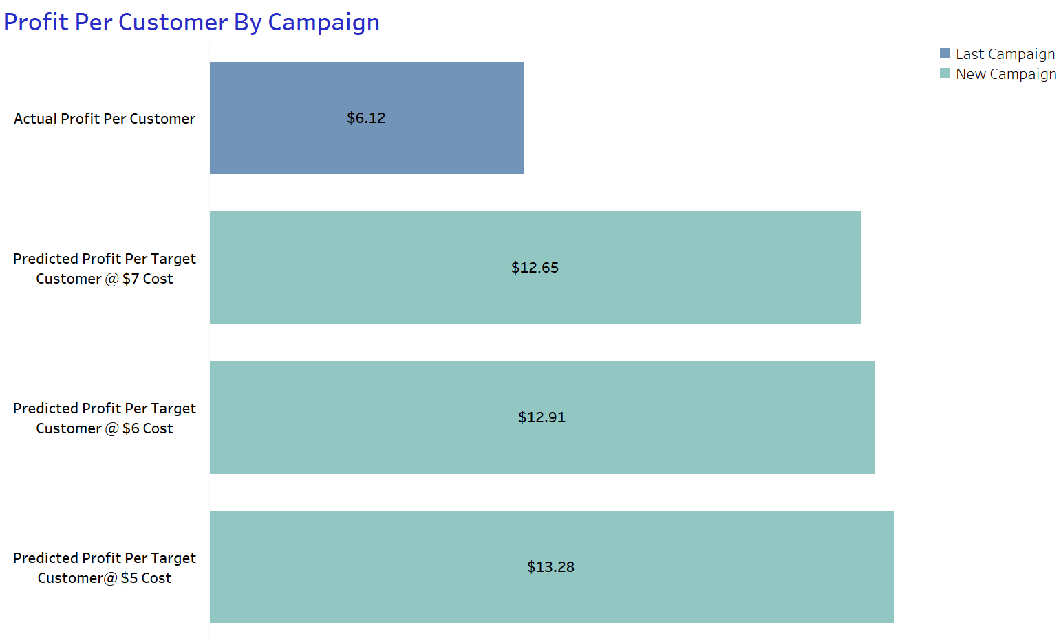

Figure ‑7 Impact of call centre costs on predicted profit per customer

Conclusion

**Re-negotiation of costs below $7 with the call centre results in increasing the number of “target” customers whilst covering advertising-to-sales ratio.**

**By contacting more customers, there are more chances for customers to “Renew” and inflates predicted profits greater than the cost saving.**

**Full financial analysis refer Appendix D**

# Conclusion

Summary

* Modelling suggests a **targeted approach can increase profits per target customer by more than double** compared to an untargeted approach.
* The variables that contribute the most to contract renewal at SY are:

Tenure - Longer tenure strongly decreases the probability of customer renewals.

Monthly Charges - Higher monthly charges have the strongest positive effect on the probability customer renewals.

Long Term Contract - longer contracts decrease the probability of a customer renewal.

For Marketing Managers

1. **Re-negotiation of costs below $7**

* Lower costs results in increasing the number of “targeted” customers therefore providing more chances for customers to renew and therefore inflates predicted profits greater than the cost saving.
* Potentially look to bring the contacting of customers internally to increase engagement with customers and lower costs simulataneously.

1. **Fine Tune “Targeted” Approach**

The methodological approach, and the R-code in Appendix G, can be re-utilized after each new campaign to update the model futher, and keep it meaningful and current as customer dynamics change.

1. **Measure Success**

After each new campaign measure the success of the “targeted approach” looking for an increase in renewals as a % of customers contacted, therefore reducing churn.

1. **Capture Defection Data**

Look to capture defection reason data when customers don’t renew after being contacted by the call centre, enhancing the model further.

For Senior Management

1. **Drill Down Deeper**

Drill down on the factors influencing renewal ratios and answer the following questions:

Tenure and Long-Term Contract – Why are long term customers leaving us? Are they leaving us at the most profitable time in their lifetime value?

Monthly Charges – Why do our high monthly spend customers more likely to renew? Are we great value on premium products?

1. **Focus on the Right Customers**

Research Customer Lifetime Value (CLV) and Customer Referral Value (CFV) metrics at SY, and the customer acquisition strategy, are we acquiring the right customers with the highest lifetime value to us?

1. **Measure and Incentivize the Right Behaviours**

Research ways to incentivize customer churn measures at SY, and make it become a KPI in the business, incentivized for all levels given the profitability of reducing churn.

Limitations of the Analysis

* The analysis cannot be interpreted as a “cause and effect” relationship but rather an association between the predictor variables and their impact on renewal.
* There are variables that have not been included such as age of customer, distance from a metro area and many other factors that may have been important predictors but omitted.
* We can only say that based on the predictor variables available and the customers from the last campaign, this is our “best guess” on what may happen in the next campaign.

# References

Gallo, A. (2014) ‘The Value of Keeping the Right Customers’, *Harvard Business Review Digital Articles*, pp. 2–5.

‘Hosmer–Lemeshow test’ (2025) *Wikipedia*. Available at: https://en.wikipedia.org/w/index.php?title=Hosmer%E2%80%93Lemeshow_test&oldid=1292036248 (Accessed: 8 June 2025).

*IBM SPSS Statistics* (2021). Available at: https://www.ibm.com/docs/en/spss-statistics/25.0.0?topic=model-r-squared-statistics (Accessed: 8 June 2025).

Ossian (2020) ‘Churn Rate vs Retention Rate - Comparison Guide’, *ReliaBills*, 17 July. Available at: https://www.reliabills.com/blog/churn-rate-vs-retention-rate/ (Accessed: 10 June 2025).

Ozili, P.K. (2022) ‘The acceptable R-square in empirical modelling for social science research’.

*What’s the Average Churn Rate by Industry?* (2025) *CustomerGauge*. Available at: https://customergauge.com/blog/average-churn-rate-by-industry (Accessed: 6 June 2025)

.

# Appendices

## Appendix A –Last Campaign Variables

|  |  |  |
| --- | --- | --- |
| Variable | Description | Recode as Numerical |
| Customer ID | Identification of a customer | N/A |
| SeniorCitizen | Whether the customer is retired | No = 0 Yes = 1 |
| Partner | Whether the customer is married (Yes/No) | No = 0 Yes = 1 |
| Dependents | Whether the customer has dependents (Yes/No) | No = 0 Yes = 1 |
| Tenure | Number of months a person has been a customer of the company | N/A |
| PhoneService | Whether the telephone service is connected (Yes/No) | No = 0 Yes = 1 |
| PaperlessBilling | Whether the customer uses paperless billing (Yes/No) | No = 0 Yes = 1 |
| MonthlyCharges | Current monthly payment | N/A |
| TotalCharges | The total amount that the client paid for the services for the entire time | N/A |
| Gender | Customer gender (Male / Female) | Gender_IsMale = 0 Gender_IsMale = 1 |
| Contract | Type of customer contract (Long Term/Short Term) | Contract_LT = 0  Contract_LT = 1 |
| Renew | Whether the customer renewed contract after call centre contact (Yes/No) | No = 0 Yes = 1 |

Table ‑ Last Campaign Variables

## Appendix B – Final Model



Table B-1 Summary output from the final model

|  |  |  |
| --- | --- | --- |
| Variable | Description | Recode as Numerical |
| SeniorCitizen | Whether the customer is retired | No = 0 Yes = 1 |
| Tenure | Number of months a person has been a customer of the company | N/A |
| PhoneService | Whether the telephone service is connected (Yes/No) | No = 0 Yes = 1 |
| PaperlessBilling | Whether the customer uses paperless billing (Yes/No) | No = 0 Yes = 1 |
| MonthlyCharges | Current monthly payment | N/A |
| Contract_LT | Type of contract (Long Term/Short Term) | No = 0 Yes = 1 |

Table B‑2 Final predictor variables for final model

## Appendix C – Model Interpretations

### Odds-Ratio (OR) Model 2

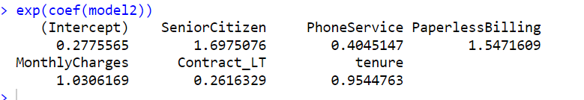

Figure C-1 Exponentiated coefficients for the final model

### Standardisation of Variable Coefficients Model 2

Figure C-2 Standardised coefficients for the final model

## Appendix E - New Campaign Targeted Approach Key Measures

|  |  |  |  |
| --- | --- | --- | --- |
| Key Term | Description | Last Campaign  (Actual) | New Campaign  (Expected) |
| Targeted Customers | Number of Contacted Customers | 4140 | 1118 |
| Untargeted Customer | Number not contacted | 0 | 717 |
| Cost of campaign | Number Of Targeted Customers × Cost Per Customer Contact ($7) | 4140 x $7 = $28,980 | 1118 x $7 =  $7,826 |
| Profit | Revenue $50 per renewal - Cost | $25,320 | $14,142 |
| Profit Per Contact | (Revenue – Cost )/ Targeted Customers | $6.12 | $12.65 |

Table E Targeted Approach Profitability

## Appendix F - Campaign Cost Financial Analysis

|  |  |  |  |  |  |
| --- | --- | --- | --- | --- | --- |
| Key Term | Description | Last Campaign  (Actual) | New Campaign  @ $7 Cost  (Predicted) | New Campaign  @ $6 Cost  (Predicted) | New Campaign  @$5 Cost  (Predicted) |
| Breakeven Threshold | **Cost Per Customer Contact ÷ Value Of Retaining An Existing Customer** | **N/A** | *$7 / $50 = 0.14* | *$6 / $50 = 0.12* | *$5 / $50 = 0.10* |
| Targeted Customers | **Number of Contacted Customers** | **4140** | *1118* | *1184* | *1243* |
| Untargeted Customer | **Number not contacted** | **0** | *717* | *651* | *592* |
| Campaign Cost | **Number Of Targeted Customers × Cost Per Customer Contact ($7)** | **4140 x $7 = $28,980** | *1118 x $7 =*  *$7,826* | *1184 x $6 =*  *$7,104* | *1243 x $5 =*  *$6215* |
| Campaign Profit | **Revenue $50 per renewal - Cost** | **$25,320** | *$14,142.45* | *$15290.61* | *$16502.84* |
| Campaign Profit Per Contact | **(Revenue – Cost )/ Targeted Customers** | **$6.12** | *$12.65* | *$12.91* | *$13.28* |
| % Profit Increase on Last Campaign | **Per Customer Contacted** | **Profit Per Customer / $6.12** | ***106%*** | ***111%*** | ***117%*** |

Table F Financial Analysis Campaign Cost Impact

## Appendix G - R-Code

# install.packages("DescTools")

# install.packages("reghelper")

library(DescTools)

library("ResourceSelection")

library(car)

library("reghelper")

#-------------------------------------------------------------

# Import data

# Last Campaign Data (sample size: 4140).

#-------------------------------------------------------------

# Pull data from the csv file

telecomm_df <-read.csv("Original_A3_Model_development.csv", header=TRUE)

#-------------------------------------------------------------

# Get an overview of the variables

#-------------------------------------------------------------

names(telecomm_df)

#-------------------------------------------------------------

# Client information

# 1. Customer ID – identification of a customer

# 2. Gender – customer gender (binary variable: male / female)

# 3. Senior Citizen – whether the customer is retired (binary variable: Yes=1/ No=0)

# 4. Partner – whether the customer is married (binary variable: Yes/ No)

# 5. Dependents – whether the customer has dependents (binary variable: Yes/ No)

# Details about the customer’s status with SY

# 1. Tenure – number of months a person has been a customer of the company

# 2. Phone Service – whether the telephone service is connected (binary variable: Yes/ No)

# 3. Contract – type of customer contract (binary variable: Long term/ Short term)

# 4. Paperless Billing – whether the customer uses paperless billing (binary variable: Yes/No)

# 5. Monthly Charges – current monthly payment

# 6. Total Charges – the total amount that the client paid for the services for the entire

# time

#-------------------------------------------------------------

#-------------------------------------------------------------

# Recoding of Dependent variable (Renew) and Predictor Variables

#-------------------------------------------------------------

# Renew: Whether the customer renews the contract (Binary variable: Yes/ No).

# Convert it to a number Renew = No -> 0 and Renew = Yes -> 1

telecomm_df$Renew <-ifelse(telecomm_df$Renew=="Yes",1,0)

# Recoding of Predictor variables convert to binary 0 or 1.

telecomm_df$Gender_IsMale <-ifelse(telecomm_df$gender=="Male",1,0)

telecomm_df$Partner <-ifelse(telecomm_df$Partner=="Yes",1,0)

telecomm_df$Dependents <-ifelse(telecomm_df$Dependents=="Yes",1,0)

telecomm_df$PhoneService <-ifelse(telecomm_df$PhoneService=="Yes",1,0)

telecomm_df$Contract_LT <-ifelse(telecomm_df$Contract=="Long term",1,0)

telecomm_df$PaperlessBilling <-ifelse(telecomm_df$PaperlessBilling=="Yes",1,0)

#-------------------------------------------------------------

# Create LastCampaign with only the columns we are interested in

# Drop the unmeaningful "CustomerID"

# Drop "gender" column and "Contract" as recoded these columns into

# Gender_IsMale and Contract_LT

#-------------------------------------------------------------

LastCampaign <- telecomm_df[, !names(telecomm_df) %in% c("customerID", "Contract", "gender")]

str(LastCampaign)

# -----------------------------------------------------------

# Logistic Regression Model Development

#-------------------------------------------------------------

# Step 1: Define research goal

#

# 1. Identify the probability of each customer to renew in the new campaign. (Renew = 1)

# 2. Customers will be identified as "Targeted" if the probability to renew is more than 0.14, else "Untargeted"

# 3. Compare the profit from the last campaign's "untargeted" approach to the expected profit from the new campaign's "targeted" approach.

#-------------------------------------------------------------

# -----------------------------------------------------------

# Step 2: Specify the model

# -----------------------------------------------------------

# First model - logistic regression model from LastCampaign data (glm) and include all independent variables as "." to predict dependent variable "Renew"

model1<-glm(Renew ~ .,data=LastCampaign, family=binomial)

#----------------------------------------------------------

# Step 3: Model evaluation.

# First, we do local model evaluation. We check model variable significance or not & multicollinearity issue

# Second, we do global model evaluation. We check Nagelkerke R square & accuracy

# -----------------------------------------------------------

# Local Model Evaluation - Multicollinearity Test

# Check for VIF over 10, this indicates multicollinearity amongst variables

vif(model1)

# Check correlation of these two variables

cor(LastCampaign$tenure, LastCampaign$TotalCharges)

# Local Model Evaluation - Significance Test

# Check significance levels of independent variables in the model

summary(model1)

#-------------------------------------------------------------

# Model Evaluation Model 1

# Local Model Evaluation: VIFs are greater than 10 for "tenure" and "TotalCharges" means there is multicollinearity issue in model.

# Additionally "Partner" and "Dependents" have significance level of well above 0.05 as does "Gender_IsMale" or not significant in predicting chance of renewal.

# Overall this is not a good model due to VIF and non-significant independent variables

# To address Multicollinarity we will drop "Total Charges" as lowest significance and highest VIF, we will leave tenure as is significant.

# To Address this we will remove - "TotalCharges", "Gender_IsMale", "Partner", "Dependents"

# Global model evaluation - We will skip for Model 1 due to high VIFs and insignificant variables that need to be fixed first

#-------------------------------------------------------------

# Adjust to Model 2 with new set of independent variables

model2<-glm(Renew ~ SeniorCitizen+

PhoneService+

PaperlessBilling+

MonthlyCharges+

Contract_LT+

tenure,

data=LastCampaign, family=binomial)

#-----------------------------------------------------------

# Step 3: Model evaluation:

# First, we do local model evaluation. We check model parameter significant or not & multicollinearity issue.

# Second, we do global model evaluation. We check Nagelkerke R square & accuracy

# -----------------------------------------------------------

# Local Model Evaluation - Multicollinearity Test

vif(model2)

# Local Model Evaluation - Significance Test

summary(model2)

# -----------------------------------------------------------

# Global model evaluation

# -----------------------------------------------------------

# -----------------------------------------------------------

# Nagelkerke R square

# It is always between 0 and 1. The higher the better.

# -----------------------------------------------------------

PseudoR2(model2, which = "Nagelkerke")

# -----------------------------------------------------------

# Global model evaluation - Prediction Accuracy

# -----------------------------------------------------------

#Create a Confusion Matrix to determine prediction accuracy of the model

#Cut off

Conf(model2, cutoff = 0.14)

# Prediction accuracy

print(paste('Prediction Accuracy Model 2:', prediction_accuracy <- (1007+1537)/ 4140))

# # ANOVA tests whether the variance in a set of data explained by the model is significantly greater than the unexplained variance.

# # Thus, we want this test to be significant (p<.05).

# # The test proceeds in a step wise manner, adding one of the independent variables

# # in each step. We are only interested in the value in the last step.

# # Here it is significant so ok.

anova(model2, test="Chisq")

# # Hosmer Lemeshow test whether the predicted values and the actual values are significantly different.

# # "Renew" identifies the observed binary, "fitted"model" the predicted.

# # The test partitions the data into groups and compares for each one

# # whether there are differences between predictions and observations.

# # "g=10" is th edefault choice for the number of groups the test uses.

# # For a good model performance we want them to be NOT different.

# # Thus, we want the Hosmer Lemeshow Test to be INSIGNIFICANT (>.05)!

# # Here it is significant, thats not a good model.

h3<-hoslem.test(LastCampaign$Renew, fitted(model2), g=10)

h3

#-------------------------------------------------------------

# Standardization of Model Coefficients

# For comparison of affect of independent variables on dependent "Renew" to see which variable has the strongest effect.

#-------------------------------------------------------------

model2.std <- beta(model2)

model2.std

# Write standardized coefficients to csv file for visualization

write.csv((coef(model2.std)[, "Estimate"]),"Standarised_Coefficients.csv")

#-------------------------------------------------------------

# Odds-Ratio Calculations

# To see how the log odds "Renew" affected by 1 unit increase in variables in model, minus the intercept

#-------------------------------------------------------------

exp(coef(model2))

# Write odds-ratios estimates and confidence intervals to csv file for visualisation

write.csv((cbind(exp(coef(model2)), exp(confint(model2)))), "Odds_Ratio.csv")

# #-----------------------------------------------------------

# # New Campaign Calculation of Target Customers at probability of Renew <.14 = Targeted

# #-----------------------------------------------------------

# Read in NewCampaign Data

NewCampaign <-read.csv("A3_Prediction.csv", header=TRUE)

str(NewCampaign)

#-------------------------------------------------------------

# Re-coding of Independent variables in NewCampaign

#

# Currently, the independent variables are character format

# To run a logistic regression, we need to convert them to binary 0 or 1

# We re code them by using if else function.

# Change Categorical values into 1 or 0 for each column in NewCampaign

#------------------------------------------------------------

NewCampaign$PhoneService <-ifelse(NewCampaign$PhoneService=="Yes",1,0)

NewCampaign$Contract_LT <-ifelse(NewCampaign$Contract=="Long term",1,0)

NewCampaign$PaperlessBilling <-ifelse(NewCampaign$PaperlessBilling=="Yes",1,0)

NewCampaign <- NewCampaign[, !names(NewCampaign) %in% c('customerID','gender','Partner', 'Dependents', 'TotalCharges', 'Contract')]

NewCampaign$Predicted.Renew <- predict(model2, newdata = NewCampaign, type = "response")

str(NewCampaign)

#-------------------------------------------------------------

# Threshold Calculation Targeted vs. Untargeted for New Campaign

#

# Advertising-to-sales ratio = Total advertising expenses / Sales revenue

#

# When a threshold is 7 (cost per customer contact) / 50 (value of retaining

# an existing customer), 0.14 means breakeven point of not churn. If the

# predicted probability of ‘renew’ is greater than 0.14 (or predicted

# probability of ‘churn’ is less than 0.86), then this customer will be the

# targeted customer.

#-------------------------------------------------------------

print(paste('Target Renew Threshold for Future Campaign:', 7 / 50))

# Classify customers "targeted" vs. "untargeted" based on the probabilities "of "Renew"

# If probability "Renew" < 0.14, then Target = 0

# If probability "Renew" > 0.14, then Target = 1

NewCampaign$Target.Customer <- ifelse(NewCampaign$Predicted.Renew > 0.14, 1, 0)

str(NewCampaign)

write.csv(NewCampaign, "NewCampaign Data.csv")

#---------------------------------------------

# Step 5: Predictions

# Advertising Campaign Statistics Prediction This Month

#

#---------------------------------------------

# Print Number of customers who will be targeted (Probability Renew > 0.14)

num_target_customers <- sum(NewCampaign$Target.Customer == 1)

print(paste('Number of Targeted Customers New Campaign:', num_target_customers))

# Print Ratio of customers who are targeted vs untargeted new campaign

print(paste("Target Customer Ratio New Campaign:", num_target_customers/nrow(NewCampaign)))

# Number of targeted customer = 1118, and they are ordered from lowest

# probability to the highest probability of churn (all will be contacted)

targeted.probabilities <- sort(NewCampaign$Predicted.Renew, decreasing = TRUE)[1:1118]

# Predicted Revenue = Probability of Renewal of Targeted Customers × Worth for retaining an existing customer

predicted.revenue <- round(targeted.probabilities * 50, 2)

# Predicted Profit = Predicted Revenue - Predicted Cost

predicted.profits <- sum(predicted.revenue) - (num_target_customers*7)

predicted.profits

#-------------------------------------------------------------

# Advertising Campaign Statistics Last Campaign vs. New Campaign

#-------------------------------------------------------------

last_campaign_renewals <- sum(telecomm_df$Renew == 1)

num_customers_contacted <- nrow(telecomm_df)

print(paste('Total Cost of Advertising (Last Campaign): $', num_customers_contacted* 7))

# Calculate Predicted Cost New Campaign

print(paste('Total New Campaign Cost (Number of Targeted Customers x $7): $',num_target_customers* 7))

# Acutal Profit Last Campaign

print(paste('Total Profit of Last Campaign (Revenue - Cost): $', last_campaign_renewals*50 - num_customers_contacted* 7))

# Predicted Profit for New Campaign

print(paste('Total Predicted Profit of New Campaign (Revenue - Cost): $',sum(predicted.revenue), '- $', sum(num_target_customers * 7), ' = $',predicted.profits))

# Acutal Profit per customer Last Campaign

print(paste('Total Profit Per Customer Contacted (Last Campaign) $', round((((last_campaign_renewals * 50) - (num_customers_contacted * 7))/num_customers_contacted), 2)))

# Predicted Profit per customer New Campaign

print(paste('Total Predicted Profit of New Campaign per Contact: $', round((predicted.profits / num_target_customers), 2)))

# And for those we calculate the expected profits,

# which are $14142.45

# Expected Profit/Customer Contacted is $12.65

# Remember: In the initial sample with the untargeted campaign,

# our profit amounted to $25320 only.

# Actual Profit Per Customer Contacted was $6.12

#-------------------------------------------------------------

# WHAT IF COST WAS $6

#-------------------------------------------------------------

print(paste('Target Renew Threshold for Future Campaign:', 6 / 50))

NewCampaign$Target.Customer6 <- ifelse(NewCampaign$Predicted.Renew > 0.12, 1, 0)

# Print Number of customers who will be targeted (Probability Renew > 0.14)

num_target_customers6 <- sum(NewCampaign$Target.Customer6 == 1)

print(paste('Number of Targeted Customers New Campaign @$6:', num_target_customers6))

# Number of targeted customer = 1118, and they are ordered from lowest

# probability to the highest probability of churn (all will be contacted)

targeted.probabilities6 <- sort(NewCampaign$Predicted.Renew, decreasing = TRUE)[1:1184]

# Predicted Revenue = Probability of Renewal of Targeted Customers × Worth for retaining an existing customer

predicted.revenue6 <- round(targeted.probabilities6 * 50, 2)

# Predicted Profit = Predicted Revenue - Predicted Cost

predicted.profits6 <- sum(predicted.revenue6) - (num_target_customers6*6)

predicted.profits6

#-------------------------------------------------------------

# WHAT IF COST WAS $5

#-------------------------------------------------------------

print(paste('Target Renew Threshold for Future Campaign:', 5 / 50))

NewCampaign$Target.Customer5 <- ifelse(NewCampaign$Predicted.Renew > 0.10, 1, 0)

# Print Number of customers who will be targeted (Probability Renew > 0.14)

num_target_customers5 <- sum(NewCampaign$Target.Customer5 == 1)

print(paste('Number of Targeted Customers New Campaign @$5:', num_target_customers5))

# Number of targeted customer = 1118, and they are ordered from lowest

# probability to the highest probability of churn (all will be contacted)

targeted.probabilities5 <- sort(NewCampaign$Predicted.Renew, decreasing = TRUE)[1:1243]

# Predicted Revenue = Probability of Renewal of Targeted Customers × Worth for retaining an existing customer

predicted.revenue5 <- round(targeted.probabilities5 * 50, 2)

# Predicted Profit = Predicted Revenue - Predicted Cost

predicted.profits5 <- sum(predicted.revenue5) - (num_target_customers5*5)

predicted.profits5