
UNSW Business School

School of Information Systems and Technology Management
Assessment 2 Cover Sheet

Student Name: Amanda Wright
Student ZID: z5535290
Course Code: ZZBU6516
Course Name: Database Management
Date Due: 5 pm (Sydney Time), Wednesday 31st July 2024

I declare that this assessment item is my own work, except where acknowledged, and has not been submitted for academic credit elsewhere, and acknowledge that the assessor of this item may, for the purpose of assessing this item:
- Reproduce this assessment item and provide a copy to another member of the University; and/or,
- Communicate a copy of this assessment item to a plagiarism-checking service (which may then retain a copy of the assessment item on its database for the purpose of future plagiarism checking).
I certify that I have read and understood the University Rules in respect of Student Academic Misconduct.
Signed (this can be either your digital signature or simply type your Full Name):

______Amanda Joy Wright__________

Date: ___29/7/2024_________

Usage of AI Tools
<Write here how you have used AI tools and how you use and change the output in your assessment. Please be honest because TurnItIn can detect the usage of AI tools.>
For research into the Paris Olympic Volunteer requirements and the Marathon event specifics.

Table of Contents
Usage of AI Tools 2
Table of Contents 3
Executive Summary 4
Entity Relationship Design 5
Relational Database Design in Oracle 6
Normalisation 6
Appendices 7
References 10
Entity-Relationship Model 11

Executive Summary
The scope for this project is to design and create a database prototype for the successful management of volunteers at the Paris Olympic Games 2024.
The Paris Olympics 2024 will have over 45,000 volunteers assisting across 19 days and over 35 venues. (“Paris 2024 - Paris 2024 volunteer programme,” n.d.)
For our prototype we have limited the system design to the Marathon event at Paris Olympics 2024.
The database will manage the volunteers who will assist in the three Marathon events two at the Olympics, a men’s, and a women’s event, and one at the Paralympics for all competitors.
The Paris Marathon is 42 kilometres long in one continuous course and the resourcing needs will be complex involving thousands of volunteers. The model will assume the course set up is done by contractors and not managed by volunteers.
The implementation and software development component of the database is being completed by a separate team.
Post design of an Entity Relationship Diagram, we will review for normalization and potential denormalization to ensure the model contains no redundancies.
Post the review of the model for normalisation we will implement the tables in Oracle using Structured Query Language(SQL).

Entity Relationship Design

Business Rules – Assumptions made in the Design Process
A “Function” is a broad overarching description of the tasks to be performed by volunteers, such as “Information,” “Food and Beverage Catering” and under each “Function” there are many roles.
Each “Role” belongs to one and only one “Function.”
The Supertype entity “Stations” contains Subtypes of “Station Type” describing the station function.
Each station can have many shifts, but each shift works one station.
Volunteers provide “Availability” of dates and times, and their “Accreditations” including Medical Licences, Food Safety Certificates, Course Marshal Accreditations and so on.
Volunteers will have multiple availability dates, and potentially multiple accreditations stored in a separate “Line No” in the Availability and Accreditation entities.
Volunteers can complete any role they are qualified for across events, but not two roles at the same event/time.
Volunteers must speak French or English as required by the International Olympic Committee.
“Shifts” are created for each of the four station types each with a unique “Shift ID” for each unique start and finish time at a specific “Station,” in a “Role” at a specific “Event.” This detail is stored in the “Shift Header” entity as it repeats for each volunteer assigned to a shift.
Each unique Shift ID is then assigned to a volunteer through the “Shift Detail” entity, based on “Availability” (by the database software) as well as the number of hours of the shift as the maximum a volunteer can work is capped by day and by week.

Relational Database Design in Oracle
Primary Keys
There are various candidate keys that could be used as primary keys, however in the end most primary keys in the model resulted in being surrogate keys.
An example is “Availability Date” appears unique when combined with a “Volunteer ID” as a composite key however, if a volunteer has two availability spans on one day it is no longer unique.
An event could have a composite key of “Event Name” and “Event Date,” however if the date should change for the event due to unforeseen circumstances it causes extra work and for simplicity a preference was made for single attribute primary keys as much as possible.
Therefore, most entities were given surrogate keys. Originally they were intended to be numeric to improve speed, however when using test values, it appeared numeric keys for a role and a station became unintelligent and not descriptive enough as a user.
This resulted in the surrogate keys being a combination of numbers and letters to improve usability of the database and assigned a VARCHAR data type for example a FUNCTION_ID is “301-INFO” rather than 301.
The “Availability” and “Accreditation” entities have composite keys as each volunteer will have multiple records for both. To maintain uniqueness Volunteer_ID was insufficient, and “Line No” was decided to assign an auto-increment for each row of data in these entities and combine in a composite primary key.(Refer Fig 1 & 2)
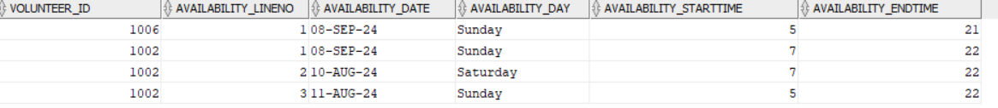
Figure 1 Example of Availability Table
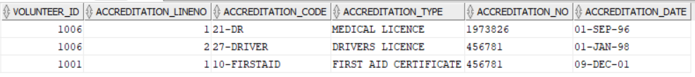
Figure 2 Example of Accreditation Table

Normalisation
After reviewing the model for normalisation, the model is in in 3NF with no partial dependencies or transitive dependencies and all nonprime attributes depend on the primary key.
There is no need for denormalization in the model currently after consideration.

Appendices
Appendix A – Paris Olympic Marathon Route 2024
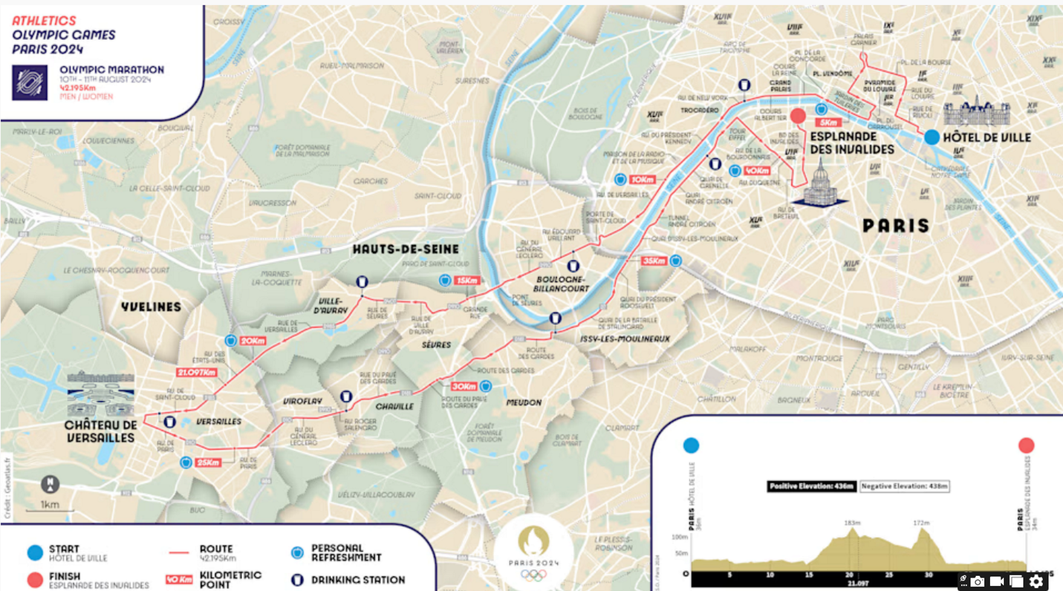

Appendix B – Example Tables

Volunteer

Accreditation

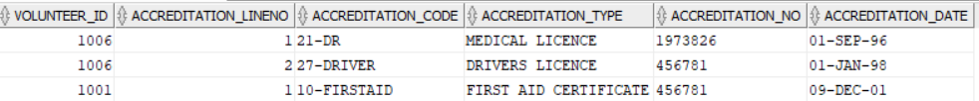

Availability

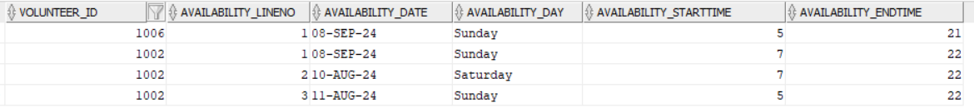

Event

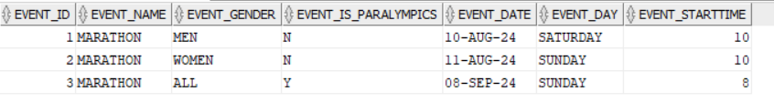

Function

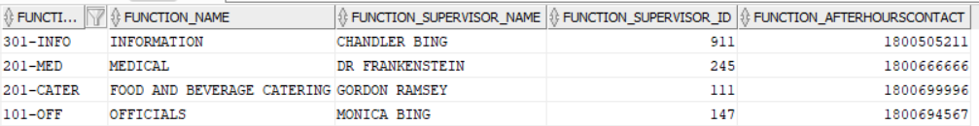

Role 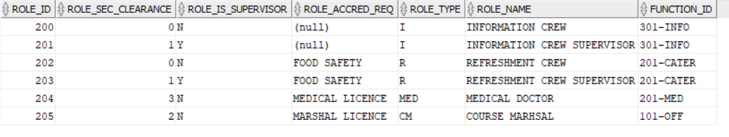

Station

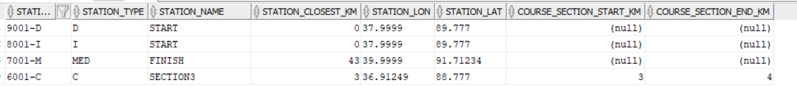

Shift Header

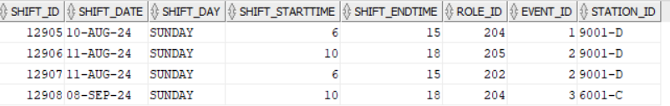

Shift_Details

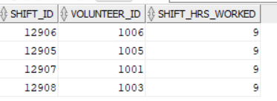
References

Paris 2024 - Olympic marathon route [WWW Document], n.d. URL https://olympics.com/en/paris-2024/information/olympic-marathon-route (accessed 7.17.24).

Paris 2024 - Paris 2024 volunteer programme [WWW Document], n.d. URL https://olympics.com/en/paris-2024/the-games/volunteers (accessed 7.17.24).

Paris 2024 - The medals of the Paris 2024 Games [WWW Document], n.d. URL https://olympics.com/en/paris-2024/paralympic-games/schedule/para-athletics (accessed 7.17.24).

World Para Athletics Classification & Categories [WWW Document], n.d. . International Paralympic Committee. URL https://www.paralympic.org/athletics/classification (accessed 7.17.24).

Volunteer - Course Roles, n.d. . Sydney Marathon. URL https://sydneymarathon.com/volunteers-3/general-volunteers/volunteer-course-roles/ (accessed 7.17.24).

