
UNSW Business School

School of Information Systems and Technology Management
Assessment 3 Cover Sheet

Student Name: Amanda Wright
Student ZID: z5535290
Course Code: ZZBU6516
Course Name: Database Management
Date Due: 5 pm (Sydney Time), Wednesday 14 August 2024

I declare that this assessment item is my own work, except where acknowledged, and has not been submitted for academic credit elsewhere, and acknowledge that the assessor of this item may, for the purpose of assessing this item:
- Reproduce this assessment item and provide a copy to another member of the University; and/or,
- Communicate a copy of this assessment item to a plagiarism-checking service (which may then retain a copy of the assessment item on its database for the purpose of future plagiarism checking).
I certify that I have read and understood the University Rules in respect of Student Academic Misconduct.
Signed (this can be either your digital signature or simply type your Full Name):

Amanda Joy Wright

Date:15/8/2024

Usage of AI Tools
I used Co Pilot at times to debug my SQL code which most the time was a comma or a semi-colon here and there.
Otherwise predominantly for research into volunteering and the Olympic Games itself, which I have acknowledged in my Part 2 Presentation References.
I did utilise Co Pilot to generate data for additional volunteers from 1012 to 1042.

Table of Contents
Table of Contents
Usage of AI Tools 2
Table of Contents 3
Executive Summary 4
Creating a Data Warehouse 5
Developing a Star Schema 5
Reports 8
Appendices 13
References 13

Executive Summary
Our scope for this project is to design and create a database prototype for the successful management of volunteers at the Paris Olympic Games 2024.
The Paris Olympics 2024 will have over 45,000 volunteers assisting across 19 days and over 35 venues.
For our prototype we have limited the design to a system for the “Marathon” event at Paris Olympics 2024.
The database will manage the volunteers who will assist in the three Marathon events two at the Olympics, a men’s and a women’s event, and one at the Paralympics for all competitors.
After building the database we will implement a Data Warehouse using a Star Schema with an archive of relevant data that can be analysed by future Olympic Organising Committees to enhance their volunteer program, including creating useful SQL queries to generate materialized views and reports.

Creating a Data Warehouse
Purpose and Possible Use Cases for Paris Marathon Historical Data
By creating a data warehouse from our Entity Relationship Model for the Paris Olympic Games Marathon, we need to consider what data needs to be archived after the events have taken place for future reporting and analysis.
Looking forward to planning the next Olympic Games, information on Availability and Accreditations are not required to be kept in the data warehouse for further data analytics, as they are predominantly valuable in the planning stage of the event.
However, what is of certain value to future organising committees is:
- demographics of the volunteer workforce such as where they hailed from globally, gender, age and language spoken
- the details of events the volunteers were assigned to
- what roles and how many volunteers were used in each role/function
- what times were volunteers rostered to and how many hours volunteers were rostered for
- what roles needed accreditations and how many volunteers were rostered to those roles for future planning purposes such as Doctors, Course Marshals etc.

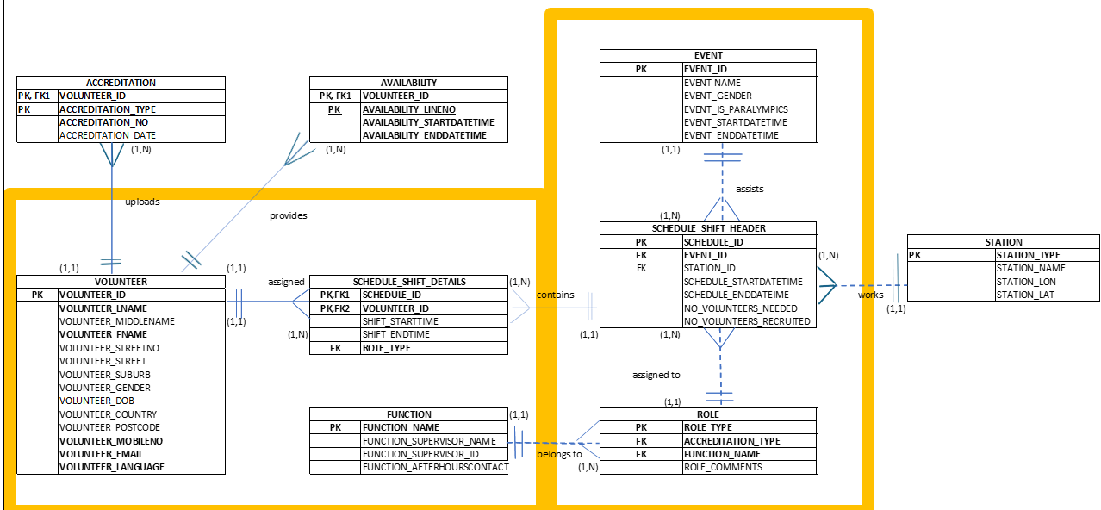
Figure 1 Entity Relationship Model - Paris Olympic Marathon

Developing a Star Schema
Data Warehouse Dimension Tables
Below is how each entity in the Entity Relationship Model has been translated into a Dimension Table in the DWPARIS data warehouse, keeping only relevant attributes needed from a historical view.

Volunteer Entity
Attributes that will change over time, such as address, email address and mobile phone number have been discarded.
Country and Post Code have been translated in the data warehouse.
Country data will assist analysis on whether a volunteer is from the host nation, and Post Code to analyse how many volunteers came from outside the host city.
This will be useful for future organising committees to review where volunteers came from historically when planning strategy to engaging their own volunteers.
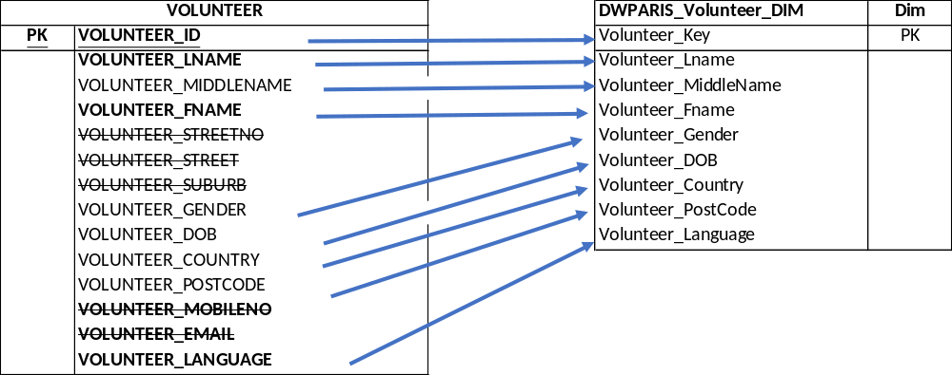

Figure 2 Volunteer Entity to DWPARIS_Volunteer_DIM
Event Entity
The event entity has been translated into the Event dimension table by combining the text over numerous attributes into one for simplicity, and the overarching sport added for potential scale up into multiple sports and events post prototype.
Event Start and End time is not particularly relevant in a historical sense and easy to search for online should need be.
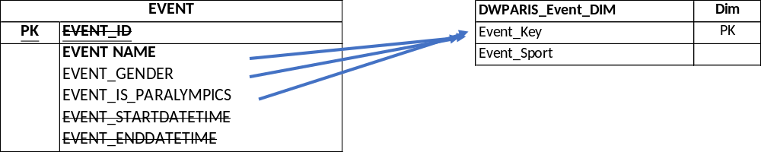

Figure 3 Event Entity to DWPARIS_Event_DIM
Role Entity
The Role entity has been translated into the Role dimension table as per below with Accreditation Requirements kept for auditing purposes and historical view on requirements for certainroles.
Function name is combined from the Function entity into the role dimension to allow views to be looked at a overarching view for example how many volunteers needed for food and catering or information services.

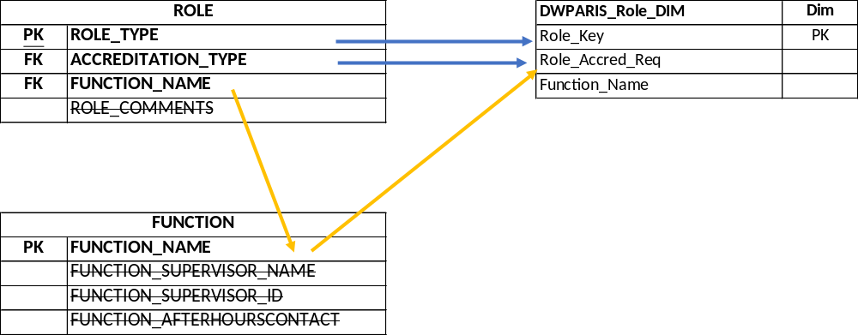

Figure 4 Role and Function Entity to DWPARIS_Role_DIM
Data Warehouse Fact Table
The information stored in the Schedule Shift Header is for planning purposes with each Schedule_ID referring a specific shift required for each event and how many volunteers required.
Whilst on the surface this may appear interesting for the next organising committee, the data of the actual number of volunteers who worked a shift is more likely to be used than the scheduling needs which are referred to more in the planning stage.
The fact table will contain the volunteer who worked the shift, on a specific date, at an event in a role with a shift start date and time and shift end date and time
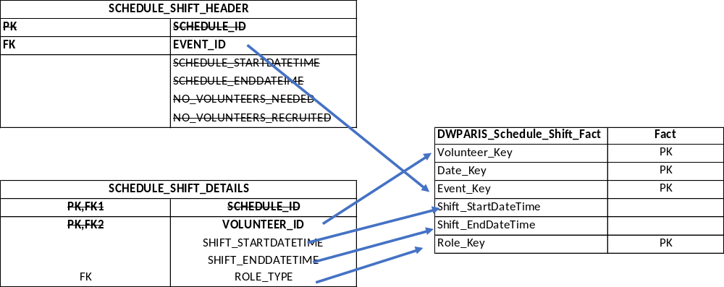

Figure 5 Schedule_Shift Header and Details to DWPARIS_Schedule_Shift_Fact Table

Star Schema
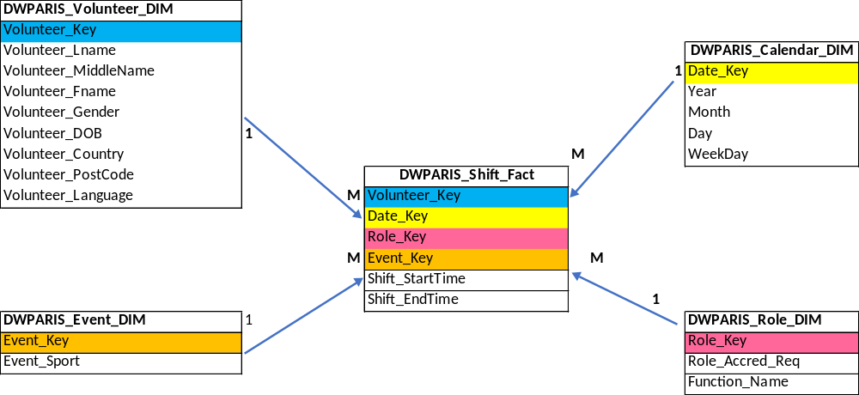

Reports
Report One
GENERATE THE TOTAL WORKING HOURS OF ALL SHIFTS BY VOLUNTEER USING GROUP BY
Purpose
Generate a report on the number of hours volunteers are rostered for in total.
This allows schedulers to ensure volunteers stick to business rules of maximum weekly and daily hours of 9 hours a day, 5 days a week which includes a 1-hour meal break
SQL Code

SELECT
V.VOLUNTEER_LNAME "Surname",
V.VOLUNTEER_FNAME "First Name",
/* Convert Timestamps to intervals, and then into seconds (divide 3600) to work out hours worked*/
/* takes off 1 hour for each shift for breaks */
SUM(
((EXTRACT(DAY FROM (SHIFT_ENDDATETIME - SHIFT_STARTDATETIME)) * 24 * 60 * 60) +
(EXTRACT(HOUR FROM (SHIFT_ENDDATETIME - SHIFT_STARTDATETIME)) * 60 * 60) +
(EXTRACT(MINUTE FROM (SHIFT_ENDDATETIME - SHIFT_STARTDATETIME)) * 60) +
EXTRACT(SECOND FROM (SHIFT_ENDDATETIME - SHIFT_STARTDATETIME)))/ 3600 ) - COUNT(SHIFT_STARTDATETIME) *1 AS "Total Hours Worked "
FROM V3_VOLUNTEER V
JOIN V3_SCHEDULE_SHIFT_DETAILS SD
ON (SD.VOLUNTEER_ID = V.VOLUNTEER_ID)
GROUP BY V.VOLUNTEER_ID, V.VOLUNTEER_LNAME, V.VOLUNTEER_FNAME
ORDER BY VOLUNTEER_LNAME, VOLUNTEER_FNAME;
Report

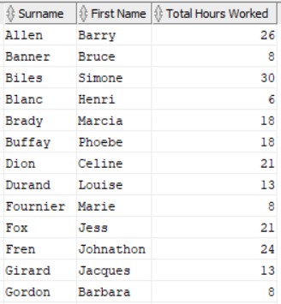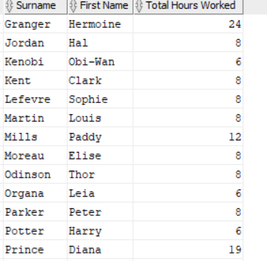

Report Two
FIND IF VOLUNTEERS 2 SCHEDULED SHIFTS ON THE SAME DAY ON A SINGLE MARATHON EVENT USING GROUP BY
Purpose
Generate a report if volunteers are rostered twice in the same day, breaking business rules and causing confusion for volunteers and resource gaps.
SQL Code

SELECT
COUNT(SD.SCHEDULE_ID) "Number of Shifts By Event ", V.VOLUNTEER_LNAME "Volunteer Surname"
FROM V3_SCHEDULE_SHIFT_DETAILS SD
JOIN V3_VOLUNTEER V
ON (V.VOLUNTEER_ID = SD.VOLUNTEER_ID)
JOIN V3_SCHEDULE_SHIFT_HEADER SH
ON (SH.SCHEDULE_ID = SD.SCHEDULE_ID)
JOIN V3_EVENT E
ON (SH.EVENT_ID = E.EVENT_ID)
GROUP BY E.EVENT_ID, V.VOLUNTEER_LNAME
HAVING COUNT(SH.SCHEDULE_ID) >1;

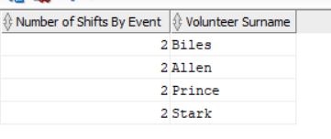

Report Three
DISPLAY THE VOLUNTEERS THAT HAVE NOT GOT A SHIFT FOR ANY EVENT USING A SUBQUERY CLAUSE
Purpose
Generate a report if volunteers not rostered to a shift, allowing use of all registered volunteers, and can be printed by day to give a call list for those who can cover absent volunteers on the day.
SQL Code

SELECT VOLUNTEER_LNAME "Surname",
VOLUNTEER_FNAME "First Name"
FROM V3_VOLUNTEER
WHERE VOLUNTEER_ID NOT IN
(SELECT SD.VOLUNTEER_ID
FROM V3_SCHEDULE_SHIFT_DETAILS SD)
ORDER BY VOLUNTEER_LNAME;

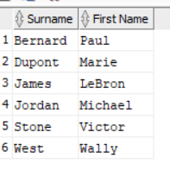
Report Four
DISPLAY THE VOLUNTEERS THAT HAVE AVAILABILITY ON 10-AUG-24 AND HAVE A MEDICAL LICENCE USING A SET OPERATOR CLAUSE
Purpose
Generate a report by specific role who are available on a given day with certification of a role.
Example here is tell me the Dr’s who are available to work on 10-Aug-24 and can be assigned to a shift.
SQL Code

(SELECT VOLUNTEER_ID
FROM V3_AVAILABILITY
NATURAL JOIN V3_VOLUNTEER
WHERE AVAILABILITY_STARTDATETIME >= '10-AUG-24' AND AVAILABILITY_STARTDATETIME < '11-AUG-24'
INTERSECT
SELECT VOLUNTEER_ID
FROM V3_ACCREDITATION
WHERE ACCREDITATION_TYPE = 'MEDICAL LICENCE');

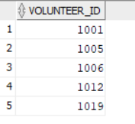
Report Five – Materialized View
ANALYSE THE COUNTRY OF ORIGIN OF THE VOLUNTEERS
Purpose
Generate a report by origin to give future organising committees insights on where volunteers can be source from for targeted recruitment.
SQL Code

CREATE MATERIALIZED VIEW DW_PARIS_VOLUNTEERS_COUNTRY_RESIDENCE_MV
REFRESH COMPLETE ON DEMAND
AS SELECT VOLUNTEER_COUNTRY AS "Country Volunteering From", COUNT(DISTINCT S.VOLUNTEER_KEY) AS "Number of Volunteers"
FROM DWPARIS_Shift_Fact S
JOIN DWPARIS_Volunteer_DIM V
on S.VOLUNTEER_KEY = V.VOLUNTEER_KEY
JOIN DWPARIS_Role_DIM R
ON S.ROLE_KEY = R.ROLE_KEY
GROUP BY VOLUNTEER_COUNTRY;
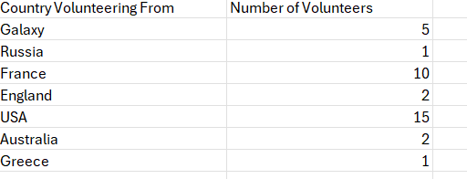
Report Six – Materialized View
ANALYSE THE NUMBER OF VOLUNTEERS BY ROLE
Purpose
Generate a report by origin to give future organising committee’s insights on the distribution of volunteers by role in previous events targeted recruitment.
SQL Code

CREATE MATERIALIZED VIEW DW_PARIS_VOLUNTEERS_NUMBERS_BY_ROLE_MV
REFRESH COMPLETE ON DEMAND
AS SELECT COUNT(DISTINCT VOLUNTEER_KEY), ROLE_KEY
FROM DWPARIS_VOLUNTEER_DIM
LEFT JOIN DWPARIS_SHIFT_FACT
USING (VOLUNTEER_KEY)
GROUP BY ROLE_KEY
ORDER BY ROLE_KEY;

COMMIT;
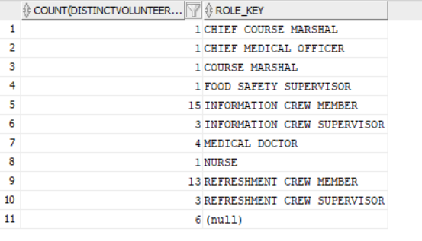

Appendices
Appendix A - Entity Relationship Model Olympic Marathon

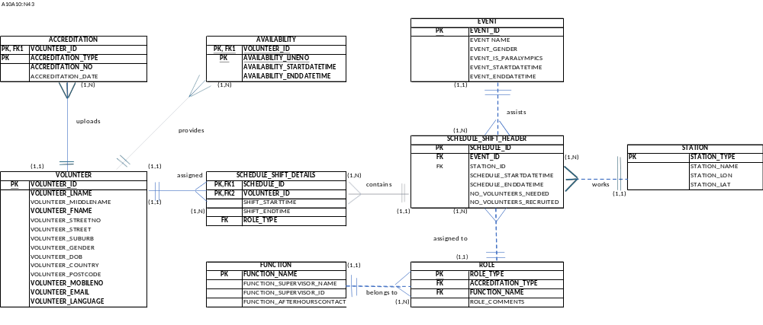

References
NIL

