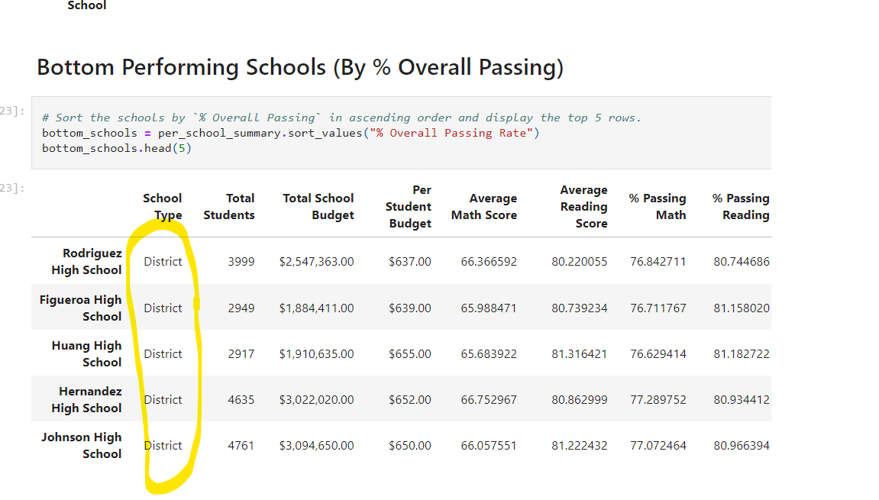 Report

School charter score higher comparisons with district schools