

**Computer Vision**

**Task 4**

**Team # 17**

|  |  |  |  |
| --- | --- | --- | --- |
|  | Name | Sec | BN |
| 1 | Khloud Abdulazeem Mostafa | 1 | 29 |
| 2 | Awatef Ahmed Hasan Ahmed | 2 | 6 |
| 3 | Meirna Kamal eldin Hussein | 2 | 36 |
| 4 | Heba Muhammed Alrefaey | 2 | 42 |
| 5 | Walaa Salah Abdullatef | 2 | 45 |

**Contact Email:**

<meirnakamal9999@gmail.com>

**Results:**

**Thresholding**

1. Optimal Thresholding

Global

Computation_time of Optimal_Global_Thresholding function= 0.10798168182373047

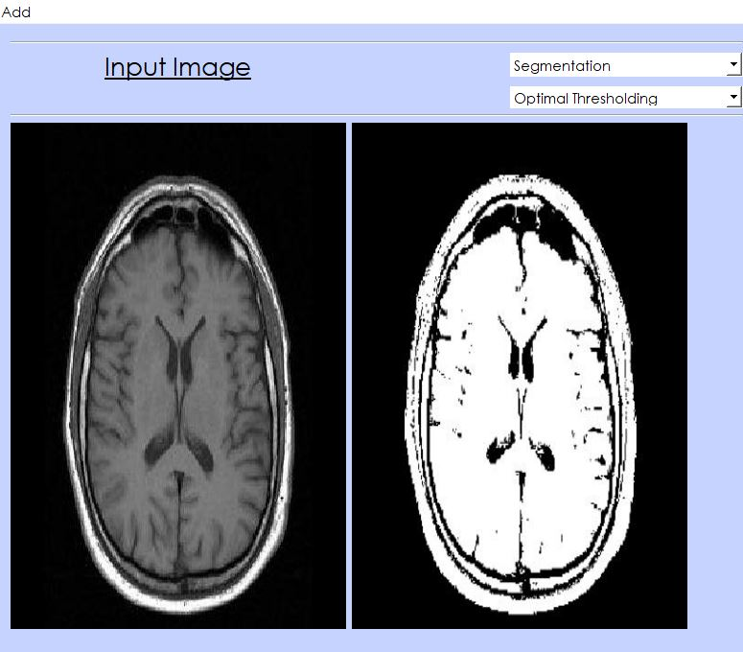

Local

Computation_time of Optimal_Local_Thresholding function= 0.19566750526428223

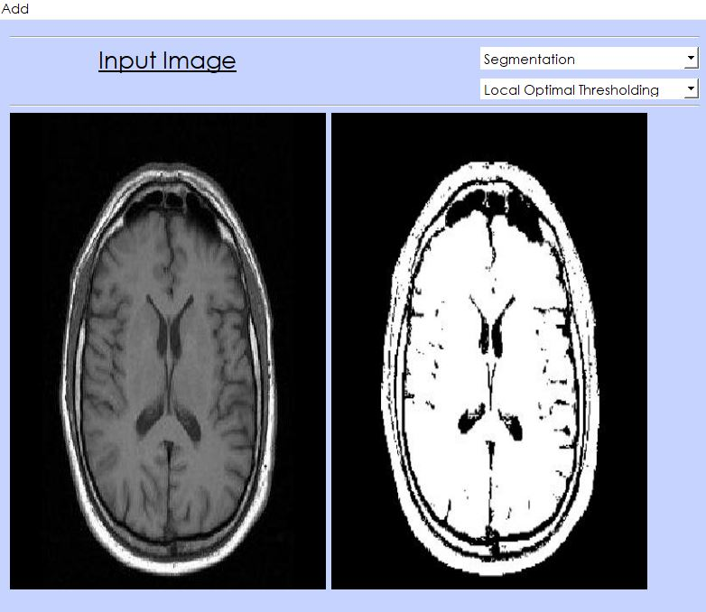

1. Otsu

Global

Computation_time of Otsu_Global_Thresholding function= 0.025985240936279297

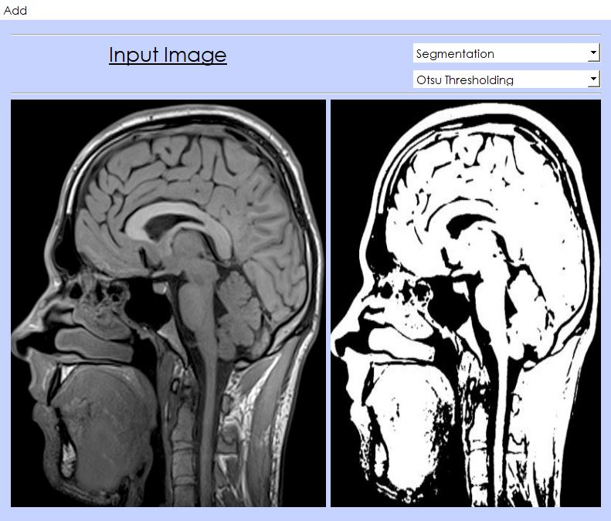Otsu threshold : 67

Local

Computation_time of Otsu_Local_Thresholding function= 0.01998591423034668

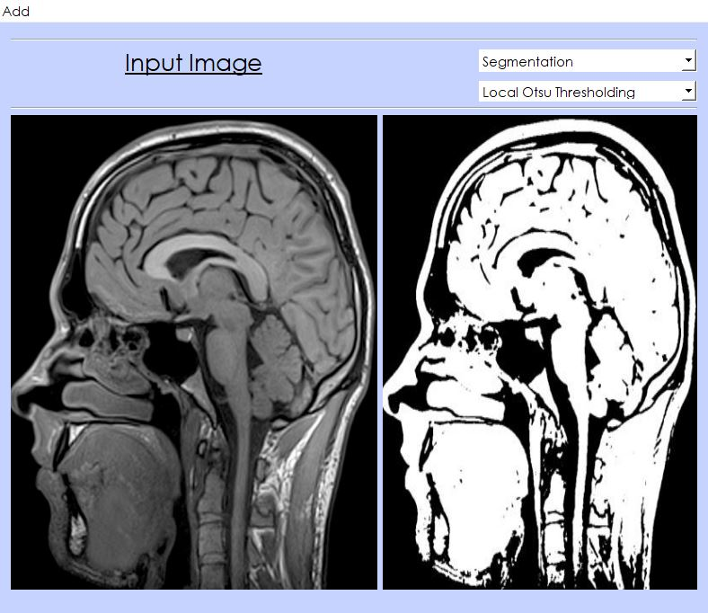

1. Spectral Thresholding

**LUV**

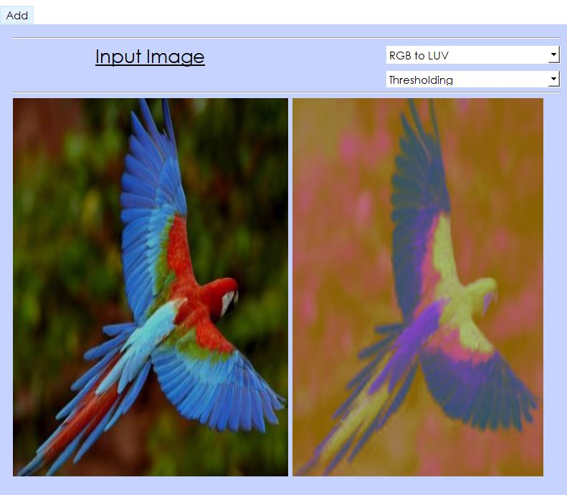

**Segmentation**

1. K-means
2. Region Growing

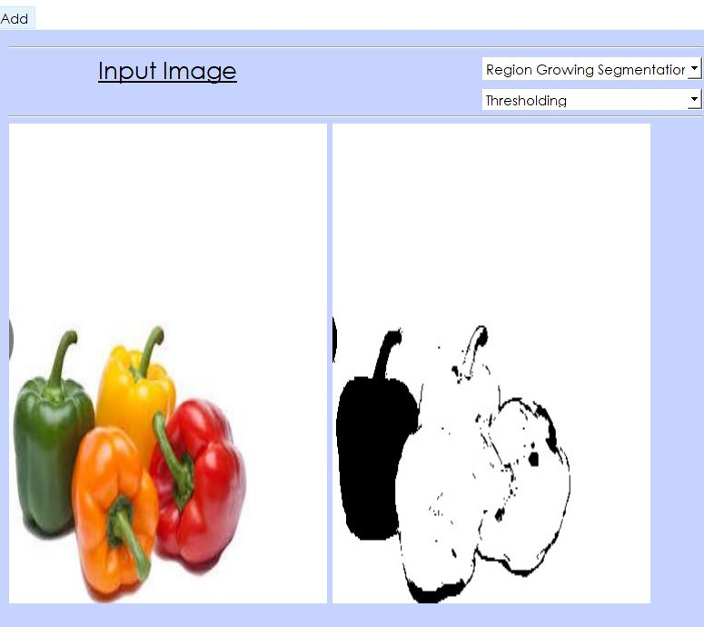

1. Agglomerative

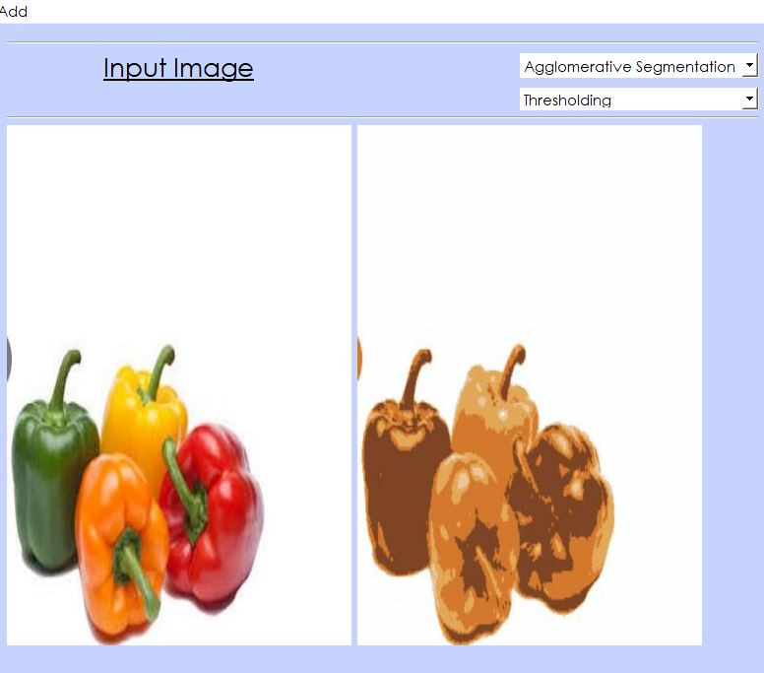

1. mean shift method.

