Extended Data
Note: this material was previously presented as an Appendix to the manuscript. It is provided here as Extended Data, per the journal’s policy of not publishing appendices or supplementary material alongside articles.
This document describes how the epidemic threshold was derived, how forecast accuracy was calculated against that threshold, and the three risk-based metrics used to translate probabilistic forecasts into intervention decisions.
A.1 Defining the epidemic threshold (baseline model)
The Ministry of Health currently defines the epidemic baseline for the MDR as the district- and month-specific average dengue incidence over the preceding five years plus two standard deviations, excluding months judged to be “large” outbreaks. This definition depends on expert input to decide which months to exclude, which introduces inconsistency at district level and is not well suited to surveillance-driven workflows. To remove this dependence, the epidemic threshold was instead derived from a baseline model that estimates expected incidence directly from the historical series.
A Bayesian temporal decomposition model was fitted separately for each district using INLA. The model decomposes the monthly time series into a long-term trend, a seasonal component, and short-term deviations. Observed case counts were assumed to follow a Poisson distribution with district population as an offset:
where is the expected number of cases in the district and month ; is the population for the district and year , included as an offset. is the intercept. is a long-term trend component modelled as a second-order random walk (RW2) over years, is a seasonal component modelled as a cyclic first-order random walk (RW1) over months, is a short-term temporal dependence modelled as a first-order autoregressive process (AR (1)). The AR (1) term is included during fitting so that short-term fluctuations are separated from the underlying trend and seasonality, but it is omitted when generating the baseline so that the threshold reflects a smoother, more stable expectation. The model was fitted to monthly data from 2004 through the previous calendar year, and the trend and seasonality were extrapolated to the current year. The epidemic threshold for each district and month was then set as the mean plus two standard deviations (mean + 2 SD) of this baseline.
A.2 Calculating forecast accuracy
Accuracy was assessed by comparing, for each district and month, a predicted outbreak label against an observed (gold-standard) outbreak label.
The observed label was taken from the historical case series: a district-month was classified as a true outbreak when observed cases exceeded the epidemic threshold (the 95th percentile of observed cases for that district and month across all available years).
The predicted label was produced by the risk-based decision rule described in A.3, not by any single model output. For each district and month, the three-risk metrics were computed from the ensemble forecast. A district-month was flagged as a predicted outbreak when the metrics agreed, in the primary specification, when all three exceeded the threshold, and when the predicted incidence also exceeded the fixed cut-off of 20 cases per 100,000 population.
Cross-tabulating the predicted labels against the observed labels gives true positives, false positives, true negatives, and false negatives, from which sensitivity (correctly detected outbreaks), specificity (correctly identified non-outbreak months), and overall accuracy (the proportion of correctly classified district-months) were calculated at each forecast horizon.
A.3 Risk-based decision metrics
Three risk metrics were computed for each district at the intended intervention time, all derived from 10,000 samples drawn from the ensemble posterior predictive distribution.
Predicted mean: the weighted mean of the forecast samples, representing the expected case burden under average conditions. The district is flagged when this mean exceeds the epidemic threshold (Mean +2 SD) of the baseline.
The absolute risk score is the risk of a high case count. For a candidate threshold A, it is the probability of exceeding A multiplied by A, P(X > A) × A, where P(X > A) is the proportion of forecast samples above A. A is varied across the forecast distribution, and the threshold giving the maximum score is identified; the district is flagged when this maximum lies above the epidemic threshold (Mean + 2SD) of the baseline.
Relative risk score, the risk that cases deviate substantially from the historical average, P(X > A) × (A − mean of the historical) / SD of the historical, where the second factor is a Z-score in standard-deviation units. As with the absolute score, the district is flagged when the threshold maximising this score lies above the epidemic threshold.
To illustrate this process, consider Error: Reference source not found :(A), which shows the historical distribution of dengue cases (on the left) with the probabilistic distribution of forecasted cases (on the right). The vertical orange line is defined as the mean plus two standard deviations of the historical distribution. This threshold serves as an alarm point for identifying unusually high case counts. Extended Data Figure 1 :(B) shows the risk profile of the absolute risk score, where the maximum risk value is highlighted by the blue cross. In this case, the threshold value corresponding to the blue cross is below the epidemic threshold (alarm threshold), and the location in this specific case is not flagged as requiring early intervention.
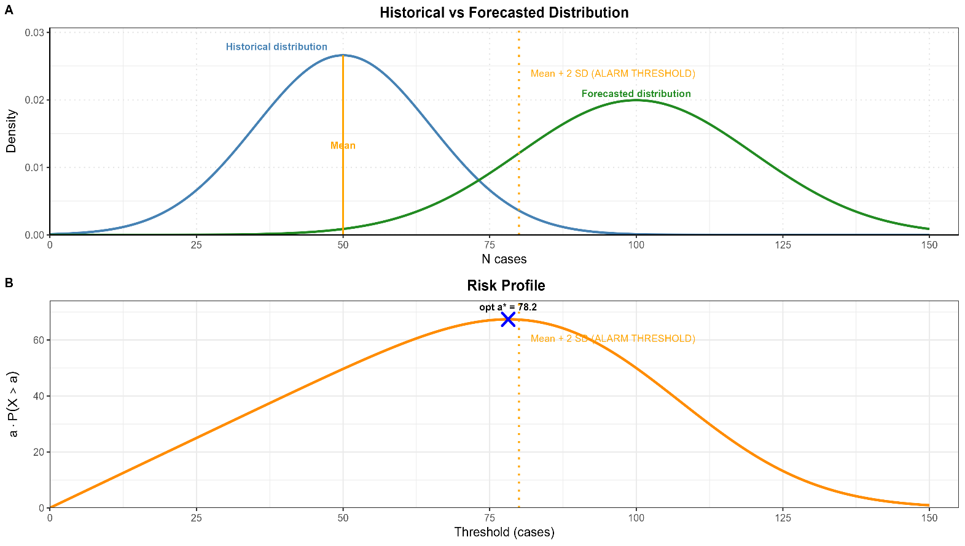
Figure 2: (A) Historical and forecasted dengue cases for outbreak detection (B) Risk Profile of Dengue Outbreak Thresholds
We used the same procedure to compute the relative risk score for each location at the intended time and flag the location as requiring early intervention if the threshold value corresponding to the maximum relative risk score of the location is above the epidemic threshold.
The three metrics were then combined into a single intervention decision plus a fixed incidence cut-off. A district was flagged for intervention in each month when the metrics agreed, all three exceeded the district epidemic threshold in the primary rule, and the predicted incidence also exceeded a fixed threshold of 20 cases per 100,000. The cut-off prevents alerts during low-incidence months.

