Extended Data
Note: this material was previously presented as an Appendix to the manuscript. It is provided here as Extended Data, per the journal’s policy of not publishing appendices or supplementary material alongside articles.
This document describes the two thresholds used in the study (the model-based alert threshold and the observed outbreak label), how forecast accuracy was calculated, the risk-based decision metrics, the model selection procedure, the ensemble weights, and additional performance results (A.4–A.8) and model specification (A.9). The code, software versions, random seeds and the order in which the scripts are run, including the threshold-derivation scripts, are in the GitHub repository (https://github.com/waladraidi/e-dengue-district-forecast).
A.1 Defining the alert threshold (baseline model)
The Ministry of Health currently defines the epidemic baseline for the MDR as the district- and month-specific average dengue incidence over the preceding five years plus two standard deviations, excluding months judged to be “large” outbreaks. This definition depends on expert input to decide which months to exclude, which introduces inconsistency at district level and is not well suited to surveillance-driven workflows. To remove this dependence, the alert threshold was instead derived from a baseline model that estimates expected incidence directly from the historical series.
A Bayesian temporal decomposition model was fitted separately for each district using INLA. The model decomposes the monthly time series into a long-term trend, a seasonal component, and short-term deviations. Observed case counts were assumed to follow a Poisson distribution with district population as an offset.
The model includes a long-term trend modelled as a second-order random walk (RW2) over years, a seasonal component modelled as a cyclic first-order random walk (RW1) over calendar months, and short-term dependence modelled as a first-order autoregressive process (AR(1)). The AR (1) term is included during fitting so that short-term fluctuations are separated from the underlying trend and seasonality, but it is omitted when generating the baseline so that the threshold reflects a smoother, more stable expectation. The model was fitted to monthly data from 2004 through the previous calendar year, and the trend and seasonality were extrapolated to the current year. The alert threshold for each district and month was then set as the mean plus two standard deviations (mean + 2 SD) of this baseline.
This alert threshold is district- and month-specific and uses only data before the forecast year, so there is no look-ahead. It defines the binary outcome for the Brier scores used in model selection and ensemble weighting, and it is used in the risk-based decision rule (A.3).
For each district and forecast year, the baseline model is fitted to monthly cases from September 2004 to the end of the previous year (Poisson, population offset), with a long-term trend over years, a cyclic seasonal pattern over calendar months and a short-term autoregressive term. The baseline for the forecast year uses the trend and the seasonal pattern only. The alert threshold is the posterior mean of this baseline plus two posterior standard deviations, taken on the log scale and converted back to cases; "mean + 2 SD" therefore describes the baseline expectation and its uncertainty, not the spread of past counts.
A.2 Calculating forecast accuracy
Accuracy was assessed by comparing, for each district and month, a predicted outbreak label against an observed (gold-standard) outbreak label.
The observed label was taken from the historical case series: a district-month was classified as a true outbreak when observed cases exceeded the observed outbreak threshold (the 95th percentile of observed cases for the same district and calendar month across all preceding years). This label uses only earlier data and is used only for the final evaluation, not for model selection or weighting. It was chosen as a proxy reference standard because the Ministry of Health does not provide an official outbreak classification; the threshold options are compared in our previous work (Draidi Areed et al., PLoS Negl Trop Dis 2025). Repeating the Brier-score analysis with the 95th percentile definition gave materially similar results.
The predicted label was produced by the risk-based decision rule described in A.3, not by any single model output. For each district and month, the three risk metrics were computed from the ensemble forecast. A district-month was flagged as a predicted outbreak when all three metrics exceeded the alert threshold (primary rule) and the predicted incidence also exceeded a fixed cut-off of 20 cases per 100,000 population.
The unit of analysis is the district-month (April–November, 2021–2025). Both the original and revised ensembles were evaluated on the same 128 districts and district-months. Cross-tabulating the predicted labels against the observed labels gives true positives, false positives, true negatives, and false negatives, from which sensitivity (correctly detected outbreaks), specificity (correctly identified non-outbreak months), and overall accuracy (the proportion of correctly classified district-months) were calculated at each forecast horizon.
A district-month is an observed outbreak when its cases exceed the 95th percentile of cases in the same district and calendar month in all earlier years from 2004, once at least five earlier years are available (99_outbreak_quant.R on GitHub).
A.3 Risk-based decision metrics
Three risk metrics were computed for each district at the intended intervention time, all derived from 10,000 samples drawn from the ensemble posterior predictive distribution.
Predicted mean: the weighted mean of the forecast samples, representing the expected case burden under average conditions. The district is flagged when this mean exceeds the alert threshold (mean + 2 SD of the baseline model; A.1).
The absolute risk score is the risk of a high case count. For a candidate threshold A, it is the probability of exceeding A multiplied by A, where the probability is the proportion of forecast samples above A. A is varied across the forecast distribution, and the threshold giving the maximum score is identified; the district is flagged when this maximum lies above the alert threshold.
Relative risk score, the risk that cases deviate substantially from the historical average: the probability of exceeding A multiplied by the number of historical standard deviations by which A lies above the historical mean (a Z-score). As with the absolute score, the district is flagged when the threshold maximising this score lies above the alert threshold.
To illustrate this process, consider Extended Data Figure 1(A), which shows the historical distribution of dengue cases (on the left) with the probabilistic distribution of forecasted cases (on the right). The vertical orange line is the alert threshold (mean + 2 SD of the baseline model; A.1). This threshold serves as an alarm point for identifying unusually high case counts. Extended Data Figure 1(B) shows the risk profile of the absolute risk score, where the maximum risk value is highlighted by the blue cross. In this case, the threshold value corresponding to the blue cross is below the alert threshold, and the location in this specific case is not flagged as requiring early intervention.
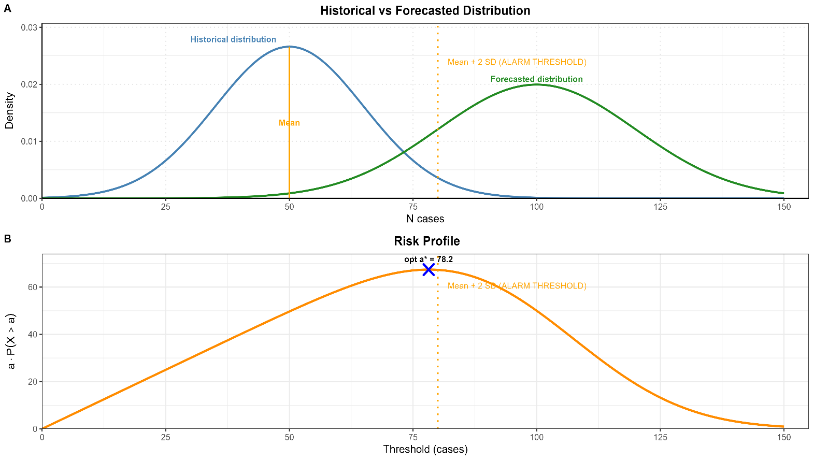
Extended Data Figure 1: (A) Historical and forecasted dengue cases for outbreak detection (B) Risk Profile of Dengue Outbreak Thresholds
We used the same procedure to compute the relative risk score for each location at the intended time and flag the location as requiring early intervention if the threshold value corresponding to the maximum relative risk score of the location is above the alert threshold.
The three metrics were then combined into a single intervention decision plus a fixed incidence cut-off. A district was flagged for intervention in a month when all three metrics exceeded the district alert threshold (primary rule) and the predicted incidence also exceeded a fixed threshold of 20 cases per 100,000. The cut-off prevents alerts during low-incidence months.
Sensitivity–specificity balance: Requiring fewer metrics to agree, or lowering the cut-off, raises sensitivity at the cost of specificity. We judged the small loss of specificity acceptable because a missed outbreak is likely to cost more than a false alarm; no formal cost analysis was done.
A.4 Study districts and model selection
In our previous work, districts with boundary changes were merged, giving 112 districts. The revised model uses the 128 units currently used by district health centres for dengue control. For the comparison, the original ensemble was re-run on the same 128 districts and evaluation period. All 128 units have complete monthly series over the study period, and both ensembles use the same units and adjacency graph.
Model selection (as in our previous work; TSCV period 2016–2020 only). (1) All 57 candidate models were scored on an identical set of district-months. (2) For each model, district, month and horizon we computed CRPS and the Brier score for exceeding the alert threshold. (3) Models were grouped by hierarchical clustering (five clusters) of their district-level CRPS profiles at the 3-month horizon, so that models that succeed and fail in the same districts were not all retained. (4) In each cluster, the best model by mean CRPS with the simplest structure was kept, giving five INLA models, and the hhh4 model was added as a semi-mechanistic component. The six models were selected after examining the TSCV results. The evaluation period (2021–2025) was not used for any selection, weighting or tuning. One INLA model was kept from each of the five clusters, plus the hhh4 model. Model 2 is nested in Model 1 but fell in a different cluster (it did well in different districts), so it adds diversity.
Selection and weighting both used 2016–2020, so performance in that period is optimistic. All reported performance is from 2021–2025, which was not used for selection, weighting or tuning. The five-season TSCV period was too short to split into separate selection and weighting windows.
Because several components changed together, the contribution of each cannot be separated; an ablation analysis is future work.
A.5 Ensemble weights
Weights were computed from TSCV Brier scores separately for each district and horizon: each model's weight is the inverse of its squared Brier score, divided by the sum of these values across the six models. Each district contributed 60 forecasts per horizon, and all 128 districts had complete data, so no district had a small sample. Brier scores were bounded below at 1 × 10⁻⁴ before inversion; a model without a forecast in a given month was excluded and the remaining weights renormalised. All weights were finite (range <0.001 to 0.99).
District weights stayed close to the average for each horizon (mean absolute difference 0.05; in 93% of combinations no weight differed by more than 0.2). The main exception was Tân Hồng, where the hhh4 model received weights of 0.99, 0.98 and 0.77 at horizons 1–3 because the other models’ Brier scores were 8 to 300 times larger. Weights spread more evenly at longer horizons.
Inverse-Brier weights changed individual weights by 0.03 on average and kept the same top model in all district–horizon combinations; equal weights differed by 0.07 but ignore real differences in performance (e.g. Tân Hồng). The median effective number of models was 4.9 of 6, and one model had more than half the weight in 4% of combinations.
For each district and horizon, the 10,000 ensemble samples are split across the six models in proportion to that district's weights for that horizon.
A.6 Performance by forecast horizon
Metric | 1 month | 2 months | 3 months
Sensitivity, % (95% CrI) | 86.1 (83.2–88.5) | 75.9 (72.5–79.0) | 66.3 (61.9–69.1)
Specificity, % (95% CrI) | 94.6 (92.8–95.2) | 93.4 (91.6–94.1) | 89.1 (88.2–93.7)
PPV, % (95% CrI) | 60.0 (46.8–73.1) | 52.9 (50.5–61.2) | 47.4 (44.5–61.6)
NPV, % (95% CrI) | 97.9 (97.4–98.3) | 96.3 (95.7–96.8) | 94.8 (94.1–95.4)
Accuracy, % (95% CrI) | 91 (85.2–92.1) | 89 (87.4–91.6) | 87 (85.2–90.3)
Calibration slope | 1.22 | 0.88 | 0.68
Coverage of 50% interval, % (original) | 53.0 (50.5) | 48.8 (43.2) | 44.2 (40.3)
Coverage of 75% interval, % (original) | 73.6 (70.5) | 68.1 (67.1) | 63.5 (60.1)
Coverage of 95% interval, % (original) | 95.8(92.2) | 93.3 (92.1) | 92.4 (90.2)
CRPS (per 100,000) | 4.43 | 6.11 | 7.7
MAE (per 100,000) | 6.14 | 8.41 | 10.05
RMSE (per 100,000) | 10.67 | 15.98 | 19.52
Table A6.1. Revised ensemble, April–November 2021–2025, by horizon. CrI = credible interval (Posterior distribution)
A.7 Temporal lag
Lag was measured for both ensembles across all 128 districts and all target months in 2021–2025: (i) cross-correlation lag, the shift of −3 to +3 months that best aligns the predicted and observed series in each district; and (ii) peak-timing error, predicted minus observed peak month across outbreak district-years. Differences were tested with the paired Wilcoxon test.
Measure | Original | Revised | p
Mean cross-correlation lag, 1 month (months) | 0.94 | 0.83 | 0.003
Mean cross-correlation lag, 2 months (months) | 1.41 | 1.09 | <0.001
Mean cross-correlation lag, 3 months (months) | 1.94 | 1.45 | <0.001
Districts within 1 month of observed curve, 2 months | 52% | 78% | <0.001
Districts within 1 month of observed curve, 3 months | 23% | 43% | <0.001
Districts with the maximum (3-month) lag, 3 months | 28 | 6 | <0.001
Mean absolute peak-timing error, 3 months (months) | 3.2 | 2.5 | <0.001
Table A7.1. Temporal lag of the original and revised ensembles.
A.8 District-level and period-specific performance
Every metric was calculated separately for each district for both ensembles (classification and probabilistic metrics over April–November; peak metrics per calendar year).
Metric (3-month horizon) | Original | Revised | Districts improved / tied | Wilcoxon p
Sensitivity, % | 43.8 [35.1–50.4] | 66.6 [40.9–75.1] | 73% / 6% | <0.001
Specificity, % | 91.2 [90.2–96.9] | 89.8 [85.8–97.4] | 45% / 31% | 0.005
Brier score | 0.074 [0.047–0.100] | 0.067 [0.045–0.103] | 62% / 0% | <0.001
CRPS (per 100,000) | 4.62 [1.93–6.73] | 3.12 [2.61–6.18] | 92% / 0% | <0.001
Calibration-in-the-large, absolute error | 0.048 [0.018–0.065] | 0.034 [0.016–0.061] | 55% / 0% | 0.20
Peak-timing error (months) | 3.8 [3.2–4.6] | 2.6 [2.0–3.2] | 56% / 13% | 0.003
Peak-magnitude error (%) | 46.8 [33.3–65.1] | 36.0 [27.3–48.8] | 70% / 0% | <0.001
Table A8.1. District-level performance, 128 districts, 2021–2025: median [IQR] across districts.

Metric (3-month horizon) | 2021–2022 Original | 2021–2022 Revised | 2023–2025 Original | 2023–2025 Revised
Sensitivity, % | 45.2 | 68.3 | 42.5 | 63.6
Specificity, % | 90.8 | 91.7 | 92.6 | 88.5
PPV, % | 60.1 | 74.9 | 22.1 | 22.9
NPV, % | 86 | 89.4 | 97.1 | 98.1
Brier score | 0.132 | 0.112 | 0.035 | 0.018
CRPS (per 100,000) | 8.85 | 8.20 | 7.10 | 6.81
Table A8.2. Original and revised ensembles by period (April–November, 128 districts). 2021–2022 included the large 2022 epidemic. Results for 2021–2025 combined are given in Table 1 of the main text and Table A6.1.
A.9 Model specification
The INLA models use a Poisson likelihood and the hhh4 model a negative binomial likelihood. In Models 4 and 5 the district AR effects absorb extra-Poisson variation; Models 1–3 have no such term, so their intervals may be too narrow. Ensemble coverage was below nominal (Table A6.1).
Model 1. Model 1 has no temporal random effect. Its dependence over time comes from the 3-month lagged incidence (with a district-specific slope) and the year-specific harmonics, which let the seasonal curve change between years. Short-term autocorrelation is represented in the ensemble by the AR terms of Models 4 and 5 and the autoregressive part of the hhh4 model. All model formulas are in Extended_Data_Candidate_Models.xlsx (INLA ensemble models M11, M22, M31, M45 and M46; the hhh4 model is described below).
Lagged cases and climate covariates for each target month come from three months before that month, so they are already observed at the forecast origin for all three horizons and no climate forecasts are needed; the cumulative incidence windows also end there. Information from the most recent months enters through the AR terms of Models 4 and 5 and the hhh4 model. The 3-month lag also covers mosquito development, incubation periods and reporting delays; alternative lags were examined in our previous work.
hhh4 model: Negative binomial counts are split into an endemic part (population, trend, annual seasonality and district random intercepts), an autoregressive part (same district, previous month) and a neighbourhood part (other districts, previous month, with power-law weights up to fifth-order neighbours). The last two parts include 3-month lagged mean temperature and precipitation. Forecasts are 10,000 simulated paths from the forecast origin (main-text references 11–12).
Spatial graph. Based on shared borders; the island districts Kiên Hải and Phú Quốc were linked to each other and to Rạch Giá.
Thermal suitability index. The index is calculated from monthly minimum and maximum temperatures when the covariate dataset is prepared. It ranges from 0 (thermally unfavourable) to 1 (optimal: minimum temperature ≥ 24°C and maximum temperature ≤ 30°C). The cut-points keep temperatures near the estimated optimum for transmission by Aedes aegypti (about 29°C; main-text reference 3). Model 3 uses the standardised index lagged by 3 months.
Cumulative incidence. The 12-, 24- and 36-month windows are a proxy for population immunity, matching the 1–3 years of temporary cross-protection after infection (main-text reference 4).

