|  |  |
| --- | --- |
| ***Module Title*** | *Web Development and HCI* |
| ***Student Name*** | *Walah Hamad Aljalahma* |
| ***Student ID*** | *@00709258* |
| ***Due Date*** | *Sunday 11th December 2022* |
| ***CRN*** | *32741* |
| ***Level*** | *4* |
| ***Assessment Title*** | *Web Development with HTML5 &CSS3* |
| ***Assessor/lecturer*** | *Dr. Stefan Pletschacher*  *&*  *Dr. Jissy George* |

**

Table of Contents

**1.** **Site content and design** 3

***Appendix 2 – Report***

# **Site content and design**

This website is all about my opinion about Makeup, Skincare, and nails. Mainly about products that are out in the market to share with you if it is worth it or not. My website is elastic because from time to time I will go down more about different products.

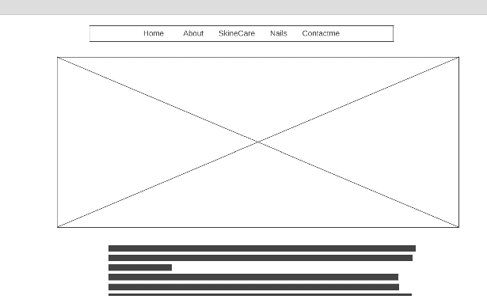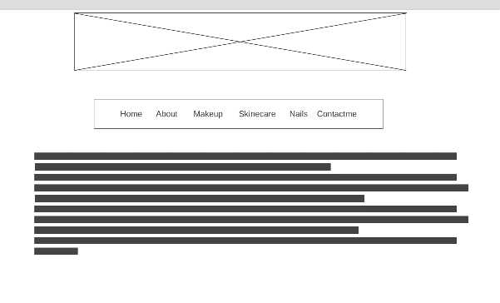

# **Use of HTML5**

I used <header> for example for the logo for all the HTML. On the other hand, I used <p> so I can wrap the paragraph of the text and it could show that it is a paragraph. I have used <div> also in all my HTML files because it can divide the content. I also use <br> to have species between the boxes on the contact page. <nav> help me in the Section dedicated to exploration links.

# **CSS Explanation**

# **4. CSS Techniques**