Create S3 Bucket With Private Access (Upload a image)

Create Config Rule

Create Lambda Function To Take Remediate Actions:

Configure Cloudwatch Rule To Trigger Remediate Lambda

Experiment On Private Bucket

Experiment On Public Bucket

## **Create S3 Bucket With Private Access (Upload a image)**

## Create Config Rule

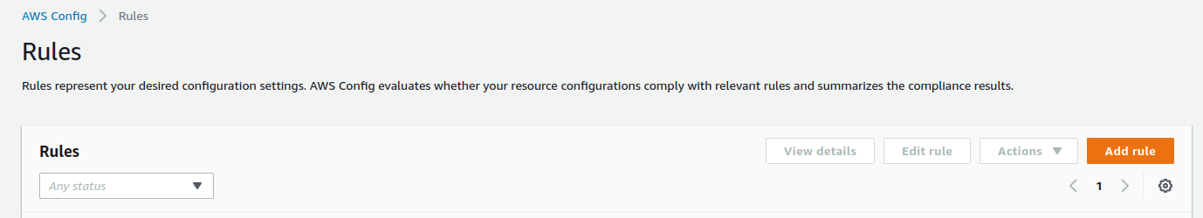

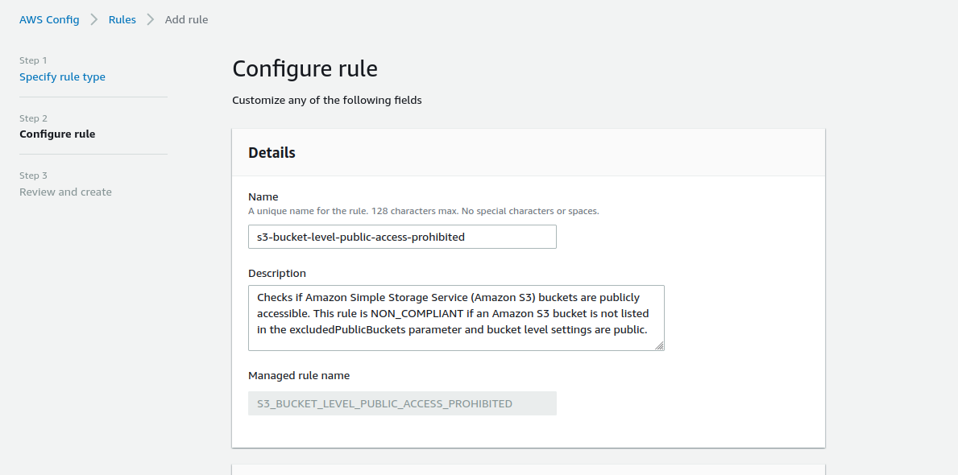

Keep other settings as defaults and create rule.

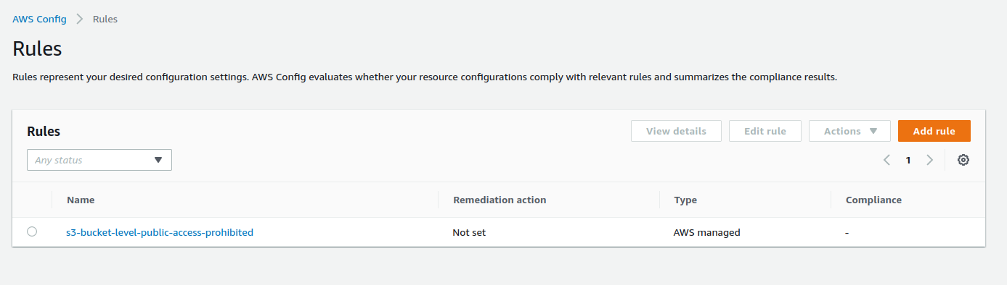

Wen we go inside the rule , we could see our bucket is in compliance list like below:

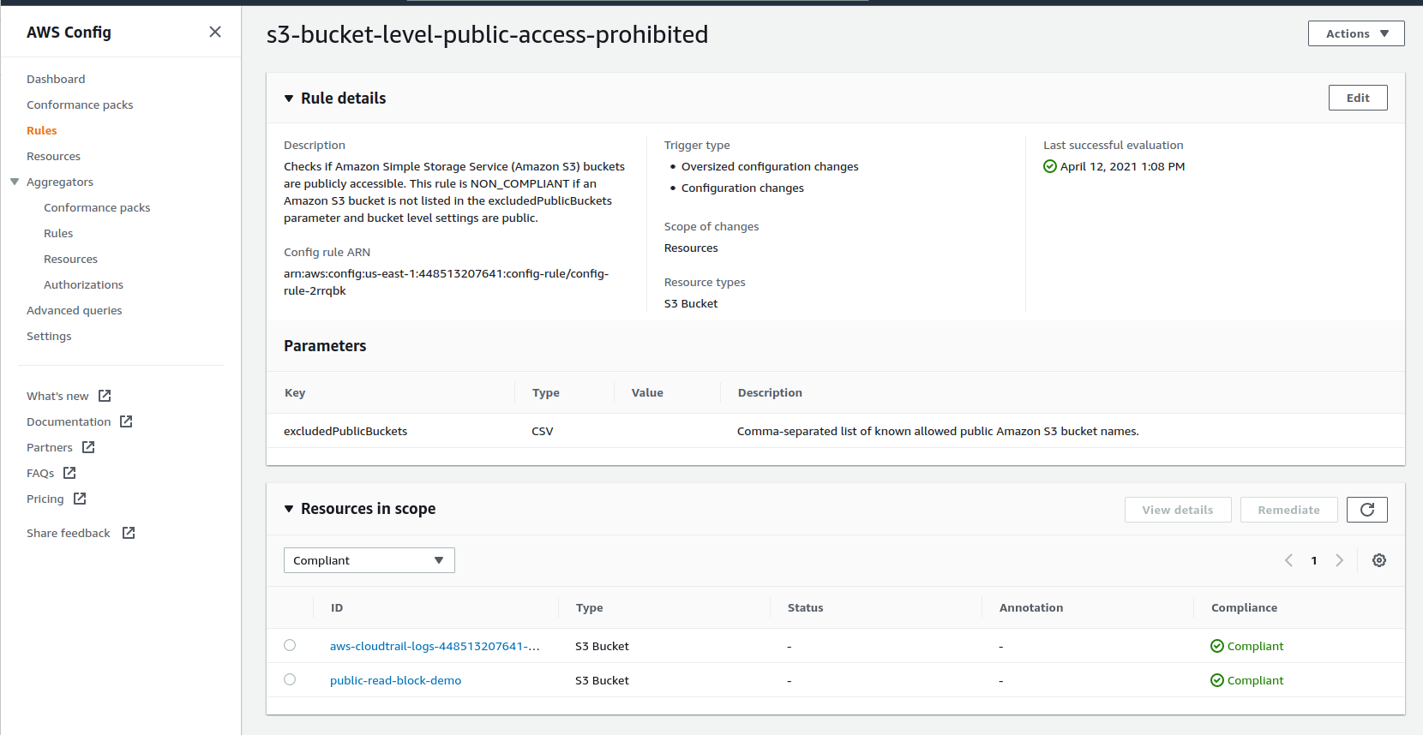

## **Create Lambda Function To Take Remediate Actions:**

* This will change bucket policy to private and send a sms when someone changed the bucket accessibility to public

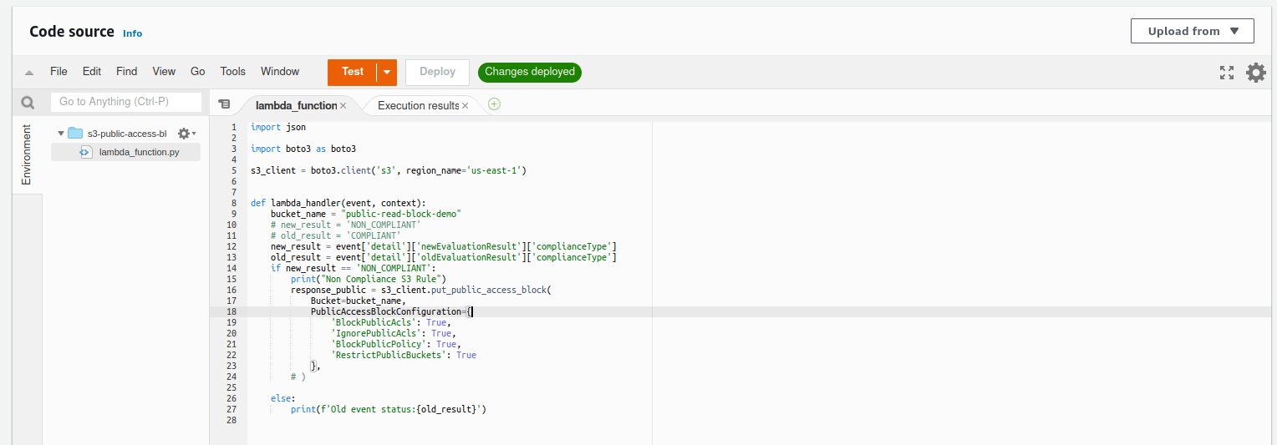

## **Configure Cloudwatch Rule To Trigger Remediate Lambda**

Select Cloudwatch rules

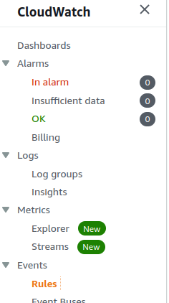

* Select “Create New Rule”
* Add pattern like below

|  |
| --- |
| {  "source": [  "aws.config"  ],  "detail-type": [  "Config Rules Compliance Change"  ],  "detail": {  "messageType": [  "ComplianceChangeNotification"  ],  "resourceType": [  "AWS::S3::Bucket"  ]  }  } |

* Select our lambda as target lambda

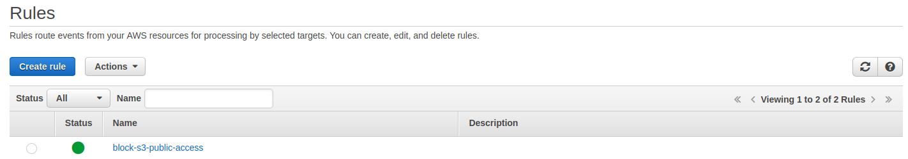

## Experiment On Private Bucket

Experiment : Try to access Bucket objects in publicly without doing any change to policy.It wont allow us.

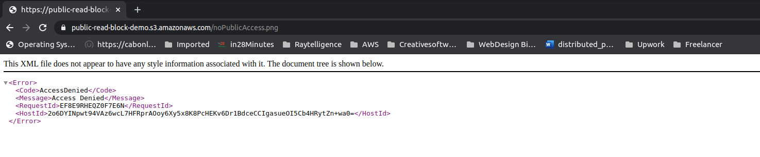

## **Experiment On Public Bucket**

Change Bucket Policy to Public Access

Default Bucket Configs

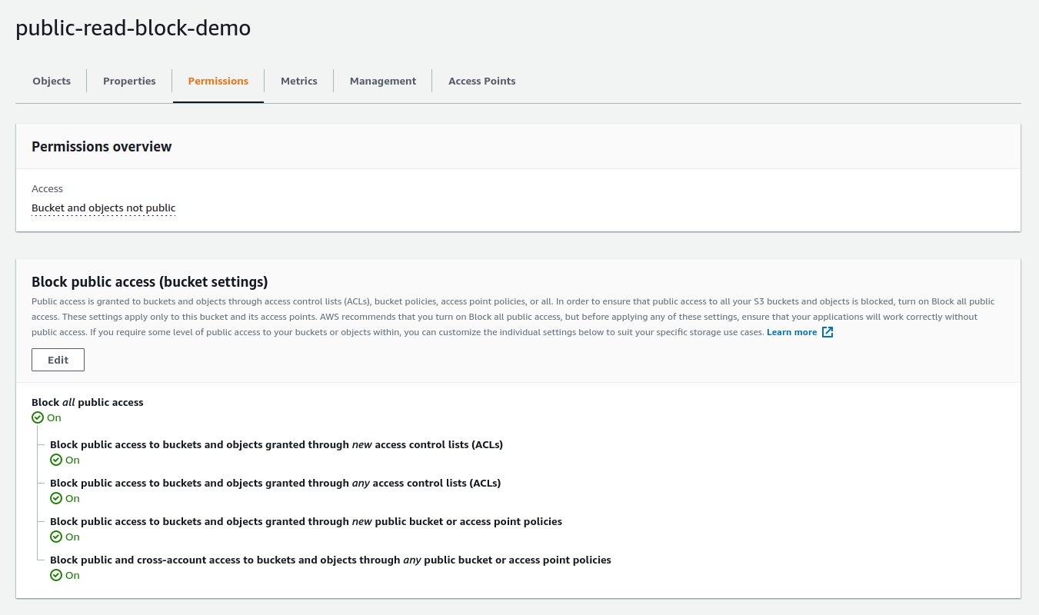

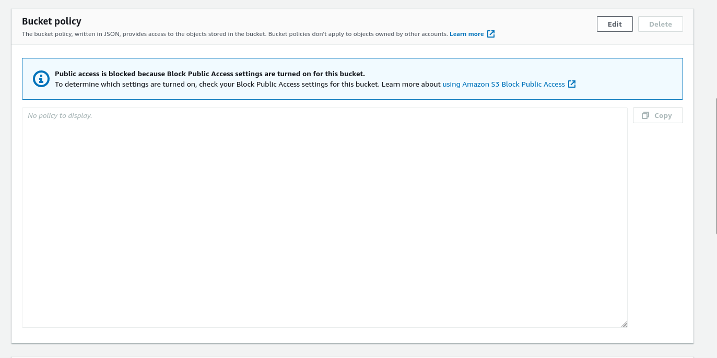

Change Bucket Policy to access public

* Uncheck the checkboxes

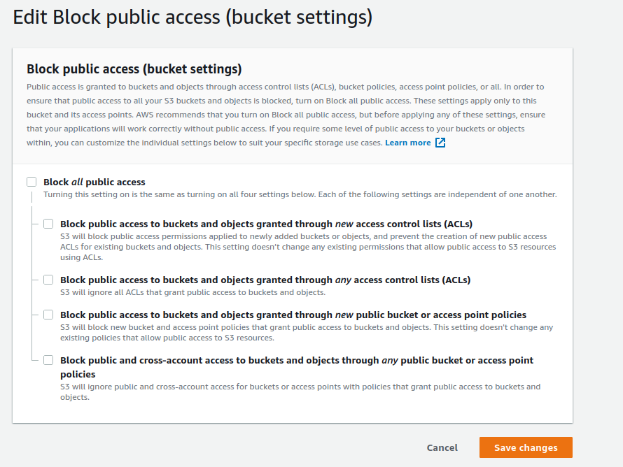

Give below policy

|  |
| --- |
| {  "Version": "2012-10-17",  "Statement": [  {  "Sid": "PublicRead",  "Effect": "Allow",  "Principal": "*",  "Action": [  "s3:GetObject",  "s3:GetObjectVersion"  ],  "Resource": "arn:aws:s3:::public-read-block-demo/*"  }  ]  } |

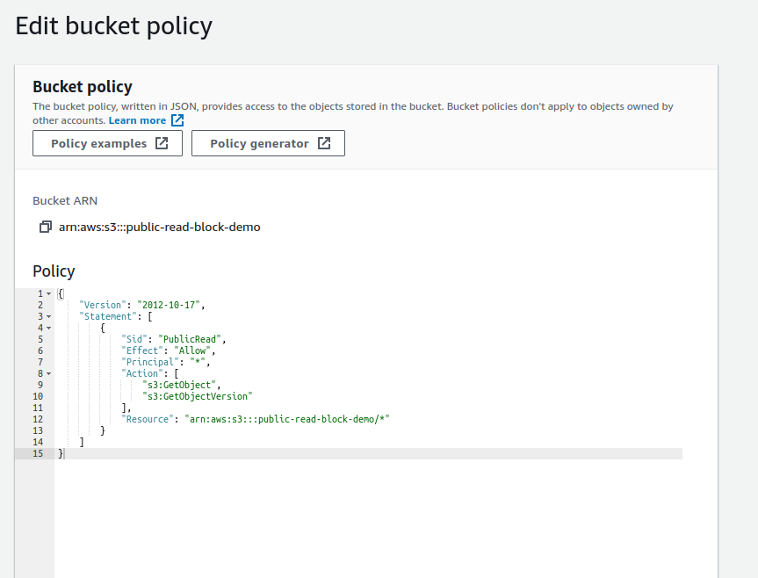

Now we could see this warning(bucket is accessible from internet)

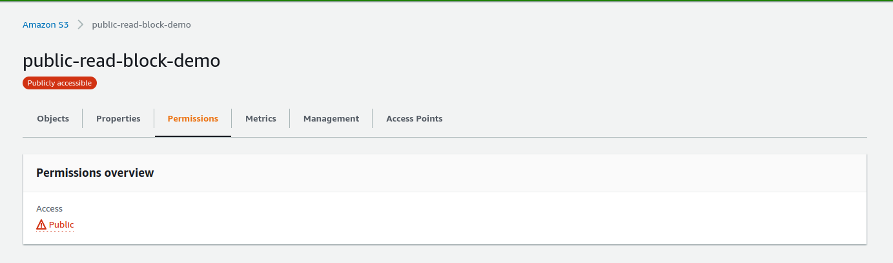

Upload an image and copy object url

<https://public-read-block-demo.s3.amazonaws.com/noPublicAccess.png>

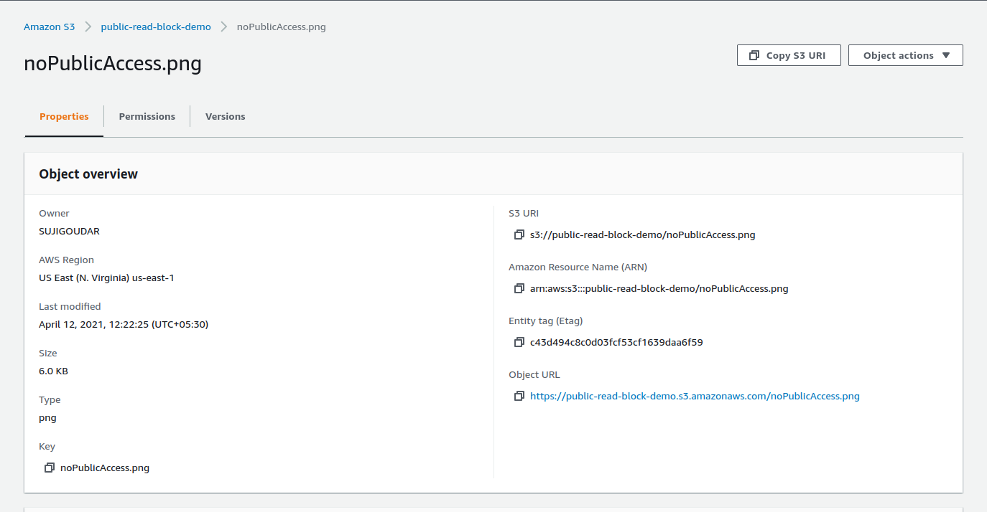

Try to access using private web window

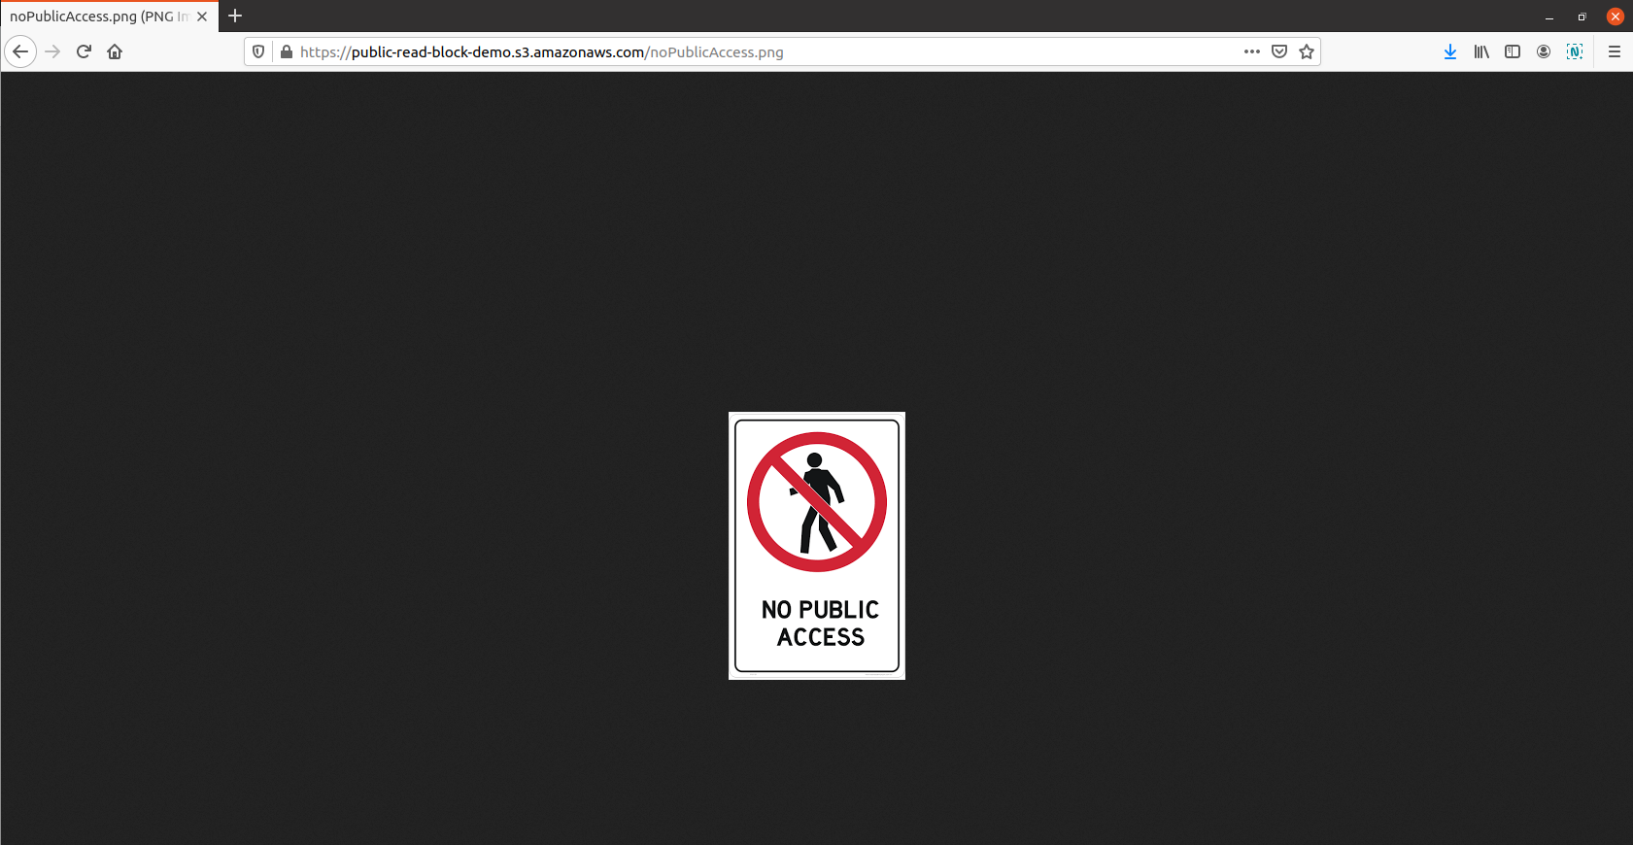

===============================================

After 3-4 minutes , you will receive a sms and when to see the bucket permission , you could see that is changed back to private (automatically)

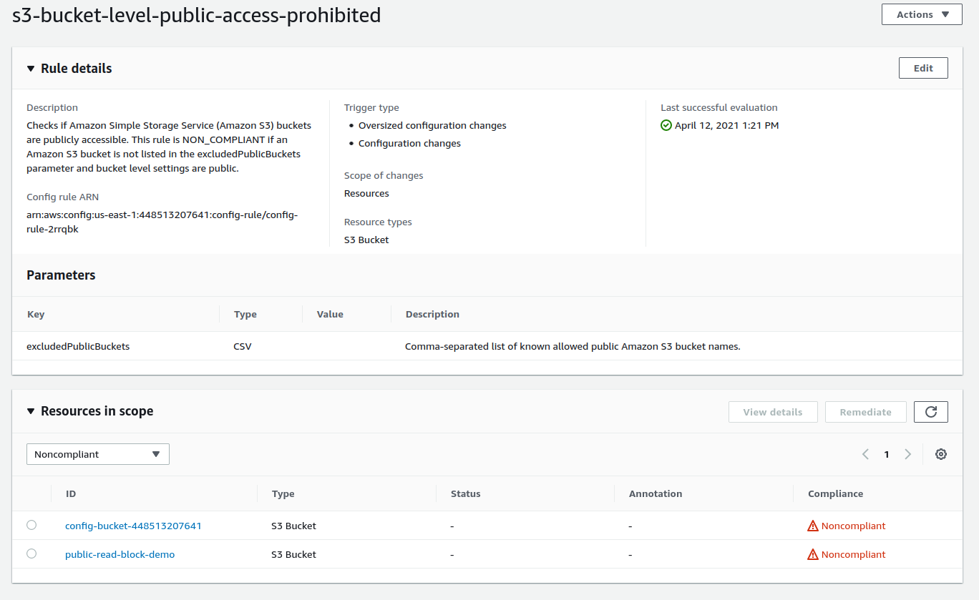

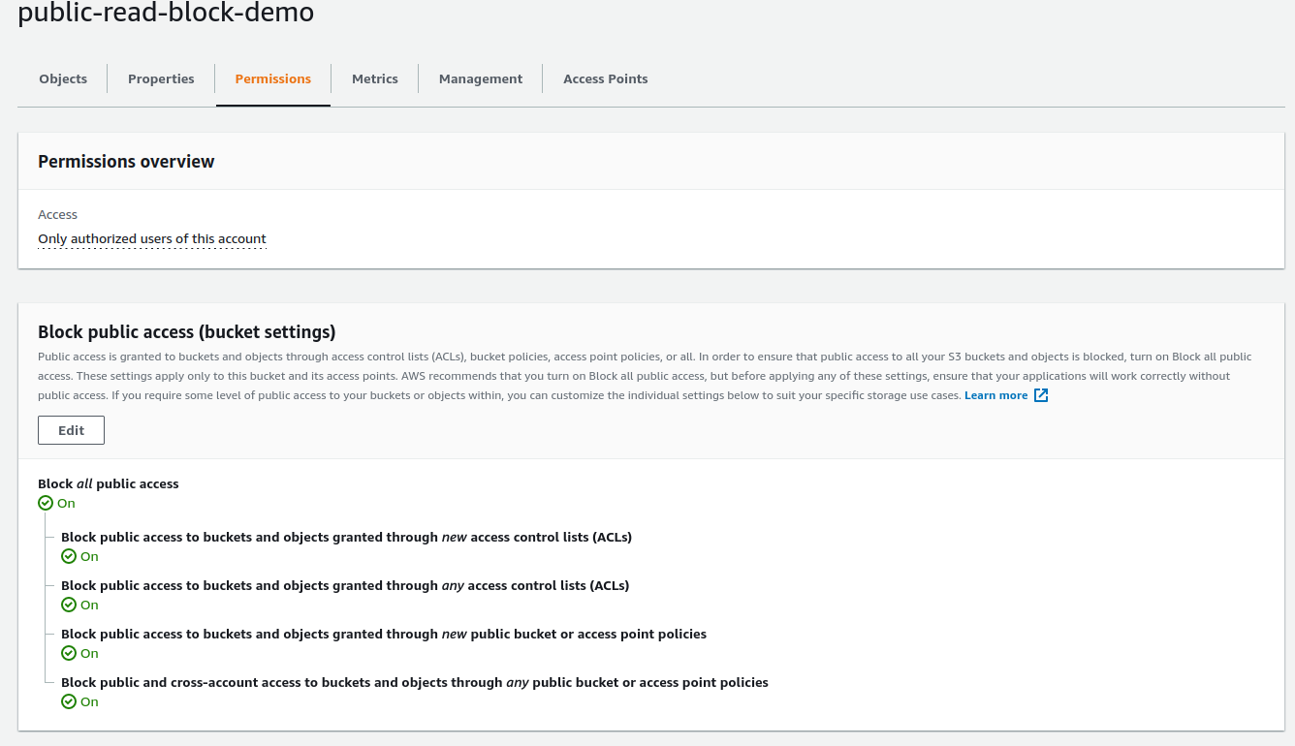

Supporting Codes:

Lambda

|  |
| --- |
| import json  import boto3 as boto3  s3_client = boto3.client('s3', region_name='us-east-1')  sns_client = boto3.client('sns', region_name='us-east-1')  def lambda_handler(event, context):  bucket_name = "public-read-block-demo"  # new_result = 'NON_COMPLIANT'  # old_result = 'COMPLIANT'  new_result = event['detail']['newEvaluationResult']['complianceType']  old_result = event['detail']['oldEvaluationResult']['complianceType']  if new_result == 'NON_COMPLIANT':  message = {"BucketInRisk": f'{bucket_name}'}  response = sns_client.publish(  TargetArn='arn:aws:sns:us-east-1:448513207641:security-alert-demo',  Message=json.dumps({'default': json.dumps(message)}),  MessageStructure='json'  )  print("Non Compliance S3 Rule")  response_public = s3_client.put_public_access_block(  Bucket=bucket_name,  PublicAccessBlockConfiguration={  'BlockPublicAcls': True,  'IgnorePublicAcls': True,  'BlockPublicPolicy': True,  'RestrictPublicBuckets': True  },  )  else:  print(f'Old event status:{old_result}') |