Song Bingo Help File

This program will create sheets and playlists using either your own music mp3 and mp4 files in a folder on your local machine or a playlist(s) from a provider like Spotify.

Create a game using your own music.

Click the radio button for full game using your own music.

Select the folder containing your music files(mp3, or mp4 or 4a only. mp4p files do not work since they are protected and the meta data can’t be read). Once the folder is selected, it will appear below the radio buttons for reference.

You can use the defaults or change any parameters as you find necessary. After they are all to your liking press Create Game. The more people playing, the more songs you will need. If you want to limit number of songs per artist then change the 0 to another number. Each sheet will have 2 bingo boards. Answer y or n for a free middle space or not.

After a short while the a folder name will be displayed on a button. Click to access the newly created files.
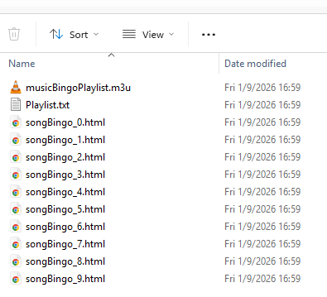

The .m3u file is the playlist that you can run from VLC player or Media Player. If you are using Windows Media Player the folder that contains the music must be added to the library of Media Player. The Playlist.txt is just a text file of all the songs used to create the Bingo sheets. The html files are the sheets and you will see the songs scattered all over the boxes in random order. They are all different so use any you want to. Right click on the .m3u file and choose “open with” to set your player.

Double click to open the .html sheet files and print them out from your browser. Start the .m3u playlist and play the game!

Create game using .csv playlist

To use a csv file is more complicated. In the File Menu you will see an entry to “Open the playlist transfer app” which is tunemymusic.com. It’s free for what we are doing. I will show an example using Spotify as a playlist source.

Select the source and in my case it’s Spotify. Log into your source if you don’t see your playlists. Uncheck the entire library and select one or more playlists that you want to include in the game. Remember you may need 40,50 or more songs depending on the number of players.

Then click the Choose Destination button on the tunemymusic app and scroll down to “Export to File” and click that. Then click CSV and then click Export.

Examine what you have selected and if it looks ok click Start Transfer. Choose where to save the .csv file, save it then click Continue. We are done with tunemymusic.com for the moment.

Now go back to the game creator and click “sheets only from .csv playlist.” The filename will appear and you can change the defaults if you like to. Limiting songs per artist is not available in this mode so that’s why it’s grayed out and left as a 0. Click “Create Game” and then click the folder to get to the new files.

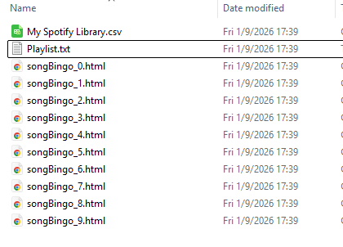

This folder contains the original .csv file, a Playlist.text and the game sheets.
Now go back to the tunemymusic.com and click New Transfer.
This time the sourse will be “Upload File”. Click on “Choose a File” and select the Playlist.txt that you just created. Or you can drag and drop it as it says on the web page.

Now choose the destination in my case Spotify. What we have to do is take the newly created playlist and add it back to Spotify(or your app). The original playlist may have contained 100 or mor songs but for the Bingo game we only selected 40 or more and those are the songs we need for the game.

Click Start Transfer and you should see all the songs get added to a new playlist on in my case Spotify. Make sure they all get transferred. If not you will get a file that shows what songs didn’t get transferred. You should manually add them to this new playlist. If you selected 40 songs, you should see 40 songs transferred.

Now open Spotify(or your music app) and you are ready to play.

