Sodexo SLU Dining — Inventory & Demand Analytics Report
Data Analysis Report | W/E April 3 – October 9, 2026
Prepared by: Olawale Ajibola Ashaolu, Data Analyst, Sodexo – Saint Louis University Dining Services
October 2026
Data Source: Sodexo Inventory Summary History Report (Report ID: INRHTSUM, Date Run: 10/13/2026); Grand Hall Day Parts Report (October 7, 2026)
This report presents a full quantitative analysis of Sodexo SLU Dining's inventory and demand data across all active units from April through October 2026. All figures are extracted directly from official Sodexo reporting systems. Findings and recommendations are grounded entirely in the data.

Executive Summary
Portfolio scope. Sodexo operates 11 active dining units across the Saint Louis University campus. As of the week ending 10/09/2026, total on-hand inventory across these units stood at $219,466.24, an average of $19,951.48 per active unit. The analysis covers 28 weeks (W/E 04/03/2026 – W/E 10/09/2026), drawing on 33 distinct report dates parsed from a 505-page inventory history report.
Key findings. Six findings define the current state of inventory and demand management:
- Grand Dining accumulation. Inventory at the primary residential hall grew +50.25%, from $24,832.87 to $37,311.63, on a trend slope of +$307.67 per week — an accumulation pattern consistent with the absence of enforced PAR levels.
- Portfolio range. Portfolio inventory peaked at $263,943.40 on 04/10/2026, inflated by a probable Panera data-entry outlier of $77,772.81, and reached a summer low of $126,289.65 on 07/10/2026.
- Concentration outside the residential hall. Catering ($29,393.10) and Starbucks ($29,045.65) each carry more on-hand inventory than any unit other than Grand Dining, and together hold more than one quarter of portfolio value.
- Procurement gap. Grand Hall procurement templates contain 409 line items with zero PAR levels set and zero order quantities logged — the most critical operational gap identified.
- Stale counts. Reinert To Go and Ameren Cafe show 56% stale-count rates (inventory value unchanged from the prior week), suggesting physical counts are not being conducted regularly.
- Demand profile. Dinner is the highest-volume meal period (992 items sold), yet Lunch generates 74.8% of daily food revenue ($1,426.92), reflecting a different transaction mix that directly informs production planning.
Three immediate priorities. (1) Establish PAR levels for all 409 procurement lines; (2) initiate weekly physical counts at Reinert To Go and Ameren Cafe; and (3) investigate Grand Dining inventory accumulation by subcategory. Because SLU Dining currently maintains no receiving logs and no waste logs, establishing both systems from scratch is also recommended (Section 8) so that the impact of these interventions can be measured.

1. Dataset Overview

1.1 Report Source and Structure
The Sodexo Inventory Summary History Report (Report ID: INRHTSUM) is an official Sodexo reporting artifact, generated on 10/13/2026. The 505-page document contains one unit-week record per page and covers all SLU dining units from W/E 04/03/2026 through W/E 10/09/2026. Each record reports the unit number, unit name, week-ending date, and the on-hand inventory value broken down by inventory category.
After full extraction, the dataset contains 33 distinct reporting dates and 16 identified units, yielding a structured longitudinal inventory panel. Eleven of these units are active and report consistently, which forms the analytical core of this report; the remaining five are closed or have never recorded inventory.

1.2 Unit Roster
Unit # | Unit Name | Status | Weeks of Data | Latest Inventory (10/09/2026)
13341001 | Grand Dining | Active | 28 | $37,311.63
13341002 | Catering | Active | 28 | $29,393.10
13341004 | Panera | Active | 28 | $25,136.70
13341011 | Fusz Simply To Go | Active | 28 | $21,430.31
13341023 | Starbucks | Active | 28 | $29,045.65
13341008 | BSC Simply To Go | Active | 28 | $19,515.86
13341027 | WOW Cafe & Wingery | Active (partial) | 8 | $14,122.00
13341013 | Qdoba | Active | 28 | $10,506.18
13341022 | Reinert To Go | Active | 28 | $10,819.42
13341012 | Subway | Active | 28 | $9,112.04
13341021 | Ameren Cafe (Einsteins) | Active | 28 | $13,073.35
13341003 | Billiken Club | Closed | — | —
13341005 | Marketplace | Closed | — | —
13341021 | Einsteins (legacy) | Closed | — | —
13341018 | Spice Market | Never Active | — | $0.00
13341020 | Fueling Station | Never Active | — | $0.00
Table 1. SLU Dining unit roster and latest inventory values
Note: Units 13341018 and 13341020 report $0.00 across the entire period and should be considered for catalog deactivation.

1.3 Inventory Category Breakdown
Inventory is tracked under the Food 6011 group — Baked Goods, Beverage, Milk & Ice Cream, Groceries, Frozen Food, Meat/Eggs/Cheese, and Produce — together with Cleaning Supplies (6022), Paper/Plastic (6026), and Bar/Merchandise (6027). At the portfolio level, value is concentrated in a small number of categories, as Table 2 shows. Groceries and Beverage alone account for more than half of all on-hand inventory value.
Inventory Category | Share of Portfolio Value
Groceries | 32%
Beverage | 20%
Meat, Eggs & Cheese | 15%
Paper/Plastic N/T | 11%
Baked Goods | 6%
Cleaning Supplies | 4%
Other (bar, merchandise, packaging) | 4%
Produce | 4%
Milk & Ice Cream | 3%
Frozen Food | 1%
Table 2. Portfolio-level inventory distribution by category

2. Inventory Trend Analysis

2.1 Portfolio-Level Inventory Trend
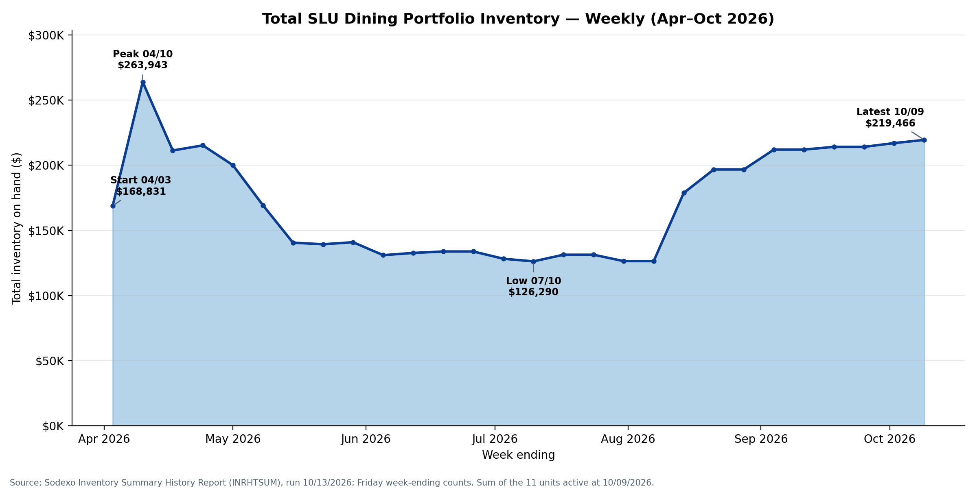
Figure 1. Total SLU Dining Portfolio Inventory — Weekly, April–October 2026
Portfolio inventory opened at $168,831.09 in W/E 04/03/2026 and peaked one week later at $263,943.40 (W/E 04/10/2026). That peak is driven largely by a single Panera record of $77,772.81, roughly four to five times the unit's typical weekly value, and should be read as an artifact rather than a true stock build. Inventory then declined to a summer low of $126,289.65 in W/E 07/10/2026.
After the summer trough, portfolio inventory recovered and trended upward through the start of the fall semester, closing at $219,466.24 in W/E 10/09/2026. The summer dip is consistent with reduced campus population during the non-academic period. This seasonal signal is pronounced and must be built into any forecasting model as an academic-calendar effect.
The portfolio weekly mean of $171,901.68 establishes the baseline against which model-driven ordering will be benchmarked. Any future PAR-based or forecast-driven ordering programme can be evaluated by comparing post-implementation inventory levels, adjusted for the academic calendar, against this baseline.

2.2 Weekly Inventory Trends by Unit
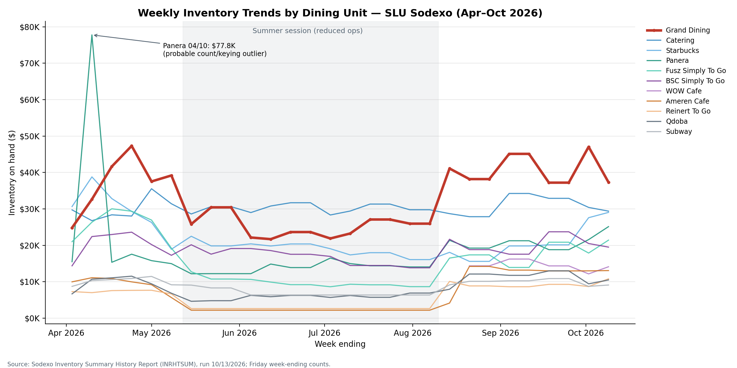
Figure 2. Weekly Inventory by Dining Unit — April–October 2026
Unit-level trends diverge sharply. Grand Dining shows a persistent upward slope across the period, ending well above its starting value. Starbucks is highly volatile, with a marked mid-period dip (to a low of $15,598.65) before recovering toward its opening level. Catering, by contrast, remains relatively flat and stable, trading within a narrow band around its $30,409.91 mean.
Panera's trajectory is dominated by the early-April outlier spike, after which it returns to a typical range before rising into the fall. WOW Cafe & Wingery appears only from mid-period onward, with 8 weeks of data, so its trend cannot yet be compared like-for-like with units that have a full 28-week history.

2.3 Grand Dining Deep Dive — 6-Month Growth
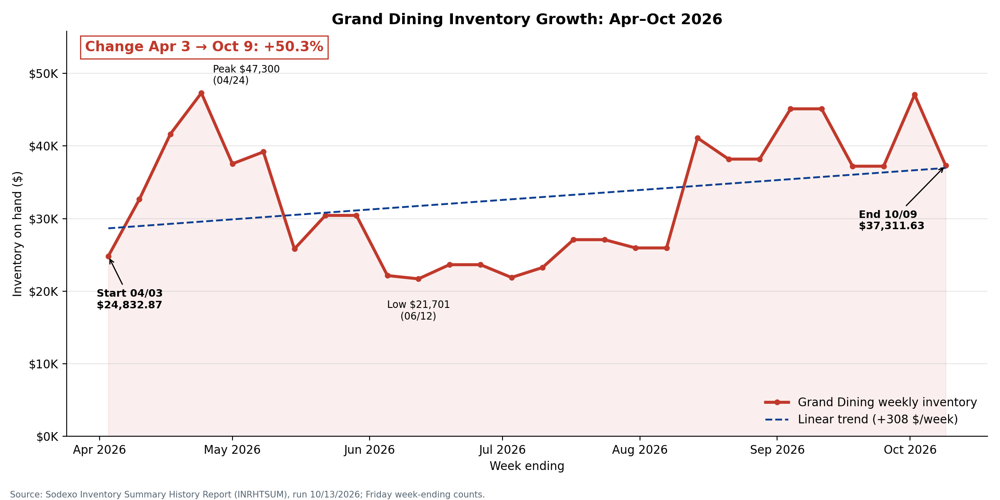
Figure 3. Grand Dining Inventory Growth Trend — April–October 2026
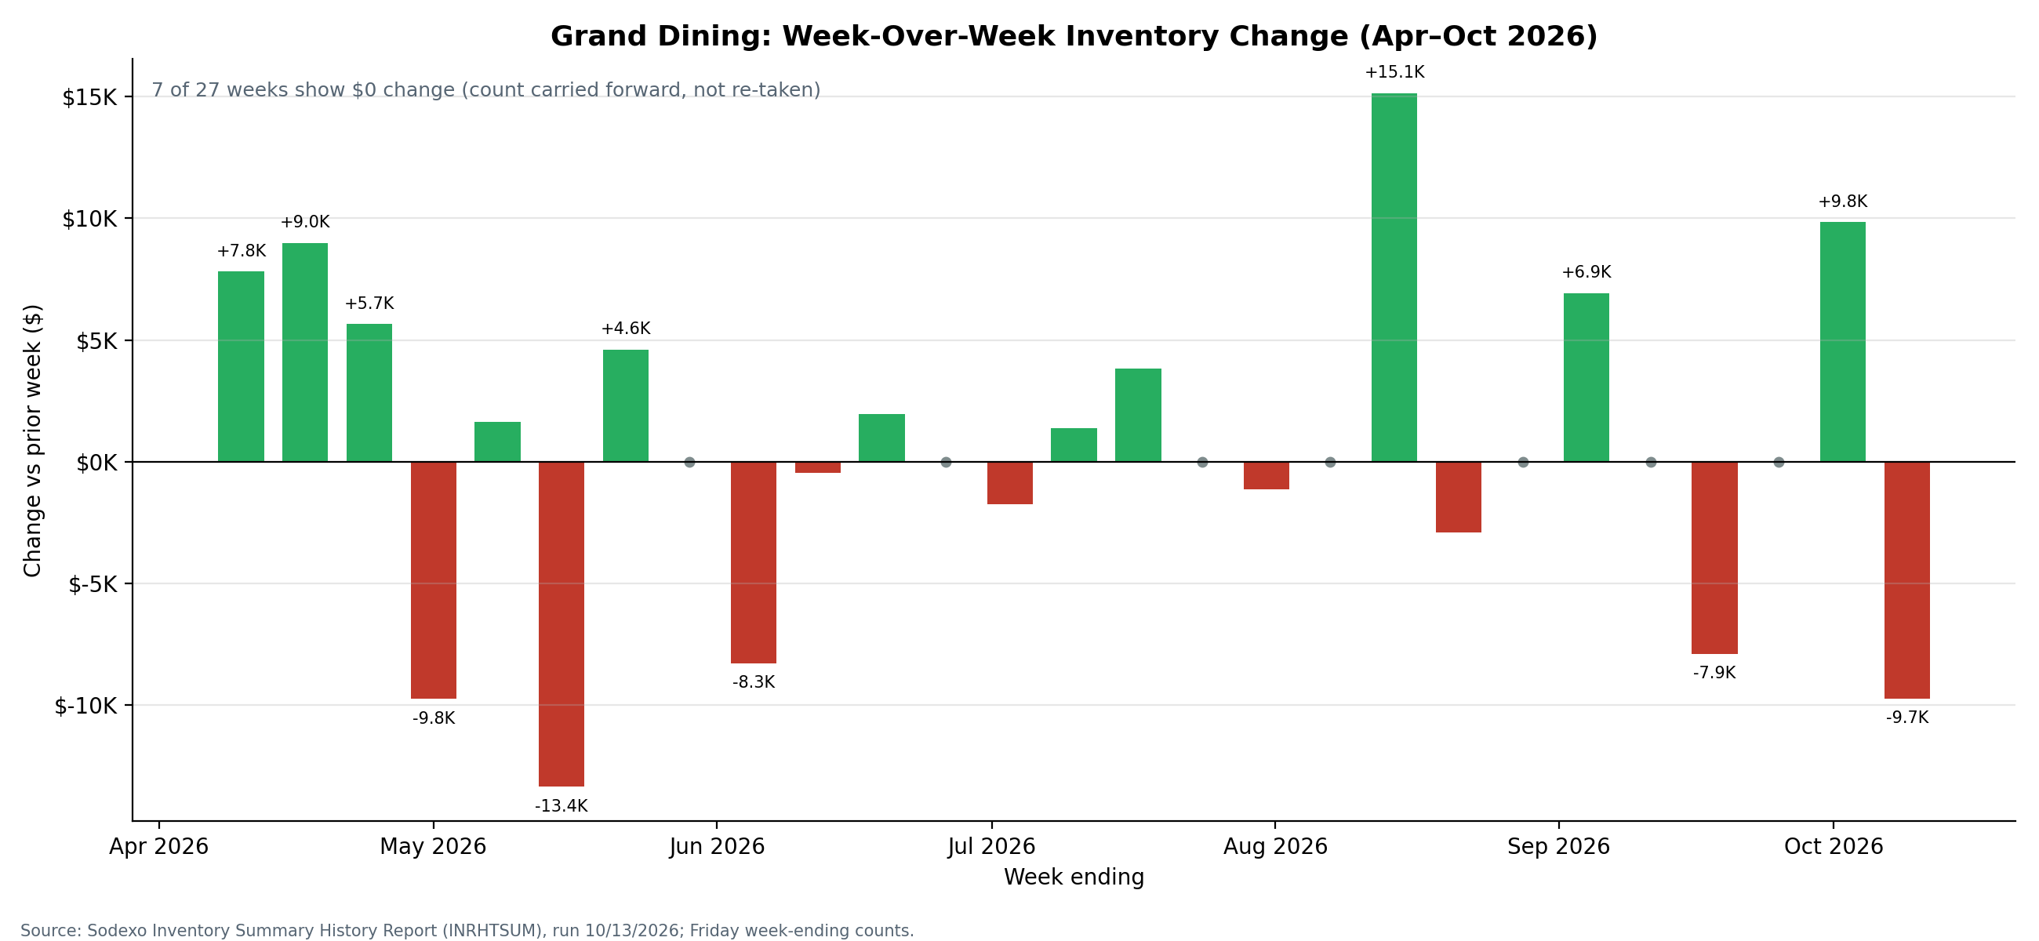
Figure 4. Grand Dining Week-Over-Week Inventory Change
Growth magnitude. Grand Dining inventory rose from $24,832.87 to $37,311.63 — a gain of $12,478.76 (+50.25%) over 28 weeks. The linear trend slope is $307.67 per week, meaning the unit accumulates roughly $1,330 in additional on-hand inventory every month (about 4.33 weeks), independent of any documented growth in meal demand.
Volatility. The unit's inventory ranged from $21,700.53 (minimum) to $47,299.91 (maximum), a range of $25,599.38. A standard deviation of $8,477.02 against a mean of $32,812.42 (coefficient of variation ≈ 0.26) indicates moderately high variability, consistent with ordering decisions that are not anchored to a set PAR level.
Flat weeks. Seven of the 27 measured weekly changes were $0.00 — an inventory value identical to the prior week — giving a stale rate of approximately 26%. Some of these weeks may reflect genuinely unchanged counts, but recurring flat periods can also indicate missed physical counts or carried-forward values rather than actual stock verification.

3. Current Inventory Snapshot (Week Ending 10/09/2026)

3.1 Inventory by Unit — Latest Week
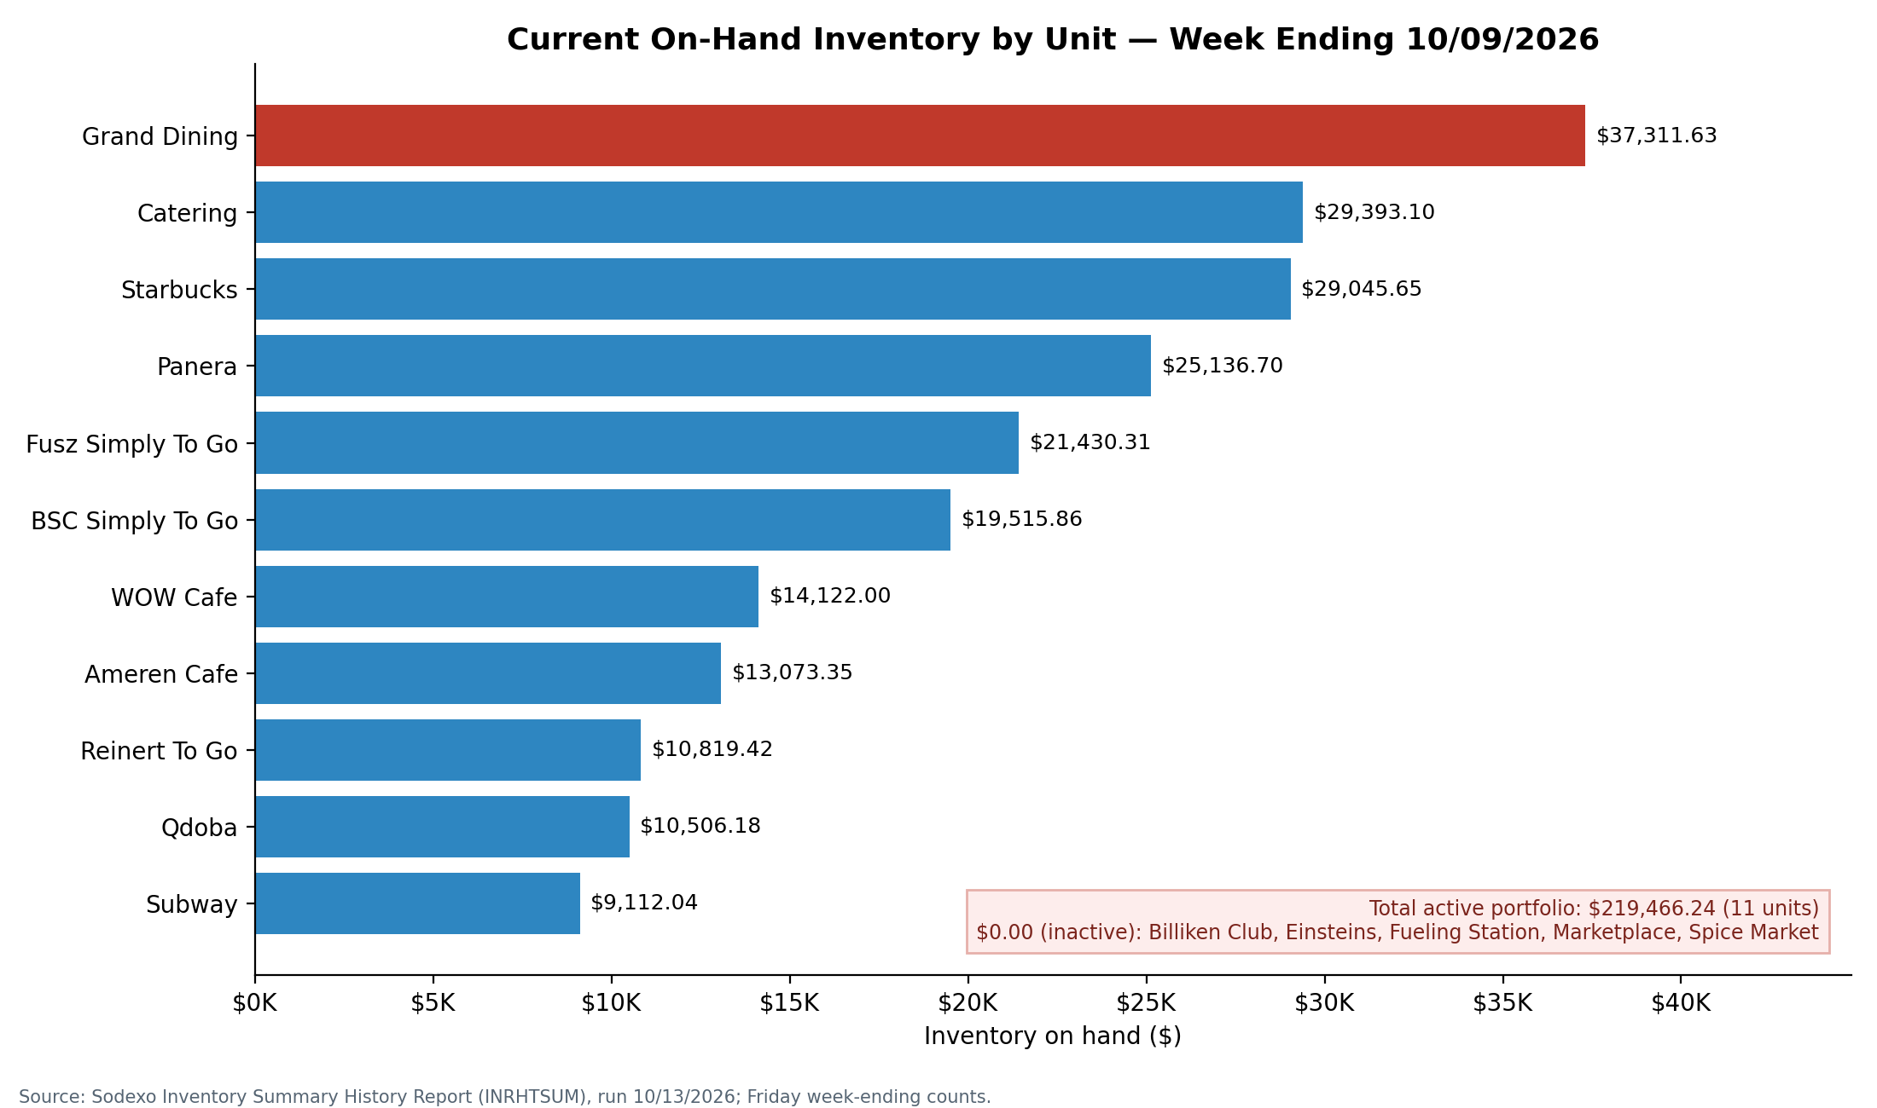
Figure 5. Current On-Hand Inventory by Unit — W/E 10/09/2026
Unit | Latest Inventory | % of Portfolio | Mean (All Weeks) | Growth vs. Start
Grand Dining | $37,311.63 | 17.0% | $32,812.42 | +50.25%
Catering | $29,393.10 | 13.4% | $30,409.91 | -1.16%
Starbucks | $29,045.65 | 13.2% | $21,802.77 | -5.24%
Panera | $25,136.70 | 11.5% | $18,704.19 | +62.0%
Fusz Simply To Go | $21,430.31 | 9.8% | $15,713.77 | +2.0%
BSC Simply To Go | $19,515.86 | 8.9% | $18,589.75 | +35.7%
WOW Cafe | $14,122.00 | 6.4% | $14,525.81 | -1.7%
Ameren Cafe | $13,073.35 | 6.0% | $7,014.90 | +31.0%
Reinert To Go | $10,819.42 | 4.9% | $5,762.71 | +48.0%
Qdoba | $10,506.18 | 4.8% | $8,363.05 | +57.3%
Subway | $9,112.04 | 4.2% | $8,577.98 | +4.3%
Total (Active) | $219,466.24 | 100% | — | —
Table 3. Latest inventory, portfolio share, period mean, and growth versus the first week of data

3.2 Inventory Share Distribution
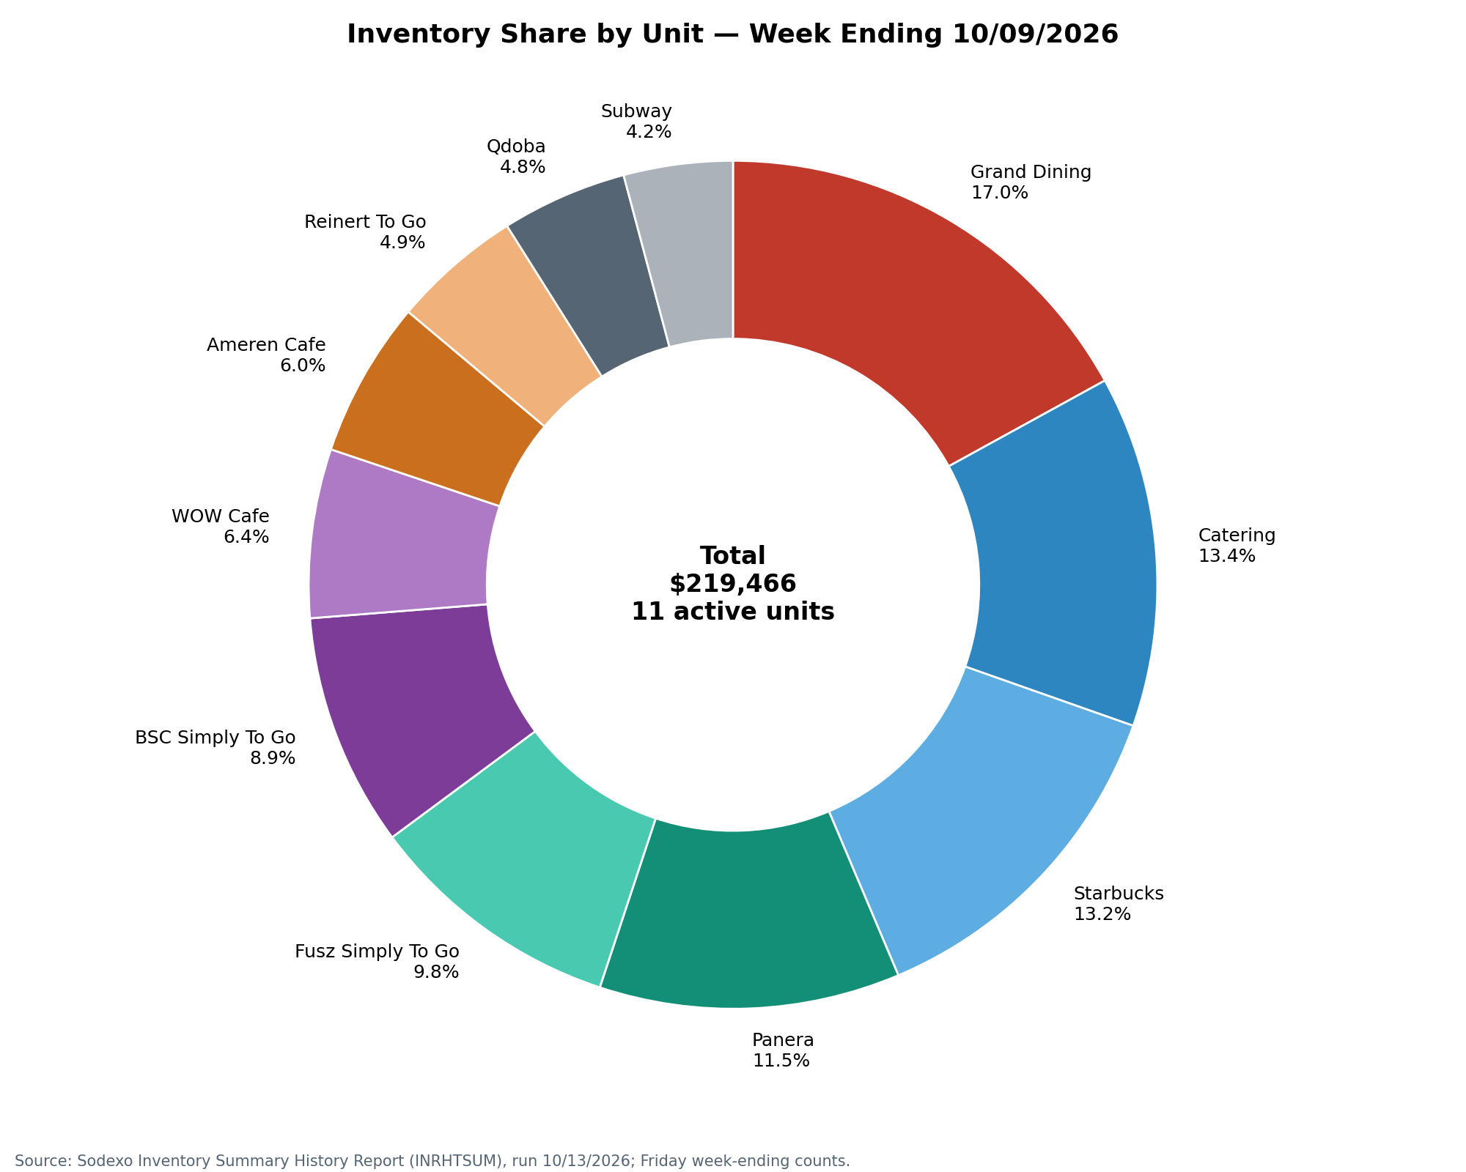
Figure 6. Portfolio Inventory Share by Unit — W/E 10/09/2026
The top three units — Grand Dining (17.0%), Catering (13.4%), and Starbucks (13.2%) — account for 43.6% of total portfolio inventory. Catering and Starbucks each hold nearly as much on-hand stock as the primary residential dining hall, despite very different demand profiles: Catering orders against scheduled events, while Starbucks is a single-concept retail outlet. This concentration warrants ongoing monitoring, particularly in Starbucks, where stock levels are also volatile.

4. Volatility and Stale Count Analysis

4.1 Inventory Volatility by Unit
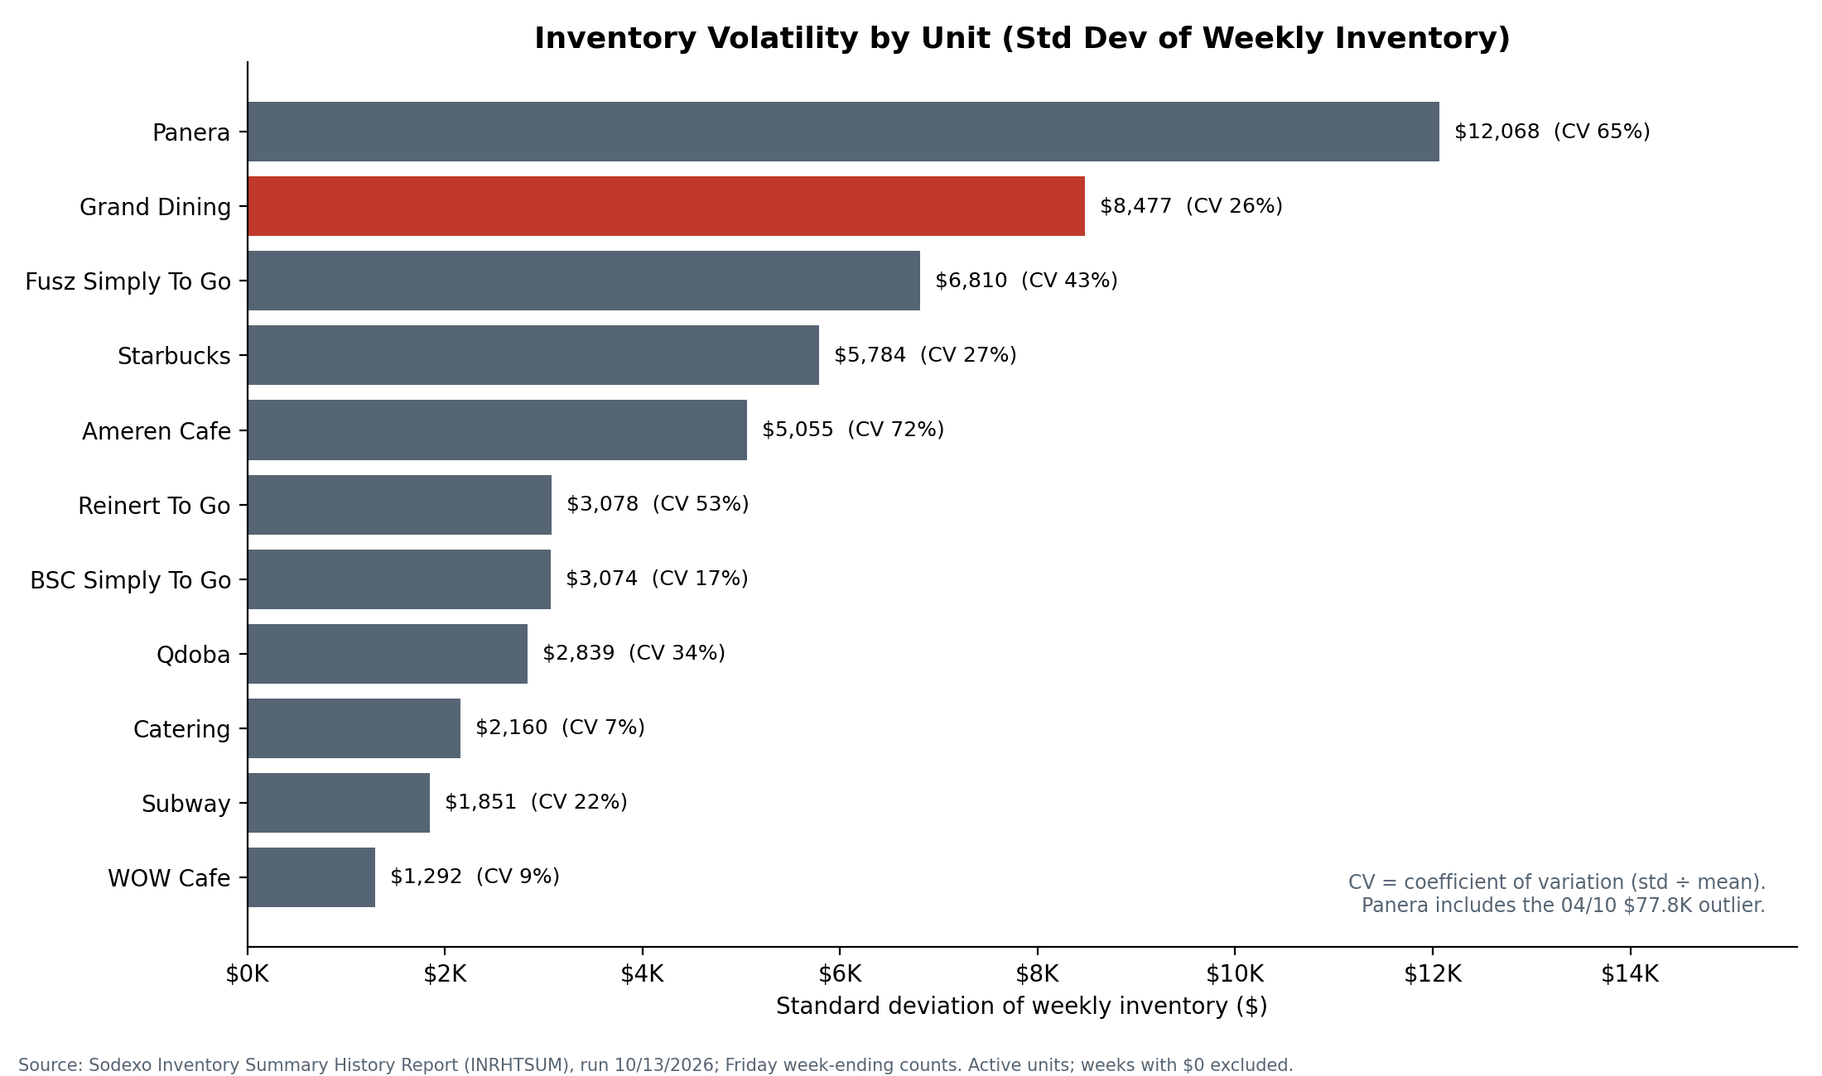
Figure 7. Inventory Volatility by Unit — Standard Deviation of Weekly Inventory
Panera shows the highest absolute standard deviation ($12,068), largely because of the April outlier. Setting that record aside, Grand Dining ($8,477 standard deviation) and Starbucks ($5,784) are the most operationally volatile of the large units: their on-hand values swing considerably from week to week, indicating inconsistent ordering behavior.
Low-volatility units — Catering (CV 0.07), WOW Cafe (CV 0.09), and Subway (CV 0.22) — show more stable patterns. Catering's stability is consistent with event-driven ordering, while WOW Cafe's low figure is partly attributable to its short eight-week reporting window. Ameren Cafe (CV 0.72) and Reinert To Go (CV 0.53) have high relative volatility on small inventory bases, which should be read alongside their stale-count rates below.

4.2 Stale Inventory Count Analysis (Data Freshness)
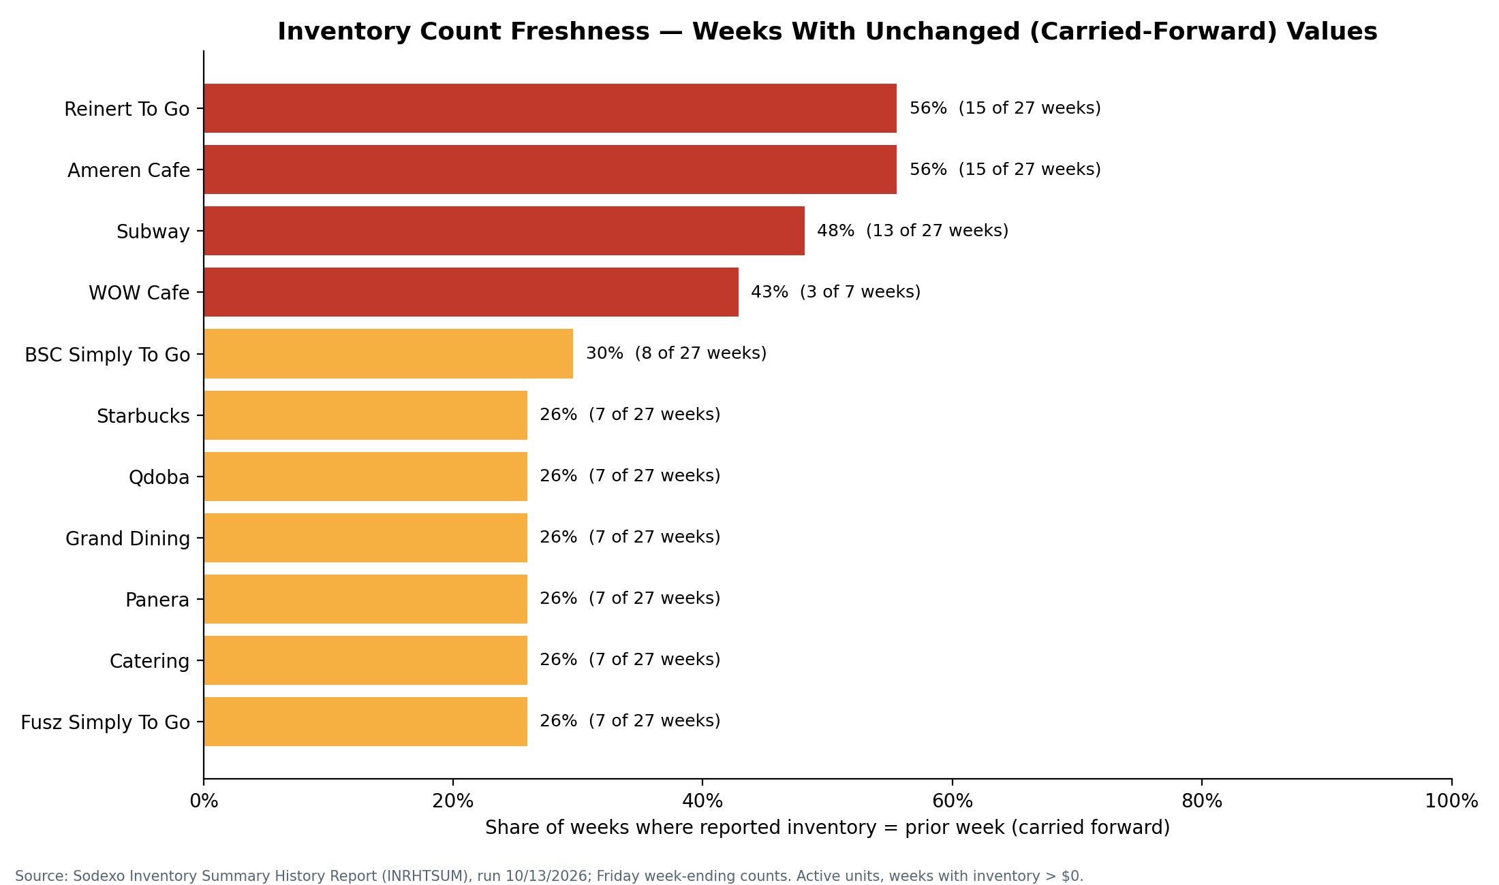
Figure 8. Inventory Count Freshness — Stale Count Rate by Unit
The stale rate is defined as the proportion of weeks in which a unit's total inventory value is identical to the prior week's value. This pattern is consistent with carried-forward counts rather than physical verification.
Reinert To Go and Ameren Cafe show 56% stale rates: 15 of their 28 weekly records are identical to the prior week. Subway shows a 48% stale rate (13 of 28 weeks). These units require immediate attention, because without verified weekly counts their inventory records cannot be relied upon for forecasting or financial reporting. The recommended action is to mandate weekly physical counts at these three units and determine why counts have not been updated regularly.

5. Demand Profiling (Grand Hall — Day Parts)

5.1 Meal Period Demand Analysis
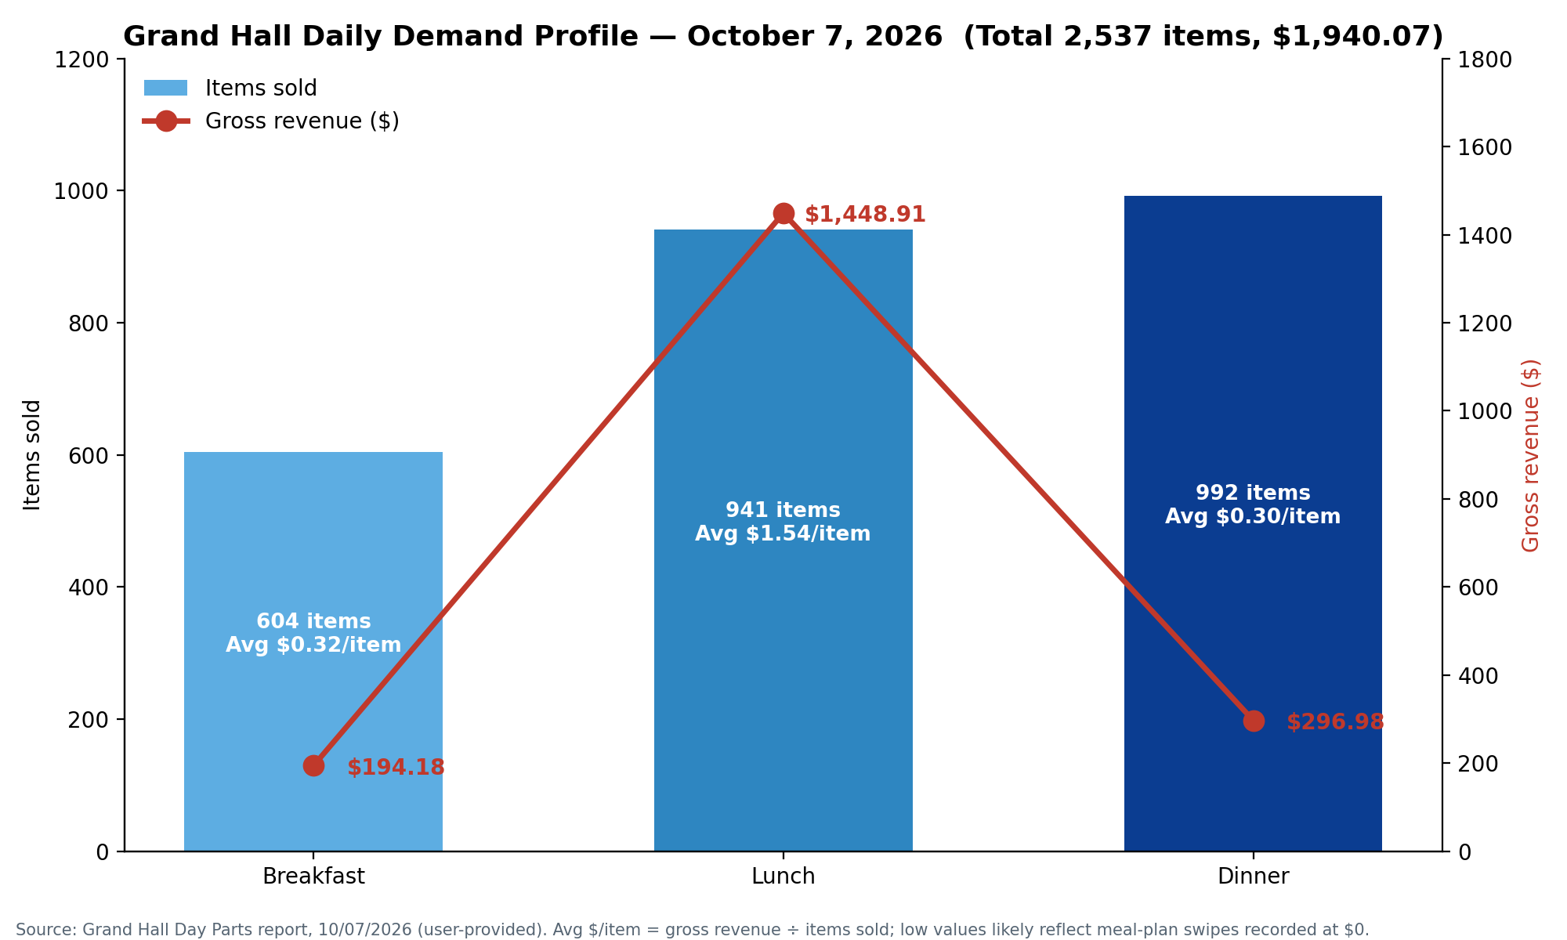
Figure 9. Grand Hall Daily Demand Profile — October 7, 2026
Meal Period | Items Sold | Food Revenue | Gross Revenue (incl. tax) | Avg Check | Control Count
Breakfast | 604 | $189.68 | $194.18 | $0.32 | 604
Lunch | 941 | $1,426.92 | $1,448.91 | $1.55 | 937
Dinner | 992 | $290.83 | $296.98 | $0.30 | 992
Total | 2,537 | $1,907.43 | $1,940.07 | — | 2,533
Table 4. Grand Hall Day Parts summary, October 7, 2026
Volume versus revenue. Dinner is the highest-volume period (992 items, 39.1% of daily items sold) but generates only $296.98 in gross revenue, an average check of $0.30. Lunch generates 74.8% of daily food revenue ($1,426.92 of $1,907.43) at an average check of $1.55, despite handling fewer transactions (941). This pattern is consistent with a residential meal-plan operation: most transactions are funded by meal swipes and carry near-zero cash revenue per swipe, while Lunch attracts a higher share of retail or cash transactions priced per item.
Production planning implication. Peak production demand occurs at Dinner, yet Dinner generates the least revenue. The kitchen must be staffed and supplied for the highest transaction volume during the period with the lowest cash yield — a common inefficiency in residential dining that demand forecasting can address by right-sizing production quantities and reducing over-production.
Forecasting this pattern. Once historical Day Parts data are exported from the point-of-sale system (a target of 24 months), a time-series model such as SARIMA or Prophet can forecast breakfast, lunch, and dinner counts with seasonal adjustments for academic-calendar events. The October 7, 2026 profile (Breakfast 604 / Lunch 941 / Dinner 992) reflects an academic weekday and serves as a reference point; additional days should be pulled to confirm how representative it is before it is used as a planning standard.

6. Procurement and PAR Level Gap Analysis

6.1 Current Procurement Status
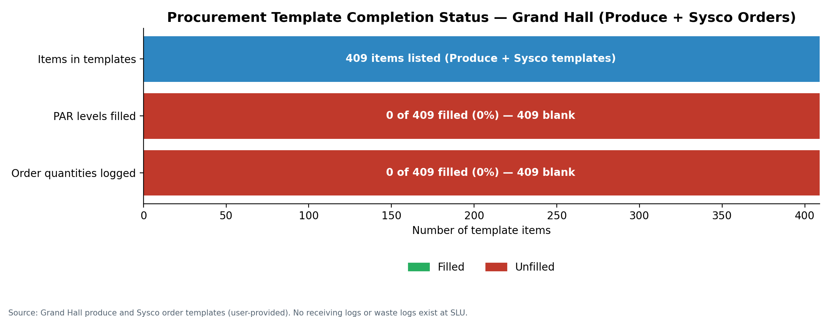
Figure 10. Procurement Template Completion Status — Grand Hall
Two procurement ordering templates exist for Grand Hall: a Produce order template and a Sysco order template. Each contains 409 line items representing the full food and supply catalog for Grand Hall operations, and both follow a Monday/Wednesday/Friday ordering cadence.
Critical gap. The PAR level column (target stock level) and the Monday, Wednesday, and Friday order quantity columns are completely empty across all 409 lines in both templates. There is no documented ordering baseline for any item, so every order is placed on ad hoc judgment without a quantitative target. The Grand Dining accumulation trend (+$307.67 per week) is consistent with this absence of stock targets.

6.2 Impact of Missing PAR Levels
Without PAR levels there is no mechanism to trigger an order when stock falls below a threshold, no mechanism to stop ordering when stock is already adequate, and no audit trail for ordering decisions. The $12,478.76 inventory accumulation observed in Grand Dining over 28 weeks is consistent with over-ordering in the absence of targets. Setting PAR levels from historical inventory counts and demand data is therefore the single intervention with the greatest expected impact on food cost and on reducing over-stock. Because no waste or receiving records currently exist, that impact can only be quantified once those systems are in place.

7. Unit Activity and Catalog Health

7.1 Unit Activity Status
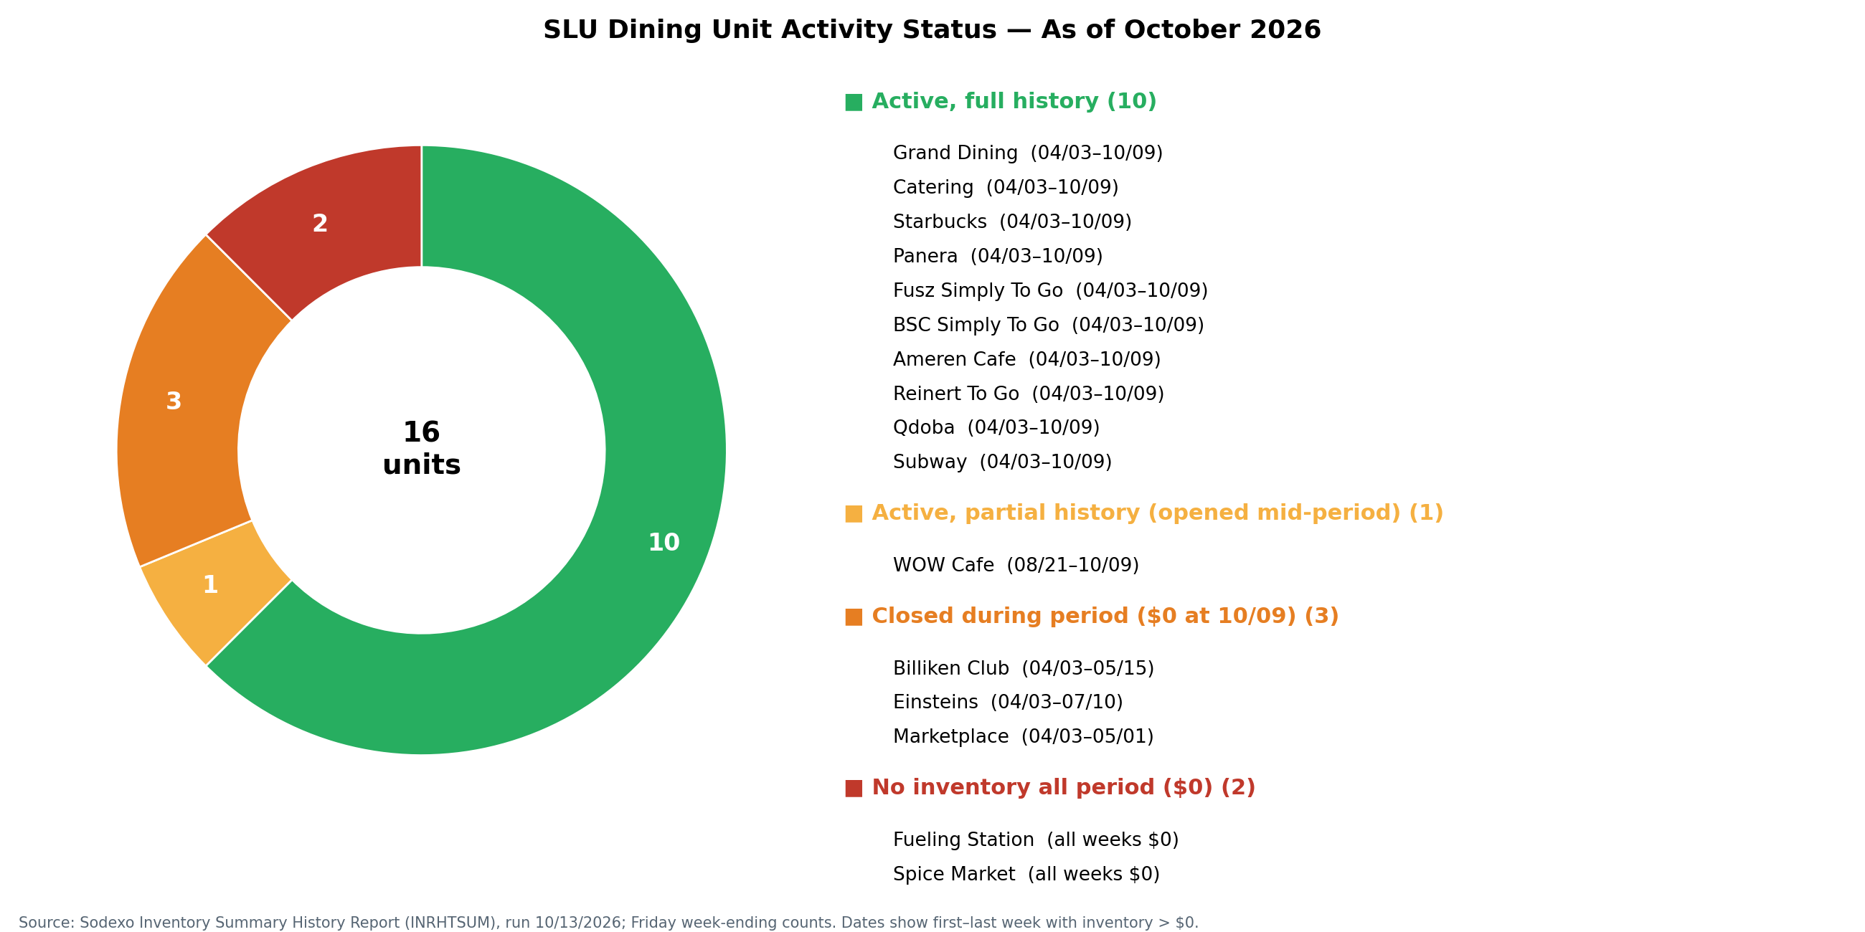
Figure 11. SLU Dining Unit Activity Status — October 2026
Of the 16 identified units, 11 are currently active, 3 are closed (Billiken Club, Marketplace, and legacy Einsteins), and 2 have never recorded any inventory (Spice Market and Fueling Station). Inactive and never-active units that remain in the active catalog add clutter to reporting, create confusion in ordering systems, and should be deactivated.

7.2 Category Mix by Unit
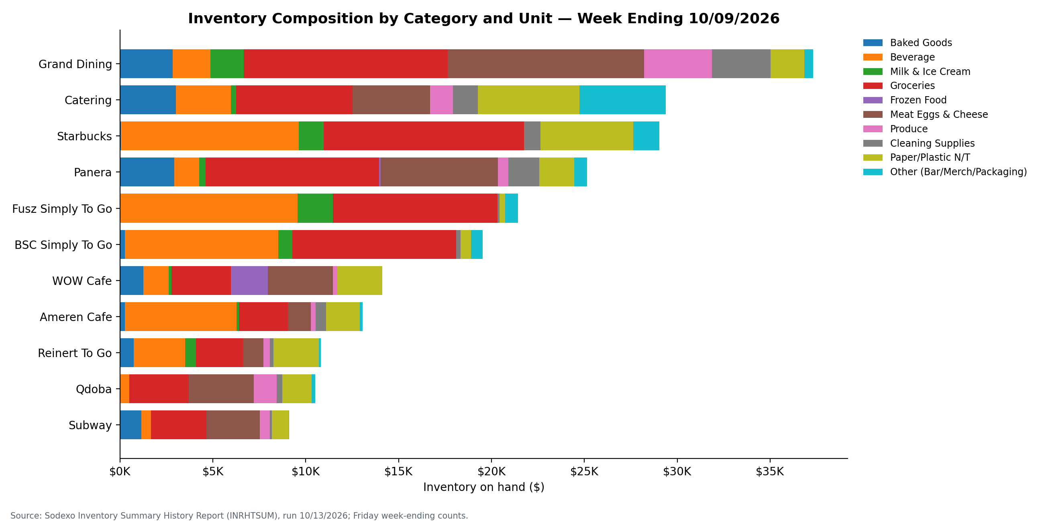
Figure 12. Inventory Category Mix by Unit — W/E 10/09/2026
Across the portfolio, Groceries (32%) and Beverage (20%) dominate, together accounting for more than half of all on-hand inventory value. Starbucks skews toward Beverage inventory, as its concept would suggest. Grand Dining's largest categories are Groceries and Meat/Eggs/Cheese, consistent with a full-service residential dining model.
Frozen Food represents only 1% of portfolio inventory, a notably low share for a food-service operation of this scale. This may reflect a fresh-forward menu philosophy, or a gap in how frozen products are classified or counted; it should be confirmed with unit managers during the PAR-setting exercise.

8. Key Findings and Specific Recommendations
Each recommendation below sets out the finding, the recommended action, and the expected impact. Percentage reductions are presented as targets to be validated against post-implementation data, not as measured results.

Recommendation 1 — Set PAR Levels for All 409 Procurement Lines
Priority: CRITICAL
Finding: Both Grand Hall procurement templates (Produce and Sysco) have 409 line items with zero PAR levels set. Grand Dining inventory has grown +50.25% over 28 weeks at a rate of $307.67 per week.
Recommendation: Working with the Executive Chef and General Manager, establish a target PAR level for every item in both templates using the 28-week inventory history now available. Set minimum reorder points and maximum stock levels by category (for example: perishables 3–5 days of cover; dry goods 7–10 days; frozen 14 days).
Expected Impact: A halt to Grand Dining inventory accumulation; a target 15–25% reduction in over-ordering, to be verified against the 28-week baseline; and an auditable ordering record for every line.

Recommendation 2 — Mandate Weekly Physical Counts at Reinert To Go, Ameren Cafe, and Subway
Priority: HIGH
Finding: These three units show stale-count rates of 48–56%: their inventory values are unchanged in roughly half of all reporting weeks, a pattern inconsistent with regular physical verification.
Recommendation: Require documented weekly physical counts at all units. For Reinert To Go and Ameren Cafe specifically, assign responsibility to a named manager and integrate count submission into the weekly reporting workflow.
Expected Impact: Accurate inventory records, reliable data for forecasting, and removal of potentially inflated or deflated on-hand values from financial reporting.

Recommendation 3 — Investigate and Resolve the Panera Outlier ($77,772.81, W/E 04/10/2026)
Priority: HIGH
Finding: Panera (Unit 13341004) recorded $77,772.81 in W/E 04/10/2026 — roughly four to five times its typical weekly value — inflating the portfolio peak to $263,943.40. This is a probable data-entry error.
Recommendation: Review the W/E 04/10/2026 Panera submission. If confirmed erroneous, restate the corrected value and document the correction. Substituting a typical Panera week (about $16,700) would put the 04/10 portfolio total near $202,900 rather than $263,943.40 — a material difference.
Expected Impact: An accurate historical baseline for portfolio-level forecasting and removal of a major distortion from trend analysis.

Recommendation 4 — Establish Waste Tracking from Scratch
Priority: HIGH
Finding: No waste tracking system, waste log, or waste data collection process exists at SLU Dining. Without waste data, food cost cannot be fully analyzed and the impact of any production-planning improvement cannot be measured.
Recommendation: Implement a daily waste log at each production outlet capturing item, quantity, production station, and reason code (overproduction, expired, damaged, customer return). Use a simple digital form on a tablet or phone, or a printed daily sheet. Begin immediately and maintain for at least one full semester before modeling.
Expected Impact: Quantification of food-cost loss, a waste-reduction metric for impact documentation, and a baseline for measuring improvement once PAR levels are established.

Recommendation 5 — Establish Receiving Verification Records
Priority: HIGH
Finding: No receiving logs or intake documentation exist at SLU Dining. Without them it is impossible to verify that ordered quantities were delivered, to detect shrinkage between the receiving dock and production, or to hold vendors accountable for fill rates.
Recommendation: Implement a receiving verification log capturing PO number, vendor name, expected quantity, received quantity, condition note, and receiver signature. Reconcile against purchase orders weekly.
Expected Impact: Vendor accountability, shrinkage detection, and completion of the procurement-to-inventory data chain required for supply forecasting.

Recommendation 6 — Review the Starbucks Inventory-to-Sales Ratio
Priority: MEDIUM
Finding: Starbucks (Unit 13341023) carries $29,045.65 in on-hand inventory — 13.2% of the portfolio — with a coefficient of variation of 0.27. Beverage dominates its inventory profile.
Recommendation: Benchmark Starbucks inventory against comparable campus Starbucks units in the Sodexo portfolio. Set beverage PAR levels from daily sales velocity and review them monthly, with a target 15–20% reduction in on-hand Beverage inventory without affecting service levels.
Expected Impact: Lower carrying cost, capital freed for other operational needs, and an improved inventory-to-sales ratio.

Recommendation 7 — Deactivate Inactive Units in the Catalog
Priority: MEDIUM
Finding: Spice Market (13341018) and Fueling Station (13341020) have never recorded inventory. Billiken Club, Marketplace, and legacy Einsteins are closed. All still appear in reporting systems.
Recommendation: Archive all closed and never-active units from the active reporting roster. Confirm deactivation with the District Manager and update the catalog in the inventory management system.
Expected Impact: Cleaner reporting and less confusion in ordering and inventory systems.

Recommendation 8 — Build the Demand Forecasting Model Using This Dataset
Priority: STRATEGIC
Finding: The 28-week inventory history, combined with Day Parts demand data, forms a longitudinal dataset sufficient to begin time-series forecasting. The seasonal pattern is already visible: a summer low (07/10/2026: $126,289.65 portfolio-wide), followed by fall recovery.
Recommendation: Export historical Day Parts data from the POS system (target: 24 months) and merge it with the inventory dataset. Build SARIMA or Prophet models for Grand Dining demand by meal period and link the forecasts to procurement recommendations. This corresponds to Stage 4 of the 26-week execution plan in the NIW Blueprint.
Expected Impact: Quantified forecast accuracy (MAPE), documented evidence of the proposed endeavor in execution, and a target 10–20% reduction in over-ordering cost.

9. NIW Relevance: How This Analysis Advances the Proposed Endeavor
This analysis constitutes a Stage 2–3 deliverable of the NIW Phase I project plan. It is the first documented, systematic extraction and analysis of SLU's multi-unit institutional inventory data, producing a longitudinal dataset, quantified baselines, and a formal recommendations report. Every metric computed here — inventory growth rates, volatility coefficients, stale-count rates, and demand profiles — is a measurable baseline against which future model-driven improvements will be benchmarked. These baselines are the documented starting point that NIW evidence requires.
Once parsed, the 505-page inventory report yields a 28-week by 11-unit panel dataset, equivalent in structure to the utilization and supply data a health institution would hold for a comparable analytics engagement. The methods applied here — trend analysis, coefficient-of-variation ranking, data-freshness auditing, and demand profiling — are the same methods the proposed endeavor applies to health-institution procurement and utilization data. Only the source systems differ.
The procurement gap analysis (409 lines, 0% PAR coverage) is particularly significant for the NIW narrative. The absence of PAR levels is precisely the kind of institutional forecasting gap the proposed system is designed to correct. Demonstrating that the gap exists at SLU, quantifying its consequence (+$12,478.76 of inventory accumulation in Grand Dining), and then implementing a predictive PAR-level model completes the full develop–validate–deploy arc on real institutional data, in a real institutional setting, with measurable impact.

Appendix — Data Notes and Methodology
Data extraction. All inventory data were extracted programmatically from the 505-page Sodexo Inventory Summary History Report (Report ID: INRHTSUM) using Python with pdfplumber/PyMuPDF. All 505 pages were processed, and flagged parsing exceptions were reviewed manually.
Stale count definition. A week is classified as stale when the unit's total inventory value equals the prior week's value exactly, to two decimal places. This may reflect a genuine absence of inventory movement or a missed or carried-forward count; verification at the unit level is required.
Panera outlier. The W/E 04/10/2026 Panera value of $77,772.81 is flagged as a probable data-entry error (roughly 4.7 times the unit's average across its other weeks). It is retained in the dataset but flagged in all analyses.
Growth versus start. Growth figures in Table 3 compare each unit's latest value with its first recorded week. For WOW Cafe, the first recorded week is mid-period, as the unit has only 8 weeks of data.
No receiving or waste logs. SLU Dining currently has no receiving logs and no waste logs. These systems are absent and must be established from scratch; they were not available as data sources for this analysis.
Day Parts data. Meal-period demand figures (Breakfast 604 / Lunch 941 / Dinner 992) are taken from the official Grand Hall Day Parts Report for October 7, 2026.

