Quarto Template
Waleed A A Ali
Table of contents

Preface

1. Quarto Template
This is a generic template for generating Quarto documents.

2. Heading

2.1 Heading

2.1.1 Heading

2.1.1.1 Heading

2.1.1.1.1 Heading

2.1.1.1.1.1 Heading
This is how to refernece sections like Section 2.1.1.1.1.1 or other chapters like Appendix A.
Right | Left | Default | Centre
12 | 12 | 12 | 12
123 | 123 | 123 | 123
1 | 1 | 1 | 1
Italic
Bold
Bold-italic
 Note
Note nte

 Warning
Warning wrn

 Important
Important imp

 Tip
Tip tip

 Caution
Caution cau

Note 2.1: Note Box Title
Note with stuff
Note box with label Note 2.1.
Caution
Collapsible caution with no icon
Blockquote
Definition 2.1 (Definition) def
Theorem 2.1 (Theorem) thm
Corollary 2.1 (Corollary) cor
Lemma 2.1 (Lemma) lem
Proposition 2.1 (Proposition) prp
Conjecture 2.1 (Conjecture) cnj
Example 2.1 (Example) exm
Exercise 2.1 (Excersise) exr
Solution 2.1 (Solution). sol
Remark 2.1 (Remark). rem
This can be referenced as Theorem 2.1.
Things that only appear in docx version.
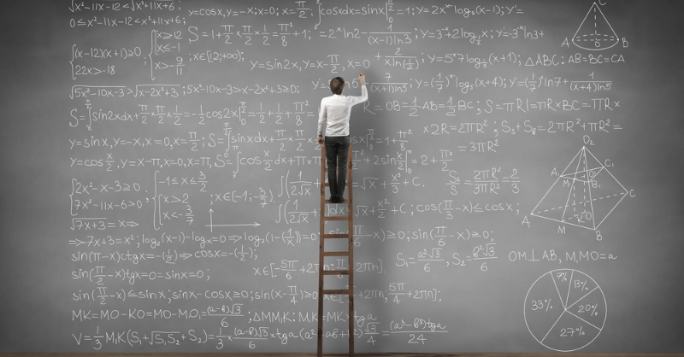
Figure 2.1: Image caption here. The image is clickable to enlarge.
In Figure Figure 2.1, there is a figure.
import matplotlib.pyplot as plt
plt.plot([1,23,2,4])
plt.show()
import matplotlib.pyplot as plt
plt.plot([1,23,2,4])
plt.show()
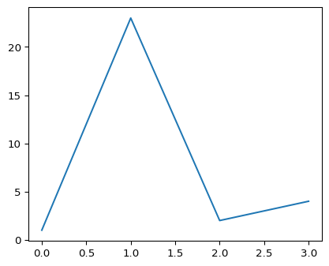
Figure 2.2: A line plot
Referencing is done similarly to BibTex using Gump (2000).

Appendix A — Appendix 1
Appendix of things.
Gump, Forrest et al. 2000. Random Thing i Made. Vol. 100. Spring.

