This week I focused on many tiny details. Following the most important improvements:

* Colour coding: Throughout the web application I implemented a colour system, which means, that the same colour always stands for the same information.

Colour yellow stands for ‘Death Cases’
Colour blue stands for ‘Confirmed Cases’
Colour green stands for ‘Recovered Cases’
Colour red stands for ‘Active Cases’

Despite that, I made sure that the order of the categories (Confirmed, Active, Deaths, Recovered) is always the same.
No matter what graphs or what button gets pressed, the order and colouring are always the same. It helps a lot with focusing on the actual information

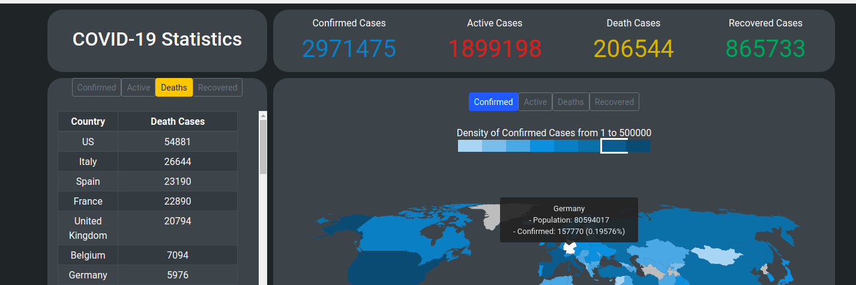
Here an example. The total numbers on the top, the buttons above the table and the buttons above the choropleth map have all the order Confirmed, Active, Death, Recovered. This can be found throughout the application. Same counts for the colouring.

* As earlier mentioned I was struggling with highlighting my bar chart, whenever a mouse hovers over it. This was a huge problem, due to the fact that with a click on the bar a second graph opens but without highlighting nobody would notice that. Even though the used library React-Vis doesn’t offer anything appropriate, I came up with an alternative solution.
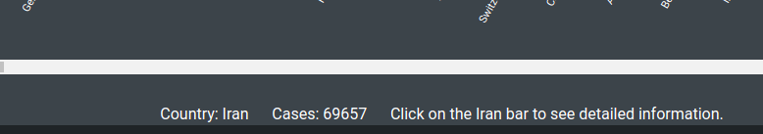

Below the graph, the bar where the mouse pointer is currently nearest gets pointed out. With the additional information to click on the bar for detailed information, I achieved an acceptable workaround. Much better would have been a highlighted bar itself but that is sadly not possible.

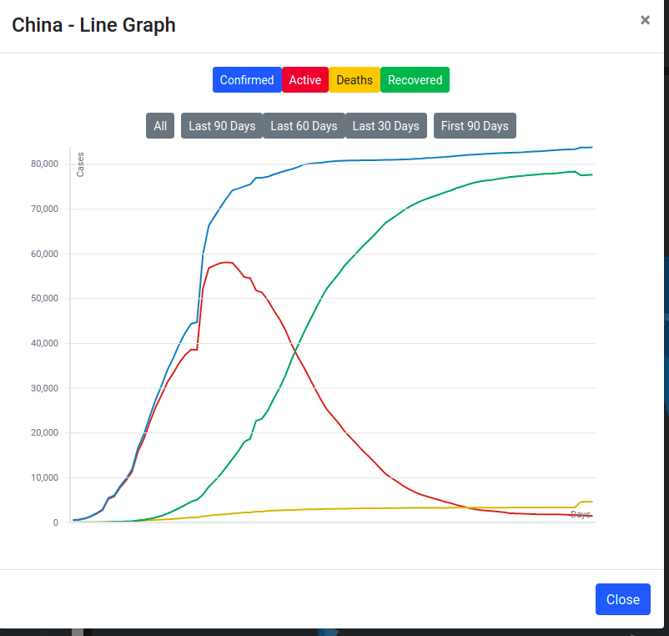
* I also mentioned in an earlier diary the problem of the timeframe. My line graph will soon have the problem of having to display too many days. Look at the graph below as an example.

In 2 month the important part of the information ( peaks) would be on the very left side, while the centre and right side wouldn’t offer any important information. As solution, I implemented the buttons All, Last 90 Days, Last 60 Days, Last 30 Days and First 90 Days. Those buttons change the time frame and make it possible to put a different focus on the graph. In six months or a year, there are probably some adaptions necessary.

* I implemented an additional graph. A pie chart can get created for every single country. Showing either the percentage or with a click on ‘Toggle’ the total numbers.
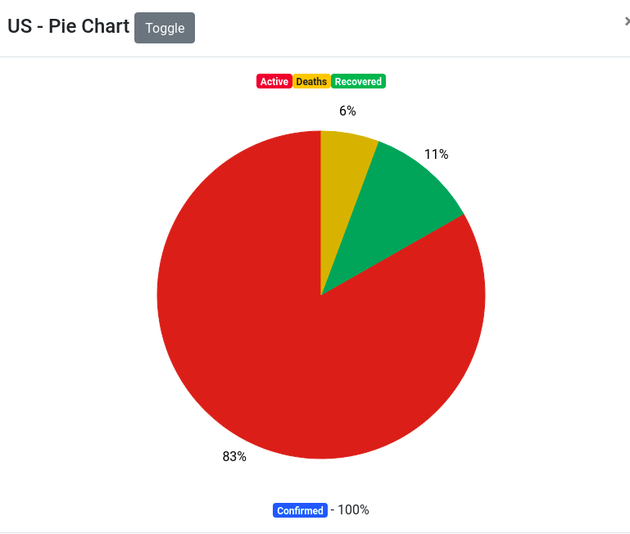

Furthermore, as can be seen in the first picture, I added a table with all cases per country. It serves as an addition to make the Choropleth map a bit clearer.

Overall, I think I have now a good mix of different graphs and are able to provide a good overview of the Coronavirus crisis. With the colouring and naming system, it is also more pleasing to look at. There were other tiny design changes such as in CSS files but they are not worth pointing out.

