**Отчет**

**Лабораторная работа №18**

**Лобанов Владимир, 2 курс 3 группа**

Рисованная схема:

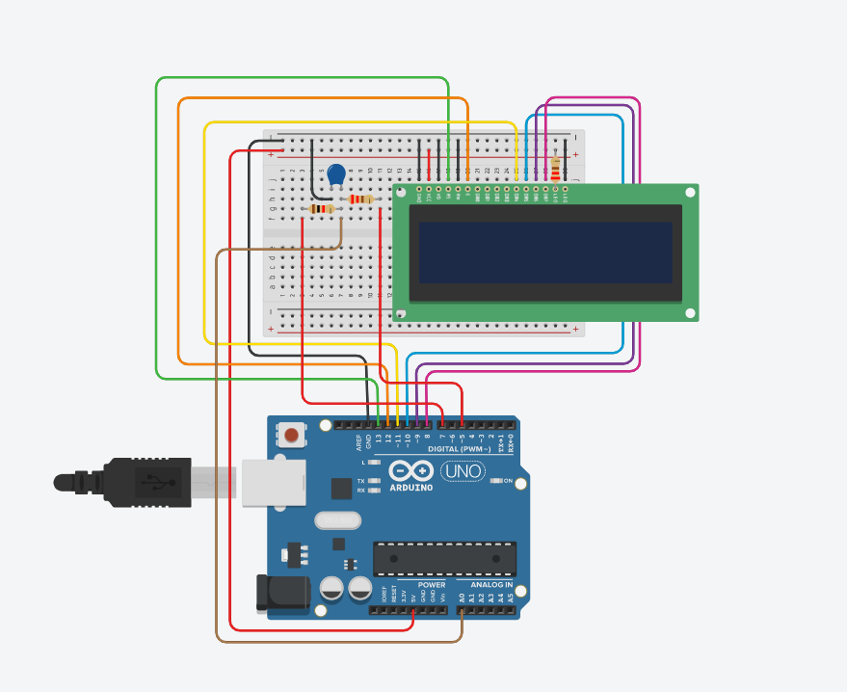

Принципиальная схема:

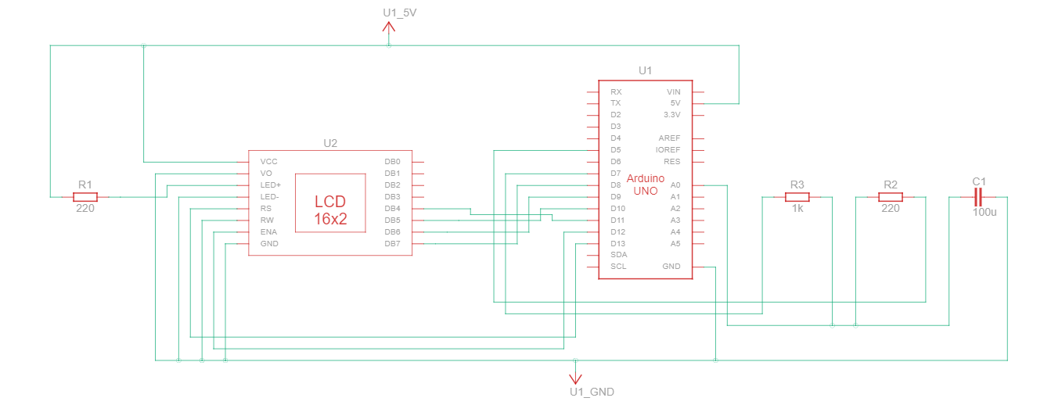

Скетч:

|  |
| --- |
| #include <LiquidCrystal.h>  #define analogPin 0 // analog pin for measuring capacitor voltage  #define chargePin 7 // pin to charge the capacitor - connected to one end of the charging resistor  #define dischargePin 5 // pin to discharge the capacitor  #define resistorValue 1000.0F // change this to whatever resistor value you are using  // F formatter tells compiler it's a floating point value  LiquidCrystal lcd(13, 12, 11, 10, 9, 8);  unsigned long startTime;  unsigned long elapsedTime;  float microFarads; // floating point variable to preserve precision, make calculations  float nanoFarads;  void setup()  {  pinMode(chargePin, OUTPUT); // set chargePin to output  digitalWrite(chargePin, LOW);  Serial.begin(9600); // initialize serial transmission for debugging  lcd.begin(16, 2);  lcd.print("Aboba");  }  void loop()  {  digitalWrite(chargePin, HIGH); // set chargePin HIGH and capacitor charging  startTime = millis();  while (analogRead(analogPin) < 648)  { // 647 is 63.2% of 1023, which corresponds to full-scale voltage  }  elapsedTime = millis() - startTime;  // convert milliseconds to seconds ( 10^-3 ) and Farads to microFarads ( 10^6 ), net 10^3 (1000)  microFarads = ((float)elapsedTime / resistorValue) * 1000;  lcd.clear();  Serial.print(elapsedTime); // print the value to serial port  lcd.print(elapsedTime);  Serial.print(" mS"); // print units and carriage return  lcd.print(" mS");  lcd.setCursor(0, 1);  if (microFarads > 1)  {  Serial.print((long)microFarads); // print the value to serial port  lcd.print((long)microFarads);  Serial.println(" microFarads"); // print units and carriage return  lcd.print(" microFarads");  }  else  {  // if value is smaller than one microFarad, convert to nanoFarads (10^-9 Farad).  // This is a workaround because Serial.print will not print floats  nanoFarads = microFarads * 1000.0; // multiply by 1000 to convert to nanoFarads (10^-9 Farads)  Serial.print((long)nanoFarads); // print the value to serial port  Serial.println(" nanoFarads"); // print units and carriage return  }  /* dicharge the capacitor */  digitalWrite(chargePin, LOW); // set charge pin to LOW  pinMode(dischargePin, OUTPUT); // set discharge pin to output  digitalWrite(dischargePin, LOW); // set discharge pin LOW  while (analogRead(analogPin) > 0)  { // wait until capacitor is completely discharged  }  pinMode(dischargePin, INPUT); // set discharge pin back to input  } |