**Отчет**

**Лабораторная работа №7**

**Лобанов Владимир 2 курс 3 группа**

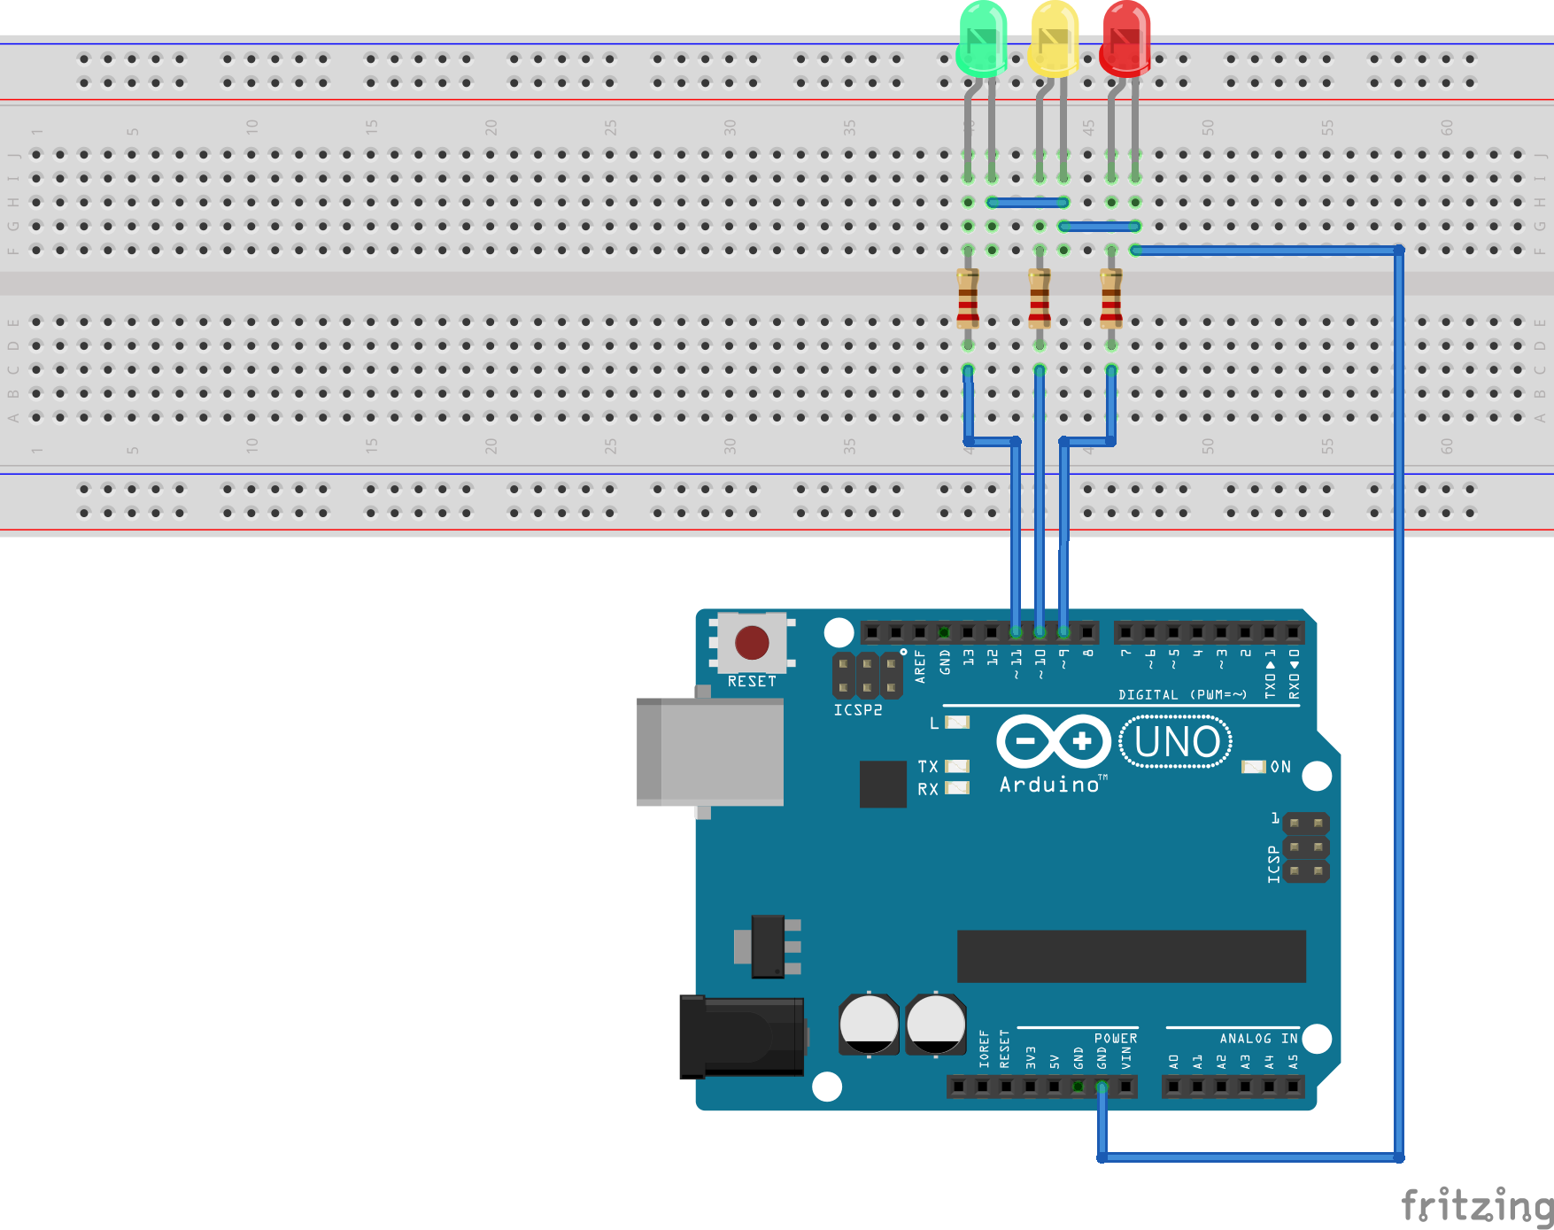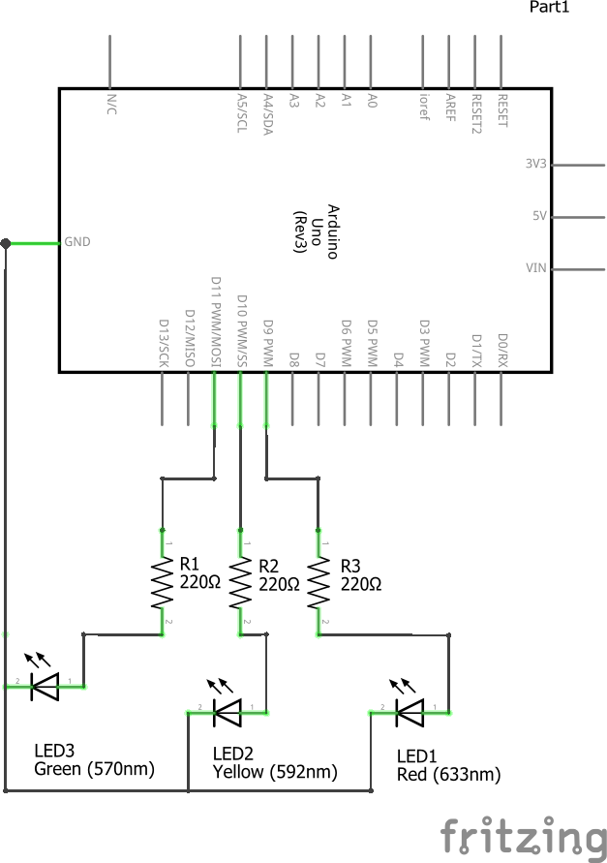

**Скетч**

|  |
| --- |
| #define RED 9  #define YEL 10  #define GRN 11  int cnt = 0;  int state = 1;  void setup() {  pinMode(RED, OUTPUT);  pinMode(YEL, OUTPUT);  pinMode(GRN, OUTPUT);  }  void loop() {  cnt++;  if (cnt == 100) {  cnt = 0;  StateMachine();  }  delay(10);  }  void StateMachine(void) {  switch (state) {  case 1:  digitalWrite(RED, HIGH);  digitalWrite(YEL, LOW);  digitalWrite(GRN, LOW);  state++; break;  case 2:  digitalWrite(RED, HIGH);  digitalWrite(YEL, HIGH);  digitalWrite(GRN, LOW);  state++; break;  case 3:  digitalWrite(RED, LOW);  digitalWrite(YEL, LOW);  digitalWrite(GRN, HIGH);  state++; break;  case 4:  digitalWrite(RED, LOW);  digitalWrite(YEL, HIGH);  digitalWrite(GRN, LOW);  state = 1; break;  }  } |