James Waller

Front End Developer / UX Designer

# Contact

Website [james-waller-digital.com](http://portfolio.james-waller-digital.com/) Email [contact@james-waller-digital.com](mailto:contact@james-waller.co.uk)

# About

My name is James Waller and I am a Web Developer specialising in everything your average web visitor sees and feels. User interface design and front end development.

I live in Sydney, Australia, after working in London, England for 9 years as a Front End Developer / UX Designer and graduating as a Bachelor of Multimedia Technology from Leeds Metropolitan University, England in 2006.

I like creating unique clean sites that are easy to understand and navigate. All my works comply with web standards, use the latest industry techniques and are hand coded.

# Skills

Web Development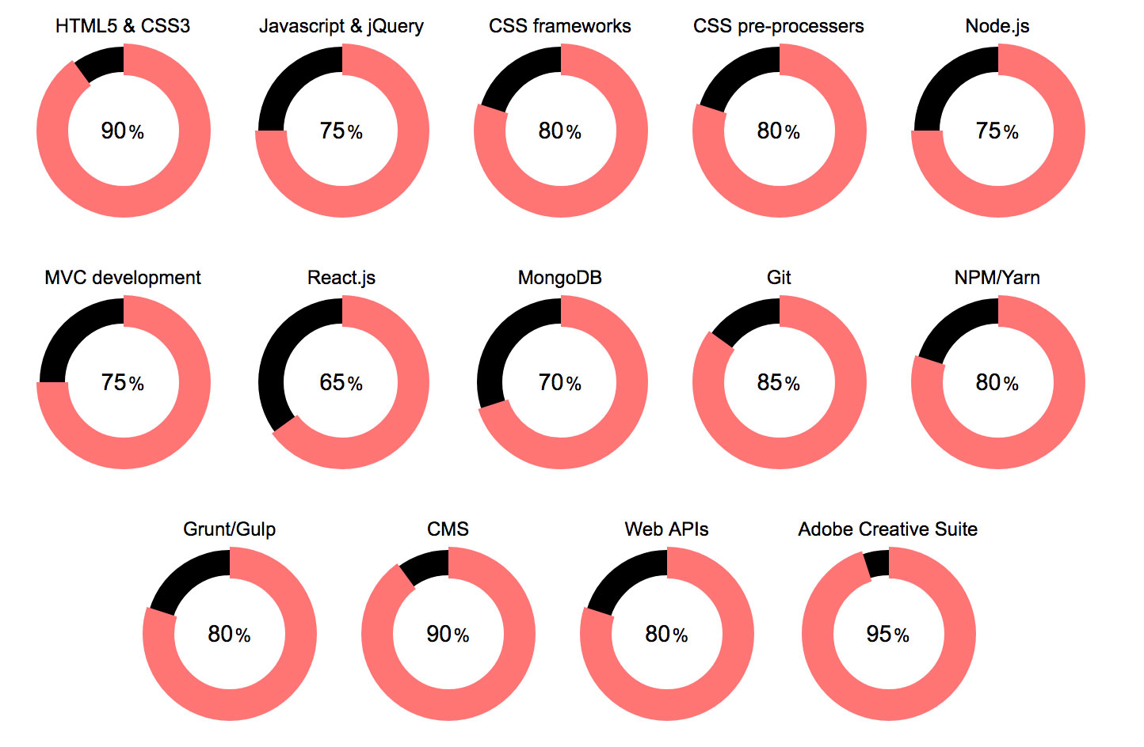

# Career History

## The Independent and The Evening Standard, London

Front-End Developer / UX Designer April 2017 - January 2018

[independent.co.uk](http://www.independent.co.uk/) [standard.co.uk](http://www.standard.co.uk/)

During my time at The Independent and The Evening Standard my day to day responsibilities were to look after the front end of both The Independent and The Evening Standard, both sites were CMS driven using Drupal 7. My typical tasks were anything from bug fixing to implementing new functionality to either site as requested by the shareholder.

I was involved with a couple of excellent projects during my time here, the first being to create a landing page for users that had subscribed to The Independent daily app to o¦er them a free gift for renewing their yearly subscription. The functionality where the user was able to select their free gift was built using javascript, with the landing page template being built using HTML and CSS and the from the user filled in using php.

The second was to re-work the whole of The Standards front end. The designs were very different from the old site, as well as this we had decided to make the site more modular on the front and back end. So, this meant changing the SASS and the template structuring. The templates were built using ejs, this allowed us to parse the data in using a json feed. The whole site, once finished now worked on the MVC framework structuring principle.

## FEED, London

Developer July 2014 - March 2017

[feed.xyz](http://www.feed.xyz/)

FEED London are the main creative marketing agency for eBay Europe. The main part of my role revolves around maintaining the company intranet infrastructure. This is divided between two MVC frameworks built using backbone.js and React.js.

The day to day tasks are typically bug fixing and adding new functionality as requested internally and from the clients. I am also heavily involved in producing applications for both web and mobile use. This is predominantly for eBay but I have worked on many campaigns all the way from simple HTML email builds up to complex CMS implementation, migration and development.

We also built tools used by eBay’s internal marketing team to automate a lot of their processes and gather data to aid their marketing campaigns.

## Freedman International, London

Digital Developer October 2013 - July 2014 [freedmaninternational.com](https://www.freedmaninternational.com/)

I predominantly worked on creating the website and application concepts for clients from the outset and I was responsible for implementing and documenting procedures for them on mobile, tablet and desktop environments as well as applications for internal use.

I was also responsible for looking after Freedman’s internal bug logging system (JIRA) which was developed to specifications drawn up by the company. There was also an element of flash development required while I was working at Freedman, so I became quite well versed in the creation of flash banners and flash based tools for clients such as EA games and Shell for example.

## Devilfish Creative, London

Front End Developer April 2013 – October 2013

My core responsibility was to look after all the websites controlled by Devilfish Creative. In this varied role I was exposed to all types of development work as I was the sole internal developer at the company.

I primary worked on the front end of these websites but have also experienced working on server side technologies, from database administration using MySQL to full on server migration. I looked after a number of CMS driven websites (Drupal and Wordpress) and I was given a large say in the look and feel of the websites we produced as well as writing documentation and bug fixing.

This role was predominantly web based but I also developed applications and tools for internal use.

## London Capital Group

Front End Developer January 2009 – April 2013 [lcg.com](https://www.lcg.com/uk)

My main responsibility at London Capital Group was the conversion of static HTML websites into CMS (Drupal) driven websites, completing full build from start to finish. I was also accountable for the build of various micro sites and email campaigns for external and internal marketing teams.

Again, I was responsible for working on the development of the numerous internal tools used for communication between the IT support team and Development team, for example the bug logging and ticketing system we used, as well as writing applications to automate different tasks performed by the support team to streamline the process as much as possible, for example the implementation of the live chat functionality for communication with clients across the business.

London Capital Group operates within an agile environment; working at the company for four years, this methodology is something I am well versed in having been exposed to.

## The Think Tank, London

Digital Designer/Developer October 2008 – November 2008 [thinktank.org.uk](https://www.thinktank.org.uk/)

I moved to The Think Tank as I was keen to work in an agency environment and enjoyed working on a number of different projects and for a number of different clients. Working in a varied role, I worked on all types of projects from developing client web sites, designing HTML email templates, launching the email campaigns through Campaign Monitor and coming up with designs for Flash banners.

Through this role I gained exposure to PHP and MySQL which is something I enjoyed greatly and have a keen interest in server side technologies and web 2.0 technologies.

## Virtual Festivals, London

Front End Developer Jan 2008 - October 2008

My duties consisted of working on the day to day running of the company’s website. This could be anything from bug fixing, adding new functionality or re skinning the site.

The main focus of my work would normally be within the XHTML, CSS, XML and XSLT languages, of which I am proficient. As well as the day-today running of the web site, I am also worked as Email Marketing Manager, creating HTML email designs to specification and overseeing the sending of the email to our users on a MySQL database.

I also did a lot of work with clients developing tools they used to gather data for marking purposes and automation of their marketing processes for them, this could be storing data from people that had purchased tickets for their events and automation of simple marketing campaign targeting them for the next event the company held.

# Education

Leeds Metropolitan University 2003 - 2006

BSc (HONS) MULTIMEDIA TECHNOLOGY

City of Norwich School, 6th Form College 2000 - 2002

A2 Level gained in IT/Computing.

AVCE (equivalent to two A levels) gained in Business and Finance.

City of Norwich School 1996 - 2000

Maths English IT

Double Science Geography History

French Technology

A2 Level gained in IT/Computing. English Literature

# Languages

English

*Native speaker*

# Personal Information

Date of Birth: 11 August 1984 Marital Status: Single Driving License: Full clean

Interests: Travelling, Football, Scuba Diving, Music and Films.

# References

On request.