**CIS115 Course Project Report**

**Week:**

**Name: ______________________**

**Submissions:**

**IPO Chart**

|  |  |  |
| --- | --- | --- |
| Inputs | Process (calculations) | Outputs |
| 1.Prompt the user for a number | 1. Convert the input from the user to a number 2. If the input cannot be converted to a number raise a ValueError and prompt user again 3. If the input is a number perform actions to check if it’s too low, too high or the guessed number and update a counter that was previously created to keep track of how many attempts made by the user | 1. The user should see a response that it guessed the correct user in X amount of attempts. |

**Code:**

import random

mynumber = random.randint(1,10)

print("Welcome to my Guess the number program!")

print(f"This is the guess number just for testing purposes: {mynumber}")

def guessNumber():

count = 1

while True:

try:

while True:

guess = int(input("Guess a number between 1 and 10: "))

if guess < mynumber:

print("Too low")

count += 1

elif guess > mynumber:

print("Too high")

count += 1

elif guess == mynumber:

print(f"You guessed it! It took you {count} attempts")

break

break

except ValueError:

print(f"Please enter a number, letters are NOT allowed")

count += 1

if __name__ == "__main__":

guessNumber()

Paste a Screenshot(s) of the complete working program here.

Test cases – you should have at least 3

Test case 1: a value between 1 and 10

Expected output:

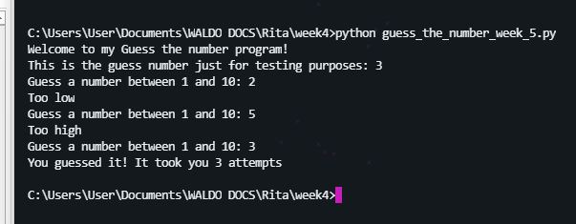

Test case 2: a value outside of 1 and 10

Expected output:

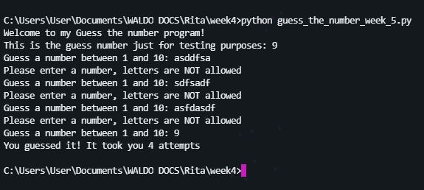

Test case 3: a letter

Expected output:

