Recognising Patterns & predicting outcomes. A case study of a diabetes data set
2024
#load the neccessary libraries
library(readr)
library(dplyr)
## Warning: package 'dplyr' was built under R version 4.3.3
##
## Attaching package: 'dplyr'
## The following objects are masked from 'package:stats':
##
## filter, lag
## The following objects are masked from 'package:base':
##
## intersect, setdiff, setequal, union
library(ggplot2)
## Warning: package 'ggplot2' was built under R version 4.3.3
library(lessR)
## Warning: package 'lessR' was built under R version 4.3.3
##
## lessR 4.3.2 feedback: gerbing@pdx.edu
## --------------------------------------------------------------
## > d <- Read("") Read text, Excel, SPSS, SAS, or R data file
## d is default data frame, data= in analysis routines optional
##
## Learn about reading, writing, and manipulating data, graphics,
## testing means and proportions, regression, factor analysis,
## customization, and descriptive statistics from pivot tables
## Enter: browseVignettes("lessR")
##
## View changes in this and recent versions of lessR
## Enter: news(package="lessR")
##
## Interactive data analysis
## Enter: interact()
##
## Attaching package: 'lessR'
## The following objects are masked from 'package:dplyr':
##
## recode, rename
library(reshape2)
library(ISLR)
library(caret)
## Loading required package: lattice
# load the data
df <- read.csv("diabetes_prediction_dataset.csv")
#view the data set
View(df)
#Examine the data
str(df)
## 'data.frame': 100000 obs. of 9 variables:
## $ gender : chr "Female" "Female" "Male" "Female" ...
## $ age : num 80 54 28 36 76 20 44 79 42 32 ...
## $ hypertension : int 0 0 0 0 1 0 0 0 0 0 ...
## $ heart_disease : int 1 0 0 0 1 0 0 0 0 0 ...
## $ smoking_history : chr "never" "No Info" "never" "current" ...
## $ bmi : num 25.2 27.3 27.3 23.4 20.1 ...
## $ HbA1c_level : num 6.6 6.6 5.7 5 4.8 6.6 6.5 5.7 4.8 5 ...
## $ blood_glucose_level: int 140 80 158 155 155 85 200 85 145 100 ...
## $ diabetes : int 0 0 0 0 0 0 1 0 0 0 ...
The data set is consists of 100,000 observations of 9 variables.
We have to re code some of the variables, as they are factors or independent variables
df$hypertension <- as.factor(df$hypertension)
df$heart_disease <- as.factor(df$heart_disease)
df$smoking_history <- as.factor(df$smoking_history)
df$diabetes <- as.factor(df$diabetes)
#recheck data frame new structure
str(df)
## 'data.frame': 100000 obs. of 9 variables:
## $ gender : chr "Female" "Female" "Male" "Female" ...
## $ age : num 80 54 28 36 76 20 44 79 42 32 ...
## $ hypertension : Factor w/ 2 levels "0","1": 1 1 1 1 2 1 1 1 1 1 ...
## $ heart_disease : Factor w/ 2 levels "0","1": 2 1 1 1 2 1 1 1 1 1 ...
## $ smoking_history : Factor w/ 6 levels "current","ever",..: 4 5 4 1 1 4 4 5 4 4 ...
## $ bmi : num 25.2 27.3 27.3 23.4 20.1 ...
## $ HbA1c_level : num 6.6 6.6 5.7 5 4.8 6.6 6.5 5.7 4.8 5 ...
## $ blood_glucose_level: int 140 80 158 155 155 85 200 85 145 100 ...
## $ diabetes : Factor w/ 2 levels "0","1": 1 1 1 1 1 1 2 1 1 1 ...

check for missing data
sapply(df, function(x) sum(is.na(x)))
## gender age hypertension heart_disease
## 0 0 0 0
## smoking_history bmi HbA1c_level blood_glucose_level
## 0 0 0 0
## diabetes
## 0
We have a complete data set!

Exploratory analysis
#The gender make up of the participants
sex_number <- df %>% group_by(gender) %>% summarise(Freq = n())
sex_number
## # A tibble: 3 × 2
## gender Freq
## <chr> <int>
## 1 Female 58552
## 2 Male 41430
## 3 Other 18
sum(sex_number$Freq)
## [1] 100000
attach(df)
# Create a table from the data
gender_table <- table(gender)
# Define custom colors (blue and cyan)
colors <- c("orange", "cyan")
# Plot the pie chart with custom colors
sex <- pie(gender_table, labels = paste0(names(gender_table), ": ", round(prop.table(gender_table) * 100, 1), "%"), col = colors)
title('Plot of Gender', col.main = 'black', cex.main = 1, font.main = 4, adj = 0, line = 0)
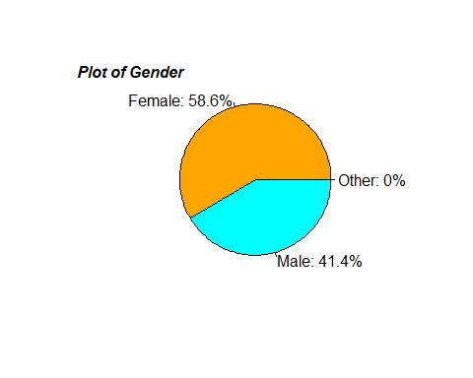
There are more females than there are males. Only a handful of persons (18 in number) have not indicated their gender.
We know proceed to check the age distribution.
``
# Customized histogram
ggplot(df, aes(x = age)) +
geom_histogram(binwidth = 1, color = "black", fill = "cyan") +
geom_vline(aes(xintercept = mean(age)), color = "red", linetype = "dashed") +
labs(title = "Age Distribution")
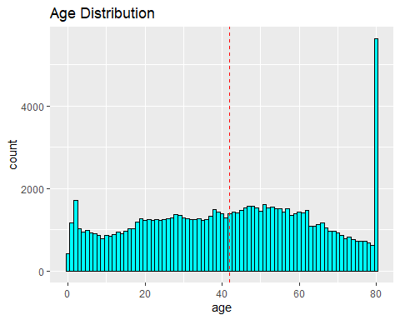
The histogram shows that we have ages from 0 to 80 all represented. The average age stands at 42.
Age 80 is the modal age. This mean we have more people covered in the age bracket than all the rest of the ages recorded.
Breaking the age in class interval shows we have more people in the age category of (40 - 60).
# Customized histogram using class intervals
ggplot(df, aes(x = age)) +
geom_histogram(bins = 20, color = "black", fill = "cyan") +
geom_vline(aes(xintercept = mean(age)), color = "red", linetype = "dashed") +
labs(title = "Age Distribution")
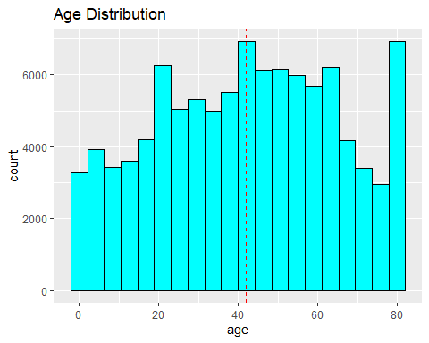
To further understand the decomposition of the age structure by gender, the plot below has the following to reveal:
#age distribution
# Create the histogram
ggplot(df, aes(x = age, fill = gender)) +
geom_histogram(bins = 20, position = "dodge") +
labs(title = "Age Distribution by Gender")
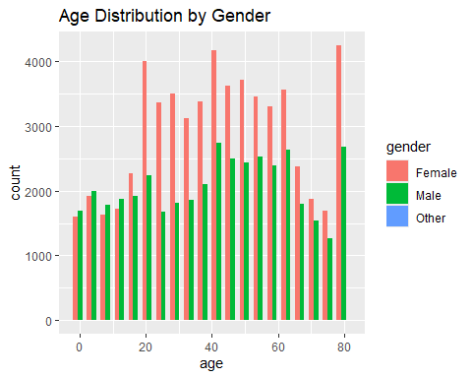
We already know there are less males than females, this chart suggest the age distribution among the gender follows a similar distribution.
We delve further to look at hypertension incidence aggregated by gender
hypertension_status <- df %>% group_by(gender, hypertension) %>% summarise( freq = n(), .groups= "drop") %>% arrange(desc(hypertension))
hypertension_status
## # A tibble: 5 × 3
## gender hypertension freq
## <chr> <fct> <int>
## 1 Female 1 4197
## 2 Male 1 3288
## 3 Female 0 54355
## 4 Male 0 38142
## 5 Other 0 18
#make it a plot
a <- ggplot(hypertension_status, aes( x= gender, y = freq, fill = hypertension))+
geom_bar( stat = "identity") + labs( title = "plot of gender hypertension status")
a + ylab ("Number of persons")
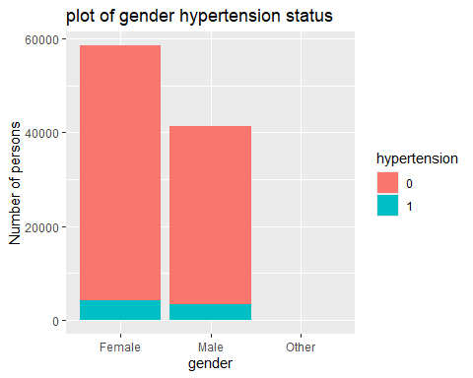
There are more females who are hypertensive than there are males. There are also more females than males who are not hypertensive.
From the gender break down pie chart, we understand that there are more females than males in the data set.
Let’s take a closer look at the figures who are hypertensive
hyper_positive <- hypertension_status %>% filter(hypertension == "1")
hyper_positive
## # A tibble: 2 × 3
## gender hypertension freq
## <chr> <fct> <int>
## 1 Female 1 4197
## 2 Male 1 3288
#make it a plot
b <- ggplot(hyper_positive, aes( x= gender, y = freq, fill = gender))+
geom_bar( stat = "identity") + labs( title = "plot of gender with hypertension ")
b + ylab("Number of persons")
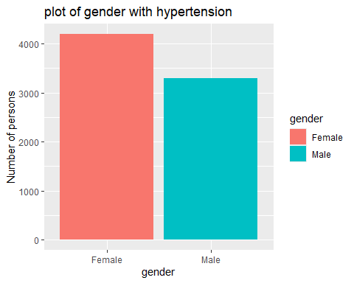 Above is a bar chart of the number of males & females who have hypertension.
The figures across the genders are close. The difference is about 900.
Next line of action is get insight from the heart disease perspective.
Heart_disease_status <- df %>% group_by(gender, heart_disease) %>% summarise( freq = n(), .groups= "drop") %>% arrange(desc(heart_disease))
Heart_disease_status
## # A tibble: 5 × 3
## gender heart_disease freq
## <chr> <fct> <int>
## 1 Female 1 1562
## 2 Male 1 2380
## 3 Female 0 56990
## 4 Male 0 39050
## 5 Other 0 18
hd <- ggplot(Heart_disease_status, aes( x= gender, y = freq, fill = heart_disease))+
geom_bar( stat = "identity") + labs( title = "plot of gender with or no heart disease status")
hd + ylab ("Number of persons")
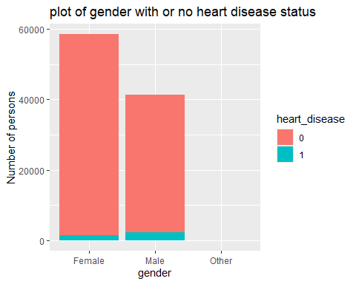 The chart shows the majority of the population are free from heart disease.
And there are more males than females who have heart diseases.
#breaking down the analysis to see population with heart disease
heart_illness <- Heart_disease_status %>% filter(heart_disease == "1")
heart_illness
## # A tibble: 2 × 3
## gender heart_disease freq
## <chr> <fct> <int>
## 1 Female 1 1562
## 2 Male 1 2380
hd <- ggplot(heart_illness, aes( x= gender, y = freq, fill = gender))+
geom_bar( stat = "identity") + labs( title = "plot of gender with heart disease ")
hd + ylab("Number of persons")
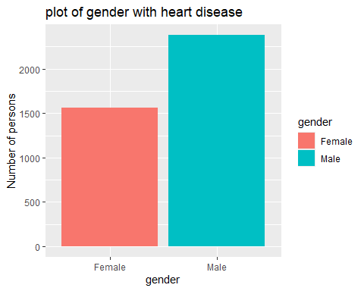
there are more males this time around with an heart disease than females.
We repeat the procedure for diabetes.
diabetes_status <- df %>% group_by(gender, diabetes) %>% summarise( freq = n(), .groups= "drop") %>% arrange(desc(diabetes))
diabetes_status
## # A tibble: 5 × 3
## gender diabetes freq
## <chr> <fct> <int>
## 1 Female 1 4461
## 2 Male 1 4039
## 3 Female 0 54091
## 4 Male 0 37391
## 5 Other 0 18
db <- ggplot(diabetes_status, aes( x= gender, y = freq, fill = diabetes))+
geom_bar( stat = "identity") + labs( title = "plot of gender diabetics status")
db + ylab ("Number of persons")
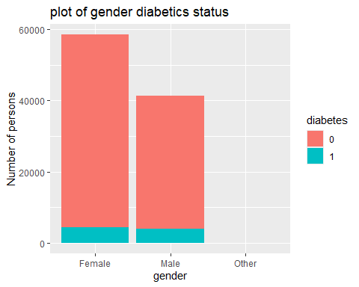 We see yet again that majority of the population are diabetes free. We shall drill down to look at the population testes positive to diabetes.
diabetics_positive <- diabetes_status %>% filter(diabetes == "1")
diabetics_positive
## # A tibble: 2 × 3
## gender diabetes freq
## <chr> <fct> <int>
## 1 Female 1 4461
## 2 Male 1 4039
dbplot <- ggplot(diabetics_positive, aes( x= gender, y = freq, fill = gender))+
geom_bar( stat = "identity") + labs( title = "plot of gender with diabetes ")
dbplot + ylab("Number of persons")
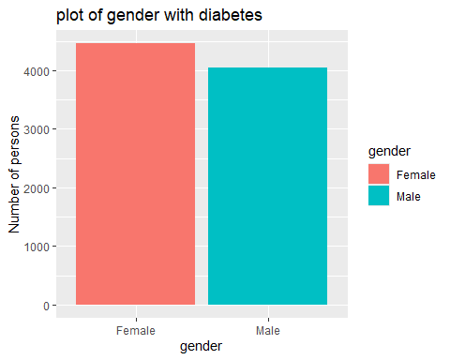 There are almost the same number of male as female who tested positive to diabetes.
Drilling into the smoking history column.
smoking_status <- df %>% group_by(gender, smoking_history) %>% summarise( freq = n(), .groups= "drop") %>% arrange(desc(smoking_history))
smoking_status
## # A tibble: 16 × 3
## gender smoking_history freq
## <chr> <fct> <int>
## 1 Female not current 3913
## 2 Male not current 2526
## 3 Other not current 8
## 4 Female No Info 19700
## 5 Male No Info 16110
## 6 Other No Info 6
## 7 Female never 22869
## 8 Male never 12223
## 9 Other never 3
## 10 Female former 4774
## 11 Male former 4578
## 12 Female ever 2238
## 13 Male ever 1765
## 14 Other ever 1
## 15 Female current 5058
## 16 Male current 4228
#make it a plot
smo <- ggplot(smoking_status, aes( x= gender, y = freq, fill = smoking_history))+
geom_bar( stat = "identity") + labs( title = "plot of gender by smoking history")
smo + ylab ("Number of persons")
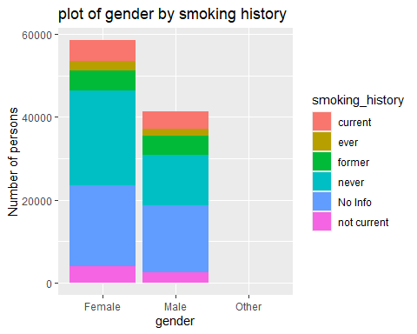
There is a similarity in the numbers or proportions across both genders with their smoking history.
It’s worth mentioning that a good number of the population have never smoked or has a ‘no smoke’ history or no longer a current smoker.
we would now filter the data to reveal information about the population who has been a former smoker, a current and ever smoker.
smokers <- smoking_status %>% filter(smoking_history == "former" | smoking_history == "current" | smoking_history == "ever" )
smokers
## # A tibble: 7 × 3
## gender smoking_history freq
## <chr> <fct> <int>
## 1 Female former 4774
## 2 Male former 4578
## 3 Female ever 2238
## 4 Male ever 1765
## 5 Other ever 1
## 6 Female current 5058
## 7 Male current 4228
smo_plo <- ggplot(smokers, aes( x= gender, y = freq, fill = smoking_history))+
geom_bar( stat = "identity") + labs( title = "plot of gender with smoking history ")
smo_plo + ylab("Number of persons")
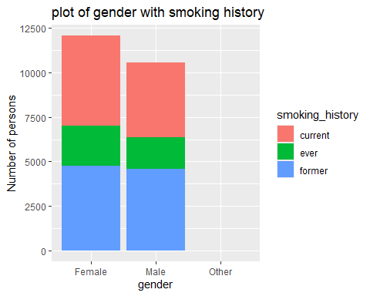 The figures of each category across the gender are similar are almost of the same number.
smoking has an habit is not gender specific.
To get a proper understanding statistic for the numerical columns in the data, we have to plot boxplots.
# Melt the data
melt_df <- df %>% select (1,6,7,8)
melted_df <- melt(melt_df, id.vars = "gender")
# Create the boxplot individually
#for bmi
melt_bmi <- melted_df %>% filter(variable == "bmi" & gender != "Other")
ggplot(melt_bmi, aes(x = gender, y = value, fill = variable)) +
geom_boxplot(color = "blue") +
labs(title = "Grouped Boxplot for BMI")
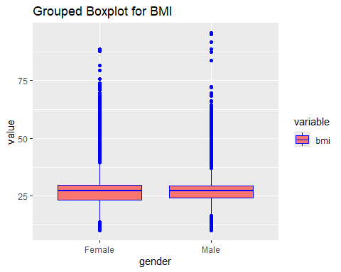
#for HbA1c_level
melt_hb <- melted_df %>% filter(variable == "HbA1c_level" & gender != "Other")
ggplot(melt_hb, aes(x = gender, y = value, fill = variable)) +
geom_boxplot(color = "orange") +
labs(title = "Grouped Boxplot for HbA1c_level")
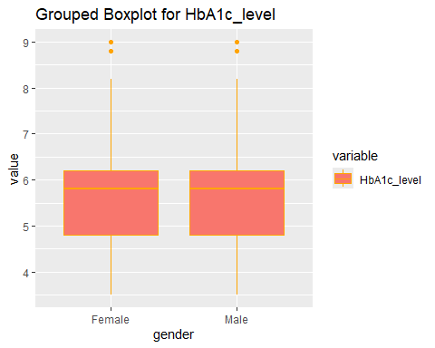
#for blood_glucose_level
melt_bgl <- melted_df %>% filter(variable == "blood_glucose_level" & gender != "Other")
ggplot(melt_bgl, aes(x = gender, y = value, fill = variable)) +
geom_boxplot() +
labs(title = "Grouped Boxplot for blood_glucose_level")
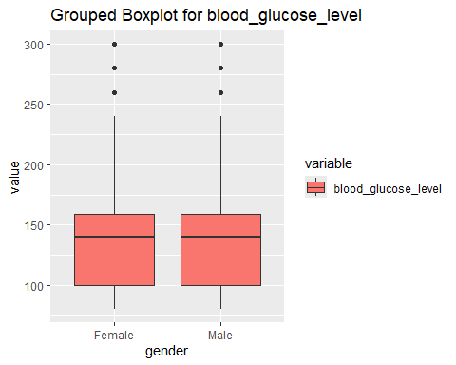 For BMi, there are quite a number of outliers outside of the expected range across both genders. Further data is required to understand the probable cause of this
For the HbA1c_level, it’s interesting to see almost the same data points and equal number of outliers for both genders for the variable.
The same pattern for hbA1c_level is also observed in the blood glusoce level variable.
##Relationship
We shall now examine the relationship between age and BMI
Then filter the dataset to reveal when the population are positive to all of hypertension, heart disease, smoking history and has diabetes to understand the relation between age and BMI all over again.
#examine relationship between BMI & age
# Create a scatter plot
ggplot(df, aes(y = bmi, x = age, fill = gender, color = gender)) +
geom_point() +
labs(title = "Scatter Plot in ggplot2")
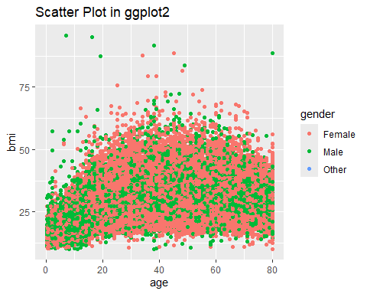 The plot shows the BMI and age of the population aggregated by their gender. As we have more females than male, there are more orange color (color code for females) than there are green (color code for males).
The peak points in the data suggests there are for male populace. Could it be that males have higher BMI than females? Well, the box plot already revealed that these data points for both gender are similar
positive_df <- df %>% filter(hypertension == "1" & heart_disease == "1" & diabetes== "1" & smoking_history == "former" | smoking_history == "current" | smoking_history == "ever")
head(positive_df)
## gender age hypertension heart_disease smoking_history bmi HbA1c_level
## 1 Female 36 0 0 current 23.45 5.0
## 2 Male 76 1 1 current 20.14 4.8
## 3 Male 37 0 0 ever 25.72 3.5
## 4 Male 40 0 0 current 36.38 6.0
## 5 Female 41 0 0 current 22.01 6.2
## 6 Male 50 1 0 current 27.32 5.7
## blood_glucose_level diabetes
## 1 155 0
## 2 155 0
## 3 159 0
## 4 90 0
## 5 126 0
## 6 260 1
#examine relationship between BMI & age
# Create a scatter plot
ggplot(positive_df, aes(y = bmi, x = age, fill = gender, color = gender)) +
geom_point() +
labs(title = "Scatter Plot in ggplot2")
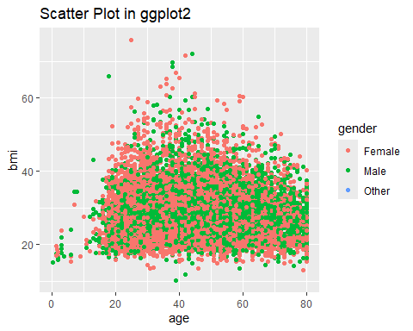 The scatter plot is the relationship between BMI and age of the population who test positive to all cases being considered.
To get a deeper understanding of the plot, let’s take a look at the boxplots
#Melt the data
long_posi_df <- positive_df %>% select (1,6,7,8)
melted_long_df <- melt(long_posi_df, id.vars = "gender")
# Create the boxplot individually
#for bmi
posi_bmi <- melted_long_df %>% filter(variable == "bmi" & gender != "Other")
ggplot(posi_bmi, aes(x = gender, y = value, fill = variable)) +
geom_boxplot(color = "blue") +
labs(title = "Grouped Boxplot for BMI")
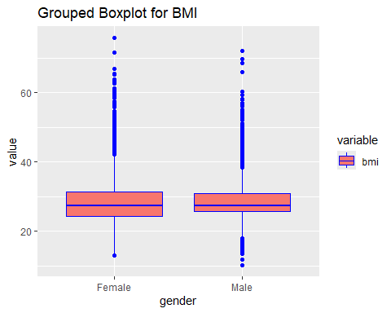
Here again, the outliers are present. This could only be saying that the fraction of the population that tests positive to any of the listed ailments has the BMI to be an anomaly.
As part of this whole process would be to collect and store health data of our potential clients, it would be nice to have a model that reads the data supplied by the customer and determine if they are likely to test positive or negative for diabetes by using a binary logistics model that has been trained by this dataset.
We start by creating a new column that categories the age of the user.
0-24 shall be young 25- 50 shall be adult 51 and above shall be old
#create a new column
pred_df <- df %>% mutate(
generation = ifelse(age < 24,"Young",
ifelse(age >= 25 & age <= 50, "Adult","Old"))
)
head(pred_df, 10)
## gender age hypertension heart_disease smoking_history bmi HbA1c_level
## 1 Female 80 0 1 never 25.19 6.6
## 2 Female 54 0 0 No Info 27.32 6.6
## 3 Male 28 0 0 never 27.32 5.7
## 4 Female 36 0 0 current 23.45 5.0
## 5 Male 76 1 1 current 20.14 4.8
## 6 Female 20 0 0 never 27.32 6.6
## 7 Female 44 0 0 never 19.31 6.5
## 8 Female 79 0 0 No Info 23.86 5.7
## 9 Male 42 0 0 never 33.64 4.8
## 10 Female 32 0 0 never 27.32 5.0
## blood_glucose_level diabetes generation
## 1 140 0 Old
## 2 80 0 Old
## 3 158 0 Adult
## 4 155 0 Adult
## 5 155 0 Old
## 6 85 0 Young
## 7 200 1 Adult
## 8 85 0 Old
## 9 145 0 Adult
## 10 100 0 Adult
check for the data type of the new column - generation
str(pred_df)
## 'data.frame': 100000 obs. of 10 variables:
## $ gender : chr "Female" "Female" "Male" "Female" ...
## $ age : num 80 54 28 36 76 20 44 79 42 32 ...
## $ hypertension : Factor w/ 2 levels "0","1": 1 1 1 1 2 1 1 1 1 1 ...
## $ heart_disease : Factor w/ 2 levels "0","1": 2 1 1 1 2 1 1 1 1 1 ...
## $ smoking_history : Factor w/ 6 levels "current","ever",..: 4 5 4 1 1 4 4 5 4 4 ...
## $ bmi : num 25.2 27.3 27.3 23.4 20.1 ...
## $ HbA1c_level : num 6.6 6.6 5.7 5 4.8 6.6 6.5 5.7 4.8 5 ...
## $ blood_glucose_level: int 140 80 158 155 155 85 200 85 145 100 ...
## $ diabetes : Factor w/ 2 levels "0","1": 1 1 1 1 1 1 2 1 1 1 ...
## $ generation : chr "Old" "Old" "Adult" "Adult" ...
convert generation and gender columns to factor
pred_df$generation <- as.factor(pred_df$generation)
pred_df$gender <- as.factor(pred_df$gender)
str(pred_df)
## 'data.frame': 100000 obs. of 10 variables:
## $ gender : Factor w/ 3 levels "Female","Male",..: 1 1 2 1 2 1 1 1 2 1 ...
## $ age : num 80 54 28 36 76 20 44 79 42 32 ...
## $ hypertension : Factor w/ 2 levels "0","1": 1 1 1 1 2 1 1 1 1 1 ...
## $ heart_disease : Factor w/ 2 levels "0","1": 2 1 1 1 2 1 1 1 1 1 ...
## $ smoking_history : Factor w/ 6 levels "current","ever",..: 4 5 4 1 1 4 4 5 4 4 ...
## $ bmi : num 25.2 27.3 27.3 23.4 20.1 ...
## $ HbA1c_level : num 6.6 6.6 5.7 5 4.8 6.6 6.5 5.7 4.8 5 ...
## $ blood_glucose_level: int 140 80 158 155 155 85 200 85 145 100 ...
## $ diabetes : Factor w/ 2 levels "0","1": 1 1 1 1 1 1 2 1 1 1 ...
## $ generation : Factor w/ 3 levels "Adult","Old",..: 2 2 1 1 2 3 1 2 1 1 ...
To perform a binary logistics regression on the data. diabetes is the dependent variable ( a binary/factor column) gender, hypertension, heart disease, smoking history, bmi, HbA1c level and blood glucose level are all the independent variable.
split the data into training and testing sets
sample <- sample(c(TRUE, FALSE), nrow(pred_df), replace = TRUE, prob = c(0.7,0.3))
train <- pred_df [sample, ]
test <- pred_df[!sample,]
model <- glm( diabetes ~ gender + hypertension + heart_disease + smoking_history + bmi + HbA1c_level + blood_glucose_level + generation, family="binomial", data=train)
#disable scientific notation for model summary
options(scipen=999)
#view model summary
summary(model)
##
## Call:
## glm(formula = diabetes ~ gender + hypertension + heart_disease +
## smoking_history + bmi + HbA1c_level + blood_glucose_level +
## generation, family = "binomial", data = train)
##
## Coefficients:
## Estimate Std. Error z value Pr(>|z|)
## (Intercept) -25.1477392 0.3334024 -75.428 < 0.0000000000000002
## genderMale 0.2593832 0.0428642 6.051 0.000000001436975067
## genderOther -8.0554210 92.8994931 -0.087 0.931
## hypertension1 0.8489890 0.0561778 15.113 < 0.0000000000000002
## heart_disease1 0.9257510 0.0724203 12.783 < 0.0000000000000002
## smoking_historyever 0.0156693 0.1100486 0.142 0.887
## smoking_historyformer 0.0742618 0.0835030 0.889 0.374
## smoking_historynever -0.0337384 0.0725911 -0.465 0.642
## smoking_historyNo Info -0.6574070 0.0801362 -8.204 0.000000000000000233
## smoking_historynot current -0.0753289 0.0996065 -0.756 0.449
## bmi 0.0814289 0.0030290 26.883 < 0.0000000000000002
## HbA1c_level 2.3261769 0.0420841 55.275 < 0.0000000000000002
## blood_glucose_level 0.0338049 0.0005724 59.059 < 0.0000000000000002
## generationOld 1.2080777 0.0500698 24.128 < 0.0000000000000002
## generationYoung -1.2503983 0.1246951 -10.028 < 0.0000000000000002
##
## (Intercept) ***
## genderMale ***
## genderOther
## hypertension1 ***
## heart_disease1 ***
## smoking_historyever
## smoking_historyformer
## smoking_historynever
## smoking_historyNo Info ***
## smoking_historynot current
## bmi ***
## HbA1c_level ***
## blood_glucose_level ***
## generationOld ***
## generationYoung ***
## ---
## Signif. codes: 0 '***' 0.001 '**' 0.01 '*' 0.05 '.' 0.1 ' ' 1
##
## (Dispersion parameter for binomial family taken to be 1)
##
## Null deviance: 40931 on 69968 degrees of freedom
## Residual deviance: 16079 on 69954 degrees of freedom
## AIC: 16109
##
## Number of Fisher Scoring iterations: 11
The coefficients in the output indicate the average change in log odds of defaulting. For example, a one unit increase in bmi is associated with an average increase of 0.079457 in the log odds of defaulting.
The p-values in the output also give us an idea of how effective each predictor variable is at predicting the probability of default:
In typical linear regression, we use R2 as a way to assess how well a model fits the data. This number ranges from 0 to 1, with higher values indicating better model fit.
However, there is no such R2 value for logistic regression. Instead, we can compute a metric known as McFadden’s R2, which ranges from 0 to just under 1. Values close to 0 indicate that the model has no predictive power. In practice, values over 0.40 indicate that a model fits the data very well.
# Fit the null model (intercept-only)
null_model <- glm(diabetes ~ 1, family = 'binomial', data = train)
# Calculate McFadden's R-squared
mcfadden_r2 <- 1 - (logLik(model) / logLik(null_model))
# Print McFadden's R-squared
cat("McFadden's R-Squared:", mcfadden_r2, "\n")
## McFadden's R-Squared: 0.6071745
McFadden’s R-squared 0.60623 suggests that the model explains more variance than the null model. In this case, 60.6% of the variation in the dependent variable (e.g., binary outcome) is accounted for by the predictors in your logistic regression model.
Good Fit: Generally, McFadden’s R-squared values above 0.2 or 0.3 are considered indicative of a good fit. A value of 0.606 suggests that the model performs reasonably well in explaining the observed outcomes.
We can also compute the importance of each predictor variable in the model.
# Compute variable importance
var_importance <- varImp(model)
# Print the results
print(var_importance)
## Overall
## genderMale 6.05128216
## genderOther 0.08671114
## hypertension1 15.11252871
## heart_disease1 12.78303852
## smoking_historyever 0.14238489
## smoking_historyformer 0.88933012
## smoking_historynever 0.46477309
## smoking_historyNo Info 8.20362446
## smoking_historynot current 0.75626466
## bmi 26.88345218
## HbA1c_level 55.27454745
## blood_glucose_level 59.05854070
## generationOld 24.12787700
## generationYoung 10.02764279
We can also calculate the VIF values of each variable in the model to see if multicollinearity is a problem.
car::vif(model)
## GVIF Df GVIF^(1/(2*Df))
## gender 1.033529 2 1.008279
## hypertension 1.045581 1 1.022537
## heart_disease 1.056413 1 1.027820
## smoking_history 1.083398 5 1.008042
## bmi 1.058008 1 1.028595
## HbA1c_level 1.051383 1 1.025370
## blood_glucose_level 1.059375 1 1.029260
## generation 1.131444 2 1.031355
As a rule of thumb, VIF values above 5 indicate severe multicollinearity. only smoking_history of the predictor variables in our models have a VIF over 5, this is probable to the variable having so many levels.
Use the Model to Make Predictions.
Once we’ve fit the logistic regression model, we can then use it to make predictions about whether or not an individual will have diabetes based on the data provided.
#select 3 rows from test data
test_run <- test[c(1:3), ]
#reorder the columns to match with variable displayed above#
test_run <- test_run %>% select(1,3,4,5,6,7,8,10)
#view data
test_run
## gender hypertension heart_disease smoking_history bmi HbA1c_level
## 3 Male 0 0 never 27.32 5.7
## 5 Male 1 1 current 20.14 4.8
## 7 Female 0 0 never 19.31 6.5
## blood_glucose_level generation
## 3 158 Adult
## 5 155 Old
## 7 200 Adult
#predictiom
predict(model, test_run, type="response")
## 3 5 7
## 0.01634942 0.02063016 0.15084863
Below is the probability that an individual will test positive for diabetes.
We can use the following code to calculate the probability of default for every individual in our test dataset:
predicted <- predict(model, test, type="response")
head(predicted)
## 3 5 7 9 13 14
## 0.016349420 0.020630156 0.150848634 0.002203570 0.007359549 0.164009844
References:
https://www.statology.org/logistic-regression-in-r/ https://search.r-project.org/CRAN/refmans/intervals/html/Intervals-class.html https://topepo.github.io/caret/variable-importance.html

