**Data Analysis**

Understanding the demography of our respondents.

**Gender - Age Group**

| Gender/Age Group | 20-35 | 35-45 | 45-55 | 55-65 | Above 65 |
| --- | --- | --- | --- | --- | --- |
| Female | 77 | 4 | 3 | 3 | 0 |
| Male | 57 | 13 | 4 | 2 | 1 |

For the Age group, we have more male gender than the female gender. With the majority of our respondents being middle-aged.

**Gender- Religion**

| Gender/Religion | Christain | Muslim | Others |
| --- | --- | --- | --- |
| Female | 77 | 9 | 1 |
| Male | 70 | 7 | 0 |

Here, we have more christain respondents compared to the Muslim and Other religion.

**Gender - Marital Status**

| Gender/Marital Status | Divorced | Married | Single | Widowed |
| --- | --- | --- | --- | --- |
| Female | 1 | 26 | 58 | 2 |
| Male | 3 | 26 | 48 | 0 |

We have more Single respondents, then the married folks, the divorced and finally, the widowed.

A pie chart of the marital status of our respondents. 64.6 % makes up the single population, 31.7% makes up the married population, 2.4% makes up the divorced population and the remaining 1.3% for the widowed population.

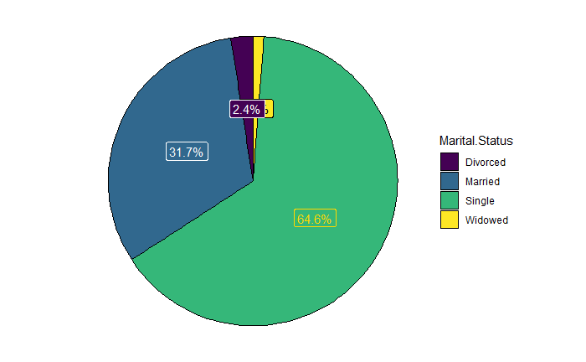

Now, we proceed to have a sentiment analysis of our respondents by marital status.

**a.) Single (Dating)**

We have a total of 61 respondents, who are single, and dating at the moment.

| **Gender/Age Group** | **20-35** | **35-40** | **55-65** |
| --- | --- | --- | --- |
| **Male** | 26 | 3 | 1 |
| **Female** | 31 | 0 | 0 |

Perusing their thoughts on “what they think should be the motive behind marriage” .

They all seem to have a good “motive” or intentions towards marriage. However, when it was asked if for any reason, they would consider divorce? 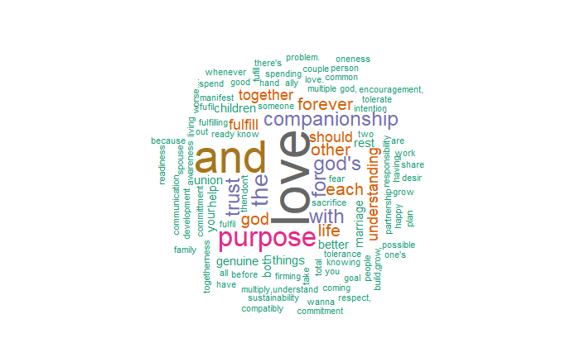  
  
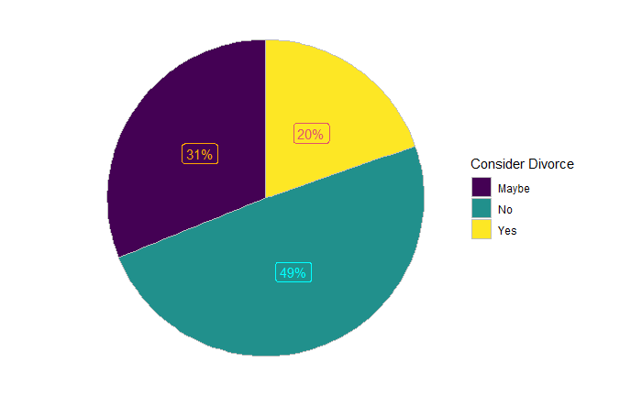

A large percentage (49%) said “No”, whereas 31% indicated “Maybe” with the remaining 20% clearly indicating they would opt for divorce when things go left.   
  
A look into whether these folks who are dating would settle with their current partner revealed this:

| yes | no |
| --- | --- |
| 58 | 3 |

**Single (Not Dating)**

For this category, we have 45 respondents with the following demography.

| **Gender/Age Group** | **20-35** | **35-45** |
| --- | --- | --- |
| **Male** | 17 | 1 |
| **Female** | 27 | 0 |

Let’s sample their “marriage motives” opinion.

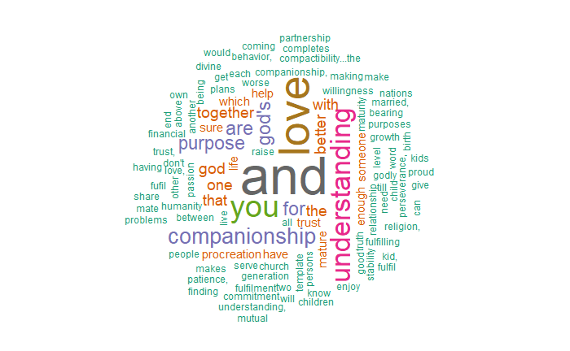

The sentiment analysis reveals the respondents' motives towards marriage to be a positive one.   
  
next , will be to determine their disposition towards divorce.

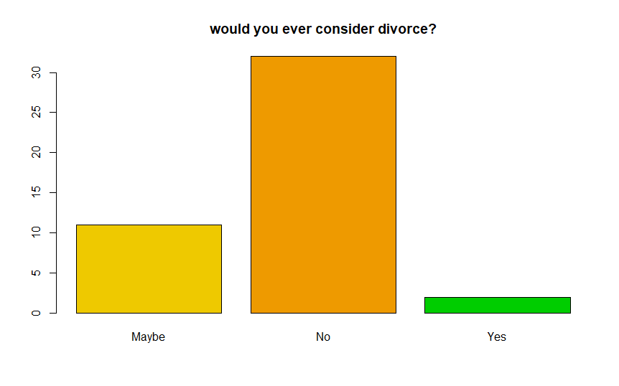

24.4% are with choice “maybe” while, 71.1% firmly hold on to “no”. And lastly, the 4.4% of them saying “yes”.

**Married**

For the married folks, we have the following demography.

| **Gender/AGe Group** | 20-35 | 35-45 | 45-55 | 55-65 | Above 65 |
| --- | --- | --- | --- | --- | --- |
| **Male** | 14 | 7 | 3 | 1 | 1 |
| **Female** | 19 | 4 | 3 |  |  |

We have an equal number of male and female respondents. With the majority of them in the 20-35 age bracket.

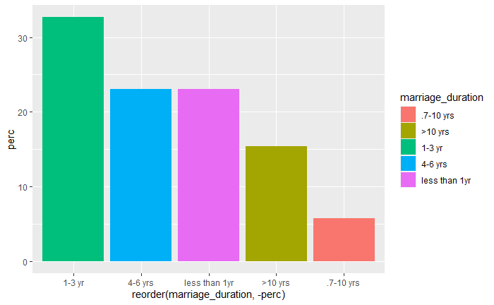

For the respondents, 32% of them are within their 1-3 years of marriage, 23% of them are both in 4-6 years and less than a year (fresh couple) while 16% have been in 0ver 10 years of marriage with 6% being in 7-10 years.

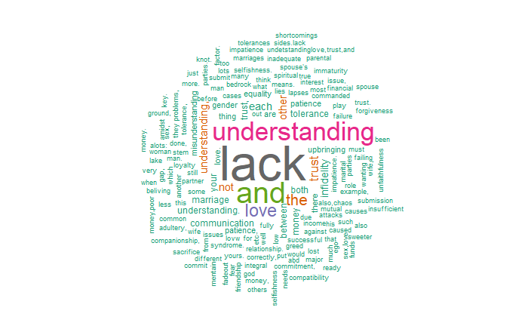

A sentiment analysis when ask for why marriages fail, saw “lack” of understanding topping the list.   
  
Here is the Marriage advise from the married to the single folks. Each word appearing in the cluster, has a minimum number of occurrence of 2.

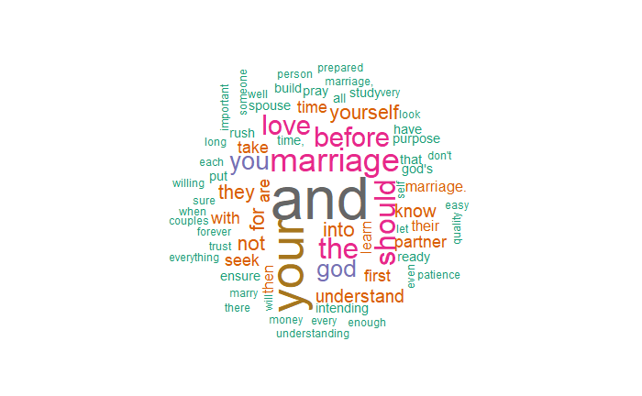

But when asked for their advice to couples, whose marriage are on the edge, 4% actually suggested divorce, if the heat gets too much.  
  
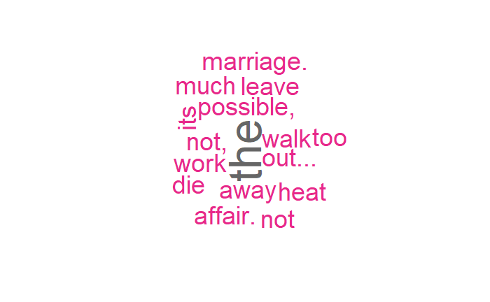

A peep into the couple live to see how they have been sustaining their marriage. The married respondents were peovided with 4 key words: Love, Trust, Understanding and and money. Of which they can pick all 4.   
  
The data reveals this.

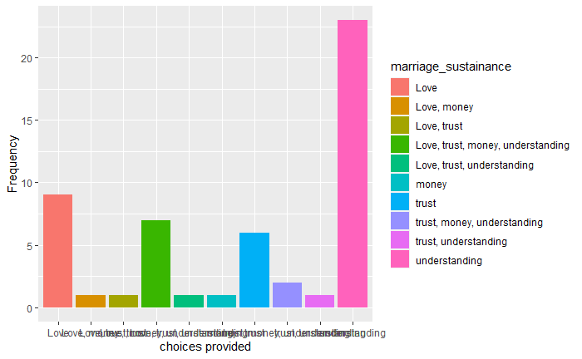

*Vero, this is for your own personal consumption. I will provide the chart above in a table, so you can make more sense of it.*

| **Choices provided** | **Frequency** |
| --- | --- |
| Love | 9 |
| Love, Money | 1 |
| Love, Trust | 1 |
| Love, trust, Money, Understanding | 7 |
| Love, Trust, Understanding | 1 |
| Money | 1 |
| Trust | 6 |
| Trust, Money, Understanding | 2 |
| Trust, Understanding | 1 |
| Understanding | 23 |

Advice for the upcoming single- pringles folks.

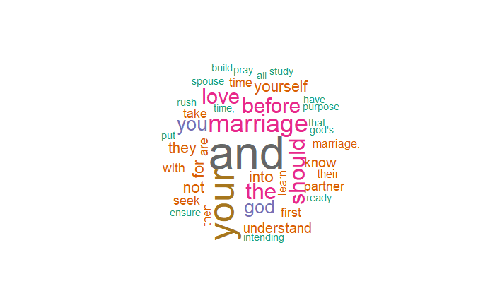

**The Divorced**

There are 4 respondents in this category.

| **Gender/Age Group** | **35-45** | **45-55** |
| --- | --- | --- |
| **Male** | 2 | 1 |
| **Female** | 1 |  |

We have older people in this category.

When asked if they felt, they married the wrong person?

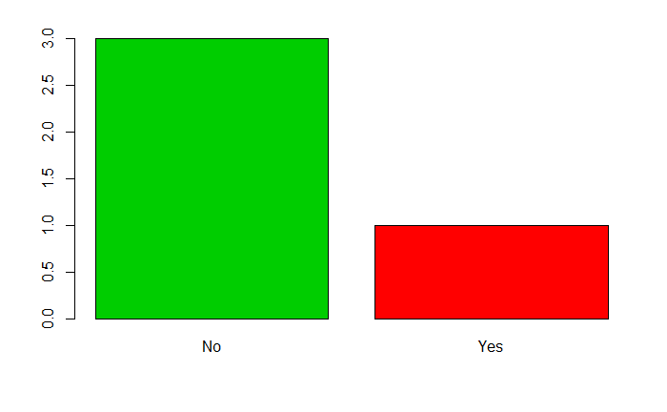

75% indicated they are sure they didn’t marry the wrong person, and 25% said yes. They felt they married the wrong person.   
  
Dating reasons:  
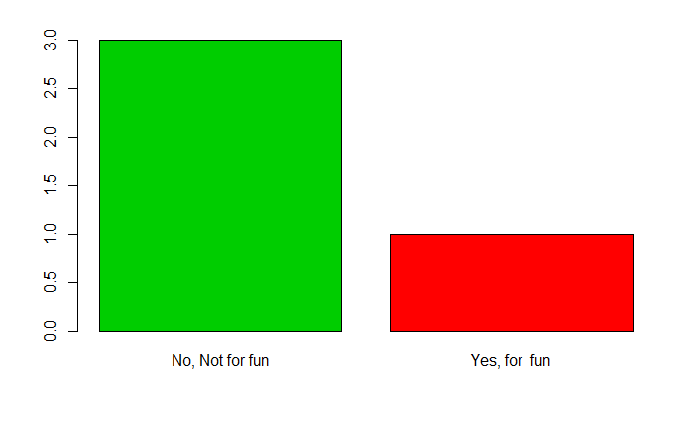  
  
Here are their intentions for settling down with their estranged partners. 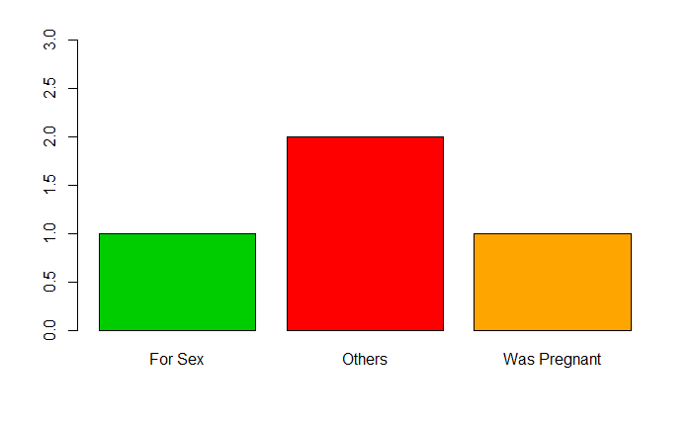

One was pregnant, another was just pregnant and 2 signified “others” as a reason for their intention while dating.   
  
  
Did you see all these red flags that led to divorce before you agreed to marry them?   
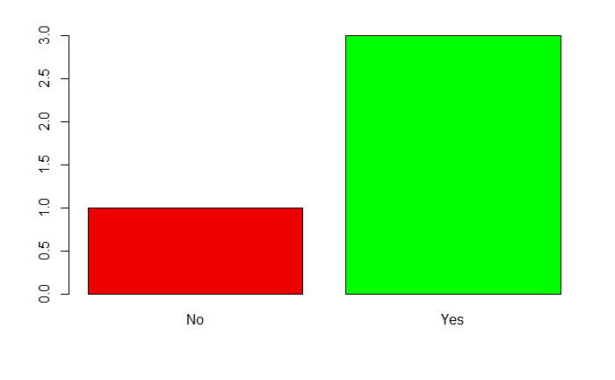

Interestingly, all respondents indicated their partners initiated the divorce.

When asked “If you were given another opportunity to set things right and make your marriage work, would you gladly agree?”  
  
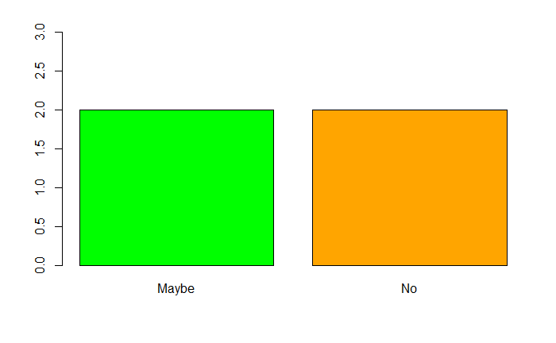

Years before marriage:  
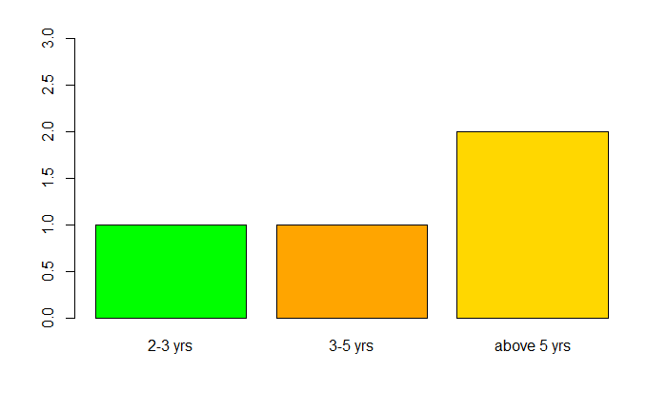  
Courtship duration

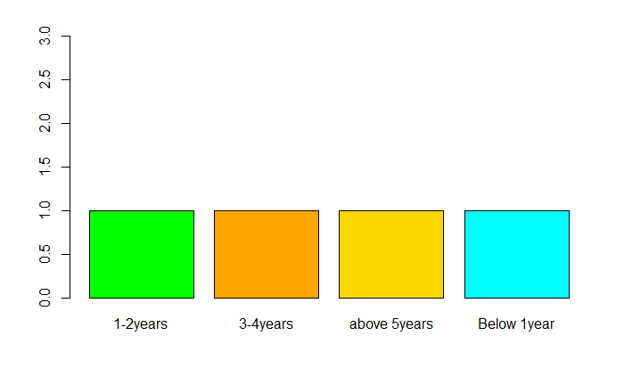

Here is the Nationality of our respondnents.

Nigeria  
Rwanda  
Cameoon