Distributed MQTT Communication Framework

1. Introduction

This RFC defines the distributed MQTT communication framework used by isiMonitor3D, a zone-based warehouse monitoring system.

As warehouse deployments expand beyond a single monitoring station, multiple Backbone nodes are required to monitor different warehouse zones. Each node publishes metadata to a central MQTT broker, where the isi-gateway aggregates the information and exposes a unified REST API for downstream applications such as AGVs, Warehouse Management Systems (WMS), and monitoring dashboards.

The framework adopts a publish–subscribe architecture that enables independent operation of Backbone nodes while providing a centralized view of warehouse activity. This design supports incremental deployment, automatic node integration, and centralized access to monitoring data.

This RFC specifies:
- The distributed communication architecture.
- MQTT topic organization and metadata exchange.
- Data aggregation through the isi-gateway.
- REST-based access for external applications.

Computer vision algorithms, object detection, calibration, tracking, and warehouse automation logic are outside the scope of this specification.

  - Design Objectives
The communication framework is designed to provide:
- Scalability – Support distributed warehouse deployments by adding Backbone nodes without architectural changes.
- Loose Coupling – Decouple monitoring nodes from downstream applications through MQTT publish–subscribe messaging.
- Fault Tolerance – Ensure failures remain isolated to individual components.
- Automatic Discovery – Allow new Backbone nodes to register automatically with the gateway.
- Unified Data Access – Provide a single REST interface for warehouse applications.

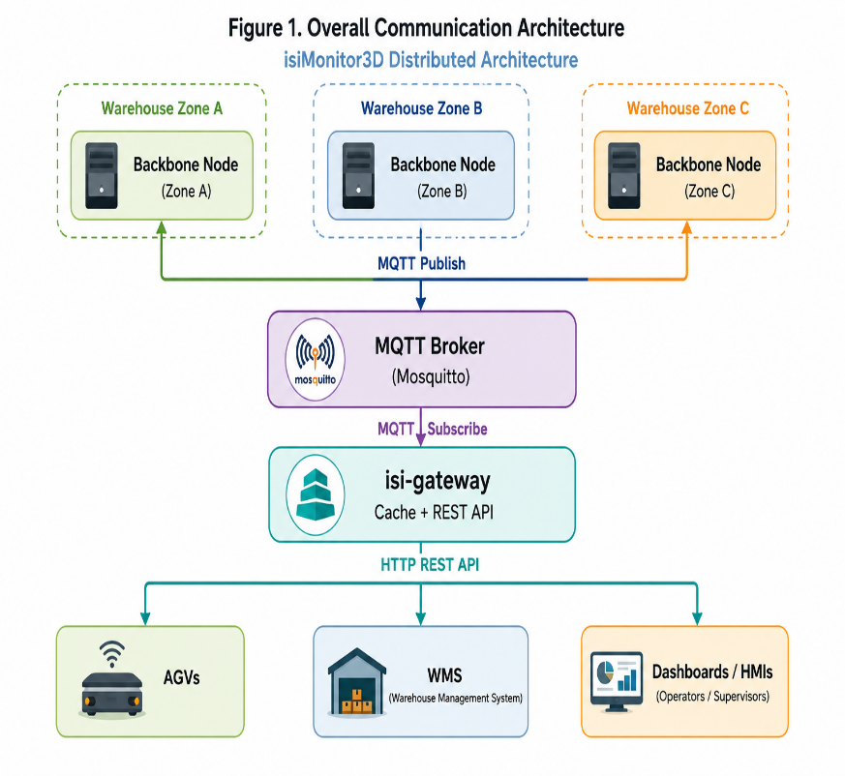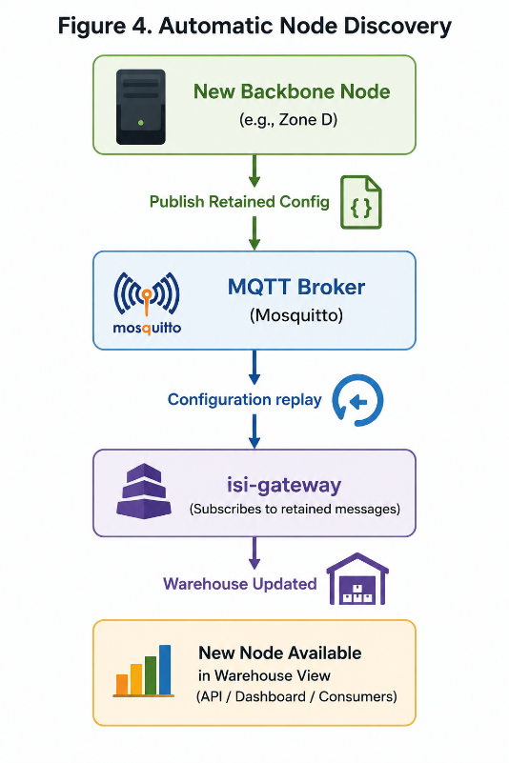

2. Communication Architecture
The communication framework uses MQTT as the messaging backbone between distributed Backbone nodes and the isi-gateway. Each Backbone node publishes metadata independently to a central MQTT broker, while the gateway subscribes to these messages to maintain a unified representation of the warehouse.

2.1 Topic Namespace
MQTT topics follow a hierarchical namespace:
isi/<version>/<node_id>/<category>/...
where:
- isi identifies the isiMonitor3D platform.
- version specifies the communication protocol version (currently v1).
- node_id uniquely identifies a Backbone node.
- category identifies the type of published metadata.
This topic structure allows the gateway to identify both the message source and its purpose without requiring additional routing information.

2.2 Message Categories
The framework defines the following primary message categories:

Category | Description
track2d | Real-time 2D object tracking information used for warehouse navigation.
track3d | Optional stereo-derived 3D object positions.
config | Retained self-description of a node (identity, mode, cameras, zones); the gateway reads it to auto-discover nodes.
passings | Zone entry and exit events generated when tracked objects cross predefined boundaries.
diagnostics | Heartbeat messages containing node health and performance metrics.

Additional categories may be introduced in future protocol versions while preserving backward compatibility through protocol versioning.

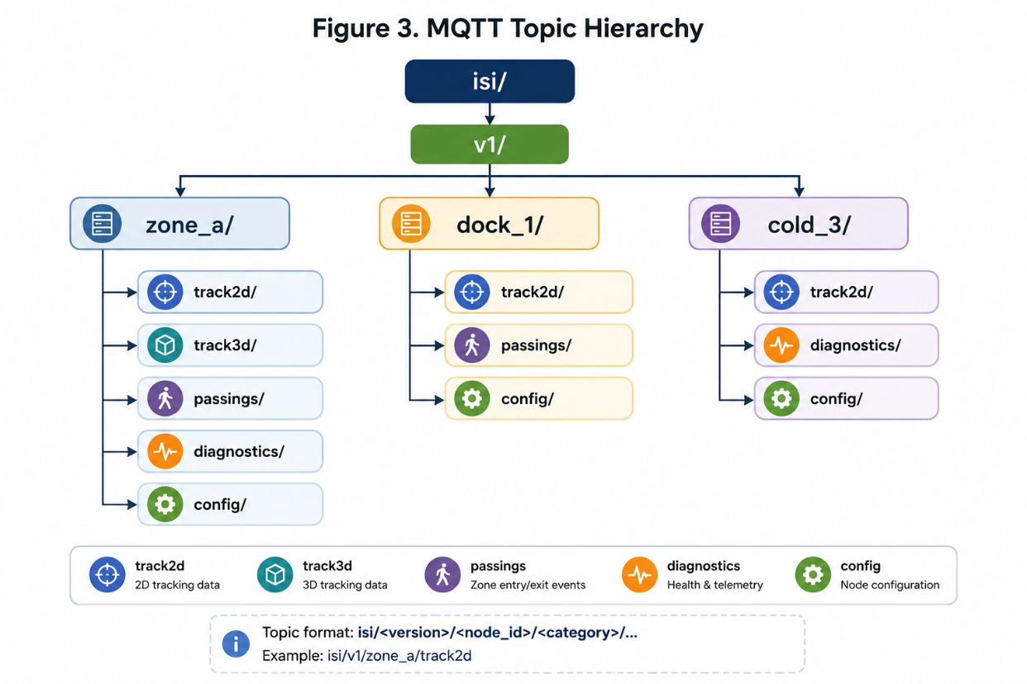
This hierarchy gives a consistent naming scheme and lets the gateway identify the source node and message type.

3. Design Principles

3.1 Automatic Node Discovery
Each Backbone node publishes a retained configuration message describing its identity, monitoring capabilities, connected cameras, and configured monitoring zones.
When the isi-gateway starts, it retrieves these retained messages from the MQTT broker and automatically builds a complete inventory of available monitoring nodes. As new nodes join the system, they are discovered without requiring manual configuration or gateway restart.

3.2 Fault Tolerance
Failures are isolated to the affected component.
If a Backbone node temporarily loses connectivity to the MQTT broker, it continues operating locally and automatically reconnects when communication is restored. If a node becomes unavailable, the gateway marks it as inactive after a heartbeat timeout while continuing to serve data from the remaining nodes.

3.3 Scalable Deployment
The framework scales horizontally by adding additional Backbone nodes.
Each node publishes metadata using its unique node_id, allowing the gateway to distinguish monitoring zones while exposing a single, unified view of the warehouse. No changes are required to the gateway or downstream applications when new nodes are deployed.

3.4 Versioned Communication
The communication framework uses versioning at both the MQTT topic and message schema levels.
- Topic Version identifies the communication protocol (for example, isi/v1/...).
- Schema Version identifies the JSON payload structure.
Independent versioning allows protocol and payload formats to evolve while maintaining compatibility during system upgrades.
4. Consumer Interface and Deployment

4.1 Consumer Interface
The isi-gateway provides the interface between the MQTT communication framework and external warehouse applications.
It continuously subscribes to MQTT topics, maintains an in-memory representation of the distributed warehouse state, and exposes this information through a centralized REST API. Consumer applications interact exclusively with the gateway and remain independent of the underlying MQTT infrastructure.

The primary REST endpoints are:

Endpoint | Description
GET /v1/nodes | Returns all registered Backbone nodes and their current status.
GET /v1/tracks | Returns active tracked objects across the warehouse.
GET /v1/zones | Returns all configured monitoring zones.
GET /v1/passings | Returns recent zone entry and exit events.
GET /v1/config | Returns each node's configuration advertisement.
GET /v1/diagnostics | Returns the latest heartbeat and health information for each Backbone node.
GET /healthz | Reports the operational status of the gateway service.

4.2 Deployment Architecture

The framework uses a centralized model: each warehouse PC runs a single Backbone node that publishes metadata to a central MQTT broker, while the isi-gateway runs on the same central server. Additional monitoring nodes can be deployed without changing the gateway or the consumer applications.

The broker and gateway are packaged as two Docker containers, started with a single Docker Compose command:

Container | Image | Port | Role
mosquitto | eclipse-mosquitto:2 | 1883 | MQTT broker; persistence keeps retained config messages across restarts
isi-gateway | isi-gateway(≈300 MB) | 8080 | aggregates node data, serves the REST API

The system currently runs the on-prem profile (plaintext on a trusted LAN). A secured cloud profile (TLS, broker authentication, reverse proxy) is paused for now, as it would require internet exposure, and can be enabled later if remote access is needed. Both containers restart automatically after a reboot.

Figure 5. Deployment Architecture

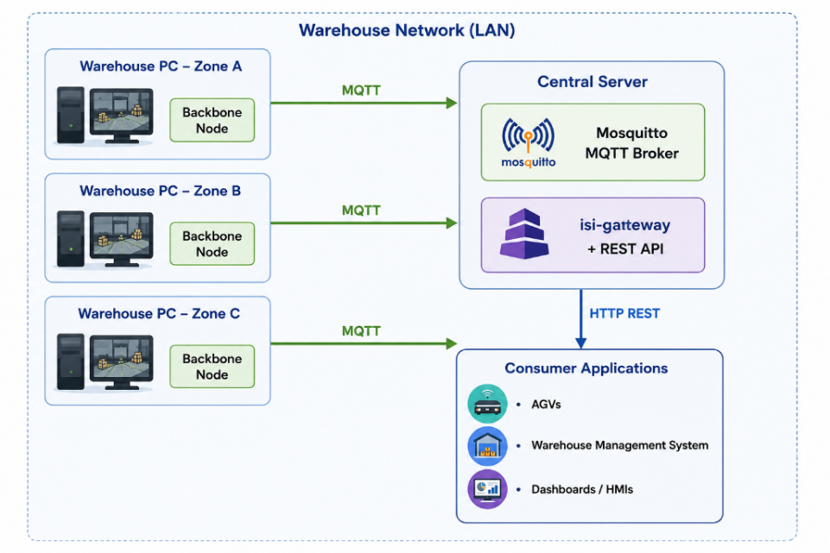
4.3 Security Considerations

The communication framework is intended primarily for deployment within trusted industrial networks while supporting future cloud-based deployments.

For on-premises installations:
- MQTT communication operates over the internal LAN.
- Backbone nodes establish outbound connections only.
- No inbound services are exposed on warehouse PCs.

For deployments across untrusted networks, the framework can be secured using:
- MQTT over TLS.
- Broker authentication.
- HTTPS for the REST API.
- Bearer token authentication for API access.
Only metadata is transmitted over MQTT. Images and video remain on the local Backbone nodes, with MQTT messages containing references to stored snapshots when required. This minimizes bandwidth usage while reducing the exposure of sensitive visual data.
Centralizing external access through the isi-gateway enables authentication, authorization, and future security enhancements to be implemented without modifying individual Backbone nodes.
5. Implementation Status, Validation and Future Work

The distributed MQTT communication framework has been successfully implemented as part of the isiMonitor3D warehouse monitoring system. The architecture has been validated using multiple Backbone nodes communicating through an Eclipse Mosquitto MQTT broker, with the isi-gateway aggregating data into a unified REST interface.
Validation confirmed reliable message exchange, automatic node registration, heartbeat monitoring, gateway aggregation, and containerized deployment in an on-premises environment.

5.1 Current Implementation
The current implementation supports:
- Distributed MQTT communication between Backbone nodes and the central gateway.
- Automatic discovery of monitoring nodes using retained configuration messages.
- Real-time aggregation of warehouse metadata.
- Node health monitoring through periodic heartbeats.
- Unified REST API access for warehouse applications.
These capabilities provide a stable foundation for deploying isiMonitor3D across multiple warehouse zones.

5.2 Future Enhancements

Future development will focus on extending the communication framework while maintaining backward compatibility.
Planned enhancements include:
- Secure remote deployment using MQTT over TLS and HTTPS.
- Evaluation of MQTT QoS 1 for safety-critical events.
- Optional WebSocket support for real-time client updates.
- Continued protocol evolution through versioned topics and message schemas.

Conclusion

This RFC defines the communication architecture that enables isiMonitor3D to operate as a scalable, distributed warehouse monitoring system.

By combining MQTT publish–subscribe messaging with centralized aggregation and a unified REST interface, the framework allows independent monitoring nodes to work together while presenting a single, consistent view of warehouse activity. The modular design supports incremental expansion, simplifies integration with downstream systems, and provides a solid foundation for future enhancements.

